## Multiple Regression and Special Issues

## Adam Samstag

options(tidyverse.quiet = TRUE)  
library(tidyverse)

## Warning: package 'tidyverse' was built under R version 3.5.2

library(GGally)

## Warning: package 'GGally' was built under R version 3.5.2

##   
## Attaching package: 'GGally'

## The following object is masked from 'package:dplyr':  
##   
## nasa

library(MASS)

##   
## Attaching package: 'MASS'

## The following object is masked from 'package:dplyr':  
##   
## select

#### Task 1

library(readr)  
bike <- read_csv("hour.csv")

## Parsed with column specification:  
## cols(  
## instant = col_integer(),  
## dteday = col_date(format = ""),  
## season = col_integer(),  
## yr = col_integer(),  
## mnth = col_integer(),  
## hr = col_integer(),  
## holiday = col_integer(),  
## weekday = col_integer(),  
## workingday = col_integer(),  
## weathersit = col_integer(),  
## temp = col_double(),  
## atemp = col_double(),  
## hum = col_double(),  
## windspeed = col_double(),  
## casual = col_integer(),  
## registered = col_integer(),  
## count = col_integer()  
## )

bike = bike %>% mutate(season = as_factor(as.character(season))) %>% mutate(season = fct_recode(season, "Spring" = "1", "Summer" = "2", "Fall" = "3", "Winter" = "4"))   
bike = bike %>% mutate(yr = as_factor(as.character(yr)))  
bike = bike %>% mutate(mnth = as_factor(as.character(mnth)))  
bike = bike %>% mutate(hr = as_factor(as.character(hr)))  
bike = bike %>% mutate(holiday = as_factor(as.character(holiday))) %>% mutate(holiday = fct_recode(holiday, "NotHoliday" = "0", "Holiday" = "1"))  
bike = bike %>% mutate(workingday = as_factor(as.character(workingday))) %>% mutate(workingday = fct_recode(workingday, "NotWorkingDay" = "0", "WorkingDay" = "1"))  
bike = bike %>% mutate(weathersit = as_factor(as.character(weathersit))) %>% mutate(weathersit = fct_recode(weathersit, "NoPrecip" = "1", "Misty" = "2", "LightPrecip" = "3", "HeavyPrecip" = "4"))  
bike = bike %>% mutate(weekday = as_factor(as.character(weekday))) %>% mutate(weekday = fct_recode(weekday, "Sunday" = "0", "Monday" = "1", "Tuesday" = "2", "Wednesday" = "3", "Thursday" = "4", "Friday" = "5", "Saturday" = "6"))

#### Task 2

So just by looking the best variables to predict count are: weathersit, season, weekday, and hr.

#### Task 3

ggplot(bike, aes(x=hr, y=count))+  
 geom_boxplot()

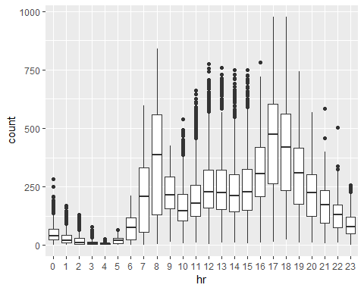 It does affect the count

ggplot(bike, aes(x=mnth, y=count))+  
 geom_boxplot()

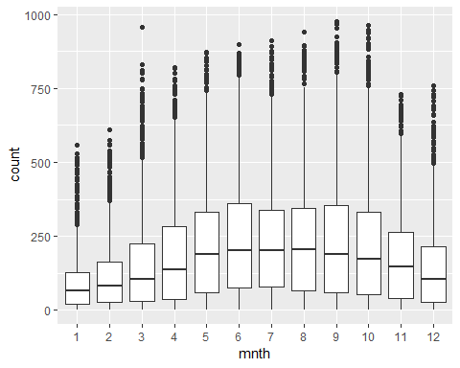 Does

ggplot(bike, aes(x=weathersit, y=count))+  
 geom_boxplot()

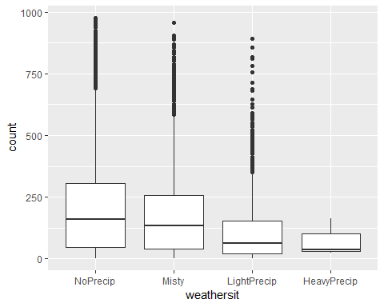 Does affect it.

ggplot(bike, aes(x=weekday, y=count))+  
 geom_boxplot()

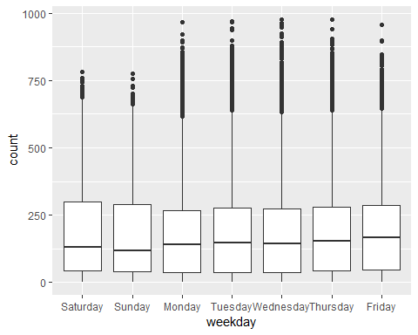 It doesn’t.

ggplot(bike, aes(x=holiday, y=count))+  
 geom_boxplot()

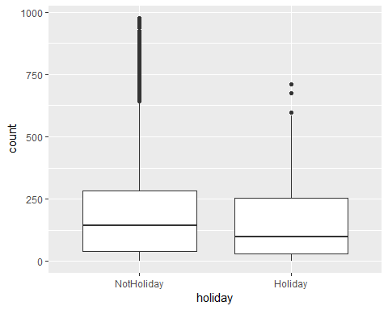 Doesn’t affect it.

ggplot(bike, aes(x=yr, y=count))+  
 geom_boxplot()

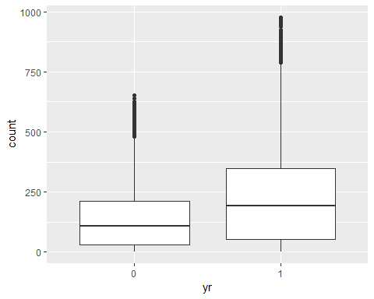 It does not affect the count.

ggplot(bike, aes(x=season, y=count))+  
 geom_boxplot()

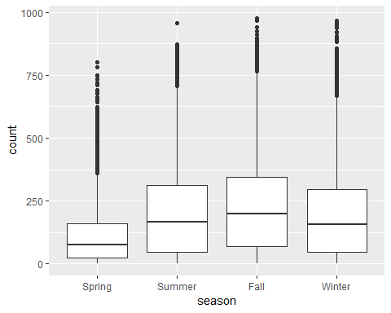 Doesn’t affect.

ggplot(bike, aes(x=workingday, y=count))+  
 geom_boxplot()

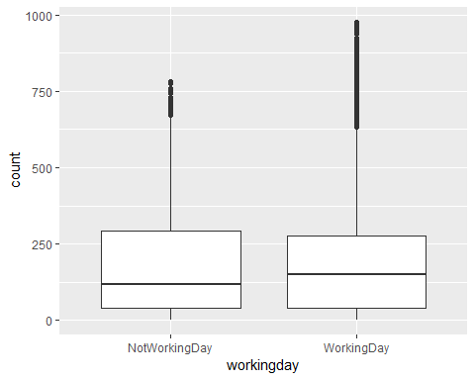 It does not affect the count.

mod1 = lm(count~.-casual-dteday-instant-registered, data = bike)  
summary(mod1)

##   
## Call:  
## lm(formula = count ~ . - casual - dteday - instant - registered,   
## data = bike)  
##   
## Residuals:  
## Min 1Q Median 3Q Max   
## -393.87 -60.66 -7.96 51.31 439.18   
##   
## Coefficients: (1 not defined because of singularities)  
## Estimate Std. Error t value Pr(>|t|)   
## (Intercept) -67.542 6.612 -10.216 < 2e-16 ***  
## seasonSummer 38.178 4.856 7.862 4.00e-15 ***  
## seasonFall 32.055 5.749 5.575 2.51e-08 ***  
## seasonWinter 67.994 4.882 13.928 < 2e-16 ***  
## yr1 85.431 1.563 54.658 < 2e-16 ***  
## mnth2 3.426 3.920 0.874 0.38219   
## mnth3 14.299 4.407 3.244 0.00118 **   
## mnth4 6.230 6.548 0.951 0.34144   
## mnth5 20.657 7.007 2.948 0.00320 **   
## mnth6 6.238 7.205 0.866 0.38662   
## mnth7 -13.269 8.082 -1.642 0.10065   
## mnth8 7.897 7.879 1.002 0.31622   
## mnth9 32.269 7.001 4.609 4.07e-06 ***  
## mnth10 15.843 6.483 2.444 0.01455 *   
## mnth11 -9.840 6.238 -1.577 0.11474   
## mnth12 -6.256 4.954 -1.263 0.20672   
## hr1 -17.294 5.345 -3.236 0.00122 **   
## hr2 -26.369 5.364 -4.916 8.91e-07 ***  
## hr3 -37.112 5.403 -6.869 6.67e-12 ***  
## hr4 -40.263 5.408 -7.445 1.01e-13 ***  
## hr5 -23.501 5.373 -4.374 1.23e-05 ***  
## hr6 35.393 5.359 6.605 4.10e-11 ***  
## hr7 170.418 5.348 31.864 < 2e-16 ***  
## hr8 310.801 5.342 58.183 < 2e-16 ***  
## hr9 163.101 5.347 30.501 < 2e-16 ***  
## hr10 108.444 5.370 20.196 < 2e-16 ***  
## hr11 133.843 5.409 24.742 < 2e-16 ***  
## hr12 173.142 5.456 31.735 < 2e-16 ***  
## hr13 168.102 5.494 30.600 < 2e-16 ***  
## hr14 152.249 5.525 27.558 < 2e-16 ***  
## hr15 161.707 5.535 29.213 < 2e-16 ***  
## hr16 223.834 5.524 40.522 < 2e-16 ***  
## hr17 377.535 5.491 68.750 < 2e-16 ***  
## hr18 345.587 5.455 63.350 < 2e-16 ***  
## hr19 236.919 5.404 43.841 < 2e-16 ***  
## hr20 157.293 5.375 29.266 < 2e-16 ***  
## hr21 107.840 5.353 20.147 < 2e-16 ***  
## hr22 70.907 5.343 13.272 < 2e-16 ***  
## hr23 32.112 5.338 6.015 1.83e-09 ***  
## holidayHoliday -26.228 4.881 -5.374 7.81e-08 ***  
## weekdaySunday -16.089 2.878 -5.591 2.30e-08 ***  
## weekdayMonday -6.814 2.970 -2.294 0.02180 *   
## weekdayTuesday -5.240 2.899 -1.807 0.07071 .   
## weekdayWednesday -2.464 2.894 -0.851 0.39469   
## weekdayThursday -2.940 2.892 -1.016 0.30947   
## weekdayFriday 1.356 2.885 0.470 0.63823   
## workingdayWorkingDay NA NA NA NA   
## weathersitMisty -10.409 1.920 -5.421 6.00e-08 ***  
## weathersitLightPrecip -65.189 3.236 -20.145 < 2e-16 ***  
## weathersitHeavyPrecip -62.580 58.893 -1.063 0.28797   
## temp 116.384 29.513 3.943 8.06e-05 ***  
## atemp 127.975 30.624 4.179 2.94e-05 ***  
## hum -82.802 5.554 -14.909 < 2e-16 ***  
## windspeed -29.167 7.052 -4.136 3.55e-05 ***  
## ---  
## Signif. codes: 0 '***' 0.001 '**' 0.01 '*' 0.05 '.' 0.1 ' ' 1  
##   
## Residual standard error: 101.7 on 17326 degrees of freedom  
## Multiple R-squared: 0.6864, Adjusted R-squared: 0.6854   
## F-statistic: 729.1 on 52 and 17326 DF, p-value: < 2.2e-16

#### Task 4

mod2 = lm(count ~1, data=bike)  
forwardmod = stepAIC(mod2, direction = "forward", scope = list(upper=mod1, lower=mod2), trace = TRUE)

## Start: AIC=180764.7  
## count ~ 1  
##   
## Df Sum of Sq RSS AIC  
## + hr 23 286734681 285026910 168713  
## + temp 1 93677759 478083832 177657  
## + atemp 1 91907421 479854170 177721  
## + hum 1 59618351 512143240 178853  
## + mnth 11 42909976 528851615 179431  
## + season 3 37729358 534032233 179584  
## + yr 1 35876722 535884870 179641  
## + weathersit 3 12285030 559476561 180393  
## + windspeed 1 4970060 566791531 180615  
## + holiday 1 546889 571214702 180750  
## + workingday 1 524387 571237204 180751  
## + weekday 6 687929 571073662 180756  
## <none> 571761591 180765  
##   
## Step: AIC=168712.5  
## count ~ hr  
##   
## Df Sum of Sq RSS AIC  
## + atemp 1 50518941 234507969 165324  
## + temp 1 50101685 234925225 165355  
## + mnth 11 44822160 240204750 165761  
## + season 3 39619754 245407156 166117  
## + yr 1 36875130 248151780 166307  
## + weathersit 3 13766672 271260238 167858  
## + hum 1 4924310 280102600 168412  
## + windspeed 1 1476211 283550699 168624  
## + holiday 1 561784 284465126 168680  
## + weekday 6 719530 284307380 168681  
## + workingday 1 485366 284541544 168685  
## <none> 285026910 168713  
##   
## Step: AIC=165324  
## count ~ hr + atemp  
##   
## Df Sum of Sq RSS AIC  
## + yr 1 33463769 201044200 162650  
## + weathersit 3 9227265 225280704 164632  
## + hum 1 7008684 227499285 164799  
## + season 3 6580442 227927527 164835  
## + mnth 11 5854560 228653409 164907  
## + weekday 6 607638 233900331 165291  
## + holiday 1 274006 234233963 165306  
## + temp 1 152153 234355816 165315  
## + windspeed 1 120557 234387412 165317  
## + workingday 1 90170 234417799 165319  
## <none> 234507969 165324  
##   
## Step: AIC=162650.2  
## count ~ hr + atemp + yr  
##   
## Df Sum of Sq RSS AIC  
## + weathersit 3 8408358 192635842 161914  
## + season 3 7190305 193853896 162023  
## + mnth 11 6486062 194558138 162102  
## + hum 1 4341837 196702363 162273  
## + weekday 6 641648 200402552 162607  
## + holiday 1 324763 200719438 162624  
## + windspeed 1 109311 200934889 162643  
## + workingday 1 106404 200937797 162643  
## + temp 1 91735 200952465 162644  
## <none> 201044200 162650  
##   
## Step: AIC=161913.7  
## count ~ hr + atemp + yr + weathersit  
##   
## Df Sum of Sq RSS AIC  
## + season 3 7771024 184864818 161204  
## + mnth 11 7464989 185170852 161249  
## + hum 1 805099 191830743 161843  
## + weekday 6 686172 191949670 161864  
## + holiday 1 413536 192222305 161878  
## + workingday 1 212428 192423414 161897  
## + temp 1 134482 192501360 161904  
## + windspeed 1 44407 192591435 161912  
## <none> 192635842 161914  
##   
## Step: AIC=161204.1  
## count ~ hr + atemp + yr + weathersit + season  
##   
## Df Sum of Sq RSS AIC  
## + mnth 11 2051323 182813495 161032  
## + hum 1 1810161 183054657 161035  
## + weekday 6 704303 184160515 161150  
## + holiday 1 392702 184472116 161169  
## + temp 1 352584 184512234 161173  
## + workingday 1 214973 184649845 161186  
## <none> 184864818 161204  
## + windspeed 1 158 184864660 161206  
##   
## Step: AIC=161032.2  
## count ~ hr + atemp + yr + weathersit + season + mnth  
##   
## Df Sum of Sq RSS AIC  
## + hum 1 2356411 180457084 160809  
## + weekday 6 692672 182120823 160978  
## + holiday 1 312321 182501174 161004  
## + temp 1 233052 182580443 161012  
## + workingday 1 203953 182609542 161015  
## <none> 182813495 161032  
## + windspeed 1 68 182813428 161034  
##   
## Step: AIC=160808.7  
## count ~ hr + atemp + yr + weathersit + season + mnth + hum  
##   
## Df Sum of Sq RSS AIC  
## + weekday 6 581105 179875980 160765  
## + holiday 1 322997 180134087 160780  
## + workingday 1 194139 180262945 160792  
## + windspeed 1 114287 180342797 160800  
## + temp 1 100025 180357059 160801  
## <none> 180457084 160809  
##   
## Step: AIC=160764.7  
## count ~ hr + atemp + yr + weathersit + season + mnth + hum +   
## weekday  
##   
## Df Sum of Sq RSS AIC  
## + holiday 1 274717 179601263 160740  
## + workingday 1 274717 179601263 160740  
## + windspeed 1 112085 179763895 160756  
## + temp 1 77171 179798809 160759  
## <none> 179875980 160765  
##   
## Step: AIC=160740.1  
## count ~ hr + atemp + yr + weathersit + season + mnth + hum +   
## weekday + holiday  
##   
## Df Sum of Sq RSS AIC  
## + windspeed 1 111562 179489701 160731  
## + temp 1 95460 179505803 160733  
## <none> 179601263 160740  
##   
## Step: AIC=160731.3  
## count ~ hr + atemp + yr + weathersit + season + mnth + hum +   
## weekday + holiday + windspeed  
##   
## Df Sum of Sq RSS AIC  
## + temp 1 160954 179328746 160718  
## <none> 179489701 160731  
##   
## Step: AIC=160717.7  
## count ~ hr + atemp + yr + weathersit + season + mnth + hum +   
## weekday + holiday + windspeed + temp  
##   
## Df Sum of Sq RSS AIC  
## <none> 179328746 160718

summary(forwardmod)

##   
## Call:  
## lm(formula = count ~ hr + atemp + yr + weathersit + season +   
## mnth + hum + weekday + holiday + windspeed + temp, data = bike)  
##   
## Residuals:  
## Min 1Q Median 3Q Max   
## -393.87 -60.66 -7.96 51.31 439.18   
##   
## Coefficients:  
## Estimate Std. Error t value Pr(>|t|)   
## (Intercept) -67.542 6.612 -10.216 < 2e-16 ***  
## hr1 -17.294 5.345 -3.236 0.00122 **   
## hr2 -26.369 5.364 -4.916 8.91e-07 ***  
## hr3 -37.112 5.403 -6.869 6.67e-12 ***  
## hr4 -40.263 5.408 -7.445 1.01e-13 ***  
## hr5 -23.501 5.373 -4.374 1.23e-05 ***  
## hr6 35.393 5.359 6.605 4.10e-11 ***  
## hr7 170.418 5.348 31.864 < 2e-16 ***  
## hr8 310.801 5.342 58.183 < 2e-16 ***  
## hr9 163.101 5.347 30.501 < 2e-16 ***  
## hr10 108.444 5.370 20.196 < 2e-16 ***  
## hr11 133.843 5.409 24.742 < 2e-16 ***  
## hr12 173.142 5.456 31.735 < 2e-16 ***  
## hr13 168.102 5.494 30.600 < 2e-16 ***  
## hr14 152.249 5.525 27.558 < 2e-16 ***  
## hr15 161.707 5.535 29.213 < 2e-16 ***  
## hr16 223.834 5.524 40.522 < 2e-16 ***  
## hr17 377.535 5.491 68.750 < 2e-16 ***  
## hr18 345.587 5.455 63.350 < 2e-16 ***  
## hr19 236.919 5.404 43.841 < 2e-16 ***  
## hr20 157.293 5.375 29.266 < 2e-16 ***  
## hr21 107.840 5.353 20.147 < 2e-16 ***  
## hr22 70.907 5.343 13.272 < 2e-16 ***  
## hr23 32.112 5.338 6.015 1.83e-09 ***  
## atemp 127.975 30.624 4.179 2.94e-05 ***  
## yr1 85.431 1.563 54.658 < 2e-16 ***  
## weathersitMisty -10.409 1.920 -5.421 6.00e-08 ***  
## weathersitLightPrecip -65.189 3.236 -20.145 < 2e-16 ***  
## weathersitHeavyPrecip -62.580 58.893 -1.063 0.28797   
## seasonSummer 38.178 4.856 7.862 4.00e-15 ***  
## seasonFall 32.055 5.749 5.575 2.51e-08 ***  
## seasonWinter 67.994 4.882 13.928 < 2e-16 ***  
## mnth2 3.426 3.920 0.874 0.38219   
## mnth3 14.299 4.407 3.244 0.00118 **   
## mnth4 6.230 6.548 0.951 0.34144   
## mnth5 20.657 7.007 2.948 0.00320 **   
## mnth6 6.238 7.205 0.866 0.38662   
## mnth7 -13.269 8.082 -1.642 0.10065   
## mnth8 7.897 7.879 1.002 0.31622   
## mnth9 32.269 7.001 4.609 4.07e-06 ***  
## mnth10 15.843 6.483 2.444 0.01455 *   
## mnth11 -9.840 6.238 -1.577 0.11474   
## mnth12 -6.256 4.954 -1.263 0.20672   
## hum -82.802 5.554 -14.909 < 2e-16 ***  
## weekdaySunday -16.089 2.878 -5.591 2.30e-08 ***  
## weekdayMonday -6.814 2.970 -2.294 0.02180 *   
## weekdayTuesday -5.240 2.899 -1.807 0.07071 .   
## weekdayWednesday -2.464 2.894 -0.851 0.39469   
## weekdayThursday -2.940 2.892 -1.016 0.30947   
## weekdayFriday 1.356 2.885 0.470 0.63823   
## holidayHoliday -26.228 4.881 -5.374 7.81e-08 ***  
## windspeed -29.167 7.052 -4.136 3.55e-05 ***  
## temp 116.384 29.513 3.943 8.06e-05 ***  
## ---  
## Signif. codes: 0 '***' 0.001 '**' 0.01 '*' 0.05 '.' 0.1 ' ' 1  
##   
## Residual standard error: 101.7 on 17326 degrees of freedom  
## Multiple R-squared: 0.6864, Adjusted R-squared: 0.6854   
## F-statistic: 729.1 on 52 and 17326 DF, p-value: < 2.2e-16

The following variables are in the model: hr, atemp, yr, weathersit, season, mnth, hum, weekday, holiday, windspeed, temp This is a good model This model inculdes all of the variables I predicted except it includes a lot of variables I didn’t predict as being factors for count.

#### Task 5

backwardmod = stepAIC(mod1, direction = "backward", trace = TRUE)

## Start: AIC=160717.7  
## count ~ (instant + dteday + season + yr + mnth + hr + holiday +   
## weekday + workingday + weathersit + temp + atemp + hum +   
## windspeed + casual + registered) - casual - dteday - instant -   
## registered  
##   
##   
## Step: AIC=160717.7  
## count ~ season + yr + mnth + hr + holiday + weekday + weathersit +   
## temp + atemp + hum + windspeed  
##   
## Df Sum of Sq RSS AIC  
## <none> 179328746 160718  
## - temp 1 160954 179489701 160731  
## - windspeed 1 177057 179505803 160733  
## - atemp 1 180751 179509498 160733  
## - holiday 1 298893 179627639 160745  
## - weekday 6 498795 179827541 160754  
## - mnth 11 2426171 181754917 160929  
## - hum 1 2300667 181629413 160937  
## - season 3 2398467 181727213 160943  
## - weathersit 3 4208731 183537478 161115  
## - yr 1 30920851 210249597 163480  
## - hr 23 196741474 376070220 173542

summary(backwardmod)

##   
## Call:  
## lm(formula = count ~ season + yr + mnth + hr + holiday + weekday +   
## weathersit + temp + atemp + hum + windspeed, data = bike)  
##   
## Residuals:  
## Min 1Q Median 3Q Max   
## -393.87 -60.66 -7.96 51.31 439.18   
##   
## Coefficients:  
## Estimate Std. Error t value Pr(>|t|)   
## (Intercept) -67.542 6.612 -10.216 < 2e-16 ***  
## seasonSummer 38.178 4.856 7.862 4.00e-15 ***  
## seasonFall 32.055 5.749 5.575 2.51e-08 ***  
## seasonWinter 67.994 4.882 13.928 < 2e-16 ***  
## yr1 85.431 1.563 54.658 < 2e-16 ***  
## mnth2 3.426 3.920 0.874 0.38219   
## mnth3 14.299 4.407 3.244 0.00118 **   
## mnth4 6.230 6.548 0.951 0.34144   
## mnth5 20.657 7.007 2.948 0.00320 **   
## mnth6 6.238 7.205 0.866 0.38662   
## mnth7 -13.269 8.082 -1.642 0.10065   
## mnth8 7.897 7.879 1.002 0.31622   
## mnth9 32.269 7.001 4.609 4.07e-06 ***  
## mnth10 15.843 6.483 2.444 0.01455 *   
## mnth11 -9.840 6.238 -1.577 0.11474   
## mnth12 -6.256 4.954 -1.263 0.20672   
## hr1 -17.294 5.345 -3.236 0.00122 **   
## hr2 -26.369 5.364 -4.916 8.91e-07 ***  
## hr3 -37.112 5.403 -6.869 6.67e-12 ***  
## hr4 -40.263 5.408 -7.445 1.01e-13 ***  
## hr5 -23.501 5.373 -4.374 1.23e-05 ***  
## hr6 35.393 5.359 6.605 4.10e-11 ***  
## hr7 170.418 5.348 31.864 < 2e-16 ***  
## hr8 310.801 5.342 58.183 < 2e-16 ***  
## hr9 163.101 5.347 30.501 < 2e-16 ***  
## hr10 108.444 5.370 20.196 < 2e-16 ***  
## hr11 133.843 5.409 24.742 < 2e-16 ***  
## hr12 173.142 5.456 31.735 < 2e-16 ***  
## hr13 168.102 5.494 30.600 < 2e-16 ***  
## hr14 152.249 5.525 27.558 < 2e-16 ***  
## hr15 161.707 5.535 29.213 < 2e-16 ***  
## hr16 223.834 5.524 40.522 < 2e-16 ***  
## hr17 377.535 5.491 68.750 < 2e-16 ***  
## hr18 345.587 5.455 63.350 < 2e-16 ***  
## hr19 236.919 5.404 43.841 < 2e-16 ***  
## hr20 157.293 5.375 29.266 < 2e-16 ***  
## hr21 107.840 5.353 20.147 < 2e-16 ***  
## hr22 70.907 5.343 13.272 < 2e-16 ***  
## hr23 32.112 5.338 6.015 1.83e-09 ***  
## holidayHoliday -26.228 4.881 -5.374 7.81e-08 ***  
## weekdaySunday -16.089 2.878 -5.591 2.30e-08 ***  
## weekdayMonday -6.814 2.970 -2.294 0.02180 *   
## weekdayTuesday -5.240 2.899 -1.807 0.07071 .   
## weekdayWednesday -2.464 2.894 -0.851 0.39469   
## weekdayThursday -2.940 2.892 -1.016 0.30947   
## weekdayFriday 1.356 2.885 0.470 0.63823   
## weathersitMisty -10.409 1.920 -5.421 6.00e-08 ***  
## weathersitLightPrecip -65.189 3.236 -20.145 < 2e-16 ***  
## weathersitHeavyPrecip -62.580 58.893 -1.063 0.28797   
## temp 116.384 29.513 3.943 8.06e-05 ***  
## atemp 127.975 30.624 4.179 2.94e-05 ***  
## hum -82.802 5.554 -14.909 < 2e-16 ***  
## windspeed -29.167 7.052 -4.136 3.55e-05 ***  
## ---  
## Signif. codes: 0 '***' 0.001 '**' 0.01 '*' 0.05 '.' 0.1 ' ' 1  
##   
## Residual standard error: 101.7 on 17326 degrees of freedom  
## Multiple R-squared: 0.6864, Adjusted R-squared: 0.6854   
## F-statistic: 729.1 on 52 and 17326 DF, p-value: < 2.2e-16

The model does not change. Workingday is represented by weekday with the working days most likely being Monday-Friday and also the holiday variable is another that represents working day, you can assume that most nonholidays are working days.

#### Task 6

bike2 = bike %>% mutate(yr=as.integer(yr)-1)  
  
allmod = lm(count~.-casual-dteday-instant-registered, data=bike2)  
emptymod = lm(count~1, data=bike2)  
  
forwardmod2 = stepAIC(emptymod, direction = "forward", scope = list(upper=allmod,lower=emptymod), trace = TRUE)

## Start: AIC=180764.7  
## count ~ 1  
##   
## Df Sum of Sq RSS AIC  
## + hr 23 286734681 285026910 168713  
## + temp 1 93677759 478083832 177657  
## + atemp 1 91907421 479854170 177721  
## + hum 1 59618351 512143240 178853  
## + mnth 11 42909976 528851615 179431  
## + season 3 37729358 534032233 179584  
## + yr 1 35876722 535884870 179641  
## + weathersit 3 12285030 559476561 180393  
## + windspeed 1 4970060 566791531 180615  
## + holiday 1 546889 571214702 180750  
## + workingday 1 524387 571237204 180751  
## + weekday 6 687929 571073662 180756  
## <none> 571761591 180765  
##   
## Step: AIC=168712.5  
## count ~ hr  
##   
## Df Sum of Sq RSS AIC  
## + atemp 1 50518941 234507969 165324  
## + temp 1 50101685 234925225 165355  
## + mnth 11 44822160 240204750 165761  
## + season 3 39619754 245407156 166117  
## + yr 1 36875130 248151780 166307  
## + weathersit 3 13766672 271260238 167858  
## + hum 1 4924310 280102600 168412  
## + windspeed 1 1476211 283550699 168624  
## + holiday 1 561784 284465126 168680  
## + weekday 6 719530 284307380 168681  
## + workingday 1 485366 284541544 168685  
## <none> 285026910 168713  
##   
## Step: AIC=165324  
## count ~ hr + atemp  
##   
## Df Sum of Sq RSS AIC  
## + yr 1 33463769 201044200 162650  
## + weathersit 3 9227265 225280704 164632  
## + hum 1 7008684 227499285 164799  
## + season 3 6580442 227927527 164835  
## + mnth 11 5854560 228653409 164907  
## + weekday 6 607638 233900331 165291  
## + holiday 1 274006 234233963 165306  
## + temp 1 152153 234355816 165315  
## + windspeed 1 120557 234387412 165317  
## + workingday 1 90170 234417799 165319  
## <none> 234507969 165324  
##   
## Step: AIC=162650.2  
## count ~ hr + atemp + yr  
##   
## Df Sum of Sq RSS AIC  
## + weathersit 3 8408358 192635842 161914  
## + season 3 7190305 193853896 162023  
## + mnth 11 6486062 194558138 162102  
## + hum 1 4341837 196702363 162273  
## + weekday 6 641648 200402552 162607  
## + holiday 1 324763 200719438 162624  
## + windspeed 1 109311 200934889 162643  
## + workingday 1 106404 200937797 162643  
## + temp 1 91735 200952465 162644  
## <none> 201044200 162650  
##   
## Step: AIC=161913.7  
## count ~ hr + atemp + yr + weathersit  
##   
## Df Sum of Sq RSS AIC  
## + season 3 7771024 184864818 161204  
## + mnth 11 7464989 185170852 161249  
## + hum 1 805099 191830743 161843  
## + weekday 6 686172 191949670 161864  
## + holiday 1 413536 192222305 161878  
## + workingday 1 212428 192423414 161897  
## + temp 1 134482 192501360 161904  
## + windspeed 1 44407 192591435 161912  
## <none> 192635842 161914  
##   
## Step: AIC=161204.1  
## count ~ hr + atemp + yr + weathersit + season  
##   
## Df Sum of Sq RSS AIC  
## + mnth 11 2051323 182813495 161032  
## + hum 1 1810161 183054657 161035  
## + weekday 6 704303 184160515 161150  
## + holiday 1 392702 184472116 161169  
## + temp 1 352584 184512234 161173  
## + workingday 1 214973 184649845 161186  
## <none> 184864818 161204  
## + windspeed 1 158 184864660 161206  
##   
## Step: AIC=161032.2  
## count ~ hr + atemp + yr + weathersit + season + mnth  
##   
## Df Sum of Sq RSS AIC  
## + hum 1 2356411 180457084 160809  
## + weekday 6 692672 182120823 160978  
## + holiday 1 312321 182501174 161004  
## + temp 1 233052 182580443 161012  
## + workingday 1 203953 182609542 161015  
## <none> 182813495 161032  
## + windspeed 1 68 182813428 161034  
##   
## Step: AIC=160808.7  
## count ~ hr + atemp + yr + weathersit + season + mnth + hum  
##   
## Df Sum of Sq RSS AIC  
## + weekday 6 581105 179875980 160765  
## + holiday 1 322997 180134087 160780  
## + workingday 1 194139 180262945 160792  
## + windspeed 1 114287 180342797 160800  
## + temp 1 100025 180357059 160801  
## <none> 180457084 160809  
##   
## Step: AIC=160764.7  
## count ~ hr + atemp + yr + weathersit + season + mnth + hum +   
## weekday  
##   
## Df Sum of Sq RSS AIC  
## + holiday 1 274717 179601263 160740  
## + workingday 1 274717 179601263 160740  
## + windspeed 1 112085 179763895 160756  
## + temp 1 77171 179798809 160759  
## <none> 179875980 160765  
##   
## Step: AIC=160740.1  
## count ~ hr + atemp + yr + weathersit + season + mnth + hum +   
## weekday + holiday  
##   
## Df Sum of Sq RSS AIC  
## + windspeed 1 111562 179489701 160731  
## + temp 1 95460 179505803 160733  
## <none> 179601263 160740  
##   
## Step: AIC=160731.3  
## count ~ hr + atemp + yr + weathersit + season + mnth + hum +   
## weekday + holiday + windspeed  
##   
## Df Sum of Sq RSS AIC  
## + temp 1 160954 179328746 160718  
## <none> 179489701 160731  
##   
## Step: AIC=160717.7  
## count ~ hr + atemp + yr + weathersit + season + mnth + hum +   
## weekday + holiday + windspeed + temp  
##   
## Df Sum of Sq RSS AIC  
## <none> 179328746 160718

summary(forwardmod2)

##   
## Call:  
## lm(formula = count ~ hr + atemp + yr + weathersit + season +   
## mnth + hum + weekday + holiday + windspeed + temp, data = bike2)  
##   
## Residuals:  
## Min 1Q Median 3Q Max   
## -393.87 -60.66 -7.96 51.31 439.18   
##   
## Coefficients:  
## Estimate Std. Error t value Pr(>|t|)   
## (Intercept) -67.542 6.612 -10.216 < 2e-16 ***  
## hr1 -17.294 5.345 -3.236 0.00122 **   
## hr2 -26.369 5.364 -4.916 8.91e-07 ***  
## hr3 -37.112 5.403 -6.869 6.67e-12 ***  
## hr4 -40.263 5.408 -7.445 1.01e-13 ***  
## hr5 -23.501 5.373 -4.374 1.23e-05 ***  
## hr6 35.393 5.359 6.605 4.10e-11 ***  
## hr7 170.418 5.348 31.864 < 2e-16 ***  
## hr8 310.801 5.342 58.183 < 2e-16 ***  
## hr9 163.101 5.347 30.501 < 2e-16 ***  
## hr10 108.444 5.370 20.196 < 2e-16 ***  
## hr11 133.843 5.409 24.742 < 2e-16 ***  
## hr12 173.142 5.456 31.735 < 2e-16 ***  
## hr13 168.102 5.494 30.600 < 2e-16 ***  
## hr14 152.249 5.525 27.558 < 2e-16 ***  
## hr15 161.707 5.535 29.213 < 2e-16 ***  
## hr16 223.834 5.524 40.522 < 2e-16 ***  
## hr17 377.535 5.491 68.750 < 2e-16 ***  
## hr18 345.587 5.455 63.350 < 2e-16 ***  
## hr19 236.919 5.404 43.841 < 2e-16 ***  
## hr20 157.293 5.375 29.266 < 2e-16 ***  
## hr21 107.840 5.353 20.147 < 2e-16 ***  
## hr22 70.907 5.343 13.272 < 2e-16 ***  
## hr23 32.112 5.338 6.015 1.83e-09 ***  
## atemp 127.975 30.624 4.179 2.94e-05 ***  
## yr 85.431 1.563 54.658 < 2e-16 ***  
## weathersitMisty -10.409 1.920 -5.421 6.00e-08 ***  
## weathersitLightPrecip -65.189 3.236 -20.145 < 2e-16 ***  
## weathersitHeavyPrecip -62.580 58.893 -1.063 0.28797   
## seasonSummer 38.178 4.856 7.862 4.00e-15 ***  
## seasonFall 32.055 5.749 5.575 2.51e-08 ***  
## seasonWinter 67.994 4.882 13.928 < 2e-16 ***  
## mnth2 3.426 3.920 0.874 0.38219   
## mnth3 14.299 4.407 3.244 0.00118 **   
## mnth4 6.230 6.548 0.951 0.34144   
## mnth5 20.657 7.007 2.948 0.00320 **   
## mnth6 6.238 7.205 0.866 0.38662   
## mnth7 -13.269 8.082 -1.642 0.10065   
## mnth8 7.897 7.879 1.002 0.31622   
## mnth9 32.269 7.001 4.609 4.07e-06 ***  
## mnth10 15.843 6.483 2.444 0.01455 *   
## mnth11 -9.840 6.238 -1.577 0.11474   
## mnth12 -6.256 4.954 -1.263 0.20672   
## hum -82.802 5.554 -14.909 < 2e-16 ***  
## weekdaySunday -16.089 2.878 -5.591 2.30e-08 ***  
## weekdayMonday -6.814 2.970 -2.294 0.02180 *   
## weekdayTuesday -5.240 2.899 -1.807 0.07071 .   
## weekdayWednesday -2.464 2.894 -0.851 0.39469   
## weekdayThursday -2.940 2.892 -1.016 0.30947   
## weekdayFriday 1.356 2.885 0.470 0.63823   
## holidayHoliday -26.228 4.881 -5.374 7.81e-08 ***  
## windspeed -29.167 7.052 -4.136 3.55e-05 ***  
## temp 116.384 29.513 3.943 8.06e-05 ***  
## ---  
## Signif. codes: 0 '***' 0.001 '**' 0.01 '*' 0.05 '.' 0.1 ' ' 1  
##   
## Residual standard error: 101.7 on 17326 degrees of freedom  
## Multiple R-squared: 0.6864, Adjusted R-squared: 0.6854   
## F-statistic: 729.1 on 52 and 17326 DF, p-value: < 2.2e-16

backwardmod2 = stepAIC(allmod, direction = "backward", trace = TRUE)

## Start: AIC=160717.7  
## count ~ (instant + dteday + season + yr + mnth + hr + holiday +   
## weekday + workingday + weathersit + temp + atemp + hum +   
## windspeed + casual + registered) - casual - dteday - instant -   
## registered  
##   
##   
## Step: AIC=160717.7  
## count ~ season + yr + mnth + hr + holiday + weekday + weathersit +   
## temp + atemp + hum + windspeed  
##   
## Df Sum of Sq RSS AIC  
## <none> 179328746 160718  
## - temp 1 160954 179489701 160731  
## - windspeed 1 177057 179505803 160733  
## - atemp 1 180751 179509498 160733  
## - holiday 1 298893 179627639 160745  
## - weekday 6 498795 179827541 160754  
## - mnth 11 2426171 181754917 160929  
## - hum 1 2300667 181629413 160937  
## - season 3 2398467 181727213 160943  
## - weathersit 3 4208731 183537478 161115  
## - yr 1 30920851 210249597 163480  
## - hr 23 196741474 376070220 173542

summary(backwardmod2)

##   
## Call:  
## lm(formula = count ~ season + yr + mnth + hr + holiday + weekday +   
## weathersit + temp + atemp + hum + windspeed, data = bike2)  
##   
## Residuals:  
## Min 1Q Median 3Q Max   
## -393.87 -60.66 -7.96 51.31 439.18   
##   
## Coefficients:  
## Estimate Std. Error t value Pr(>|t|)   
## (Intercept) -67.542 6.612 -10.216 < 2e-16 ***  
## seasonSummer 38.178 4.856 7.862 4.00e-15 ***  
## seasonFall 32.055 5.749 5.575 2.51e-08 ***  
## seasonWinter 67.994 4.882 13.928 < 2e-16 ***  
## yr 85.431 1.563 54.658 < 2e-16 ***  
## mnth2 3.426 3.920 0.874 0.38219   
## mnth3 14.299 4.407 3.244 0.00118 **   
## mnth4 6.230 6.548 0.951 0.34144   
## mnth5 20.657 7.007 2.948 0.00320 **   
## mnth6 6.238 7.205 0.866 0.38662   
## mnth7 -13.269 8.082 -1.642 0.10065   
## mnth8 7.897 7.879 1.002 0.31622   
## mnth9 32.269 7.001 4.609 4.07e-06 ***  
## mnth10 15.843 6.483 2.444 0.01455 *   
## mnth11 -9.840 6.238 -1.577 0.11474   
## mnth12 -6.256 4.954 -1.263 0.20672   
## hr1 -17.294 5.345 -3.236 0.00122 **   
## hr2 -26.369 5.364 -4.916 8.91e-07 ***  
## hr3 -37.112 5.403 -6.869 6.67e-12 ***  
## hr4 -40.263 5.408 -7.445 1.01e-13 ***  
## hr5 -23.501 5.373 -4.374 1.23e-05 ***  
## hr6 35.393 5.359 6.605 4.10e-11 ***  
## hr7 170.418 5.348 31.864 < 2e-16 ***  
## hr8 310.801 5.342 58.183 < 2e-16 ***  
## hr9 163.101 5.347 30.501 < 2e-16 ***  
## hr10 108.444 5.370 20.196 < 2e-16 ***  
## hr11 133.843 5.409 24.742 < 2e-16 ***  
## hr12 173.142 5.456 31.735 < 2e-16 ***  
## hr13 168.102 5.494 30.600 < 2e-16 ***  
## hr14 152.249 5.525 27.558 < 2e-16 ***  
## hr15 161.707 5.535 29.213 < 2e-16 ***  
## hr16 223.834 5.524 40.522 < 2e-16 ***  
## hr17 377.535 5.491 68.750 < 2e-16 ***  
## hr18 345.587 5.455 63.350 < 2e-16 ***  
## hr19 236.919 5.404 43.841 < 2e-16 ***  
## hr20 157.293 5.375 29.266 < 2e-16 ***  
## hr21 107.840 5.353 20.147 < 2e-16 ***  
## hr22 70.907 5.343 13.272 < 2e-16 ***  
## hr23 32.112 5.338 6.015 1.83e-09 ***  
## holidayHoliday -26.228 4.881 -5.374 7.81e-08 ***  
## weekdaySunday -16.089 2.878 -5.591 2.30e-08 ***  
## weekdayMonday -6.814 2.970 -2.294 0.02180 *   
## weekdayTuesday -5.240 2.899 -1.807 0.07071 .   
## weekdayWednesday -2.464 2.894 -0.851 0.39469   
## weekdayThursday -2.940 2.892 -1.016 0.30947   
## weekdayFriday 1.356 2.885 0.470 0.63823   
## weathersitMisty -10.409 1.920 -5.421 6.00e-08 ***  
## weathersitLightPrecip -65.189 3.236 -20.145 < 2e-16 ***  
## weathersitHeavyPrecip -62.580 58.893 -1.063 0.28797   
## temp 116.384 29.513 3.943 8.06e-05 ***  
## atemp 127.975 30.624 4.179 2.94e-05 ***  
## hum -82.802 5.554 -14.909 < 2e-16 ***  
## windspeed -29.167 7.052 -4.136 3.55e-05 ***  
## ---  
## Signif. codes: 0 '***' 0.001 '**' 0.01 '*' 0.05 '.' 0.1 ' ' 1  
##   
## Residual standard error: 101.7 on 17326 degrees of freedom  
## Multiple R-squared: 0.6864, Adjusted R-squared: 0.6854   
## F-statistic: 729.1 on 52 and 17326 DF, p-value: < 2.2e-16

The forward stepwise model changed but the backwards stepwise model did not.