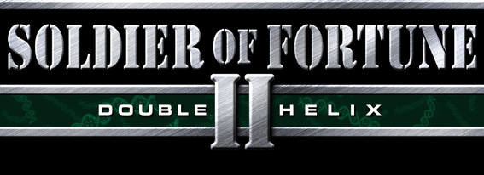

WEAPON .FRAMES FILE

BY RAVEN SOFTWARE

1.0 What the heck is a “.frames” file anyway?

A .frames file contains information pertaining to the length of each animation available for the skeleton of a certain Ghoul2 model. It’s a product of the process (Carcassing) by which we compile all of the separate animations belonging to a skeleton into one animation file (a .gla file) that corresponds to a certain model.

Below is an excerpt straight out of the M4.frames file for the M4 rifle.

s:/ani/base/models/weapons/m4/m4fire.xsi
{
"startframe" "451"
"duration" "2"
"fps" "20"
"averagevec" "0.000 0.000 0.000"

notetrack
{
"frame" "1"
"note" "fire"
}
}

2.0 What is the purpose of this file?

.frames files are read directly by SOF2 when it loads a level; so their primary purpose is to inform the game as to the availability of animations for a given model. However, for some models (i.e. weapons) you must edit the .frames with any text-editing software (like Notepad) and add notetracks to the animations.

2.1 Huh? “Notetracks”? Speak English!

A notetrack is a piece of information that is associated with a frame of an animation. Certain parts of SOF2 – like the AI and the weapon system – are designed to perform certain tasks when a notetrack is come across during an animation. The most common notetrack – “eos” or “end of sequence” -- exists automatically at the end of every animation. This notetrack lets the game know it’s reached the end of the current animation and can move on with life. There are several other important types of notetracks specific to the weapon system, though, and here they are:

- fire and altfire – these essentially do the same thing…tell the weapon system to either fire a bullet or launch a projectile depending on the definition of the weapon
- pin_pull – starts the timer on a hand grenade
- sound notetracks – these are specified in the .inview file (see SoF2_Weapons_InviewFile) and play the given sound when the notetrack occurs
- surface notetracks – these are specified in the .inview file (see SoF2_Weapons_InviewFile) and turn certain model surfaces on/off when the notetrack occurs

3.0 Default information

There are four pieces of information that are automatically generated for each animation in the .frames file.
- startframe – out of all the frames of animation available for a model, this is the first one of those frames that begins this particular animation. If you’ve got a twenty-four frame anim and it has a startframe of 460 that’s kind of like saying there’s a twenty-four page chapter in a book and the first page of the chapter is 460.
- duration – the total number of frames in this animation
- fps – this is the originally desired playback rate of the animation, measured in frames per second.
- averagevec – hard to explain and only applicable to the motion of human models so I’ll just say, “Ignore this” and leave it at that.

4.0 How do I add a notetrack?

Let’s say there wasn’t a “fire” notetrack for the M4 and you wanted to add one. You’d open m4.frames in Notepad and find the “m4fire” animation. It’d look like this:

s:/ani/base/models/weapons/m4/m4fire.xsi
{
"startframe" "451"
"duration" "2"
"fps" "20"
"averagevec" "0.000 0.000 0.000"
}

After the information that’s currently present for that animation add your notetrack definition, indicating the frame on which it should occur and what the note actually is. When you’re done the “m4fire” anim would look like this:

s:/ani/base/models/weapons/m4/m4fire.xsi
{
"startframe" "451"
"duration" "2"
"fps" "20"
"averagevec" "0.000 0.000 0.000"

notetrack
{
"frame" "1"
"note" "fire"
}
}

Now you’re telling the game that the note fire is going to show up on frame 1 of the fire animation. One thing to note is that frames are zero-indexed which means the very first frame in the animation is frame 0, not frame 1. Therefore the above definition for m4fire says that the second frame (frame 1) is going to have the fire notetrack.

5.0 Anything Else I Should Know?

The only warning I can think of is that you shouldn’t specify more than one notetrack for the same frame of the same animation. Other than that you can have as many notetracks in an anim as you like.

