https://writerduet.com/script/

* Strong introduction with awesome visuals and a hook. No bs logo gotit?
* Strong intro with immediate voice to hook in (hook in statement)… Then quick epic intro with you
* great content that breaks through the noise is content that isn't afraid to be different and go against the status quo.﻿

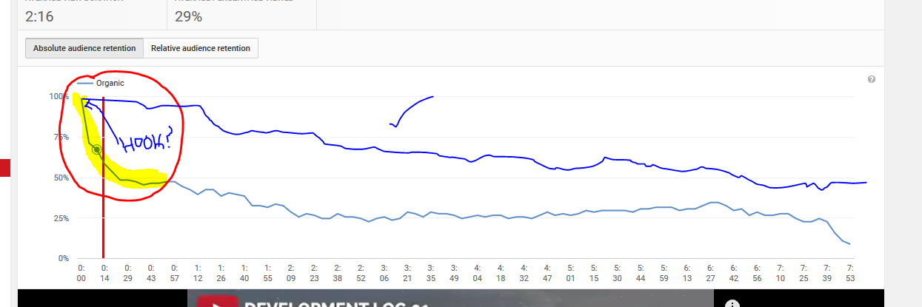

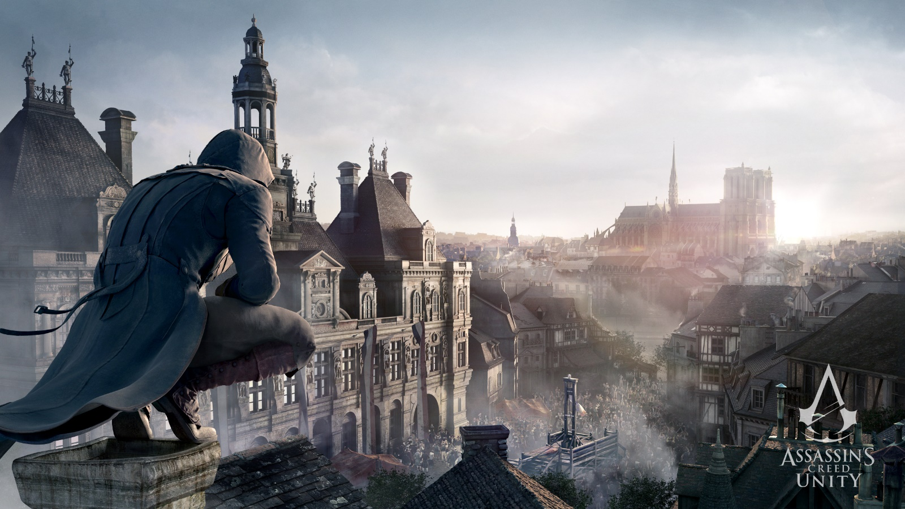

That’s the thumbnail of our new series ‘AC Unity Wallpaper’

What are really common topics that you will have to address –

* Talk about this series and why you made it
  + You made it because you have been in this industry for the last 3 years and I have learn a lot of things that I found difficult when I started and I want to help them hit the ground running, tell them you are still learning but you wanted to make this video because you are in the middle of developing your own game as well – Link em’.

Hey YouTube, if you’ve every played an awesome game and you’ve been inspired to build your own, well done. You have taken the first step towards being a game developer, so I welcome you to an episode where I will be giving you a head start into the development world so in no time you’ll be making your very own games. Unfortunately This is such a massive subject and I won’t be able to cover it all in this video alone so I will be posting multiple videos on getting started so smash that subscribe button so you can keep up and become an epic indie developer. In this episode I will try my best to give you a lot of useful advice that would have helped me out a lot when I was trying to begin game development I will also try and kick you into the development wolr with a bunch of useful resources amd tools. Before we get started let me tell you why I am making this video really quickly and what I will be covering. The reason I am making this video is because I am finally at a stage where I am building my first ever project that will take longer than a year, and this is no small task for a indie developer and I have faced many challenges to get to this point and I want to ease the learning curve so it’s not as scary for new developers, I will be covering how to get started into development, some common misonceptions, how you can improve and grow your skills and much more. So let’s jump into the video.

* Talk about the industry and the brutality, talk about how hard it is to be original and stand out. But it is possible. Don’t get me rude but you have to drop the idea that you are going to make a AAA title by yourself as soon as you begin, this will only de-motivate you when you find out how hard it really is to build a game. These triple A titles have hundreds of people working on these games full time with million dollar budgets, if you think you can out-do these guys – you got another thing coming.
* Talk about pre-requisites – You can begin making games on a $0 budget, all the amazing engines are free, you just need a computer and an internet connection and you can learn how to code, design and make games – talk about how you have been making games for a long time with no payments, you don’t need assets you don’t need anything. Once you decide you want to make a professional game which may take a while before you have the skills you may need to invest a bit of money depending on what you want to make.
* Talk about motivation for building games and they way you can stay commited to one idea – give a tip : select one idea and usually when starting out you may be discouraged because you have bad art or bad code in your game so select the point you are strong in and focus on that first and then use the internet to build up the other part of your game slowly, but understand that it is an iterative process and will take a while. The other problem that developers have when starting out is they loose motivation in the current idea that they have and switch to another idea, loose motivation in that and change and change and this is a never ending cycle and it is your job to locate this loop hole and patch it up. I myself was stuck in this cycle for a long time and one of the techinques I used when I got another idea is I wrote it down somewhere and promised myself that I would get back to it when I finished this game. Another reason people loose motivation is because they don’t have a clear idea of what to do, they get lost. Here comes my biggest next tip.
* Planning, yeah you can go ahead and groan now. I was like this as well when I started, planning who needs that, let me just get started right into the mechanics and Ill put it together eventually. I never ever finished a game because of this stupid technique. This is okay if you are experimenting or learning but if you have an idea and you don’t want to loose it I recommend you plan, but since this is a big one for me I am going to teach you how to plan, not just to plan . Famous quote goes – ‘Failing to plan is planning to fail’.
* Teach them about trello, game design document, estimating times and planning out a time table show them that you do this for your game, tell them about the benefits and why it helps. Teach them what they need in their games. Talk about time management and how key it is to developing games.
* Talk about starting out, talk about what engines and options they can use and the tutorials. Tell the best way to learn what they want is to make games and use the one week to month principle, where you get a very small idea and build that game in a week, this will not only challenge you but also teach you so much along the way, now repeat this with a bunch of ideas and build up your skill in the engine or language you are using and eventually work your way up to one month ideas and build up your commitment. Keep building skill and tell them you can never stop learning, watch lots of GDC talks, get into the game development world and just interact with people. Grow your knowledge in a certain engine and become a guru, for example in Unity I just started out using the built in physics system all the time and using the character controller but now I build my own physics and controllers customly changing it for my game, building your own editors and extending the editor for your purposes. You can never compare two engines, it’s the way you use those engines that really change the game. You have to know about the tools you use to the entire extend.
* Talk about the assets and how they should be used to an extent but never further than that, tools are okay but models etc shouldn’t be used in professional games because they look stitched together, you should build a team because you can never be good at all aspects, talk about how weaknesses can actually enchance your creativity and how games don’t need the best art or programming in order to be amazing and give examples like Undertale etc.. Really motivate people, understand you don’t have to be the best at everything to create a good game, focus on what you are good at for some people it may be music, art, level design or programming but whatever it is go really indepth with it and also try and branch our your knowledge as much as you can.
* Don’t do it for the money… do it because you enjoy it, if you came here thinking oh im going to make a million dollars from this new AAA title that Im going tro drop, you are going to loose your motivation really quickly and Im sorry but game development isn’t for you. It’s a very tough and painful process and can take years to finish a single game, and no matter how small the game is you will always face difficulties whether it be technical, visual or just not able to get the game out there. These are all things I personally have faced and it’s not good, but don’t let it de-motivate you. You just have to stick with it and keep improving and getting better.
* Tell them to watch your development logs on how you started out your game and how you are going with it, struggles that you went through to keep your motivation during the time of this game because of the limited time you have for development. But just keep telling yourself it will pay off in the end, tell them about your story re-writes and always staying true to the core nature of the game.
* Tell them about minimalistic design and the advantages it has, link them to the really good YouTube video that one person did about the topic and tell them about Journey and stuff like that, being a developer means solving problems and you will have a lot so get involved in Stack Overflow etc to really be able to ask for help when you need it.
* Game development is half about building up skills, learning, using the engine and being smart and half about being organised, disciplined, motivated and core qualities like that that really help you to finish your game and get it out there, it’s not a simple process and if you’re in it for the long run like me, welcome on board into the game development community, drop a quick comment below If you’re in and smash that sub button to keep up with the dev logs so you can also find out how I tackle the development process, the first video is already out so check that out. Until next time guys, stay awesome.

What are some really un-common topics that will help out the audience –

* Talking about coding your own assets and trying to get innovative with the editor and building up knowledge as much as possible in one skill.

Quality Control (What is expected in this video) :

* Very different game visuals + people working on games

People need to get value from this :

* How to get started in game development,
* Give people some good places to get started with game development

How will you promote this video :

* Go and comment on other sections, provide value in the video that is that
* Go and promote your video on fullscreen.com which you still have an account at
* Go and promote it on Twitter
* Promote on previous videos and similar videos