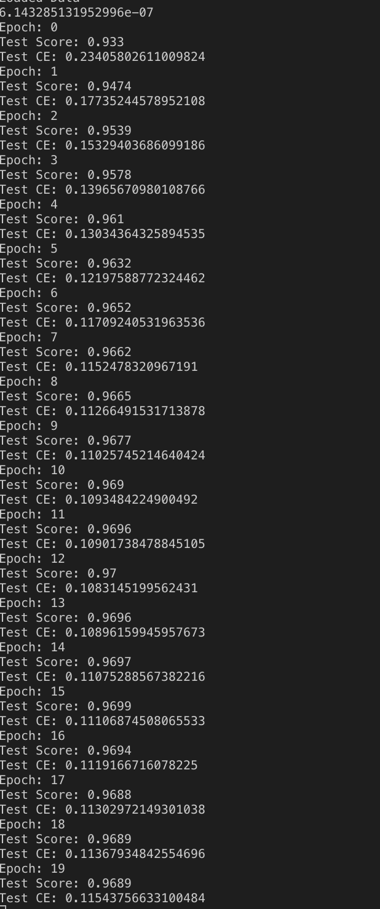Alexander Wurts

Final 20 Epochs

Neural Network Assignment 6 Machine Learning

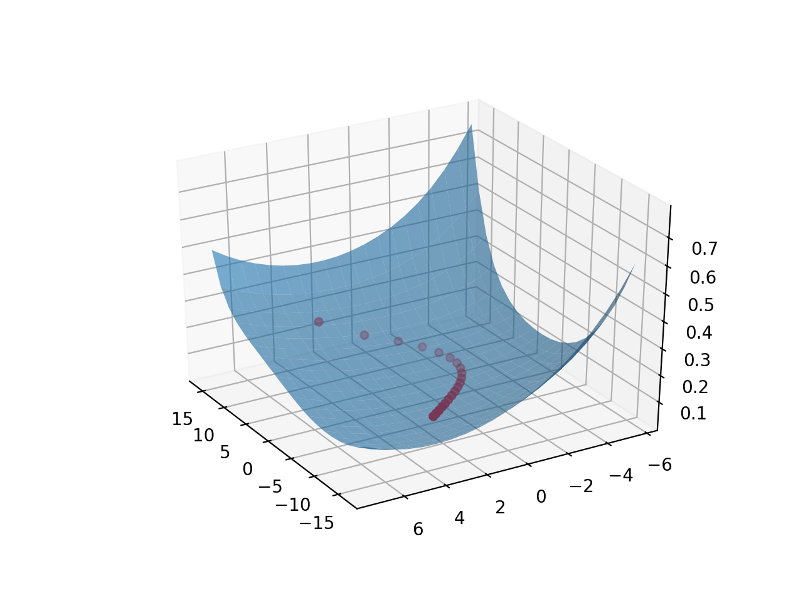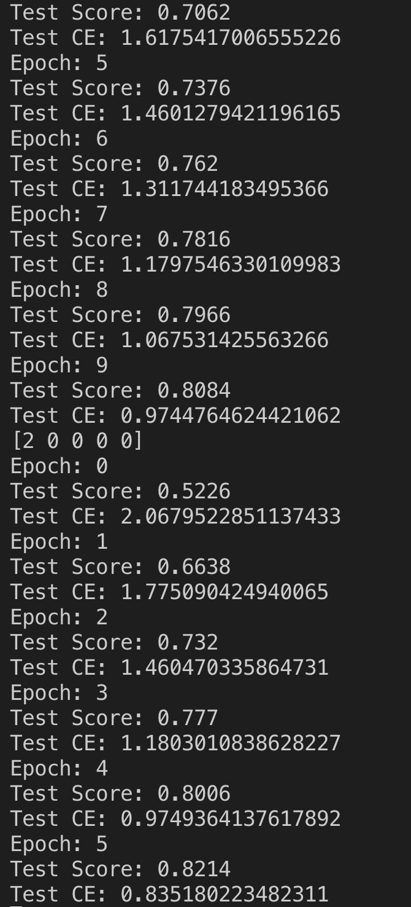

Best Hyper Parameter Function working. Used algorithm very similar to assignment one to optimize. It says test score but it’s actually optimization score for the left pictuxre.

Final Optimization Results

Learning Rate: 0.01

L2 Reg Coefficient: 0.0001,

L1 Reg Coefficient: 0

Batch Size: 8

Epochs: 30

Part 2 Graph