SVKM’s NMIMS
Mukesh Patel School of Technology Management & Engineering
DataScience Department
Program: MBA Tech. Semester: III

Course: Applied Artificial Intelligence

Faculty: Kshamta Mathur w.e.f. 14th July 2025

* Students are expected to be ready with the prerequisite before attending the lab
Experiment No.03
PART A
(PART A: TO BE REFFERED BY STUDENTS)
Experiment 5
A.1 Aim:
To find shortest path from the starting node to a goal node using BFS and DFS algorithm with Python

A.2Prerequisite: Basic understanding of search algorithms

A.3 Learning Outcome:
After completing this experiment, you will be able to-
After completing this experiment, you will be able to:
- Understand differences between BFS and DFS
- Implement both search algorithms in Python
- Analyze the behavior of each algorithm in terms of completeness and optimality
A.4 Theory:
A.4.1 Breadth-First Search (BFS)
- Explores the graph level by level
- Uses a queue (FIFO) to keep track of nodes
- Guarantees the shortest path in terms of number of edges (if all edges have equal weight)
- Time Complexity: O(V + E) for a graph with V vertices and E edges

A.4.2 Depth-First Search (DFS)
- Explores as deep as possible along one branch before backtracking
- Uses a stack (LIFO) or recursion
- Does not guarantee the shortest path
- Good for exploring all paths or solving puzzles (like mazes)

A.4.3 A.4.3 Algorithm Steps

BFS Steps
- Start by putting the starting node in a queue
- Mark it as visited
- While the queue is not empty:
  - Remove the first node
  - If it’s the goal, stop
  - Else, add all unvisited neighbours to the queue

DFS Steps
- Start by putting the starting node in a stack
- Mark it as visited
- While the stack is not empty:
  - Pop the top node
  - If it’s the goal, stop
  - Else, add all unvisited neighbours to the stack
Example- Travel from “a” to “z”
Here the number on the edges represent distance from one node to another. And number written on each node is distance of the node from the goal node.
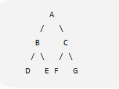
Figure 1 Graph showing paths from A to Z

A.5 Task to be completed:
To find shortest path from the starting node to a goal node using BFS and DFS algorithm with Python

References:
Stuart Russel and Peter Norvig, Artificial Intelligence: A Modern Approach, 4th edition, Pearson Education, 2021.
***************************************************************************
PART B
(PART B: TO BE COMPLETED BY STUDENTS)
(Students must submit the soft copy as per following segments within the submission timeline. The soft copy must be uploaded on the MS Teams assignment link at the end of the practical)
Roll No. S050 | Name: Aleric Pinto
Program : MBA Tech DS | Division: J
Batch: J2 | Date of Experiment: 31-7-26
Date of Submission: 31-7-26 | Grade :

B.1 Tasks given in PART A to be completed here
(Students must write the answers of the task(s) given in the PART A /Students must copy the code, output screenshots here based on the task(s) given in section A.5)
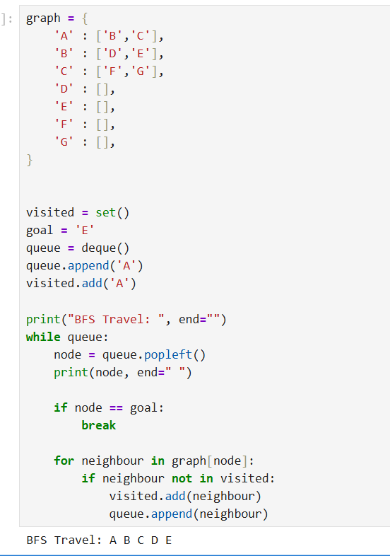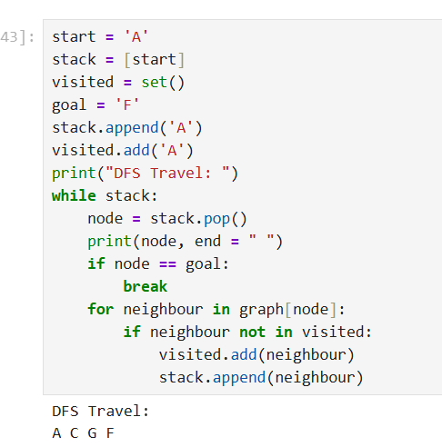
graph = {
'A' : ['B','C'],
'B' : ['D','E'],
'C' : ['F','G'],
'D' : [],
'E' : [],
'F' : [],
'G' : [],
}

parent = {'A': None}

visited = set()
goal = 'E'
queue = deque()
queue.append('A')
visited.add('A')

print("BFS Travel: ", end="")
while queue:
node = queue.popleft()
print(node, end=" ")

if node == goal:
break

for neighbour in graph[node]:
if neighbour not in visited:
visited.add(neighbour)
parent[neighbour] = node
queue.append(neighbour)

# Reconstruct the path
path = []
current = goal

while current is not None:
path.append(current)
current = parent[current]
path.reverse()

print("shortest Path:", " -> ".join(path))
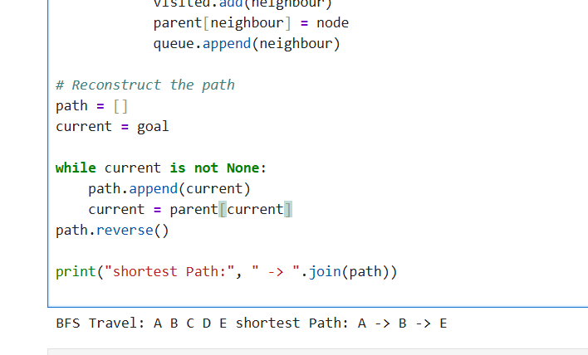

start = 'A'
stack = [start]
visited = set()
parent = {start: None}
goal = 'F'
stack.append('A')
visited.add('A')
print("DFS Travel: ")
while stack:
node = stack.pop()
print(node, end = " ")
if node == goal:
break
for neighbour in graph[node]:
if neighbour not in visited:
visited.add(neighbour)
parent[neighbour] = node
stack.append(neighbour)

path = []
current = goal

while current is not None:
path.append(current)
current = parent[current]
path.reverse()
print("shortest Path: ","->".join(path)) 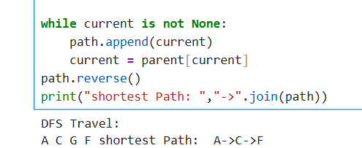
B.2 Observations and Learning:
(Students must write the observations and learning based on their understanding built about the subject matter and inferences drawn)
We understand how DFS and BFS words, There are no heuristics as they are both blind search algorithms, The code uses deque from collection and stack for BFS and DFS respectively
B.3 Conclusion:
The Breadth-First Search (BFS) algorithm was successfully implemented in Python to traverse a graph and find the shortest path to a goal node. By utilizing a queue (FIFO) structure, the algorithm explored the graph level by level, ensuring that the first time the target node 'E' was reached, the path taken was optimal in terms of the number of edges. Additionally, maintaining a parent dictionary proved essential for backtracking and reconstructing the exact shortest path (A -> B -> E) from the start node to the destination
B.4 Question of curiosity:
(No, it will not be guaranteed to be the shortest path.
Replacing the Queue with a Stack changes the algorithm from Breadth-First Search (BFS) to Depth-First Search (DFS).
- BFS explores all neighbors at the current depth level before moving deeper, making it mathematically guaranteed to find the shortest path in an unweighted graph.
- DFS, on the other hand, explores as deep as possible along each branch before backtracking. If node 'E' happened to exist much further down a long, convoluted branch that DFS chose to explore first, DFS would return that long path instead of the direct, shorter one.

Match the columns

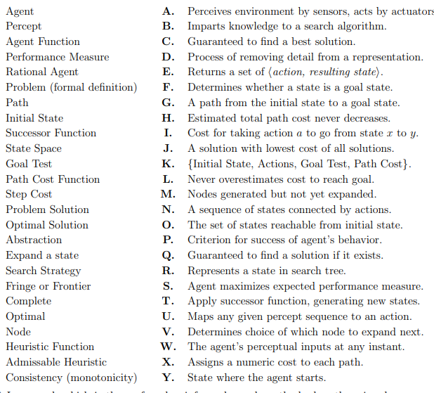
1-A, 2-W, 3-U, 4-P, 5-S, 6-K, 7-N, 8-Y, 9-E, 10-O, 11-F, 12-X, 13-I, 14-G, 15-J, 16-D, 17-T, 18-V, 19-M, 20-Q, 21-C, 22-R, 23-B, 24-L, 25-H

***************

