CHAPTER I

THE PROBLEM AND ITS BACKGROUND

1.1 Introduction
A library plays a very important role in promoting progress of knowledge. The library occupies a very important place in school. With its books suited to the interest and aptitude of students of different age group, with its magazines, periodicals, newspapers and with its calm and tranquil atmosphere it has a special call to the students who went there to for reading the materials which cannot be provided in classroom. Here they found an environment which is conductive to the building up of habit of self-learning.
Using manual management in the library slows down the process of logging in and out of students and the borrowing and returning of books. The lack of Information of Reports and Updates with respect to library transactions and services are not well disseminated. The issuing of book is slow where borrowers (faculty, students, staff and clients) will have to wait for further library transactions. Slow retrieval of Data viewing of library reports and files in terms of issuing and returning of books were not well-established/implemented. The library services in terms of issuing of books through library cards consumed a lot of time. Manual management make things complicated and inconvenient.
That is the reason why the researchers proposed a system that reduced the processing time of borrowing and returning of books and the logging of the students with the use of barcode and radio frequency identification technology for academic libraries. This was done by the use of an Arduino microprocessor with a RFID reader to read and identify the RFID tags attached the user’s library card and a barcode reader to read and identify books being borrowed. From the Arduino the data is to be sent using a universal serial bus (USB) to the server’s computer and to be processed in the graphical user interface (GUI) that will be created using Visual Studio. The processed data will be displayed into a database which is to be created using Microsoft access. The books and the students can be registered into the data base, the users can also see a catalogue of books in the database for them to search for the book/s that they were looking and the time of the books that were borrowed will be logged into the database and if the book was returned but either damaged or overdue it will cost a penalty or fine. The time limit and the fine can be set by the researchers on the installation of the said device.

1.2 PROBLEM STATEMENT
Manual management consumes so much time and effort leading to worthless exhaustion and human error that usually creates problems in managing the library and is also slows down the process such as logging in and out of students, borrowing and returning of the books. A Library Management System using Barcode and RFID is needed, to reduce the processing time and to make things more convenient for the students and the librarian.

1.3 OBJECTIVE OF THE STUDY
    - GENERAL OBJECTIVES
- To create a library management system that will help in managing an academic library using Radio frequency identification (RFID) and barcode technology. It helps to automate borrowing and returning processes and allows identification of students and tagged objects like books, using radio waves and barcode.
    - SPECIFIC OBJECTIVES
- To be able to create a database system using Visual Basic.
1.1 To create Software based catalogue
1.1.1 To help the student to search for specific book they need if available or not.
1.1.2 To create a book inventory using database.
1.2 To create a student Attendance logging system.
2. To be able to create a device using Radio Frequency Identification (RFID) and barcode technology.
2.1 To directly provides the book information and library member information to the
Library management System.
2.2 To borrow books using barcode and RFID technology.
2.3 To return books using barcode only.
2.4 To log the users who enter the library easily using Radio Frequency Identification
(RFID).
3. To be able to create a device using Arduino Uno.
3.1 To send data to process the server through a Local Area Network.
3.2 To receive data from the Radio Frequency Identification (RFID) and barcode.
4. To be able to create a GUI (graphical user interface) using Visual Basic to be the
Platform of the database.
4.1 To be able to create database using Microsoft access

1.4 SCOPE AND DELIMITATION
1.4.1 SCOPE
The study covers the use of the library by making it more convenient for both the user and librarians by streamlining the process of borrowing a book from the library. This is done through the use of barcode tags.
The study requires both the user and the books to be registered to a central database. This means that a new user is provided a way to register into the system to access the library.
The study provides a searchable database running on Microsoft access which contains all the information regarding the books and who borrowed them. This database is searchable by anyone who is inside the library.
The study also provides a graphical user interface (GUI) to be the platform of the database to process the data from the arduino using visual basic.
Each book supposed to have a barcode tag. To borrow a book, the user must bring the book and be scanned at a barcode reader connected to an Arduino. The Arduino in turn sends data to process the server through a Local Area Network.
The study also provided a way on monitoring who goes in and out of the library with the use of a library card that contains information about the user. This library card is also equipped with a RFID tag. The users have to be registered to have (RFID) to use for logging and borrowing/returning of books.

1.4.2 DELIMITATION
There are some limitations implementing the device. The active Radio Frequency Identification (RFID) tag has limitations on the lifetime of the tag (5 years), so the consumer needs to change the tag every time the tag expires, the researchers may conduct a maintenance for the system and to change the RFID tags. RFID tag does not contain a power source; the power is supplied by the reader. The passive tags can be read only at very short distances, typically a few feet at most. The barcode tags can only be read in a few centimetres. The location of the book cannot be tracked because the researchers did not make use of RFID Tracking tags. This device is not concerned about lost and misplaced items of the library and cannot notice if a student has released the book in the library without scanning the barcode and RFID. This device is not supported by internet, so they are only connected through Local Area Network.

1.5 SIGNIFICANCE OF THE STUDY
This system is designed to make library’s processes easier and more convenient to the users and also to the staffs of the library, considering the hassle of queuing in library just to login and the time consuming of searching books. The following is the benefits of this system.
To the Students, The students can easily login by just tapping their library card and they can easily borrow books. And it can also save time for the students, who are searching for the book they need.
To the Librarian, The system makes the librarian’s job easier. They no longer need to issue forms for the students and make soft copies of the forms to borrow/return books, to register, and to log in and log out to the library.
To the Schools, The schools make students comfortable in using library. And it is also advantage for them as they offer modern way of using library.
To the Researchers, This system can be serve as their reference or guide in making their own research that can help solve problems in our society.
To the Future Researchers, this system will help them as guide in their system that will solve future problem in the future society.

CHAPTER II

REVIEW OF RELATED LITERATURE AND STUDIES
2.1 RELATED LITERATURE
2.1.1 FOREIGN LITERATURE
Radio-frequency identification devices are a daily part of the electronic age — found in passports, and library and payment cards. Eventually they’re expected to replace barcode labels on consumer goods. Now schools across. Like most state-financed schools, the district’s budget is tied to average daily attendance. If a student is not in his seat during morning roll call, the district doesn’t receive daily funding for that pupil because the school has no way of knowing for sure if the student is there. But with the RFID tracking, students not at their desk but tracked on campus are counted as being in school that day, and the district receives its daily allotment for that student.

Each active-tag reader captures the ID number of every badge within range and transmits that information to the Wade Garcia software. The badge's active tag is typically set to beacon its ID number every 28 seconds. In the system's software, a tag's ID is linked to the name of the individual assigned to that badge, as well as to some details, such as whether he or she is a student or staff member—and, if that person is a student, his or her grade level. The district can log into the software at any time and views the locations of specific individuals on the premises.
The idea is to install card readers in all classrooms that seat 50 or more students -- those in which it'd be difficult or time-consuming to take attendance every day. Professors who teach smaller classes would have to find another way to take attendance. Given that class sizes shrink as a student's education progresses, the policy would likely impact freshmen and sophomores. Students wouldn't have to take their ID cards out, because the readers would be sensitive enough to pick up signals from anywhere in the room. Data from each class would be recorded, and instructors would get reports on who was in class, the Arizona Republic reports.
As part of a controversial trial that could someday include 112 schools and nearly 100,000 students, North side Independent School District in San Antonio, Texas, recently issued students at two of its campuses new badges with an embedded RFID (radio-frequency identification) chip in order to track their locations. Unlike passive chips that transmit data only when scanned by a reader, these chips have batteries and broadcast a constant signal so they can track students’ exact locations on school property, down to where they’re sitting—whether it’s at a desk, in a counsellor’s office, or on the toilet.
Grade-school students in a north-eastern Brazilian city are using uniforms embedded with locator chips that help alert parents if they’re cutting classes, the city education secretary said Thursday. Twenty thousand students in 25 of Vitoria da Conquistas 213 public schools started using T-shirts with chips earlier this week, Secretary Coriolano Moraess aid. By 2013, all of the city’s 43,000 public school students, aged 4 to 14, will be using the chip-embedded T-shirts, he added. Radio frequency chips in "intelligent uniforms" let a computer know when children enter school and it sends a text message to their cell phones. Parents are also alerted if kids don’t show up 20 minutes after classes begin with the following message: "Your child has still not arrived at school".
According to Robson (2001) usability is a key requirement for users, says Elisabeth Robson, Product manager for Online Computer Library Center. The catalogue has become a way to pull together disparate resources, including commercial resources and web links. Management systems also allow circulation, including check in/check outland enable libraries to purchase materials and track where they are.
According to Primer (2005) for many businesses automating the collecting of employee attendance data when employees begin their shifts is still a manual process. Even business that has automated or computerized processes such as scheduling, inventory, purchasing, general ledger and payroll processing still use manual methods such as timecards or attendance sheets to collect time and attendance data.
According to E. Valentin (2006) from the article entitled D. “The State of Library Management Systems” are systems that helps big in terms of some transactions on the library. On this article the automated library systems said that it can do multitasking. It can do recording books on library, but it can also make direct transactions It will make the library service convenient like making card cataloging. Therefore, multitasking inside the library is very nice. He system will be the one who records all the transactions inside the library so it decreases the tasks of the librarian so it can avoid the cases of lost records due to human errors.
Simmond (2001) highlights the role of electronic information resources on collection management in academic libraries. He says that the advent of electronic information resources created new methods of document delivery and access to information. With the application of internet and the use of new information technologies the range of services provided by academic libraries increased dramatically. He also stressed that users can access the libraries resources without stepping into library building. Further they can also access other library resources like online catalogues and freely available databases.
Based on Henderson (2008), Inventory System Consist: An inventory control system is used in many warehouses to track location, quantity and status of goods that are to be sold. Shipping and receiving of products are scheduled by and inventory control system. Inventory control uses barcodes and RFID tags to track specific items. An audit, or a physical count of inventory, is used to find out how many items are in an inventory. Inventory taking is often required in order to get an accurate count for accounting valuation purposes. Some inventory items have barcodes attached to them or imprinted on them. These barcodes can be read during audit by barcode reading devices.
2.1.2 LOCAL LITERATURE
A librarian demonstrates how to use the Self-Service Library Check-out Station, where students can check out books themselves. Among the library processes that will benefit from the UHF RFID solution are the circulation services, inventory, and security system. The solution can provide real-time statistics of both Intramuros and Makati libraries’ patron visits and can generate inventory reports instantly. “This UHF-RFID system is very efficient and a logical move for us because we are a technological school,” said Lansangan. “Apart from making our processes here efficient, this is also to keep up with the technology employed in the US.
The Citra Metro Manila Toll Ways Corporation has begun its phasing out of the old e-Pass and will be replacing it with RFID passes. CMMTC has posted guidelines on how to get the new e-Card system with the first 200,000 applicants getting them for free. The RFID consists of the e-Card itself as well as two kinds of RFID stickers to be placed on the car. The first option will be to place the sticker on the corner of the headlight or where it doesn't obstruct the beam of light. The other will be placed in the windshield of the car. According to a report by Inquirer, the system will be able to scan a vehicle even at a speed of 50 kilometers per hour.
“We believe that the RFID technology can complement the DOST’s Smarter Philippines program, the essence of which is the effective generation, gathering, and analysis of data to enable timely and effective decision making and planning,” said Louis Casambre, Executive Director, ICT-Office. At present, RFIDs are being used in DOST’s project NOAH or Nationwide Operation on assessment of Hazards. According to Casamabre, RFIDs are crucial for NOAH’s micro-mapping project that uses Light Detection and Ranging (LiDAR), an equipment designed to survey the entire topography of the Philippines at very high resolution.

According to Aquilan (2004) made a comparable thesis on the automation of time attendance. That records the time in and time out of every employee using barcode system. It tends to eliminate the manual recording system of time and attendance and also include salary computation of each employee based on the time and attendance report.

According to D. Lourdes (2012) from the article entitled “The DOST-ESEP Libraries: The First Library Network in the Philippines” the planning of this system are way back year 1995 but it’s difficult to implement in during those time so it took long time to be able to release it on the public. There some universities that quickly get the partnership since it was started in 2012. It means networking is also a major key on collaborating inside the library. Therefore, this type of system is exactly a big help on the state of the Philippine libraries. It can make our library a world class and can compete on the other country’s libraries.

Ramon Faloran (2005) wrote in the article “The Computer Edge of the New Employment and Opportunities “in the Philippine Daily Inquirer. He stated that computer gives you a different feeling about what is happening in the company. Business will be highly competitive and innovative because the computer provides instant information.

According to Eden (2011), Views that most libraries are forced to work with fewer staff because of the having a more improved and modernized system for their library. According also to the study, the library administration needs to emphasize to their staff that the organization has a vested interest in providing them with the tools and training they need to assist the organization in the new information marketplace. These may include search engines, circulation systems, and the online public access catalog.
"Biometrics Technology to be Implemented in PNP”, 2009 The Philippine National Police (PNP) also made by the international crime detection technologies in the market, the said Philippine agency decided to adopt NEC’s (mentioned above) Automated Fingerprint Identification System. Via the technology, PNP staff and experts are able to authenticate unique body demographics, such as fingerprints in the particular case. The technology also allows an almost instantaneous identification. The technology was used however by first building an initial database of 210,000 fingerprints. According to the mentioned above with the use biometrics technology the PNP was able to identify a suspect because of the fingerprints. The city’s Mayor, Jun Bernabe, says the new attendance machines will enable it to resolve the issues of long queues as well as employee complaints. A total of 40 Model 628 Double Engine ZK Fingerprint Standalone Time Recorders were purchased. City hall took 15 units while the rest were installed in other local government facilities. The upgrade was jointly run by the city government’s Human Resource Management Office and the Electronic Data Processing (EDP) Office. “A side from cutting manpower downtime, it makes timekeeping and payroll preparation simpler, systematic and more accurate. It also provides an additional way to identify, discipline and fire habitual later-comers, absentees and ghost employees,” says Mayor Bernabe.

Study by Cantoma (2004) in her thesis entitled “Computer Library System for St. James Academy” stated that, in manual system in retrieving, maintaining security and piling records take place because of the years gone by. Furthermore, these files were only kept in envelopes and folders in wooden rocks. There are also instances when the right information is given to a wrong person, which affect quality of service.

Sciences (CHSS) and the College of Science and Mathematics (CSM). The Main Library transferred to the newly renovated building where the main collection was set-up beside the books of the CHSS and the CSM. In July 2002, the library established the Library Educational Media and Information Technology Office (LEMITO). The LEMITO handles the audio-visual services, internet and the connectivity of the library. It currently holds office at the Elias B. Lopez Hall Dormitory. Later, the Main Library collection which grew from 100 titles to 6,191 volumes at the end of May 2004, and was transferred to the Administration Bldg today, the Main Library occupies the former UP in Mindanao Cultural Center (UPMCC) building.

2.2 RELATED STUDIES
2.2.1 FOREIGN STUDIES
ID/Admin number from the SIMS student record. Again, all card readers were connected to a PC. Access to all rooms can be controlled through 'timed' and 'dated' cards. One of the other participating colleges gave complete commitment to a swipe card registration system, only to later discontinue it. In summer 1990 the entire college site was wired with readers and through 1990-1991 a pilot scheme ran on six courses. This was reasonably effective, mainly because everyone knew it was a pilot and so staff and students were vigilant about working it. Full implementation was introduced in 1991. However, since this was a response to a need for careful monitoring following financial difficulty it was not a strategically planned process. The swipe system was relatively primitive: 'dumb' readers which simply displayed a red light when a swipe was done. Cards were very basic. Lecturers had to swipe two cards to identify themselves and the module or class they were teaching. Students were required to make a single swipe.
RFID tag type of ID card make the process of taking the attendance easier, faster and secure as compared to conventional method. Students or workers only need to place their ID card on the reader and their attendance will be taken immediately. With real time clock capability of the system, attendance taken will be more accurate since the time for the attendance taken will be recorded. The system is connected to the computer through RS232 and store the attendance taken inside database. The proposed system utilized GSM short message service to perform remote data monitoring. The communication software written in VB language achieved efficient control of serial interface port and real-time synchronization of remote data into system database. The computer and GSM (Global System for Mobile communication) Module i.e. SIM 300 are connected by RS232.
Columbia State Community College (2006) uses computer identification account (Log in Name and Password) for access to the institutions computer usage logs occurs electrically through the individual users log in/out process. Users are also informed that they are responsible for any computer file’s, database and/or internet sites that are accessed through their computer identification account, notwithstanding their failure to adhere to the log in/out process, on their voluntary publication of their account information to others.
My Time Force (2006), Time Force is the key to proficient and successful time tracking and management in your workplace. It is a software-based time and attendance system that allows the user to collect and organize employee time data simply and accurately. You can use Time Force to: (a) Easily and efficiently track your employee time; (b) Manage your time & attendance data and employee profiles; (c) Eliminate buddy punching; (d) Make employee scheduling a breeze; (e) Reduce the headaches and time associated with payroll. Best of all, Time Force can quickly pay for itself in time savings, reduction of time theft and elimination of payroll errors. Time Force is the manifestation of 10years of experience, customer feedback, and research and development in the time and attendance market. Over 35,000 businesses use Time Force.
According to Nasir Uddin (2011), for the developing economies like Bangladesh capital market is like an engine for growth. It acts as an intermediary between surplus units and deficits units. Whereas, transparent and investors friendly business atmosphere is essential in capital market for building confidence of general investors. There are a wide range of investors from well-known informed to rumourmonger, the gambler to complete risk avoider. So, a common strategy from the regulator should be taken to balance the whole market. The monitoring investigation, grievance and legal department of DSE plays an important role to build up investor’s confidence by providing service to its broker house as well as the investors. The bourse has a strong monitoring cell, which prime objective is to provide a perfect working environment by providing service to the member houses and investors. Since 2003 the monitoring cell is doing its operation by a fearless team. Over the years, the department has earned its trust and confidence and support through its enthusiasm. This paper is an outcome of study conducted in DSE; the study has identified the reasons for some irregularities in the stock market and tried to find out what are the loopholes to the securities laws and regulations. The findings of the study revealed that the present market is not limited with the high-income people of the society; the small income investors are also spontaneously investing their savings.

According to Selamat and Majlis (2006) in their study entitled 'Challenges in Implementing RFID Tag in a Conventional Library' opined that while implementing RFID technology in IMEN University of Malaysia, main challenges during the implementation related to system integration, parallel operation with existing system, and procedure changes. They highlighted that one of the main challenges was to integrate RFID tagging system with the Library Management System. They opined that self-check counter makes borrowing and returning book process more automated with less involvement of librarians; therefore, librarians can focus on providing more effective work to better serve the library. They suggested that it is necessary to have both systems, i.e., barcode and RFID running in parallel so that library could operate normally while conversion process is in progress.
Bansode and Desale, (2009) discussed that according to their case study entitled 'Implementation of RFID technology in University of Pune Library' highligted various problems faced by library staff with regard to the lack of availability of technology experts, resistance of the users towards change, lack of standards, etc. They reported major benefits of implementing RFID in stock verification, tracking of shelving of the books and missing books, quick circulation of books, Inventory control, etc. They concluded that RFID technology is a boon for a library, as it requires less manpower to service more books and users.
According to Singh & Midha (2008) in their article entitled 'RFID: A new technology in library management systems' discussed the importance of using RFID in libraries and highlighted its various advantages like speedy circulation operations, self-charging/discharging, highly reliable, high-speed inventory control, automated handling of material, long life of RFID tags, etc. They also discussed the disadvantages of RFID systems like high cost, accessibility to compromise and removal of exposed tags. They pointed out some of the characteristics to be considered while evaluating RFID vendors which include security feature, reader collision, tag memory capacity, anti-collision, standards, etc. They concluded that RFID is increasing in popularity among libraries, as the early adopters of this technology have shown that it makes good economic sense for all types of libraries.
Vasishta, (2009) discussed that according in her paper entitled 'Roadmap for RFID Implementation in Central library, PEC University of Technology' described the basic and optional components required for smooth working of the RFID. She outlined various issues and possible solutions involved in the process of implementing RFID applications. She concluded that although the RFID technology is quite expensive, yet it has yielded excellent results for many libraries throughout the world. It has the capability of making the management process in a library more convenient and the synergy between the latest technology like RFID and libraries can create wonders resulting in empowerment of both users as well as the librarian.
Kumar et al, (2007). in their paper entitled 'Development of RFID Interface for LMS: Solutions and Techniques' examined various issues related to integration of Library Management Software and RFID. They observed that the SIP2 interface developed for
integrating RFID with SOUL is a general solution, which can be adopted for any LMS software with slight modifications. They opined that introduction of such a solution in the academic libraries in the country will boost the modernization activities to
turn the library to a fully user-centered automated library.
2.2.2 LOCAL STUDIES
There's still some library system in the Philippines such as Integrated library system (iLib) which is similar to Department of Science and Technology - Engineering and Science Education Project (DOST-ESEP) it is Online Public Access Catalog (OPAC) based system that is created by University of the Philippines-Diliman (UPD). There are few libraries in the Philippines that uses RFID base system. A private school based in Manila has the distinction of being the first in the Philippines to have a high-tech self-service library checkout station based on radio frequency ID (RFID).

The RFID system involves an RF tag, an RF reader and a database. A reader scans the tag with the use computer program and transmits the information to the computer. The captured information will be processed for intended use. Wireless transmission of identification data rather than by manual transcription increases the quality and speed of data transmission and reception. Presently the library of Lyceum of the Philippines-Laguna is using a traditional system wherein students and employees will have to write their names in the log sheet for their attendance in the library. With the current system, the librarian has a hard time in determining the statistics of the library users. Moreover, it is hassle for the users to log in the logbook and most of the time they forgot to log in. This continuously observed situation led the proponent to investigate and find ways on how to address the need of technology. The application of radio frequency identification would be a good solution.
In the 2005 annual report of the Forest Products Research and Development Institute under the Department of Science and Technology, it is said that, “The computerized database and attendance on Forest Products Research and Development Institute was designed to facilitate the Institute's data entry, processing, computation and maintenance of employee time and attendance transactions. The system allows employees to log in/out as the swipe their IDs through a barcode reader attached to a computer terminal. The processing forms include those for legal holidays, travel order, tardiness, under time, vacation and sick leave. Pertinent Report forms have been designed for easier access to all these data.”
According to Lou (1986), a survey on the computer application in 223 libraries in Metro Manila. The study revealed that they prioritize the three library functions to be computerized as cataloging, indexing, and circulation. However, the plans for automation for the libraries cannot be implemented due to financial incapability of the libraries, and the lack of funds from the government. Despite of this drawback, the libraries are not turning their backs unto the automation of their libraries.
Study by Cantoma (2004) in her thesis entitled “Computer Library System for St. James Academy” stated that, in manual system in retrieving, maintaining security and piling records take place because of the years gone by. Furthermore, these files were only kept in envelopes and folders in wooden rocks. There are also instances when the right information is given to a wrong person, which affect quality of service.
In the advent of technology, communication becomes faster and easier in a tap of a fingertip. In an academic institution per se, communication between parents and school is very challenging and important one. It needs full effort to understand one another. One of the worries of the parents is that if their children are really attending or not in the school during their class period. This is one of the challenges that Lipa City Colleges is confronting, since at present, the school has no way of providing the immediate information to the parents if their children are in or out of the school premises in a particular time. Hence, the researcher conducted this system development study which is considered a new technology which helped the school to solve the problem in monitoring the students’ whereabouts. Specifically, it aimed to 1.) Design a system which will maximize the use of SMS module and RFID technology 2.) Develop a system which will guarantee the privacy and security of information saved in a database. 3.) Determine the benefits of using the SMS Module and RFID technology as a method of communication between the parents and the school 4.) Test and evaluate a system in terms of its performance, functionality, usability, reliability and extensibility.

According to (Q.J. Pastrana, 2013) from the study entitled “Library System with web android based OPAC” technology is a big factor to keep the students keep going to the library. So, the author thinks that android devices can use to attract the students on going to the libraries. In terms of their device they can easily search or monitor the books inside the library. Whether the books that they want to borrow are on the borrowed section of it is still available. So, on this situation the students will have more fun of this new library system. Therefore, the author uses what is the trending device to make students come to the libraries because their task on searching books inside the library become easier and faster.
According to Rhowel M. Dellosa, Elinor Hemedes (2014) The study aimed to develop a computer program that monitored the library users by means of capturing their attendance through radio frequency identification (RFID). A Radio Frequency (RF) reader, RF tag, web camera and computer were utilized to develop and perform the system’s operation. The researcher used developmental method to fulfill its objectives. The system was able to capture the attendance of the library users with the aid of their identification card. The system is acceptable based on the test and evaluation made by the students during system implementation in the library. Several recommendations in connection with the tapping of identification card, the full utilization of capturing device, database update, client-server application, interface design and display of unreturned books.
According to Angela M. Verzosa (1994) In the Philippines, only a few academic and or research libraries have taken the lead in spearheading library automation. As one of the three leading educational institutions, De La Salle University took on the challenge of charting a strategic course towards a totally automated library environment. This case study attempts to make an assessment of the University Library’s computerization planning process, through an analysis of the issues and concerns it had to face in developing an automation program and concludes with a strategic plan for its implementation and future directions.
Book monitoring in a library set-up is essential not only for library administrators but for students and faculty as well. Library administrators need to close certain sections of their libraries in order to perform inventory. For students and faculty, the task of locating books in shelves is often disregarded. Searching books in the library can be hard when books that are searched are misplaced or missing from their specified shelves. Borrowing and returning functions of students can also be done without the need for library supervision. Radio Frequency Identification (RFID) Technology used in a library set-up provides solutions to these problems. By applying a program that incorporates the RFID reader with high-frequency tags attached in books, the tasks of library personnel, students and faculty in searching, monitoring and supervising books are supported and made easier.

2.3 CONCEPTUAL FRAMEWORK
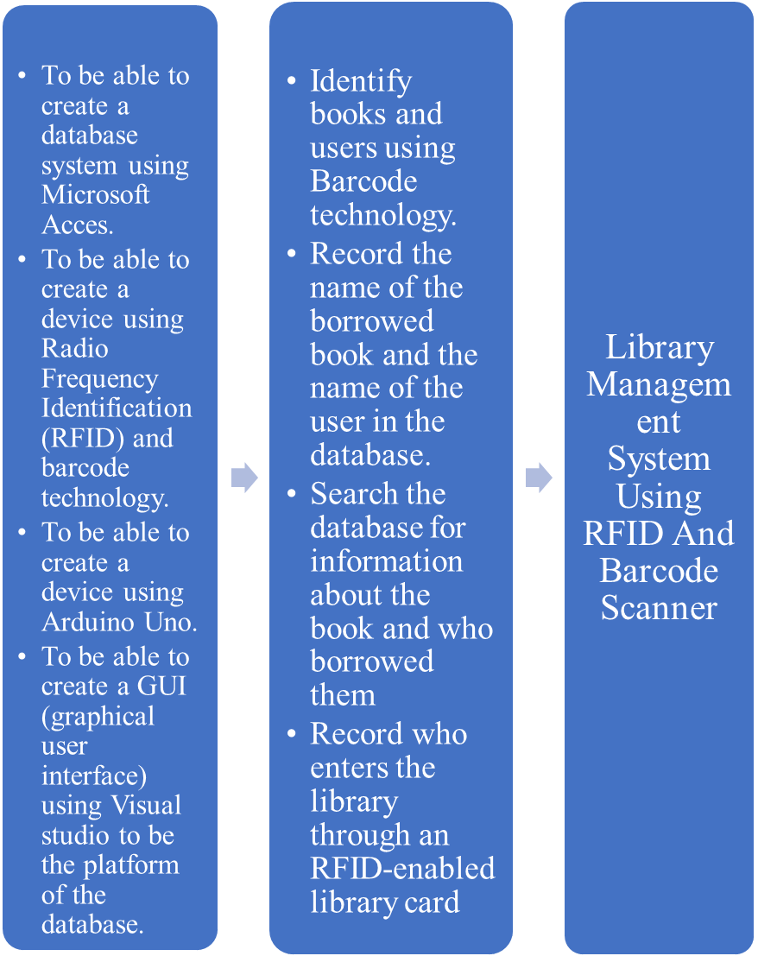
INPUT PROCESS PROJECT

Fig. 2.1 CONCEPTUAL FRAMEWORK
Figure 2.1 depicts the objectives of the researchers in the input section. The researchers will use Barcodes and RFID to identify the books and the user respectively. The Barcodes are located inside the books in the library and another RFID tag is inside the user’s library card. The barcode will bes scanned by a Barcode scanner then sent through the local area network by a computer to the main server. The RFID tag will be read by the RFID reader that is connected to an Arduino UNO. The Arduino will be the one who decodes the RFID information. There will be two RFID terminals, one will scan the user’s library card as the user enters the library, and the second one is where the user can scan to borrow or return a book. This data will be sent through a Local Area Network to the main server computer. The computer contains a searchable database where it registers the book and its user. The user can search this database to find more information about the book and if the book is available to be borrowed.

CHAPTER III
METHODOLOGY
This chapter discusses the development of the project to answering the questions in the system. This also provides the outline of the project’s methodology, the research and development method, project design, operation flow, descriptions of materials used, project development, testing methods, evaluation process and criteria, instrument and technique used, and the analysis of data gathering methodology.

3.1 PROJECT DEVELOPMENT MODEL
RESEARCH AND DEVELOPMENT METHODS OF RESEARCH
The researchers used Research and Development procedure. This process is a systematic activity which aims to discover solution for existing problems or to create a new goods and knowledge with the use of both basic and applied research. Development is the systematic utilization of the knowledge or understanding gained from research toward the production of useful materials, devices, systems, or methods, including design and development of prototypes and processes. The researchers will be discussing the Design, Fabrication and Evaluation phases in this area.

3.1.1 Design phase
In design phase, the researchers gather all the data and materials in order to provide the objective of the proposed system. The proposed system titled as “BARCODE AND RFID BASED LIBRARY MANAGEMENT SYSTEM” which is a system that uses RFID tags and barcode to record the transactions happens in the library through database. The researchers also make use of Arduino IDE as the microprocessor, Microsoft Accees for database and Visual Basic for the GUI (Graphical User Interface) of the system. The hardware of the proposed system composed of Arduino, RFID Tags, Barcode Sticker, Buzzer Server (Computer), Arduino’s RFID reader, Barcode scanner.

3.1.2 FABRICATIONAL PHASE
The researchers make use of barcodes on the books and RFID Tags on the library card of the users. This RFID tag would be a passive RFID tag requiring no power source for it to function.
The researchers also make use of RFID reader. The reader would be connected to an Arduino Uno microcontroller to act as the terminals that read the RFID tags. The Arduino Uno sends the data to a computer, then this computer sends the received from the Arduino through a Local Area Network.
Located in the LAN are two computers. The first computer is running Microsoft Access servers which contain the database for both the books and the users. The second computer is the user-facing computer. This computer terminal is where the users can search for books in the library and to log.

3.1.3 EVALUATION PHASE
To ensure the functionality and quality of the project, the researchers have conducted a self-testing method. This method helps the researchers to know the problems of the project before the evaluation. To be able to test it, the researchers use the project inside the library. They connect their device into the librarian’s computer. After the self-testing method, the researchers consulted the students, faculty and expert to check the functionality, reliability, maintainability, extensibility, and economic feasibility of the project, and ask some advices or opinion on how they will enhance and improve their project. Lastly, the researchers conducted an evaluation of the project to some respondents to determine the weaknesses of the project that helps them to improve it.
3.2 PROJECT DESIGN
The project aims to make the use of the library more convenient for both the user and the library staff. The project aims to smooth out the process of borrowing a book from the library.
The project uses RFID tags and Barcodes to keep track of information of the user and the books in the library respectively. Each book in the library would contain a Barcode with a unique identifier for different books. For a user to borrow a book, the user must scan the barcode of the book on a barcode scanner.
The RFID reader is connected to an Arduino Uno Microcontroller that decodes the RFID tag. The Arduino and the barcode scanner in turn sends the data to a computer then this computer sends the data through a Local Area Network to a server to process the data. The server is running a Microsoft Access database that contains all of the data regarding the books in the library. This data contains the title of the book, author of the book, the subject of the book, and the amount of the available book/s. The server also contains another database which has the data about the users. This data only contains the details of the users who are registered to the library. This means that for each user who wants to use the library, they must avail a library card. The library card is made of RFID tag which is unique to the user. This means the system can provide a way to track who goes in the library by having the user check-in when entering the library. To acquire all the data needed for the system to work, the researchers sets up a terminal where new books and users can register into the system.
The process of borrowing a book requires the user to search for the book that they want to borrow. The project is equipped of another computer terminal connected to the server. This terminal contains a search function and the logging function for students to search for a certain book and to log in and log out to the library.
3.3 OPERATION FLOW
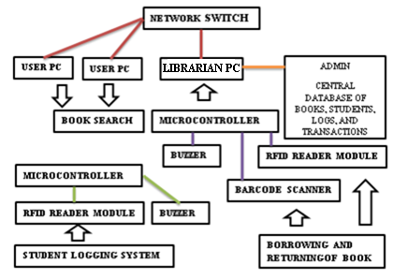
FIGURE 3.1 BLOCK DIAGRAM OF THE SYSTEM
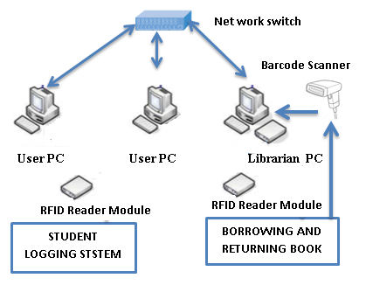
FIGURE 3.2 SYSTEM ARCHITECTURE
Barcode System are used to automate data collection where hand recording is neither timely or cost effective. RFID system uses tags, or labels attached to the objects to be identified. Two-way radio transmitter-receivers called interrogators or readers send a signal to the tag and read its response. RFID Tags are attached in the books and on library cards of the user that sends radio frequency in the RFID Reader through tapping. RFID reader is placed on the booth of the library and will send signal to the Arduino to send data to process the server to a Local Area Network.

3.4 DESCRIPTION AND SPECIFICATIONS OF MATERIALS
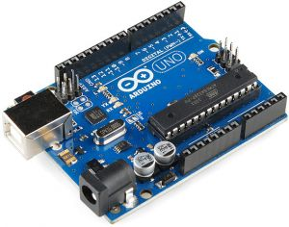
FIGURE 3.3 ARDUINO UNO
ARDUINO UNO is a microcontroller board based on the ATmega328P. It has 14 digital input/output pins (of which 6 can be used as PWM doutputs), 6 analog iputs, a 16MHz quartz crystal, a USB connection, a power jack, an ICSP header and a reset button. It contains everything needed to support the microcontroller, simply connect it to a computer with a USB cable or power it with AC-to-DC adapter or battery to get started.
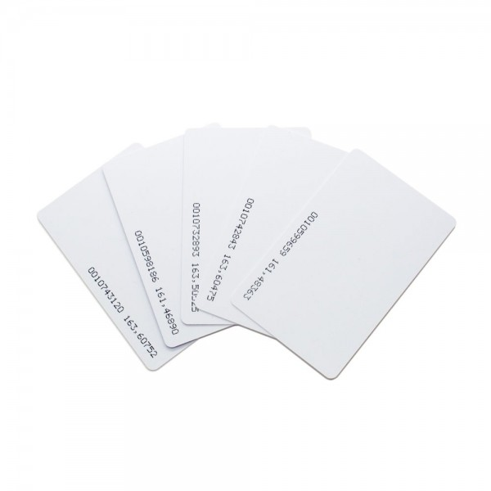
FIGURE 3.4 Radio Frequency Identification card
Radio Frequency Identification card uses electromagnetic fields to automatically identify and track tags attached to objects. The tags contain electronically-stored information. Passive tags collect energy from a nearby RFID reader's interrogating radio waves. Active tags have a local power source (such as a battery) and may operate hundreds of meters from the RFID reader.

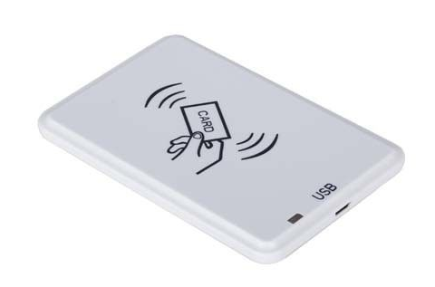
FIGURE 3.5 Radio Frequency Identification Readers
Radio Frequency Identification Reader is a device used to gather information from an RFID tag, which is used to track individual objects. Radio waves are used to transfer data from the tag to a reader.

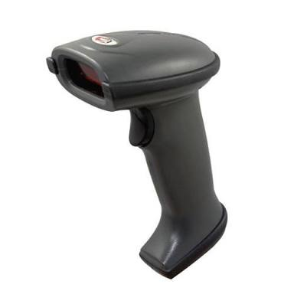
FIGURE 3.6 BARCODE SCANNER
BARCODE SCANNER is an electronic device that can read and output printed barcodes to a computer. Like a flatbed scanner, it consists of a light source, a lens and a light sensor translating optical impulses into electrical ones. Additionally, nearly all barcode readers contain decoder circuitry analysing the barcode’s image data provided by the sensor and sending the barcode’s content to the scanner’s output port.

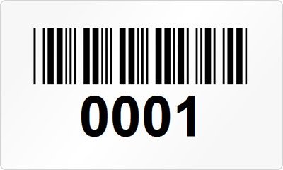
FIGURE 3.7 CUSTOMIZE BARCODE STICKER
CUSTOMIZE BARCODE STICKER is ready to meet your barcode labeling needs with pre-printed or custom barcode labels.

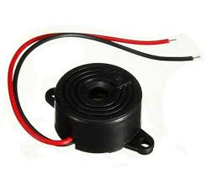
FIGURE 3.8 PIEZO ELECTRONIC BUZZER ALARM
PIEZO ELECTRONIC BUZZER ALARM is an audio signalling device, which may be mechanical, electromechanical, or piezoelectric. Typical uses of buzzers and beepers include alarm devices, timers, and confirmation of user input such as a mouse click or keystroke.

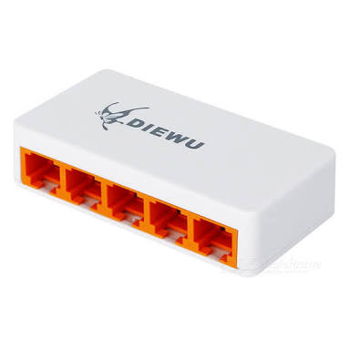
FIGURE 3.9 NETWORK SWITCH

NETWORK SWITCH is a computer networking device that connects devices together on a computer network by using packet switching to receive, process, and forward data to destination device. A network switch is a multiport network bridge that uses hardware addresses to process and forward data at the data link layer (layer 2) of the OSI model.
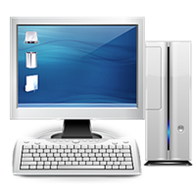
FIGURE 3.10 PERSONAL COMPUTER
Table 3.1 Specification for Personal Computer

CPU | Intel BayTrail-T CR (Z3735F) Quad Core /1.8GHz
OS | Windows 10
GPU | GEN7 GPU accelerated processor
RAM | DDR3, 1GB
Display | 10.1 Inch IPS,1280x800 (WXGA -screen)
Memory Capacity | 32GB on board Storage Memory
Support | - Micro SD Expansion up to 64GB

PERSONAL COMPUTER is a multi-purpose computer whose size, capabilities, and price make it feasible for individual use. PCs are intended to be operated directly by an end user, rather than by a computer expert or technician. Computer time-sharing models that were typically used with larger, more expensive minicomputer and mainframe systems, to enable them to be used by many people at the same time, are not used with PCs.
BILL OF MATERIALS
The Table 2 presents the overall material cost of the proposed system spent for its development.

TABLE 3.2 BILL OF MATERIALS
Product Name | Unit Price | Quantity | Total Price
Arduino Uno | Php 240 | 2 | Php 480
RFID Tag | Php 20 | 4 | Php 80
RFID Reader module | Php 250 | 2 | Php 500
BARCODE SCANNER | Php 1,500 | 1 | Php 1,500
PRINTED BARCODE | Php 1 | 5 | Php 5
BUZZER | Php 30 | 1 | Php 30
Total Cost | - | - | Php 2595

3.5 PROJECT DEVELOPMENT
TABLE 3.3 The Researchers’ Calendar of Activities Using Gantt Chart
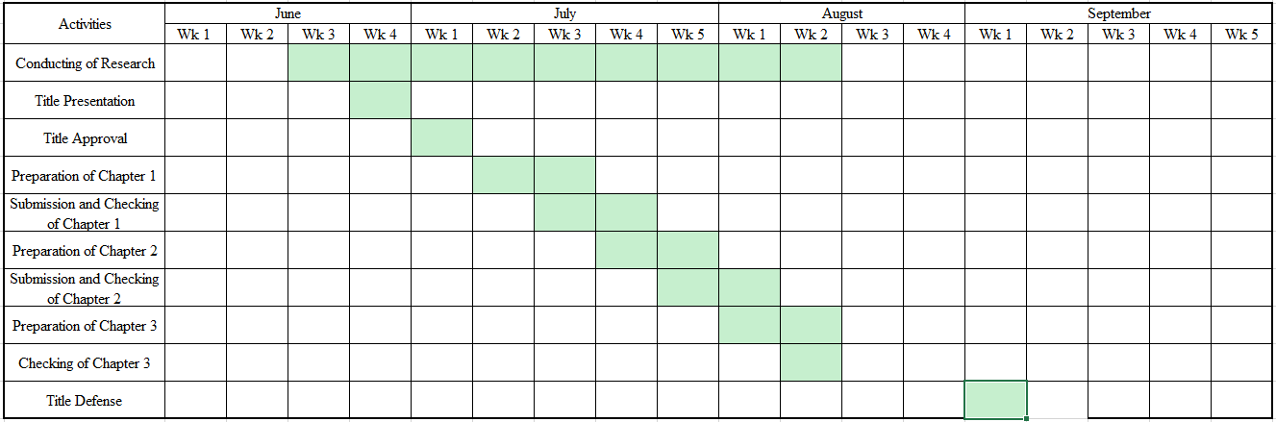
The researchers conducted their study on the beginning of the First Trimester, S.Y. 2018-2019, starting from the third week of June. After a week, the researchers presented ten titles for approval. The approved title was given the following week. In the second week of July, the preparation for the first chapter was underway. This includes research, and discussions for Chapter 1. The manuscript of Chapter 1 was submitted on the third week of July and was resubmitted the following week after some revisions. That same week the preparation of Chapter 2 was started. Chapter 2 was submitted on the last week of July and then resubmitted after revisions to Chapter 2 the following week. Chapter 3’s preparation was started on the first week of August and was submitted the following week. The researchers submitted and defended the project on the first week of September.

3.6 TESTING METHODS
To ensure that the proposed Smart Library System will work properly, the researchers conducted different testing, trials, method and troubleshooting after the development of the system.
1. The researchers inspect the cable connections for each device and assure that the system is working properly.
2. The researchers checks that the components are all in working order.
3. The researchers inspected the synchronization of the components to be sure that the system is operating effectively and efficiently.
4. The researcher checks the database program does not have any bugs.
5. The researchers also asks ten faculty, thirty-five students and five experts to evaluate the project if it is functional and ensure its quality.
3.7 EVALUATION PROCESS
To be able to check the quality of the system, the researcher begun an evaluation process. The respondents are issued with an evaluation sheet containing the criteria during the evaluation. The researchers begin with presenting their project before the evaluation. The following are the 50 individuals that the researchers ask to evaluate for the quality test of this project.
A. Students (35)
B. Faculty (10)
C. Experts (5)
3.8 EVALUATION CRITERIA
The Table 4 presents the criteria that the respondents observed and considered during the evaluation of the system.
TABLE 3.4 CRITERIA FOR SYSTEM EVALUATION
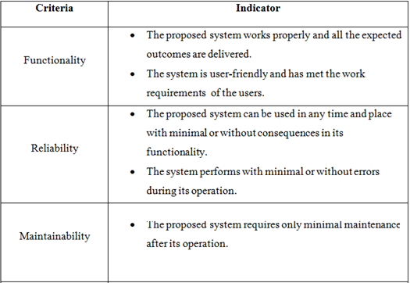

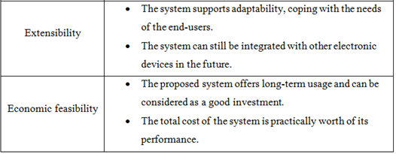

3.9 INSTRUMENT AND TECHNIQUE USED
The researchers used an evaluation sheet contained all the necessary criteria for the evaluation of the system.
TABLE 3.5 EVALUATION SHEET FOR THE PROPOSED SYTEM

AMA COMPUTER COLLEGE MALOLOS
City of Malolos, Bulacan
SOLAR POWERED COIN BASED MOBILE CHARGING STATION
EVALUATION SHEET
Name of Respondent: Date: ___________
Occupation: _______________________ Age: ___Sex: _______
INSTRUCTION: Rate the system based on the given criteria by encircling the corresponding number.

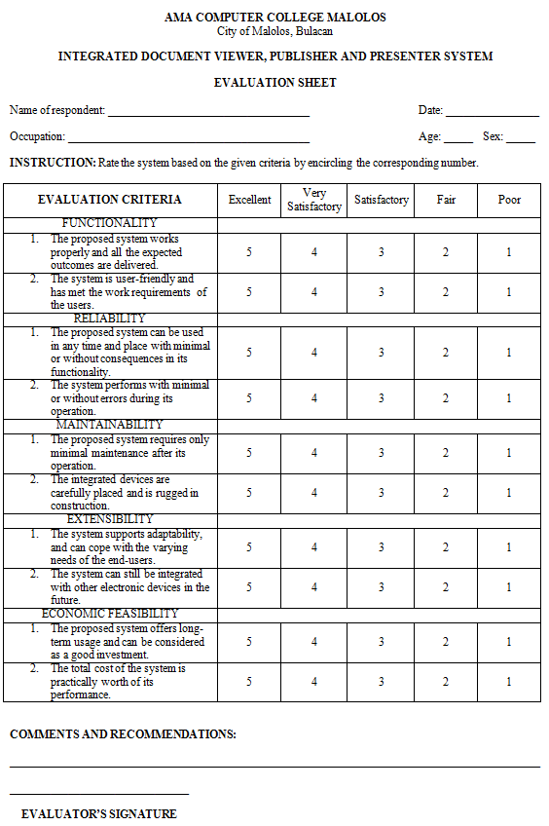

3.10 ANALYSIS OF DATA GATHERING METHODOLOGY
After the evaluation of the responders in the evaluation process, the researchers tallied the data that they gathered to them using the Likert Scale as seen in the Table 3.6. A Likert item is simply a statement which the respondent is asked to evaluate according to any kind of subjective or objective criteria; generally, the level of agreement or disagreement is measured. This can help the researchers to determine the capability. The data has to be thoroughly checked to fulfill the strict formal axioms of the project.
TABLE 3.6 The Likert Scale
Rating | Scale | Range
5 | Outstanding | 4.51-5.0
4 | Above Satisfactory | 3.51-4.5
3 | Satisfactory | 2.51-3.5
2 | Below Satisfactory | 1.51-2.5
1 | Needs Improvement | 1.0-1.50

CHAPTER IV

TESTING, EVALUATION AND RESULTS

This chapter presents the testing and evaluation of the system, including the computation and analysis of gathered data as well as the interpretation of results.

4.1 Initial testing stages of the project
The researchers conducted troubleshooting after the hardware was integrated and an initial testing of the device and its software to eliminate bugs. This was done to check if the system is working properly and efficiently. The researchers have thoroughly checked the wire connection and correct positioning and installation of each component inside the device to ensure all parts are functioning properly.
4.2 Evaluation of the system
The researchers have conducted an evaluation to assess the acceptability and feasibility of the system with the help of various professionals from different fields. The researchers have used the stratified sampling method to obtain respondents. The respondents were composed of 10 professional, 35 students, and 5 experts. The respondents were asked to assess the potential of the development of the study in their area. The researchers provided them with evaluation sheets containing all the necessary criteria for the evaluation of the system.
The respondents have evaluated the system for its functionality, usability, performance and maintenance, which were explained earlier in the Evaluation Criteria section of Chapter 3.
The computation of the weighted means was done in order to interpret the results and presented by tables.
The following tables are the evaluation result of the weighted means.
Table 4.1 Evaluation on Functionality
Professional | 4.7 | Outstanding
Expert | 4.6 | Outstanding
Student | 4.6 | Outstanding
Mean Score | 4.63 | Outstanding

Table 4.1 presents the evaluation on functionality of the system. Static shows that the functionality of the system is rated “Outstanding” with the computed mean score of 4.62.
This data imply that the respondents are astounded by the functionality of the project. The system works properly, and all the expected outcomes are delivered. The system is user friendly and has met the work requirements of the users.

Table 4.2 Evaluation on Reliability
Professional | 4.65 | Outstanding
Expert | 4.7 | Outstanding
Student | 4.3 | Above Satisfactory
Mean Score | 4.55 | Outstanding
Table 4.2 presents the evaluation on reliability of the system. Static shows that the reliability of the system is rated “Outstanding” with the computed mean score of 4.55.
This data imply that the respondents are astounded by the reliability of the project. It can be used in any time and place with minimal or without consequences in its functionality. The system performs with minimal or without errors during its operation.
Table 4.3 Evaluation on Maintainability
Professional | 4.4 | Above Satisfactory
Expert | 4.4 | Above Satisfactory
Student | 4.4 | Above Satisfactory
Mean Score | 4.4 | Above Satisfactory

Table 4.3 presents the evaluation on maintainability of the system. Static shows that the maintainability of the system is rated “Above Satisfactory” with the computed mean score of 4.4.
This data imply that the respondents are above satisfied in maintainability of the project. The system only requires only minimal maintenance after its operation. The integrated devices are carefully placed inside the case and the system is rugged in construction.

Table 4.4 Evaluation on Extensibility
Professional | 4.65 | Outstanding
Expert | 4.5 | Above Satisfactory
Student | 4.53 | Outstanding
Mean Score | 4.56 | Outstanding

Table 4.4 presents the evaluation on extensibility of the system. Static shows that the extensibility of the system is rated “Outstanding” with the computed mean score of 4.56.
This data imply that the respondents are astounded by the extensibility of the project. The system supports adaptability, coping with the needs of end-user. The system can still be integrated with other electronics devices in the future.

Table 4.5 Evaluation on Economic Feasibility
Professional | 4.7 | Outstanding
Expert | 4.8 | Outstanding
Student | 4.5 | Above Satisfactory
Mean Score | 4.67 | Outstanding

Table 4.5 presents the evaluation on feasibility of the system. Static shows that the feasibility of the system is rated “Outstanding” with the computed mean score of 4.67.
This data imply that the respondents are astounded by the feasibility of the project. The project offers long term usage and can be considered as a good investment. The total cost of the system is practically worth of its performance.
4.3 Overall Evaluation
As stated in Chapter 3, the researchers have used the Likert scale to measure and interpret the evaluation results of the respondents. Based on the results, the respondents agree that the system is highly functional, maintainable usable and performs well for the blind person.

Table 4.6 Summary of Overall Evaluation
Functionality | 4.63 | Outstanding
Reliability | 4.55 | Outstanding
Maintainability | 4.56 | Outstanding
Extensibility | 4.4 | Above Satisfactory
Economic Feasibility | 4.67 | Outstanding
Grand Mean | 4.562 | Outstanding

Table 4.6 presents the Summary of Overall Evaluation of the system. Static shows that the feasibility of the system is rated “Satisfactory” with the computed mean score of 3.76.

CHAPTER V

SUMMARY, CONCLUSION AND RECOMMENDATION

5.1 SUMMARY
The researchers underwent various steps in the development of Library Management System. The need to minimize work of librarian and to reduce processing time of borrowing and returning of books also the logging of the students, the researchers develop a RFID and barcode technology-based device that intends to address these concerns.
Initially, the researchers conducted research and collected significant ideas from related literatures and studies regarding the efficiency and operation of RFID and Barcode. Next, the researchers carefully planned the system’s design and identified the components that were used in the system’s construction.
After the analysis and conceptualization of the system design, the researchers bought all the necessary components and tools then proceeded to the construction of the circuitry and the integration of the system’s components.
The researchers did thorough tests after its construction for output analysis comparison and made adjustments to correct and maintain the proper operation of the system. Lastly, the researchers conducted an evaluation from a gathered group of respondents to determine the acceptability and feasibility of the system.
All of the stated processes have eventually led to the output: “Library Management System Using RFID and Barcode Scanner”.

5.2 CONCLUSION
After painstaking work and thorough experimentations, the researchers can say that the objectives of this particular study have been successfully achieved. The study Library Management System Using RFID and Barcode has been successfully achieved. The overall functionality, reliability, maintainability, extensibility, economic feasibility of the research based on the respondents is satisfactory. The overall evaluation of the research is satisfactory based on the Likert scale with a grand mean of 3.73. this is a study that intends to reduce the process of borrowing and returning of books and the logging of the students using RFID as the library card of each students and Barcode as the id of each books, as well as to log all the transactions and the status of the transaction whether who borrows a certain book, when the book is borrowed, when the book returned, identifying penalties whether the book returned before the due date and the catalogue of the book containing the definition, status, and the shelf number of the book through a database using Microsoft Access and visual basic as the GUI, the transactions can be seen in the librarians computer as the server and the students can search a book in a client computer connected into LAN. After careful and thorough analysis and evaluation of the results, the researchers firmly believe that the project have met the objectives in producing device and provide significant benefits to the society.

RECOMMENDATION
The project study can be further improved by overcoming its limitations. Several recommended modifications that can improve the performance of the project are the following:
- All scanners should be in the server only
- Make use of raspberry pi instead of arduino to make the device portable
- Make use of the tracking ability of RFID
- Use RFID for admins account

