RESEARCHER`S WEEKLY PROGRESS REPORTS
AMA COMPUTER COLLEGE-MALOLOS
ECE 201:DESIGN PROJECT 2
WEEKLY PROGRESS REPORT

PROJECT TITLE: | Automated Library Management System using Barcode and RFID
PROPENENTS: | Melvin Dela Cruz  Carlo Dominic De Guzman  John Philip Tuazon  Joash Christian Liwanag
Date Submitted | October 19, 2018
Period Covering | October 22, 2018 TO October 26, 2018
Over-all Project Status (%) | 10%

Status | Milestone Description
 | Purchasing of Items
 | Connecting the MySQL Database to Visual Studio
Highlight Progress
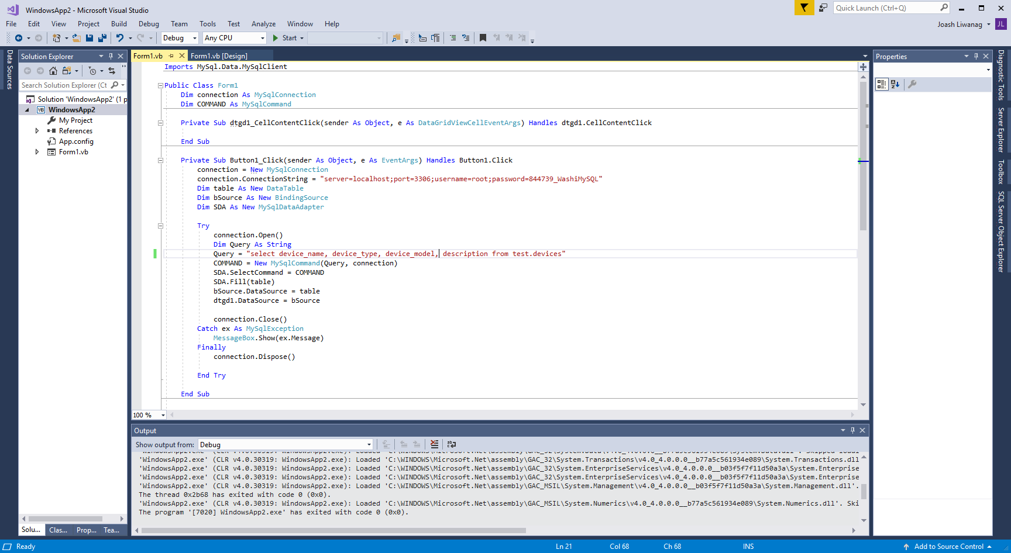
Figure 1. Visual Basic code to connect to MySQL.
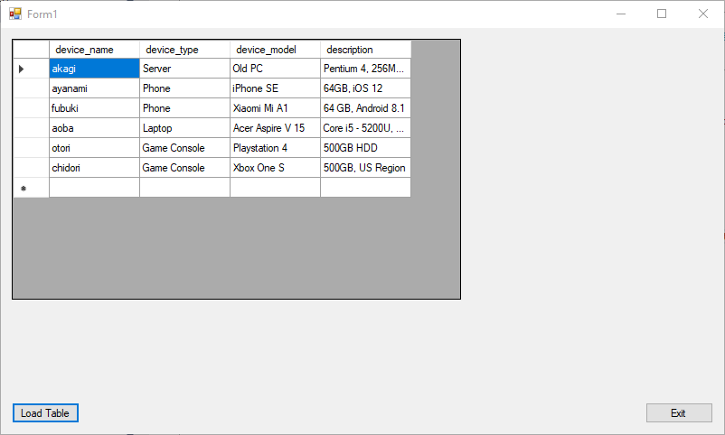
Figure 2. Resulting Program showing the MySQL table in the database.
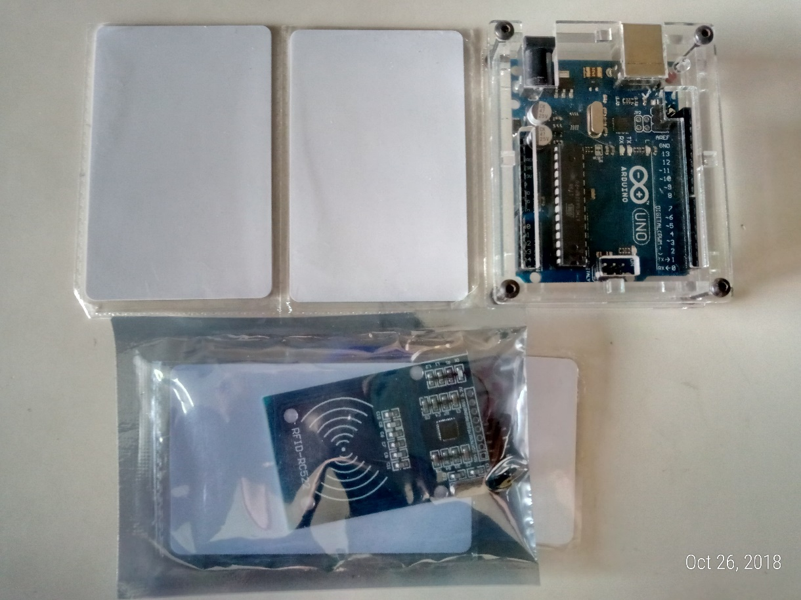
Figure 3. RFID Cards (Top Left), Arduino Uno (Top Right), RFID module for Arduino (Bottom)

