RESEARCHER`S WEEKLY PROGRESS REPORTS
AMA COMPUTER COLLEGE-MALOLOS
ECE 201:DESIGN PROJECT 2
WEEKLY PROGRESS REPORT

PROJECT TITLE: | Automated Library Management System using Barcode and RFID
PROPENENTS: | Melvin Dela Cruz  Carlo Dominic De Guzman  John Philip Tuazon  Joash Christian Liwanag
Date Submitted | October 19, 2018
Period Covering | October 15, 2018 TO October 19, 2018
Over-all Project Status (%) | 7%

Status | Milestone Description
 | Installed Visual Studio and MySQL
 | Tested remoting into a different PC running a MySQL server
Highlight Progress
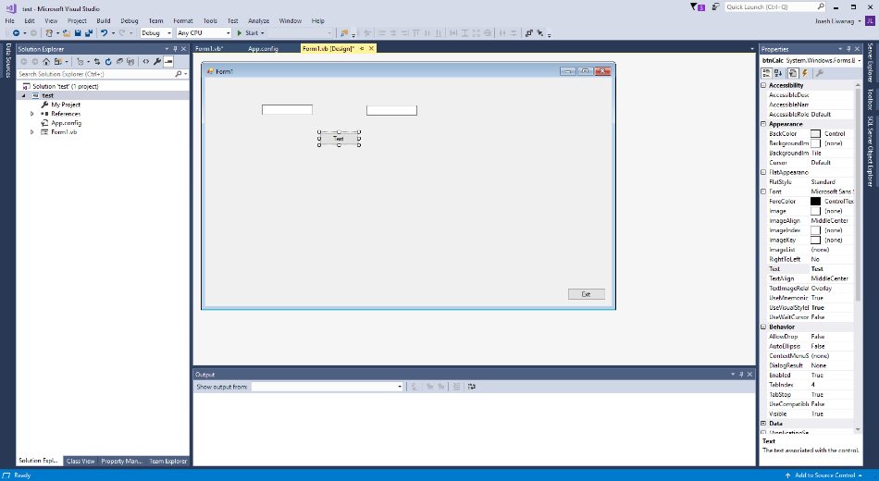
Figure 1. Visual Studio 2017 with a Test Project Open.
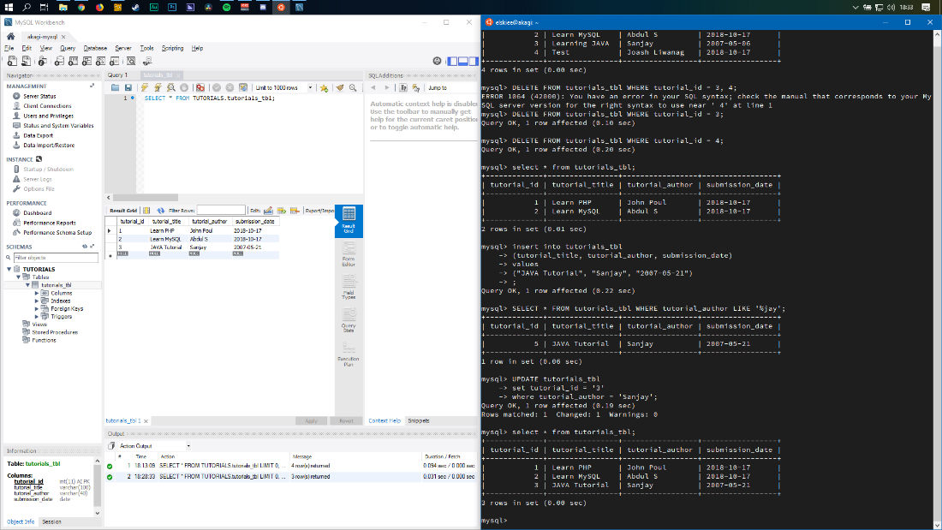
Figure 2. MySQL Workbench (left) connecting to a MySQL database on a server running on Ubuntu (right).

