RESEARCHER`S WEEKLY PROGRESS REPORTS
AMA COMPUTER COLLEGE-MALOLOS
ECE 201:DESIGN PROJECT 2
WEEKLY PROGRESS REPORT

PROJECT TITLE: | Automated Library Management System using Barcode and RFID
PROPENENTS: | Melvin Dela Cruz  Carlo Dominic De Guzman  John Philip Tuazon  Joash Christian Liwanag
Date Submitted | November 9, 2018
Period Covering | November 5, 2018 TO November 9, 2018
Over-all Project Status (%) | 25%

Status | Milestone Description
Working | RFID Test
In Progress | Login Interface and Main Interface
In Progress | Database
Highlight Progress
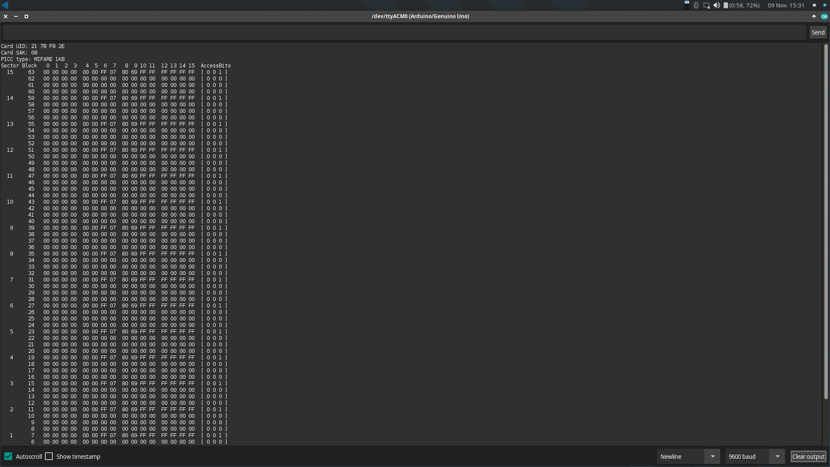
Figure 1. Serial monitor output of the RFID.
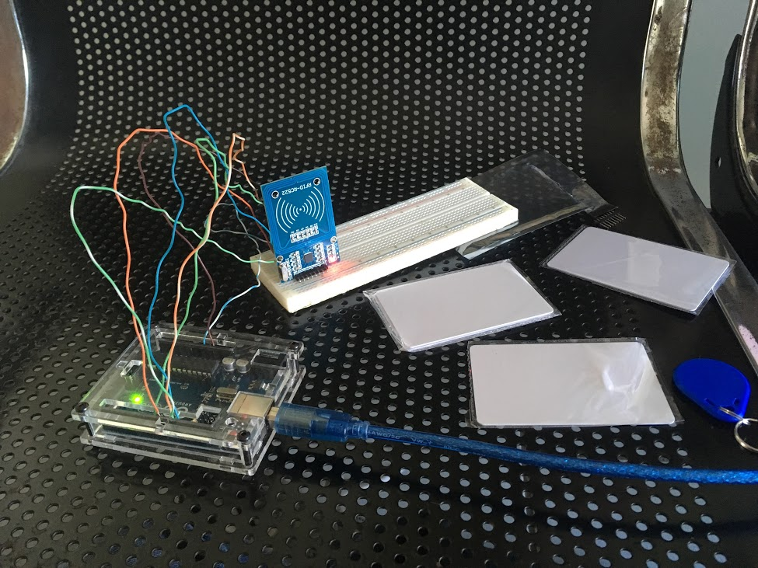
Figure 2. RFID test setup.
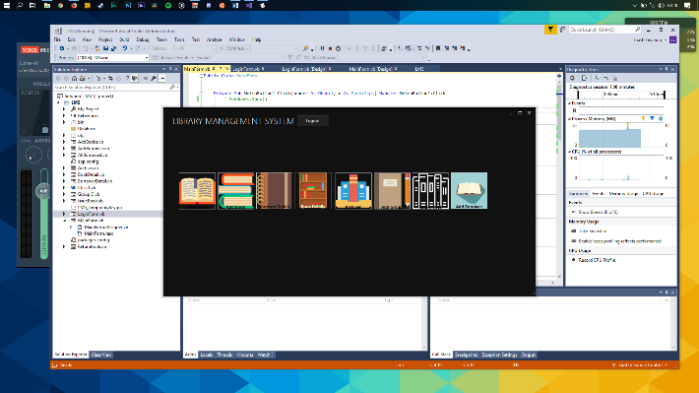
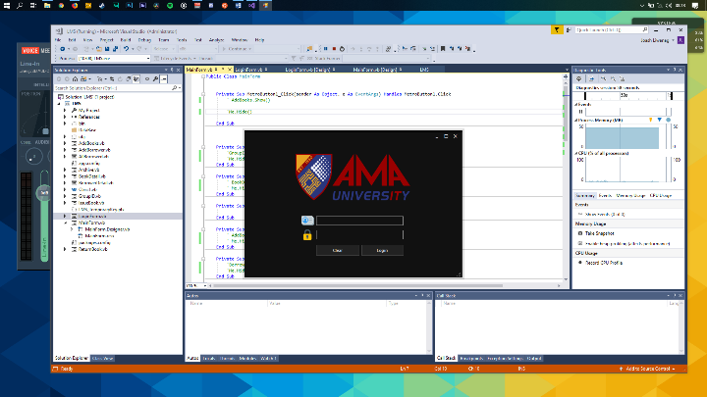
Figure 3. Login Form and

