RESEARCHER`S WEEKLY PROGRESS REPORTS
AMA COMPUTER COLLEGE-MALOLOS
ECE 201:DESIGN PROJECT 2
WEEKLY PROGRESS REPORT

PROJECT TITLE: | Automated Library Management System using Barcode and RFID
PROPENENTS: | Melvin Dela Cruz  Carlo Dominic De Guzman  John Philip Tuazon  Joash Christian Liwanag
Date Submitted | November 23, 2018
Period Covering | November 12, 2018 TO November 23, 2018
Over-all Project Status (%) | 50%

Status | Milestone Description
Working | RFID and Barcode test
In Progress | Reading of the RFID UID on Visual Studio
Purchased | USB Barcode Scanner
Highlight Progress
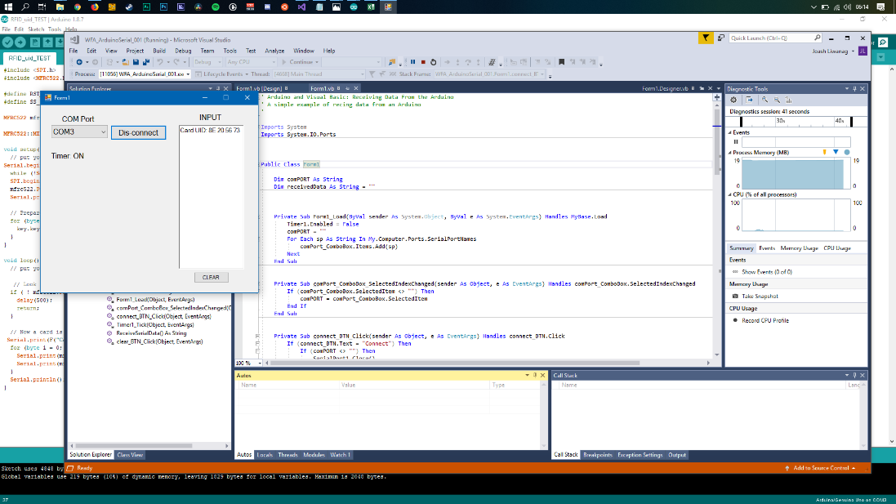
Figure 1. Reading of Serial output on a test Visual Basic program through COM Port 3.
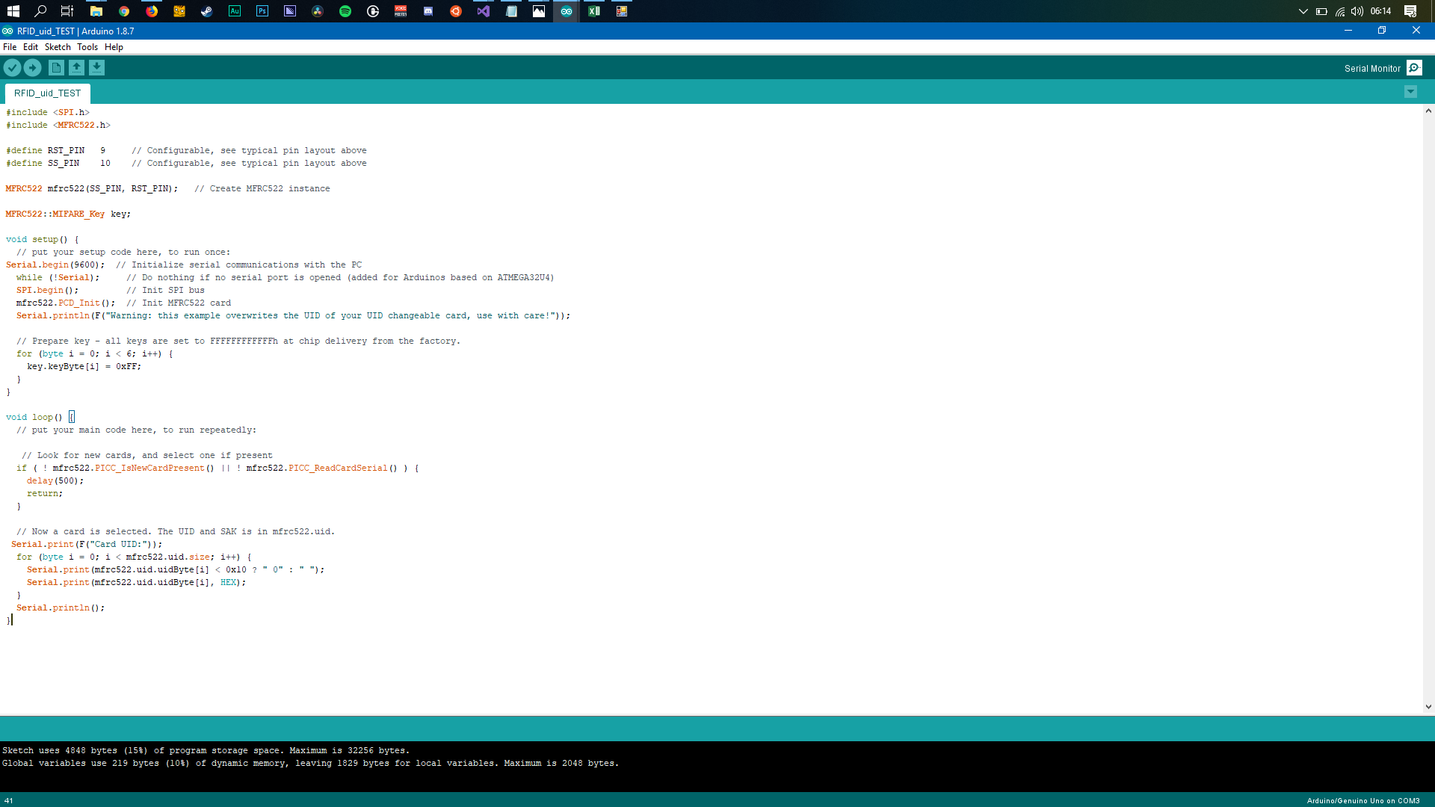Figure 2. Arduino Code for reading the RFID UID.
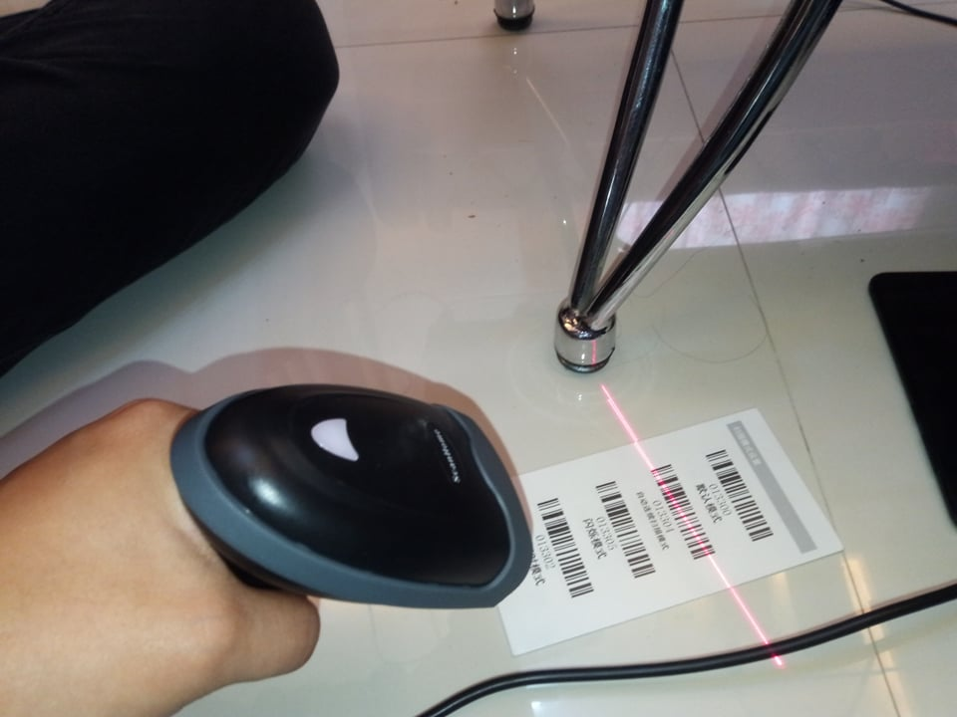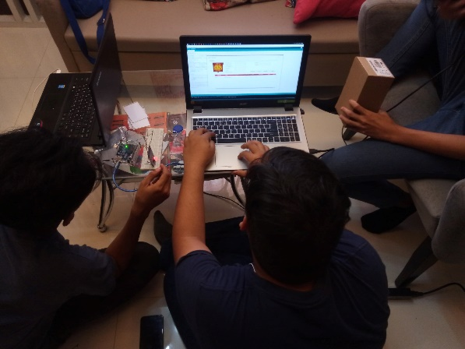
Figure 3. Testing out the Barcode Scanner

