SME Procurement Support Agent — Final Engineering Report
Course: BSE4104 — Emerging Trends in Software Engineering (AI-native & agentic capstone)
Institution: Makerere University, Year IV, Semester I
Date: 23 October 2026 (first release 20 October 2026)
Repository: https://github.com/AJmight/Capstone_project- · Release tag: v1.0.0 + post-release fix (PR #3, F-26)
Lead Academic Convener: Dr. Kamulegeya Grace B (PhD)
Group: not stated in supplied source materials
Member | Reg No | Role
Mwesigwa Arnold Mugahi (GitHub: AJmight) | 23/U/24738/PS | AI Engineering Lead (principal author of this report)
Boonabaana Bronia (GitHub: broniaB2) | 23/U/07647/EVE | Storage & UI Lead
Naisanga Patricia | 23/U/13204/EVE | Team Member
Nakyambadde Mariam | 23/U/13953/EVE | Team Member
Tulinawe Ismail | 23/U/18058/EVE | Team Member
Individual contributions are listed after the References.

1. Executive Summary
A small stationery shop in Uganda keeps its stock levels, supplier quotes and purchase history in spreadsheets. When the person who knows the shop is not there, the shop's memory is lost: nobody can say what is low, how much to order, from whom, or what the shop's own rules allow. This project builds an assistant for that situation. It reads the shop's inventory, compares supplier quotes, computes reorder quantities, answers policy questions from the shop's own documents, and drafts purchase requisitions — which a human then reviews and approves.
The engineering argument of the project is deliberately narrow and, we believe, defensible: AI supports, never decides. The language model is used only for what a language model is good at — reading a request, choosing which of the eight approved tools to call next, and explaining the result in the shop's language. Every number, every rule and every permission lives in deterministic Python. There is no tool that approves an order, signs a purchase order, pays a supplier or contacts anybody, so the model cannot do those things even if it tried, and the tests that prove it are in the repository.
Eight weeks produced a working, tested, reproducible system: 8 tools, a bounded agent loop, a BM25 retrieval pipeline over a 12-document policy corpus, an explicit finite state machine, justified memory partitioned per shop, an MCP server, four layers of deterministic guardrails, and 26 documented failures with their root causes, fixes and regression tests. The final offline regression is 119 of 119 across nine suites, plus 10 of 10 retrieval queries at hit@3 and 15 of 15 grounded policy answers. A browser interface (src/streamlit_app.py, Streamlit) calls the same functions as the console; its home screen is finished and the remaining screens are in progress for the hosted demo.
The principal limitation is not a bug but a boundary: the system is a decision support tool, not an agent that can act. The value is in the draft and in the explanation, and a shop still has to make the call.

2. Problem Context and Requirements

2.1 The problem
The brief's motivating story is a water-damaged exercise book: when the shop's records are lost, the institutional knowledge goes with them. In the synthetic scenario we model here, the shop's knowledge lives in three CSV files and a folder of policy documents, and the person who understands them is one person with a busy day. The task is therefore not "make decisions faster"; it is make the shop's own rules and numbers available and checkable, without letting a probabilistic system make the money decisions.

2.2 Users and scope
Two user roles appear in the Week 1 stories: a Procurement Officer and a Shop Owner/Manager. In the built system they are the same trusted user (docs/requirements/decision-001-single-trusted-user.md, 13 October 2026): a shop of this size has one person who does the ordering, so role-based access control would be theatre. What remains protected is the separation between shops, which is enforced with a shop_id partition key in code (see §7.2).
In scope: inventory visibility, low-stock flagging, quote comparison, trend-based reorder estimates, budget planning, draft requisitions, historical queries, grounded policy answers, a manual override with an audit trail, a human approval gate, and a 200% safety cap. Out of scope and descoped with a reason: parsing PDF supplier quotes (user story 3) — quotes are read from supplier_quotes.csv, and PDF extraction is listed as future work rather than pretending to be done.

2.3 User stories and acceptance criteria
Twelve stories were consolidated from the team's Week 1 document into docs/requirements/user-stories.md; eleven are implemented and the twelfth is descoped with a stated reason. Each story is mapped to the code that satisfies it and to the test id that proves it (the full table is in Appendix A).

2.4 The AI Boundary Matrix
docs/requirements/ai-boundary-matrix.md is the document that answers the brief's central question — where does AI add value and where must it not decide? — and it is enforced column by column:
Capability | AI (model) | Deterministic core (Python) | Human | Implementation
Low-stock flagging | chooses the tool, summarises | stock <= reorder_point | sets reorder points | procurement.get_low_stock
Quote comparison | explains the options | sorts by price, tie → lead time | may choose a dearer supplier with a written reason | compare_supplier_quotes
Reorder quantity | explains the working | ceil(avg × 1.5) − stock, MOQ, exact fractions | sets the quantity where there is no history | estimate_reorder_quantity
Budget planning | decides to plan, explains deferrals | urgency order, greedy fit within budget | funds deferred items or not | plan_within_budget
Draft requisition | decides which items to request | builds lines, totals, ±10% band, id, date, creator | — | draft_requisition
Policy questions | answers only from retrieved passages, cites them | BM25 retrieval, score gate, citation check | maintains the documents | rag/, search_policy
Manual override | — | recalculates totals and the cap, logs the original and the reason | changes the quantity, gives a reason | approvals.edit_quantity
Approval | never (no such tool exists; it refuses) | requires typed confirmation, reasons for reject and over-cap, audit log | approves or rejects | approvals.decide
Ordering / payment | never (refuses) | no integration exists | places the order and pays, outside the system | —
Access & tool control | — | tool allow-list, task allow-list, parameter validation | controls who has access | registry.execute_tool
The "never" rows are the load-bearing part. They are not prompt instructions: they are the absence of a tool, checked by src/tools/registry.py before any call runs, and demonstrated live in the demo (Appendix G).
All six of the project's own success criteria were met; the table with the evidence for each is in Appendix H.

3. System Architecture

3.1 The shape of the system
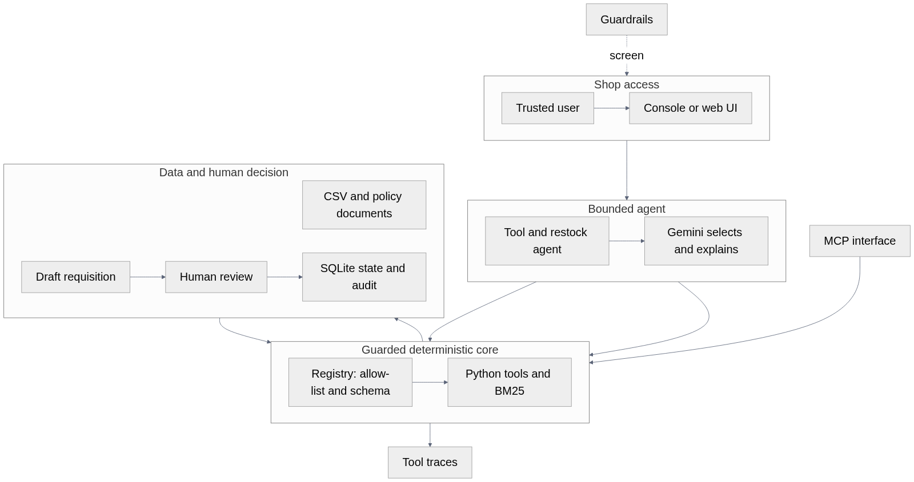
Figure 1 — System context and module map.

3.2 The deterministic core and the AI shell
The architecture is one sentence: an AI shell around a deterministic core.
Layer | Module | Responsibility | Can it approve or pay?
Presentation | src/app.py, src/streamlit_app.py | Console menu and web UI over the same five actions; input screening | No
Agentic | src/tool_agent.py, src/restock_agent.py | Bounded model↔tool loop; explicit state; code-decided outcome | No
Interface | src/rag/policy_qa.py, src/mcp_interface.py | Grounded answers; MCP JSON-RPC surface | No
Tools | src/tools/procurement.py, src/tools/knowledge.py | Every calculation and lookup; draft creation | No (drafts only)
Gate | src/tools/registry.py, src/approvals.py | Allow-list, argument validation, trace; the human decision | The human only
Safety | src/guardrails.py | Input screening, budget ceiling, human-only actions | No
State | src/state.py, src/memory.py, src/storage.py | SQLite FSM, justified memory, scoped drafts / audit / sessions | No
Model | src/llm_client.py | One client, one fallback chain, one trace format | No
A useful property of this shape: the failure mode of the model is a bad explanation, not a wrong transaction. If the model is confused, the worst possible outcome is that a human reads a confusing summary of a correct draft.

3.3 Data and provenance
All data is synthetic and generated with a fixed seed (data/*.csv): 15 inventory items, 10 of them at or below their reorder point; supplier quotes for four suppliers; and 24 months of purchase history. The policy corpus is 12 hand-written markdown documents with a corpus register recording who wrote each one and why (knowledge/source-register.md). No real shop, supplier, price or person appears anywhere in the repository.

4. Foundation Model and Prompt Engineering

4.1 Model choice
docs/requirements/model-selection.md records the decision. The runtime model is gemini-3.8-flash through the official google-genai SDK, with a fallback chain of gemini-3.7-flash → 3.6 → 3.5 → 3.5-flash-lite → 3.1-flash-lite.
Two things the project learned the hard way, both recorded as failures:
- F-06 — gemini-2.5-flash returns 404 for this key although it was still listed; src/test_models.py --probe now calls a model before it is trusted.
- F-02 — the free tier allows 20 requests per model per day. The chain gained wait-and-retry rounds, and every release suite is offline, verifiable with no quota left.
The decision also has a cost: the flash tier is weaker at instruction following than a large model, which is exactly why the hard requirements were moved out of the prompt and into code.

4.2 Prompt engineering as version history
Prompts are versioned files in prompts/, and every change is a new file, a row in that file's Version History, a row in prompts/prompt_history.md, and a re-run of the tests. The progression is the clearest single piece of evidence that the project learned from its failures (every version and its result: Appendix C).
The most important version is 2.0.0. Before it, the prompt asked the model to compute reorder quantities. Under injection the model produced Erasers 70 instead of 63, Paper 50 instead of 53 and Staplers 114 instead of 88 (F-04) — a model that is good at language is simply not good at this arithmetic, and no wording fixes it. Moving the arithmetic into estimate_reorder_quantity and draft_requisition fixed the class of failure permanently, and it is the reason the agent can be trusted with money-adjacent numbers at all.

4.3 Prompt discipline
Three rules held throughout, and each cost a failure to learn:
- Never ask for a number the code can produce. The prompt names tools, not formulas.
- Never rely on the prompt for a permission. The allow-list is in code; the prompt merely describes the tools (F-07 — the model called draft_requisition anyway).
- Version everything. prompts/archive/ keeps the old files unchanged, so the claim "this iteration fixed that failure" can be checked by diffing two files.
No prompt was changed in Week 8. The last three defects were in the deterministic layer, and a prompt is not a fix for a function call.

5. Context Engineering and RAG

5.1 Why a corpus at all
The shop's rules — who may approve what, when a reorder point rises, how to handle a supplier pushing a discount — live in documents, not in the CSVs. A model asked "who can approve an 800,000 UGX requisition?" from memory will either hallucinate or answer from its training data. The corpus makes the answer grounded and citable, which is the difference between a demo and something a shop can rely on.

5.2 The pipeline
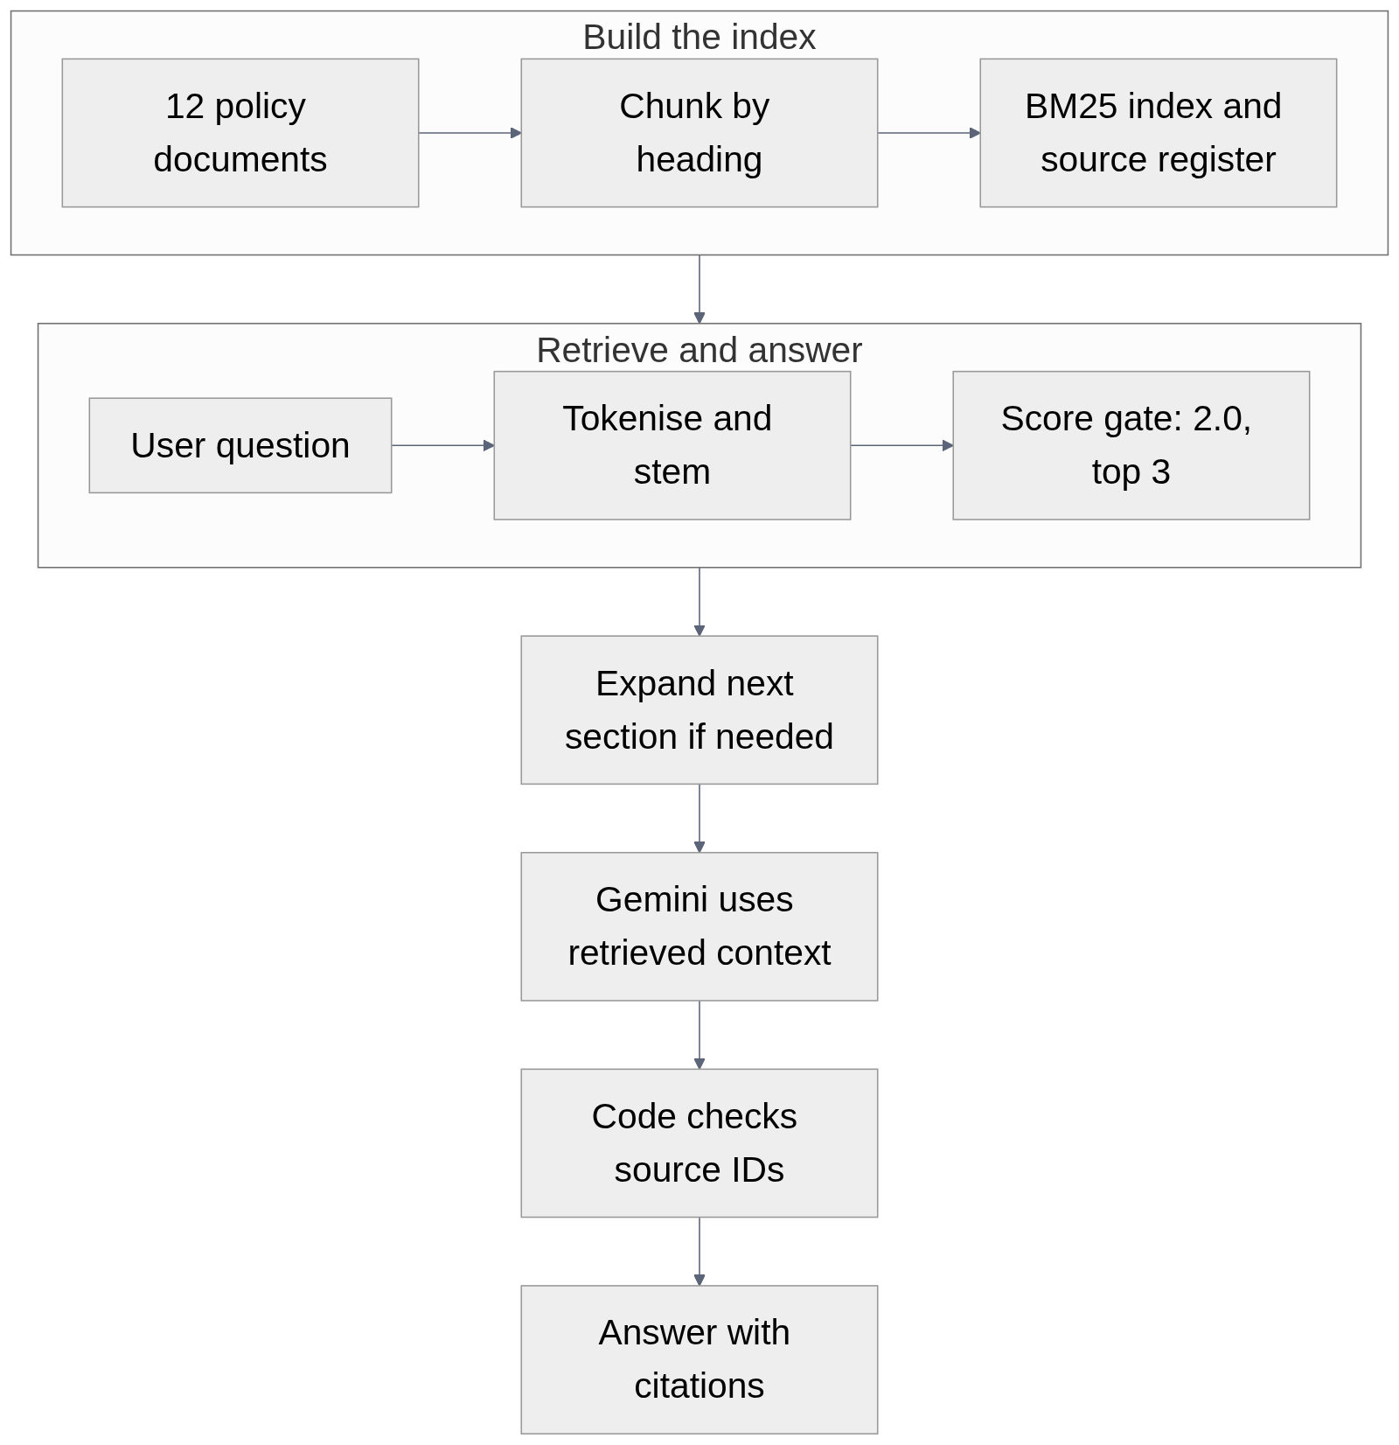
Figure 2 — Retrieval-augmented generation pipeline.
Implementation: src/rag/index.py (chunking, tokenising, the BM25 index) and src/rag/policy_qa.py (retrieval, the answer call, the citation check). The search_policy tool exposes the same corpus to the agent, so a policy question inside a conversation is answered the same way as a standalone one.

5.3 Retrieval results
py tests\test_week3_rag.py --offline → hit@3 10/10, context hit 10/10, MRR 0.88, and the live suite answers 15/15 grounded questions with valid citations (docs/evaluation/week3-rag-evaluation.md).

5.4 The retrieval failures we are happy to show
The brief asks for at least three retrieval failures. We have five (week3-rag-evaluation.md, R-1 … R-5; table in Appendix I): a stemming gap, an answer split across sections, boilerplate retrieved as content, numeric thresholds, and a citation parser that was stricter than the model. Four are fixed or mitigated.
R-4 is the most interesting one and we left it open on purpose: it is a real limitation of keyword retrieval over a numeric threshold table, and the honest fix is a structured tool, not a better regex.

5.5 Grounding rules
The RAG prompt forbids answering from memory and requires a source_id for every claim; policy_qa.py then verifies that the cited ids exist in the retrieved set. An unanswerable question returns "not in the provided documents" rather than a guess. R-5 exists because the checker was once weaker than the model.

6. Tools and the Agentic Workflow

6.1 The eight tools
Every tool is a Python function in src/tools/procurement.py or src/tools/knowledge.py, registered in src/tools/registry.py with a JSON Schema contract, a side-effect label and a permission. The machine-readable schemas are exported to docs/requirements/tool-schemas.json.
# | Tool | Reads | Side effect | Permission
1 | get_low_stock | current_stock.csv | none | read
2 | compare_supplier_quotes | stock, quotes | none | read
3 | estimate_reorder_quantity | stock, history, quotes | none | read
4 | plan_within_budget | stock, history, quotes | none | read
5 | draft_requisition | stock, history, quotes | saves a draft (SQLite) | draft write
6 | get_inventory | current_stock.csv | none | read
7 | query_purchase_history | past_purchases.csv | none | read
8 | search_policy | the policy corpus | none | read
Two properties matter more than the list:
- No tool approves, orders, pays, signs or contacts anybody. The list above is the complete set. A model that asks for approve_requisition receives UNAUTHORIZED_TOOL from the registry (F-07, test O-15).
- Trusted values are injected by the registry, never by the model. created_by comes from the session; a model that tries to set it is rejected (test O-18).

6.2 How a tool call happens
- Is the tool on the allow-list? 2. Do the arguments match its JSON Schema?
- The registry injects the trusted context (created_by, shop and user).
- The tool runs and returns a status (ok, tool_error, blocked, invalid, crashed). 5. The call is written to the trace. The diagram is Figure 5 (Appendix M).
Steps 1, 2, 4 and 5 are code. The model contributes only step "name + args", and the registry is the gate.

6.3 The bounded agent
src/tool_agent.py is a plan–act–observe loop with hard limits: 6 model turns and 12 tool calls for a conversation, 5 turns and 6 tool calls for the weekly task, one retry per call after a SERVICE_UNAVAILABLE, and a repeat-call guard. The model chooses which approved tool to call next and how to explain the result; the code decides the outcome.
src/restock_agent.py adds the explicit task contract (docs/requirements/agent-task-contract.md):
0. PRECONDITIONS (code) budget a positive whole number?
1. SENSE (code) get_low_stock through the registry
nothing low -> NOTHING_TO_DO, no model call
2. PLAN/DECIDE (model) chooses the next tool within the contract
3. ACT (code) registry runs it
4. OBSERVE (code) explicit AgentState updated after every result
RE-PLAN budget too small -> drop items; a transient failure -> one retry
5. POST-CONDITIONS (code) draft == plan, total <= budget, status is DRAFT,
the summary says it awaits approval
6. STOP (code) the OUTCOME is decided by code, never by the model's wording
The outcome vocabulary is closed and code-decided: DRAFT_READY, NOTHING_FITS_BUDGET, NOTHING_TO_DO, PRECONDITION_FAILED, POSTCONDITION_FAILED, BUDGET_CEILING_EXCEEDED, HANDOFF_MODEL_UNAVAILABLE, HANDOFF_SENSE_FAILED, HANDOFF_NO_DRAFT.

6.4 A worked example (all figures computed by the tools, not by the model)
With a budget of UGX 300,000 and the synthetic data:
- get_low_stock → 10 of 15 items are at or below their reorder point.
- estimate_reorder_quantity("ITM001") → Bic Pens (Blue): 555 purchased over 12 months = 46.25/month; ×1.5 = 69.375; −5 in stock = 64.375; rounded up = 65 (cost 65 × 476 = 30,940).
- estimate_reorder_quantity("ITM003") → Rulers 30cm: 469/12 = 39.08/month; ×1.5 = 58.625; −2 = 56.625; rounded up = 57 (cost 57 × 938 = 53,466).
- draft_requisition(["ITM001","ITM003"]) → total UGX 84,406, estimate band 75,965 – 92,847, status DRAFT - AWAITING HUMAN APPROVAL, id REQ-YYYYMMDD-HHMMSS-XXXX, creator = the logged-in user.
- plan_within_budget(<all low items>, 300000) → 4 items, UGX 294,130, UGX 5,870 left, 2 items deferred, 4 items that cannot be priced automatically and are handed to the human with a reason.
The agent then hands the draft to src/approvals.py, where a person approves, rejects (with a reason) or edits a quantity first. Nothing is sent to a supplier, because nothing in the system can send anything to a supplier. The generated workflow diagrams in Figures 6 and 7 summarize the recorded live run and of the approval gate are Figures 6 and 7 (Appendix G).

6.5 What the agent may never do
It may not approve, order, pay, sign, contact a supplier, change a reorder point, set a quantity for an item with no history, or answer a policy question from memory. Each of these is either the absence of a tool or a rule in _reorder_calculation; each has a test.

7. Memory, State and Interoperability (Week 6)

7.1 An explicit finite state machine
src/state.py stores each procurement session in SQLite and advances it only through a declared graph:
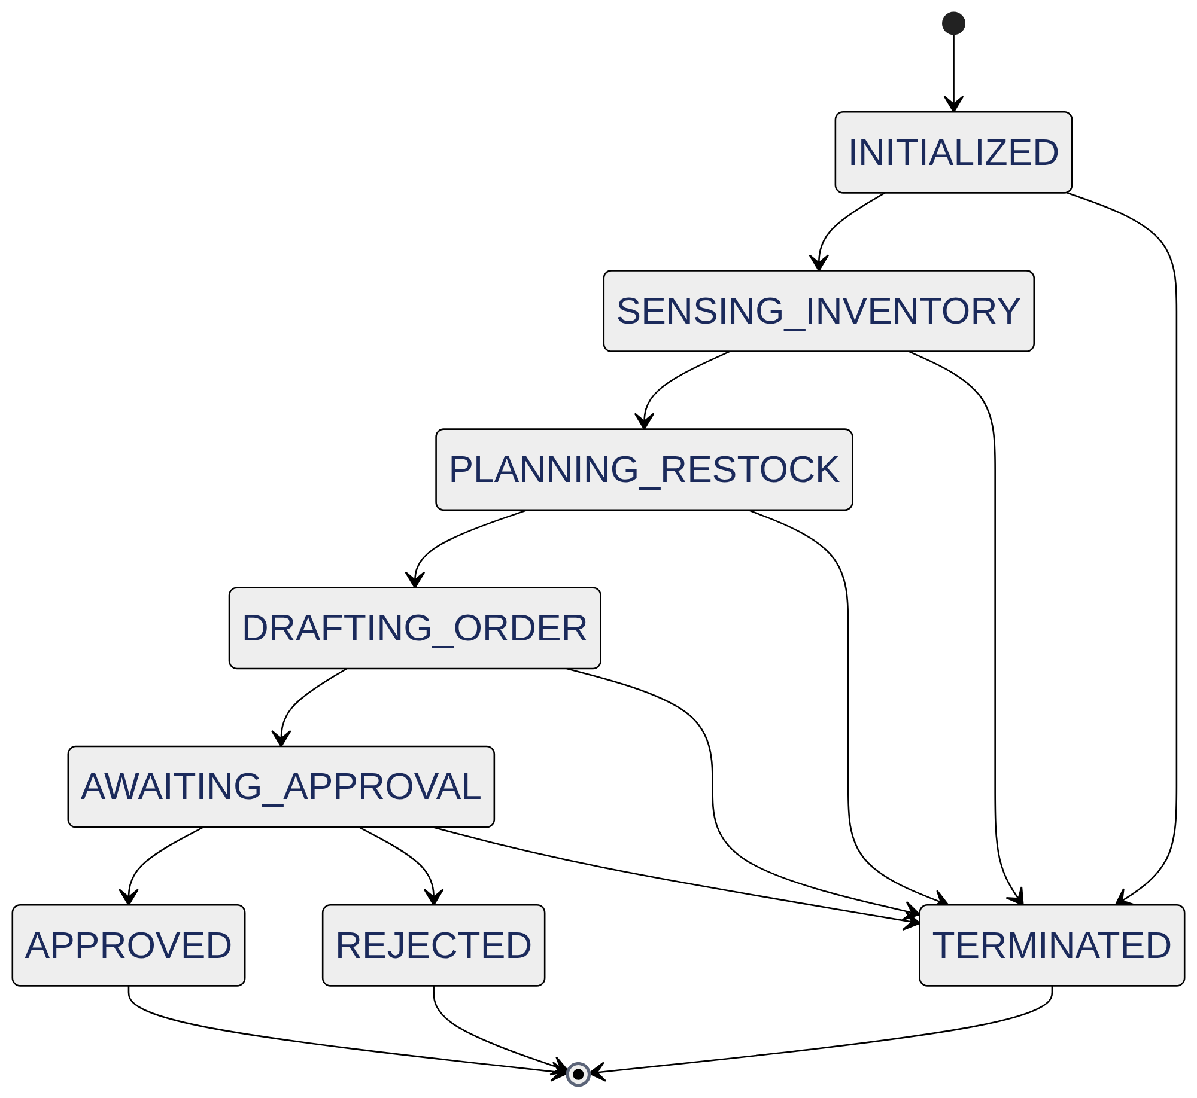
Figure 3 — Workflow state machine; approval is reachable only after a human decision.
APPROVED is reachable only from AWAITING_APPROVAL, and the only code that may perform that transition is the human approval gate. This is the answer to "how do you prove the AI cannot skip the human?": the proof is a table, a transition log, and the absence of any other caller.
Week 8 found and closed a gap here (F-24): the approval gate recorded the decision but never moved the session, so the graph was correct and the system was not. The gate now finds the session by draft id and transitions it, with the approver's name in the reason, and the regression test test_approval_moves_the_session_to_approved proves it.

7.2 Justified memory, partitioned by shop
src/memory.py stores a small number of justified memories: supplier preferences and owner feedback, never raw conversation transcripts. Every query is WHERE shop_id = ? AND target_key IN (...) with a compound index, so one shop's records can never reach another shop's session (F-17). The owner can list and delete their own memories (delete_memory, clear_shop_memories), which is the erasure right in the data-protection plan.
Week 8 closed a second gap here (F-25): the MCP server had been taking the shop_id from the model's arguments, which handed the model the key to the partition it had just built. The server now owns its tenant, validates it at construction, and refuses a cross-shop request.
Two Week 6 implementations were built in parallel and merged afterwards, so persistent state lives in two SQLite files. data/state.sqlite3 (src/storage.py) holds the drafts, audit events and sessions, every row scoped by tenant_id and user_id, which the registry injects from trusted context (the model cannot choose its shop). data/procurement.db (src/state.py, src/memory.py) holds the workflow sessions and the shop memories. The merge itself caused the most serious late defect, F-26: the tool saved drafts to SQLite while the approval gate still read JSON files, so no draft ever reached the human. One draft store now serves both sides (§8.5). Merging the two files into one database is listed as future work.

7.3 The MCP interface
src/mcp_interface.py implements the Model Context Protocol as a JSON-RPC 2.0 server: initialize, tools/list, tools/call, resources/list and resources/read, with three permission levels (read_only, draft_write, admin_approval). admin_approval is explicitly refused to the model.
The Week 6 unit tests verified the handshake and the tool list but never executed a call, so a broken tools/call passed (F-23). Week 8 fixed the call and added a test that actually runs get_low_stock through the server.

7.4 Data protection
One trusted user per shop (decision-001, §2.2); the separation that matters is between shops, enforced in code by the allow-list, the shop partition keys, the tenant bound to the MCP server, and the fact that no tool can spend money. There is no login, so access control is the machine's access control (a stated limitation).

8. Evaluation, Observability and Guardrails (Week 7 and Week 8)

8.1 The evaluation suites
Suite | What it measures | Result
tests/test_week2_cases.py | prompt behaviour, 10 cases | 9/10 on v1.2.0 (live)
tests/test_week3_rag.py | retrieval quality and grounded answers | hit@3 10/10, MRR 0.88; answers 15/15 (live)
tests/test_week4_tools.py | tool contracts, permissions, failure modes | 22/22 offline, 6/6 live
tests/test_week5_agent.py | the bounded agent, post-conditions, hand-offs | 17/17 offline, 4 live traces
tests/test_mvp_tools.py | the MVP console behaviours | 7/7 offline, 6/6 live
tests/test_week6_state_memory.py | FSM, memory isolation, erasure, MCP | 9/9
tests/test_week7_evaluations.py | 31 scenarios in six categories | 31/31
tests/test_week8_release_checks.py | the release regressions | 19/19
tests/test_week6_storage.py | scoped SQLite storage, cross-shop isolation, protected context | 9/9
tests/test_ui_home.py | the web UI home screen (headless Streamlit AppTest) | 5/5
Total offline: 119 of 119 (re-run on 23 October 2026 after the F-26 fix; output in evidence/final/f26_regression_offline_2026-10-23.txt). Every suite is model-free, so the release is verifiable without quota.

8.2 The 31-scenario Week 7 suite
Six categories: normal (5), edge (6), corrupted data (5), adversarial (5), tool or infrastructure failure (5) and unauthorised action (5). What each category probes is in Appendix J; the scenario list is docs/evaluation/week7-evaluation-dataset.md.

8.3 Observability
Four trace streams, all written by code, not by the model:
- evidence/traces/llm_calls.jsonl — every model call: model, round, latency, outcome.
- evidence/week4/tool_traces.jsonl — every tool call: run id, args, status, latency, result.
- evidence/week5/trace_T*.md — human-readable agent traces (Sense → Plan → Act → Observe → Stop).
- audit_events (SQLite, data/state.sqlite3) — every human decision and edit, with time, name, reason, the estimate band and the allocated budget.
- state_transitions (SQLite) — every workflow transition with its reason.
This is what "the agent can inspect what the AI did" means in practice: the demo opens a trace file and reads a row aloud.

8.4 Guardrails, and the week they became real
src/guardrails.py holds four deterministic layers:
Guardrail | Blocks | Called from
InputGuardrail.validate_user_prompt | prompt injection and jailbreak phrasing | src/app.py (the console), the MCP server
InputGuardrail.validate_budget / validate_shop_id | impossible budgets; hostile tenant ids | src/app.py, src/mcp_interface.py
BudgetCeilingGuardrail | a draft total above the allocated budget | src/restock_agent.py, src/approvals.py
HumanInTheLoopGuardrail | the AI attempting a human-only financial action | src/mcp_interface.py, src/approvals.py
The honest observation of Week 8: in Week 7 these guardrails were correct and only the tests called them. A guardrail that the product does not use is documentation. Week 8 wired each one into the path a user actually takes, and added tests that fail if the wiring is ever removed.

8.5 The failure catalogue — 26 failures, honestly
docs/evaluation/failure-catalogue.md documents every failure with a symptom, a root cause, the fix and the test that proves it. 26 failures across Weeks 2–8 and the post-release merge; 23 closed, 1 mitigated by design (F-07), 1 monitored (F-08), 1 open design note (F-10). Seven are written up as case studies, including the three Week 8 defects and F-26.
F-26, the failure we show in the presentation. After the v1.0.0 tag, a second Week 6 branch was merged and the conflicts were resolved automatically: one author's approvals.py and restock_agent.py (reading data/drafts/*.json) were kept next to the other author's procurement.py and storage.py (saving drafts to SQLite). The agent still reported "draft created, awaiting human approval", but the approval list was empty, and the offline suites fell to 20/22, 16/17 and 5/7. Each branch had been green on its own; only a full run after the merge exposed the break. The fix gave both sides one scoped draft store, and the before/after runs are kept in evidence/final/.
The catalogue was re-based in Week 8 so that every id keeps one meaning across all documents, and three earlier entries with no evidence behind them were removed rather than renumbered (details in the catalogue, §3.2).

9. Software Engineering Quality

9.1 Tests
119 offline assertions across nine suites, all model-free. Expected values are computed from the CSVs, never typed in by hand — the reorder quantities, totals and budget figures in the tests are derived by the same code path the product uses, so a change in the data cannot make a test silently wrong. Live suites are recorded separately in evidence/ and are not re-run until the offline suites pass, because a live suite consumes the 20 requests per day the free tier allows.
Configuration and secrets, versioning discipline and the reproducibility steps are in Appendix K.

9.2 What is not there, and why
- No CI pipeline. The suites are one command each, but a hosted CI workflow would need repository secrets for the live suites and was not attempted in the time available. This is a real gap, listed in §10.
- The web UI is partial. src/streamlit_app.py calls the same functions as the console (no new business logic). The home screen is done and tested; the five action screens and the hosted deployment (Render or Streamlit Community Cloud) are being finished for the presentation. On free hosting the disk is temporary, so drafts made in a hosted demo do not survive a redeploy.
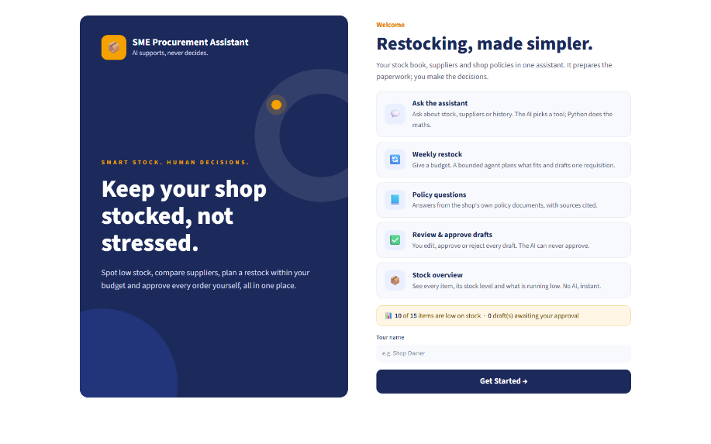
Figure 4 — The web UI home screen. The status line (10 of 15 items low) comes from get_low_stock(), not from the model. * No login. Deliberate (decision-001) and stated as a limitation.

10. Results, Limitations and Reflection

10.1 What works
- The architecture holds: no tool can approve, order or pay, and the refusal is visible in the demo.
- The tools are exactly right: 8 capabilities, deterministic, schema-validated, traced, and the arithmetic is correct (Bic Pens 65, Rulers 57, a two-item draft of UGX 84,406, a UGX 300,000 plan of 4 items and UGX 294,130).
- The agent is bounded and always stops, and the outcome is decided by code.
- The retrieval pipeline is good enough to answer 15 policy questions with citations, and honest enough to admit what it cannot do (R-4).
- The evaluation is real: 119 offline assertions, 31 adversarial scenarios, 26 documented failures, and four defects found and fixed after the feature work (F-23 to F-26).

10.2 What does not work, or does not work well
- Numeric threshold questions over the corpus (R-4) — keyword retrieval cannot reason about ranges. A structured approval_threshold(amount) tool is the fix.
- The 200% cap (F-10) cannot be reached by the reorder formula, so it only guards supplier MOQs and manual edits. It is kept for that reason, but it is not the general safety net it looks like.
- Prompt adherence is weaker on the flash tier than on a large model. The project answered this by moving requirements into code — but it means the system is more code and less prompt than a demo would be.
- No authentication and no CI, and the web UI is partial (see §9.2).
- Shop isolation covers drafts, memory and traces, not the data files. Every shop reads the same three CSVs, and state is split over two SQLite files (§7.2).
The risk register (likelihood, impact, mitigation) is in Appendix L.

10.3 Future work (in priority order)
- A structured approval_threshold(amount) tool and a numeric-aware retriever (closes R-4).
- Finish and host the web UI, merge the two SQLite stores into one, and add a login so the single-trusted-user decision can be revisited with evidence.
- A CI workflow that runs the nine offline suites on every push (and after every merge, the lesson of F-26), and a nightly live suite with a stored key.
- A "explain this number" feature: every figure in a draft links back to the CSV row and the formula that produced it.
- Real PDF quote extraction (the descoped user story 3), with the same tool-only arithmetic discipline.

10.4 Reflection
The project set out to test whether an agentic system could be useful to a small shop without being responsible for the shop's money. The answer we reached is that those two things are not in tension, but only if the boundary is made of code rather than instructions. Every time we were tempted to solve something in the prompt, the fix belonged in a tool; every time we were tempted to let the model decide, the answer belonged in a rule. The failure catalogue is the honest record of how often we got that wrong — a false draft claim (F-13), a budget band above the budget (F-12), an MCP server that could not call its own tools (F-23).
The most useful thing the last weeks produced was not a feature but a habit: for each deliverable, ask which production path it actually uses and whether a test reaches it, and run every suite after every merge. That habit found F-23 to F-26, and every one of them had been hiding behind a passing suite.
The second thing worth saying plainly is that the human in the loop is not a formality that we bolted on at the end. It is the part of the design that makes the rest possible: because the model cannot spend money, the shop can let it draft; because the draft is auditable, the owner can check it; because the approver's decision moves the workflow, the system can be trusted to know where every session stands. AI supports, never decides is not a slogan in this repository — it is the absence of a tool, and the presence of a test.

References
- Anthropic. Building Effective Agents (2024) — patterns for workflows and agents. https://www.anthropic.com/research/building-effective-agents
- Lewis et al. Retrieval-Augmented Generation for Knowledge-Intensive NLP Tasks (NeurIPS 2020).
- Robertson & Zaragoza. The Probabilistic Relevance Framework: BM25 and Beyond (2009) — the ranking function used in src/rag/index.py.
- Google. Function Calling / Tool Use with the Gemini API — the tool-calling contract used in src/tool_agent.py.
- Model Context Protocol — specification. https://modelcontextprotocol.io
- Huyen, T. AI Engineering (2025) — Chapter 5, evaluation (the structure of the Week 7 dataset).
- Osmani, A. The 12-Factor Agents (2025) — context engineering, state, guardrails. 8.OWASP. Top 10 for LLM Applications 2025 — prompt injection and excessive agency (the categories behind the Week 7 scenarios).
- Regulation (EU) 2016/679 (GDPR), Articles 15–18 — the erasure right implemented in src/memory.py.
- BSE4104 capstone brief and the team's Week 1 document User stories and acceptance criteria (2).docx.

Individual contributions
Project tracking records are available as docs/team/task-board.csv. No ClickUp screenshot was included in the supplied source materials.
Member | Main contributions | Evidence
Mwesigwa Arnold Mugahi | Model integration and fallback chain; prompts v1.0–v2.5; the eight tools and registry; bounded and restock agents; RAG pipeline and corpus; state machine, justified memory and MCP server; guardrails; Week 7 evaluation and Week 8 hardening; principal author of this report | Commits on main, tags week2-complete … v1.0.0
Boonabaana Bronia | Week 6 scoped SQLite storage (src/storage.py), trusted shop/user context in the registry, tenant-scoped RAG, tests/test_week6_storage.py; post-release review, the F-26 fix and failure write-up; the Streamlit web UI; this report update and the slide deck | Commit 741a29e, PR #1, PR #3, branch ui-streamlit
Naisanga Patricia | Contribution details are not recorded in the supplied project evidence. | No contribution-specific commit, PR, or report was supplied.
Nakyambadde Mariam | Contribution details are not recorded in the supplied project evidence. | No contribution-specific commit, PR, or report was supplied.
Tulinawe Ismail | Contribution details are not recorded in the supplied project evidence. | No contribution-specific commit, PR, or report was supplied.

Appendices

Appendix A — User stories and acceptance criteria
docs/requirements/user-stories.md (12 stories, 11 implemented, 1 descoped with a reason).
# | Story | Status | Evidence
1 | Inventory viewing | ✅ | get_inventory; M-O01, M-O02, M-01, M-06
2 | Low-stock flagging | ✅ | get_low_stock, estimate_reorder_quantity; O-01, L-01
3 | PDF quote upload | ❌ descoped | quotes read from CSV; future work
4 | Quote comparison | ✅ | compare_supplier_quotes; O-06, L-02
5 | Draft requisition | ✅ | draft_requisition; O-09
6 | Historical query | ✅ | query_purchase_history; M-O03, M-02, M-03
7 | Trend-based reorder estimate | ✅ | estimate_reorder_quantity basis; O-02, L-02
8 | Budget range (±10%) | ✅ | draft_requisition budget_range_ugx; O-09 (F-12)
9 | Manual override | ✅ | approvals.py edit; M-O06, M-O07
10 | Manager approval | ✅ | approvals.py, app.py option 4; O-21
11 | Audit lineage | ✅ | evidence/*traces.jsonl, audit_events table in data/state.sqlite3
12 | 200% safety guardrail | ✅ | safety_cap, requires_override; O-12, O-22, M-O07

Appendix B — Tool schemas
docs/requirements/tool-schemas.json (exported from the code by docs/requirements/tool-catalogue.md §"Tool schemas"), and the per-tool contract — purpose, input, output, data read, permission, failure behaviour — in docs/requirements/tool-catalogue.md.

Appendix C — Prompt versions
prompts/ (current) and prompts/archive/ (every earlier version, unchanged) and prompts/prompt_history.md (the reason for each change).
Version | Change and why | Result
1.1.0 | First working version | 7/10 cases
1.2.0 | Hard rule 4 ("include only the named items"), Example D, formulas in code spans (F-01, F-03) | 10/10, then 9/10 with the checker tightened (F-05)
2.0.0 | Major: maths moved out of the prompt and into tools (F-04) | live agent 6/6
2.1.0 | Tool descriptions tightened | traces 4/4, Week 4 regression 5/6
2.2.0 | Hard rule 3 — no draft claim without a draft (F-13) | Week 4 regression 6/6
2.2.1 | The status line only when a draft exists (F-14) | T4 clean
2.3.0 | The three MVP/RAG tools added to the tool table | MVP live 4/6 (F-16)
2.4.0 | Error rule for UNKNOWN_CATEGORY (F-16) | MVP live 6/6, Week 5 traces 4/4
2.5.0 | User roles removed (decision-001); refusals explained in the shop's terms | regression results recorded in decision-001
policy_qa 1.0.0 | Separate prompt for the RAG path, with citation rules | RAG answers 15/15

Appendix D — Traces
evidence/traces/llm_calls.jsonl, evidence/week4/tool_traces.jsonl, evidence/week5/trace_T1…T4*.md, the audit_events table in data/state.sqlite3, and the state transition table in data/procurement.db.

Appendix E — Failure catalogue
docs/evaluation/failure-catalogue.md (26 failures, 7 case studies) and the per-week evaluations in docs/evaluation/.

Appendix F — AI Engineering Log
docs/weekly-reports/week1…week8-ai-log.md. Summary: Claude Code (Weeks 1–5), Google Antigravity CLI / agy (Weeks 6–7), Kilo (Week 8 hardening and this report), Claude Code again after the release (the F-26 review and fix, the web UI and this update), gemini-3.8-flash as the runtime model, and DeepSeek, ChatGPT and GitHub Copilot for review and completion.

Appendix G — Demo script and presentation outline
Live demo (4 minutes, AI Engineering Lead).
py src\tool_agent.py "Prepare this week's requisition. Stay under 100,000. Prioritise lowest stock." --user "Demo"
py src\approvals.py list
py src\approvals.py show REQ-XXXX
py src\tool_agent.py "Approve draft REQ-XXXX" # the refusal
Narration: the model calls get_low_stock, then estimate_reorder_quantity for each item — the arithmetic is done in Python, because in Week 2 the model got it wrong (F-04) — then compare_supplier_quotes, then the plan within budget, then it drafts. The draft is a draft: py src\approvals.py list shows it waiting, and asking the AI to approve it produces a refusal, because no such tool exists.
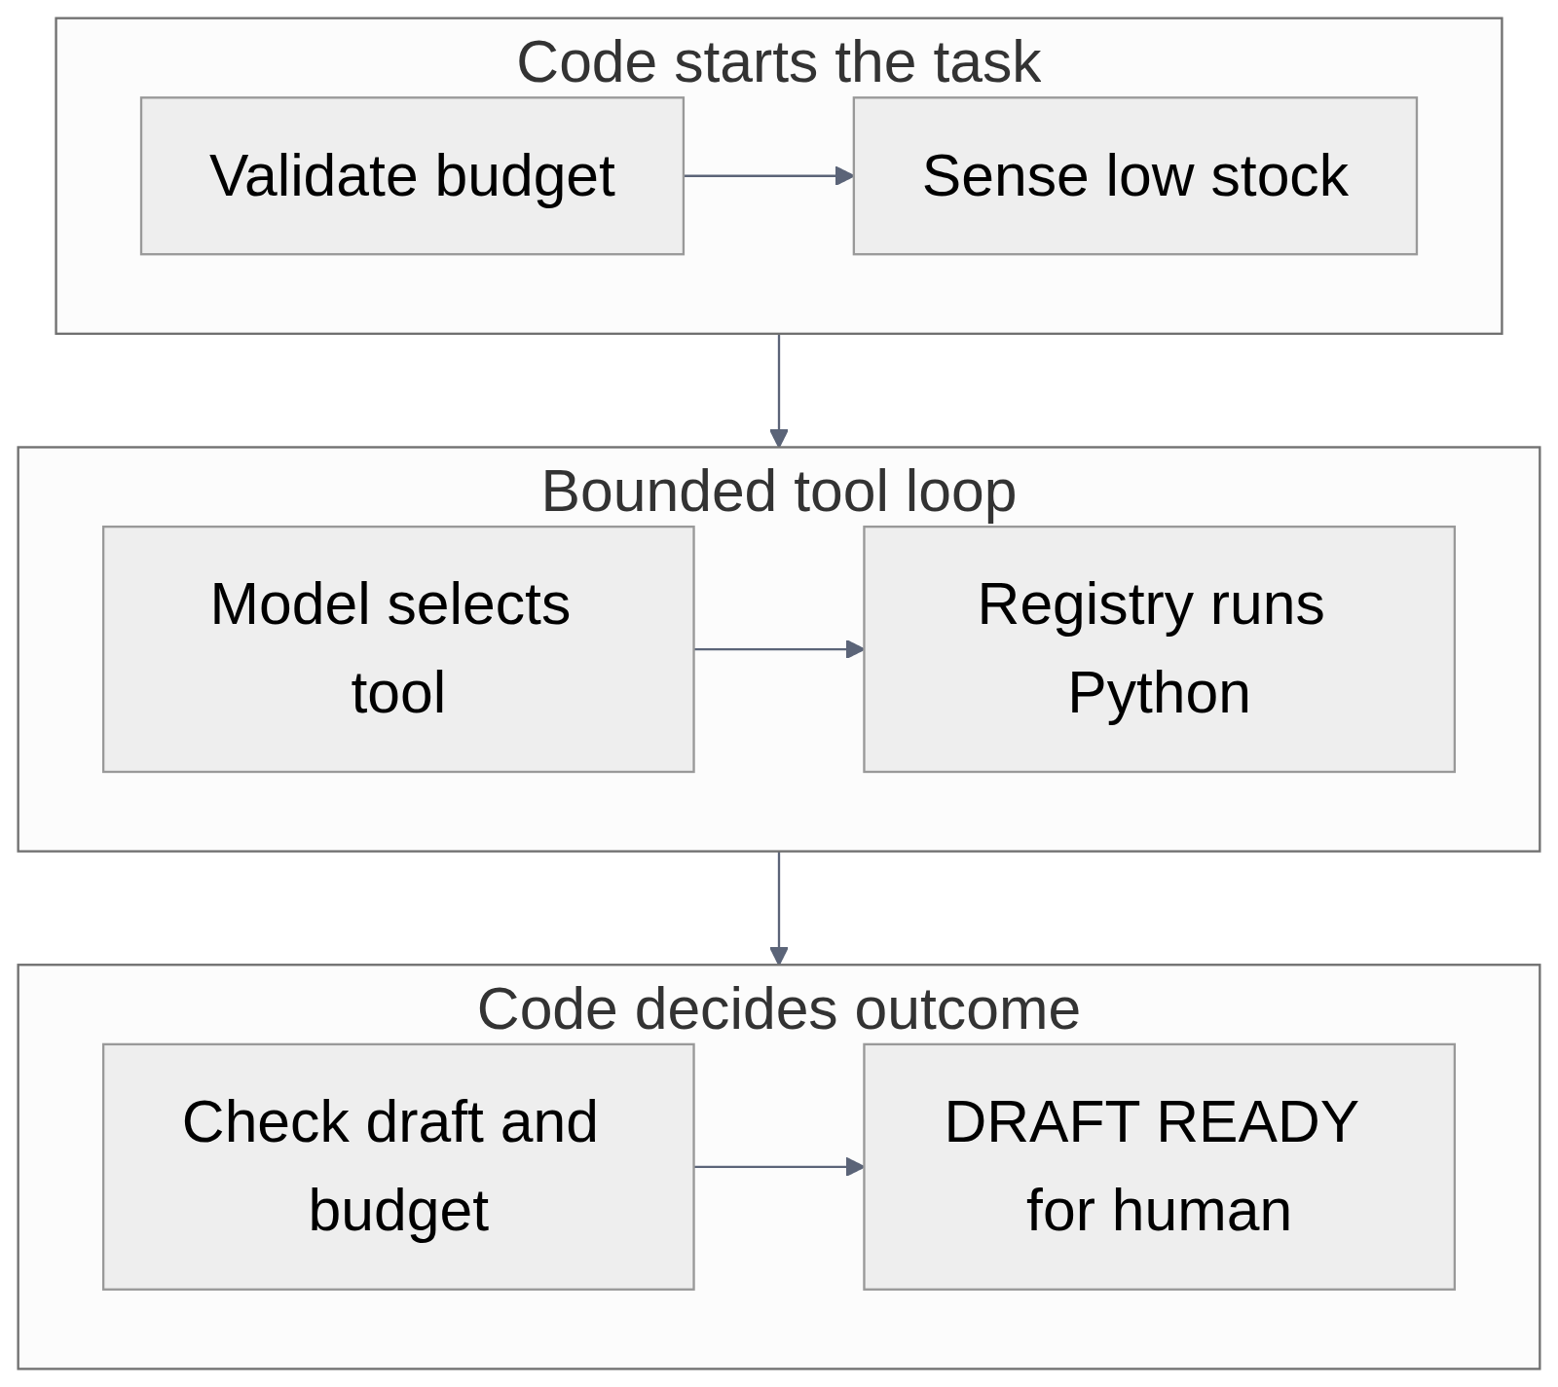
Figure 6 — Restock workflow: sense, plan, draft, observe, and stop. This is a generated workflow diagram, not a terminal screenshot.
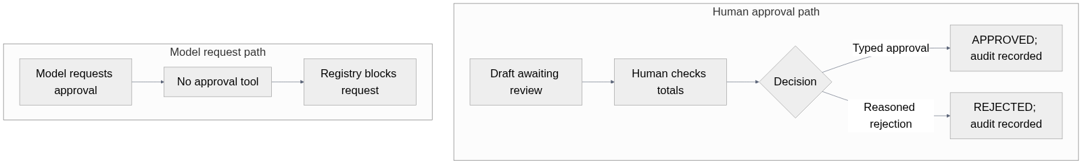
Figure 7 — Human approval boundary. This is a generated workflow diagram, not a screenshot.
Deck. docs/final/presentation.pptx (18 slides with speaker notes; rebuild with py scripts\build_slides.py). It follows the brief's order: problem, architecture, live demo, traces and logs, a real failure (F-26), safety controls. Images still to be added by the team are listed in docs/final/PLACEHOLDERS.md.

Appendix H — Success criteria
The project's own success criteria, and where they ended up:
Criterion | Result
The model never computes a business figure | Achieved — all arithmetic is in src/tools/procurement.py; F-04 is the failure that proved the point
The model cannot approve, order or pay | Achieved — no such tool; the allow-list refuses it (F-07)
Policy answers come from the shop's documents, with citations | Achieved — 15/15 grounded answers, citation checker in rag/policy_qa.py
The agent is bounded and always stops | Achieved — max 5 turns / 6 tool calls / 3 tools per task, repeat guard, code-decided outcome
A human can inspect what the agent did | Achieved — tool traces, agent traces, model-call traces, state-transition audit trail
The system runs on a clean machine | Achieved — pip install -r requirements.txt, one command, no database to provision

Appendix I — Retrieval failures (R-1 … R-5)
ID | Failure | Root cause | Fix | Status
R-1 | "…how many days does Kampala Office Supplies take to deliver…" ranked the Delivery section 5th | the stemmer kept "deliver" and "delivery" apart | strip "y"/"ies" (index v1.1.0) | Fixed — rank 2
R-2 | "Sales rep pushes a today-only discount" put the answer in rank 3, just above the score gate | section chunking separates the question's words from the answer | next-section expansion in policy_qa.retrieve() | Mitigated
R-3 | Disclaimer lines became "Introduction" chunks and were retrieved for unrelated questions | boilerplate indexed as content | skip disclaimer-only introductions (73 → 61 chunks) | Fixed
R-4 | "who approves 800,000" returns the wrong section — keyword search cannot reason that 800,000 lies between two thresholds | keyword search, not semantic | planned: a structured approval_threshold(amount) tool, query rewriting, embeddings | Open
R-5 | A correct answer citing "[S1, S3]" was flagged as uncited | the parser only knew "[S1]" | parse grouped citations | Fixed

Appendix J — Week 7 scenario categories
Category | Scenarios | What it probes
Normal | 5 | stock sensing, quote sorting, MOQ arithmetic, budget planning, session progression
Edge | 6 | zero/negative budget, budget below MOQ, absurd budget, no history, empty prompt
Corrupted data | 5 | unknown item ids, SQL injection in shop_id, non-numeric budgets, empty payloads
Adversarial | 5 | prompt injection, auto-approval commands, disbursement requests, cross-shop spoofing, script payloads
Tool / infrastructure failure | 5 | budget overrun, missing session, corrupted memory, closed database, unauthorised transition
Unauthorised action | 5 | the AI attempting to approve, pay, sign a PO, or bind a supplier

Appendix K — Engineering practice
Configuration and secrets. .env is git-ignored and never committed; .env.example documents the four settings (key, primary model, fallback chain, timeouts). No key appears in any file, log, trace or screenshot. The model chain lives in one place (src/llm_client.py), and every call in the system goes through it, so there is exactly one place where a model name can be wrong — and src/test_models.py --probe exists to check that before it matters (F-06).
Versioning discipline. Prompts are versioned files with history; code modules carry a version and a one-line change note in their header; the failure catalogue, the prompt history and the weekly engineering trails explain why each change was made. The engineering trail for this week is docs/weekly-reports/week8-engineering-trail.md.
Reproducibility.
git clone https://github.com/AJmight/Capstone_project-
cd Capstone_project-
py -m venv venv
.\venv\Scripts\Activate.ps1
pip install -r requirements.txt
copy .env.example .env # add your own GEMINI_API_KEY
py tests\test_week8_release_checks.py
py src\app.py # console
py -m streamlit run src\streamlit_app.py # web UI, http://localhost:8501
The runtime SQLite stores (data/state.sqlite3, data/procurement.db) are created on first run and are git-ignored, so a clean clone behaves exactly like the development machine. The synthetic data is generated with a fixed seed.

Appendix L — Risk register
Risk | Likelihood | Impact | Mitigation now
The model invents a figure in free text | Low | High | The prompt forbids it and every figure the user sees comes from a tool; a future check could scan the final text for unattributed numbers
A draft is approved on a wrong quantity | Medium | High | The approver sees the working (basis), the estimate band, and the 200% cap flag; the exact total is checked against the allocated budget
A supplier pressure prompt in free text influences the plan | Low | Medium | The plan is computed in Python from prices, not from the model's reading of a quote
The memory store grows or leaks across shops | Low | High | shop_id partitioning in SQL, the tenant bound to the MCP server, erasure functions, and an isolation test
Quota exhaustion during a demo | Medium | Low | the demo script has a recorded fallback; the live demo needs one question, not twenty

Appendix M — How a tool call happens (sequence)
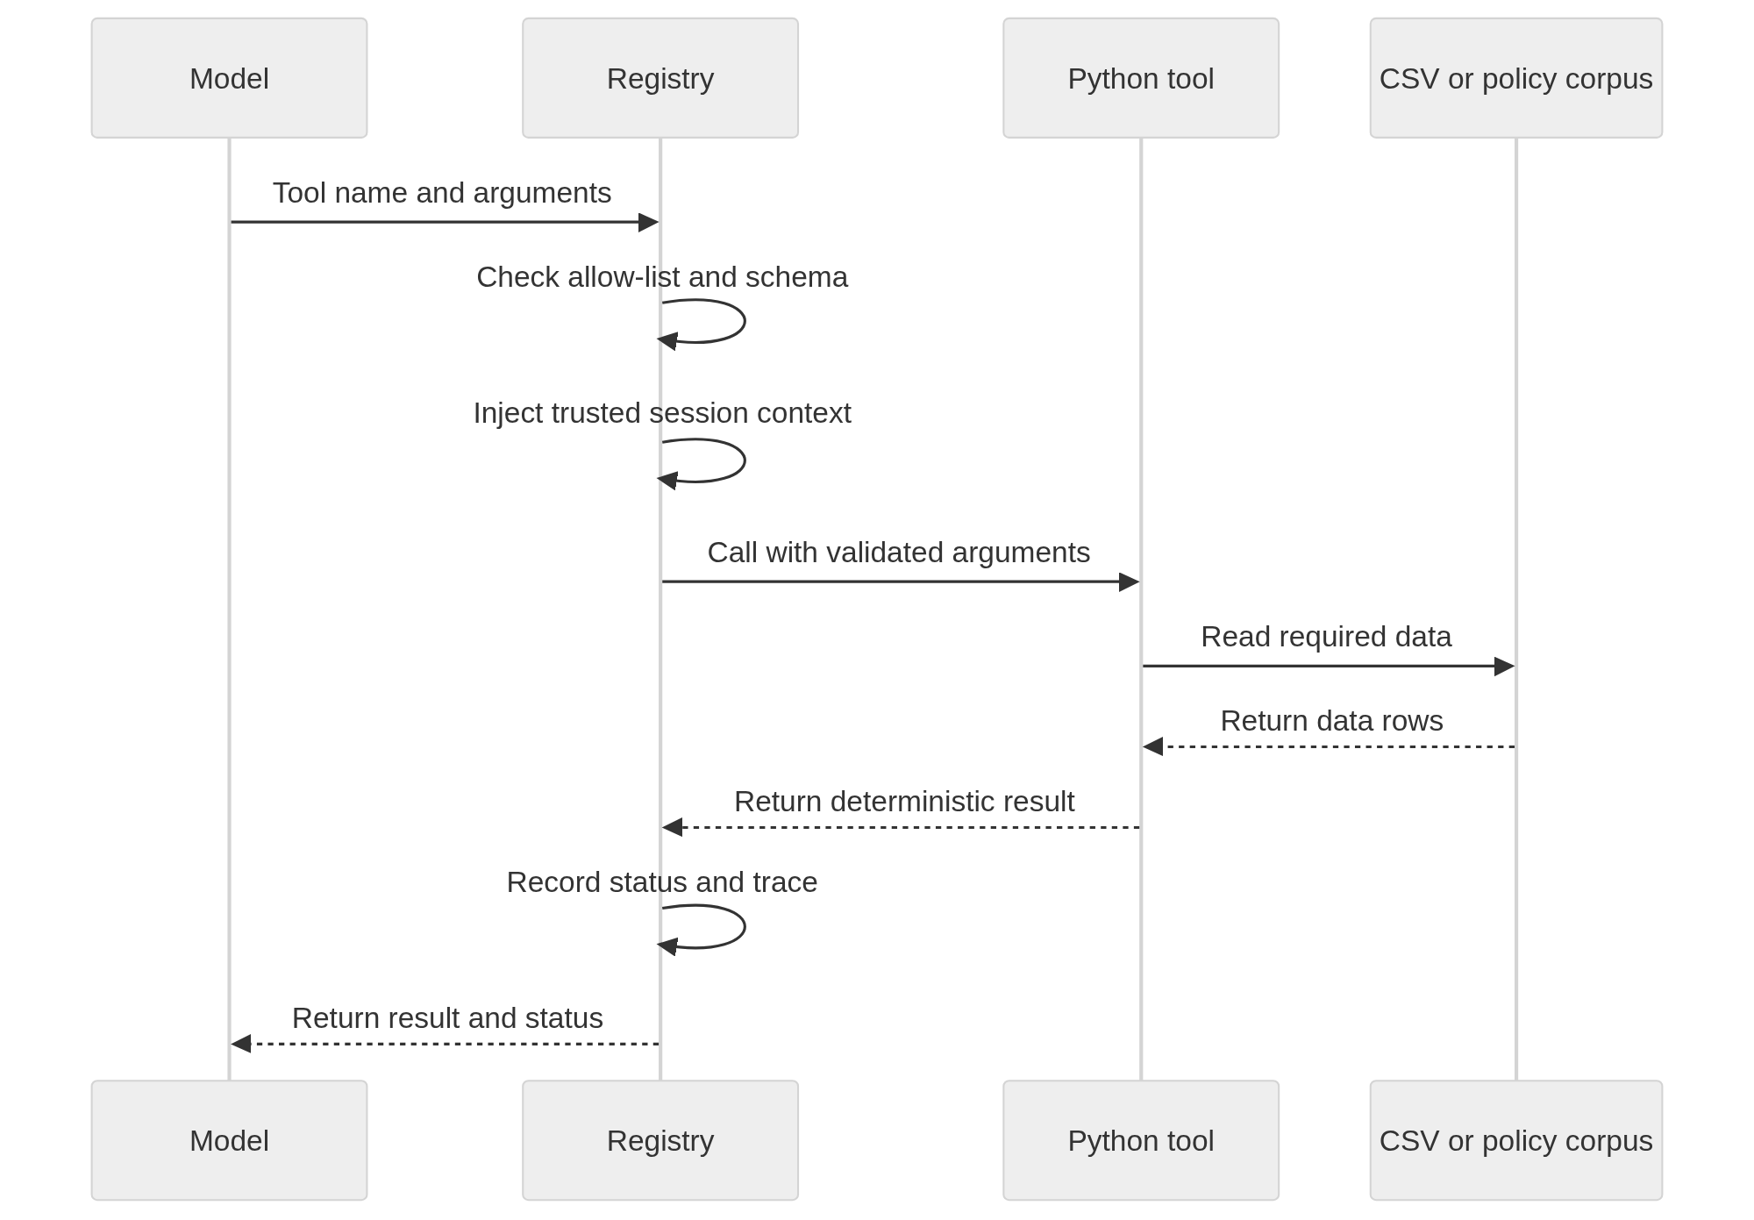
Figure 5 — A tool call passing through the registry gate.

Appendix N — Project management records
The available project-management record is the task-board CSV at docs/team/task-board.csv. No ClickUp screenshot was included in the supplied source materials.

