The Planetary Systems Research Hub for Biosphere & Anthroposphere Survival.

"Nature does not treat carbon as toxic waste to be buried underground; Nature uses carbon to build the world."
John Harrison, Founder

The Mission
Humanity is facing a compound systemic crisis: a rapidly degrading atmosphere, hydrosphere and biosphere and a decaying Anthrosphere, where real wealth per capita is eroded by institutional bloat, Parkinson’s Laws, and a diminishing Genuine Progress Indicator (GPI).
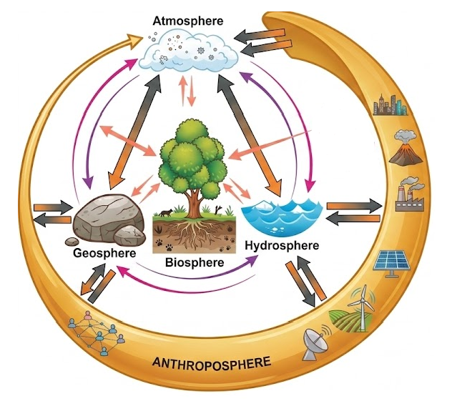
This reality is the subject matter of Gaiaengineering.org which John Harrison has repurposed as a knowledge hub focusing on the degrading biosphere and issues in the anthroposphere.
As Natural Wealth depletes, human institutions expand administrative overhead to manage the resulting systemic friction. This expansion of Parkinson’s Laws artificially inflates nominal income (GNI/GDP) while causing genuine progress (GPI) and Real Wealth per capita to collapse together.
John Harrison who was the author of the TecEco.org web and since 2020 pioneered the foundational science relating to the use of reactive MgO (rMgO) in cements, concretes and other building materials. He also demonstrated that bio mimetic carbon capture was the only viable way to sequester gigatons of CO₂. His Eco-cements emulated nature by using CO2 to build our infrastructure. While modern startups spend billions attempting to reinvent these proven principles, TecEco.org continues as the originator and repository of knowledge on the science. Papers from other authors are welcome and they will not necessarily be rejected because we disagree with them.
John has extended the boundaries of the original work he did as on the TecEco.org web site to many other issues and repurposed Gaiaengineering.org, as a knowledge hub focusing on the degrading biosphere and productivity issues in the anthrosphere. _Problems and concerns addressed on Gaiaengineering.org including the loss of polar ice, methane emissions, rising ocean acidity and many other alarming signals of imminent potential biosphere collapse that most people are unaware of.

