SmartCare v0.4 - Domain Implementation Workbook
Week 7 student resource

UML-to-Code Trace
UML element | Python element | Implemented? | Notes
Patient
- name: str | __name: str | Yes
+ get_name(): str | get_name() | Yes
+ matches_name(term): bool | matches_name(search_term) | Yes | Case-insensitive partial match, FR-11 amended
+ is_valid(): bool | none | Removed | Validation moved into the constructor so an invalid Patient cannot exist
not in v0.3 | __patient_id, get_patient_id() | Added | Adopted from the Week 7 Assignment 2 discussion
Practitioner
- name: str | __name: str | Yes
+ get_name(): str | get_name() | Yes
+ is_valid(): bool | none | Removed | As for Patient
not in v0.3 | __practitioner_id, get_practitioner_id() | Added | Adopted from the discussion
not in v0.3 | __specialty, get_specialty() | Added | Adopted from the discussion. Optional, since v0.2 records practitioner fields as an open question
Appointment
- patient: Patient | __patient: Patient | Yes
- practitioner: Practitioner | __practitioner: Practitioner | Yes
- date_time: str | __date_time: datetime | Changed | Type changed from str per the type hints slide
- status: str | __status: AppointmentStatus | Changed | Enum replaces module constants
+ get_patient() / get_practitioner() / get_date_time() / get_status() | same | Yes | Return types updated to match
+ cancel(): None | cancel() | Yes | Now raises InvalidStatusTransitionError on an illegal repeat
+ mark_attended(): None | none | Removed | COMPLETED collapses attended and did-not-attend
+ mark_did_not_attend(): None | none | Removed | As above. Recorded as a new open question
+ is_booked(): bool | is_scheduled() | Renamed | Follows the new status vocabulary
+ is_cancelled(): bool | is_cancelled() | Yes
+ is_for(practitioner): bool | is_for(practitioner) | Yes
+ occurs_at(date_time): bool | occurs_at(date_time) | Yes
+ occurs_between(start, end): bool | occurs_between(start, end) | Yes
not in v0.3 | __appointment_id, get_appointment_id() | Added | Adopted from the discussion
not in v0.3 | mark_completed() | Added | COMPLETED was unreachable without it
not in v0.3 | AppointmentStatus enum | Added | Replaces the four module constants
not in v0.3 | InvalidStatusTransitionError | Added | Domain exception named in the discussion
Status note: four module constants | none | Removed | Replaced by the enum, three members
Traced against the approved SmartCare v0.3 model as recorded at step A. Differences in both directions are listed here, the updated model is in section 5. AppointmentBook and PatientRegister are unchanged from v0.3 and outside the scope of this stage.

Domain Invariants

Class | Invariant / rule | How protected
Patient | A Patient always has a non-empty id and name | Constructor raises ValueError. No setters, so neither can be changed afterwards
Patient | Stored values never carry leading or trailing whitespace | Both inputs stripped before validation and before storage, so a whitespace-only name is rejected rather than stored
Practitioner | A Practitioner always has a non-empty id and name | Constructor raises ValueError
Practitioner | Specialty may be empty | Deliberately not an invariant. Defaults to ""; v0.2 records practitioner fields as an open question, so requiring it would invent a rule the client never stated
Appointment | An Appointment always has an id, a patient, a practitioner and a date/time | Constructor raises ValueError on any missing value
Appointment | Patient, practitioner and date/time never change after construction (NFR-06) | Structural: no setters exist, so there is no way to change them
Appointment | A cancelled appointment is retained, never removed (FR-08) | cancel() changes status only. No delete operation exists anywhere in the class
Appointment | Status is always one of exactly three values | Structural: AppointmentStatus is an enum, so an arbitrary string cannot be assigned. In v0.3 the permitted values were module constants and nothing enforced them
Appointment | Status changes only along legal transitions | Only SCHEDULED can be cancelled or completed. cancel() and mark_completed() each check the current status and raise InvalidStatusTransitionError otherwise

Composition / Inheritance Decisions
Relationship | Decision | Rationale
Appointment to Patient | Association | An appointment is not a kind of patient, it has one. Not composition: composition means the appointment is destroyed with the patient, and FR-08 retains cancelled and past appointments
Appointment to Practitioner | Association | Same shape. One practitioner to zero or many appointments, each appointment to exactly one practitioner
AppointmentBook to Appointment | Composition | The book creates its appointment records and they have no life outside it, which FR-08 reinforces by keeping cancelled ones there
PatientRegister to Patient | Composition | The register creates and owns its patient records (FR-01)
Patient / Practitioner to a shared superclass | Rejected | Both carry a name and the same validation rule, but that is code reuse, not a genuine is-a relationship. Rejected in v0.3 and unchanged
Appointment to AppointmentStatus | Dependency | The enum is a type the appointment uses, not a domain entity it owns. Modelling status as a class would be a design decision rather than a domain one

AI Pair-Programming Record

AI contribution | Conforms? | Decision | Reason | Verification
Appointment class structure: four private attributes, no setters, status starting at SCHEDULED | Yes | Accept | Matches the approved design and NFR-06 | Step F check 1: object constructs, status SCHEDULED
cancel() guarding against an illegal repeat | Yes | Accept | Implements the business rule as specified | Step F check 4: raises on second cancel
No database, UI, notification, service or repository class; no inheritance | Yes | Accept | Constraints held. These are the failures the lecture predicts | Step E review: none present
patient: Any, practitioner: Any | No | Modify | Erases the relationship the UML specifies. Type hints are design communication, Any is valid and design-silent at once | Replaced with Patient and Practitioner at step G
Constructor with no validation | No | Modify | Step F showed an Appointment created with an empty id and no patient in the same run where Patient rejected an empty id | Step G added validation, re-run raises ValueError
COMPLETED declared but unreachable | No | Modify | Only cancel() changed status, so the enum declared a state no operation could produce | Step G added mark_completed(), re-run reaches COMPLETED
Generic AppointmentDomainError | Partly | Modify | Says something failed, not which rule broke. The discussion names InvalidStatusTransitionError | Renamed at step G
Enum values in title case, justified as readability for logs and UI | Partly | Accept with note | Harmless, but the rationale reaches into UI concerns the prompt excluded | Kept, recorded as an implementation choice made outside the brief
Offer to add unit tests | n/a | Reject | Outside the step's scope. Step F asks for manual behaviour checks

5. Updated UML
Insert updated UML only if implementation revealed a justified design change. Explain every change.

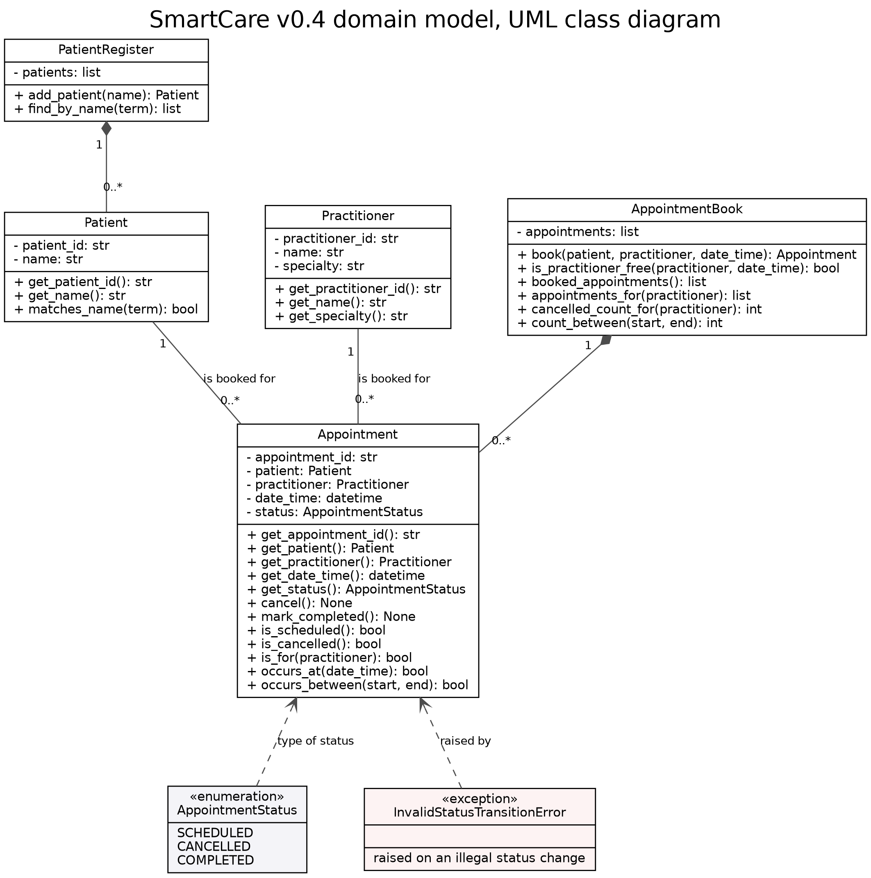

As result of Week 7 Assignment 2 discussion
- patient_id, practitioner_id, appointment_id added. The SmartCare Domain Classes slide specifies an identifier on each. v0.3 identified a patient by name only, which FR-11 made fragile since two patients can share a name.
- specialty added to Practitioner. I rejected this in v0.3 because nothing confirmed it, and the brief now asks for it. I've made it optional rather than required, because v0.2 still lists practitioner fields as an open question and I didn't want to invent a rule saying every practitioner must have one.
- date_time changed from str to datetime. Used in the type hint examples so implemented here.
- AppointmentStatus enum replaces four module constants. My constants were really just a note saying which values were allowed, and nothing stopped anyone using a different string. The enum means an invalid status can't be set at all.
- Status vocabulary changed to SCHEDULED, CANCELLED, COMPLETED. My four were an assumption, since v0.2 records the status set as a question the client never answered, the new content actually specified. The issue now is that FR-06 separates a patient who attended from one who didn't, and COMPLETED merges both, so I can't represent a no show anymore. This would be a new open question.
- InvalidStatusTransitionError added.
- Contact details not added, although the slide show lists them. No fields are specified and v0.2 records patient fields beyond the name as provisional, so inventing them would not be supported by anything.
Driven by this exercise
- is_valid() removed from Patient and Practitioner. Working through encapsulation showed it protected nothing. You could still make a patient with an empty name, and the rule only held if the caller remembered to check. Moving it into the constructor means an invalid object can't be created at all..
- mark_attended() and mark_did_not_attend() removed, mark_completed() added. Follows from change 5. COMPLETED was unreachable in the generated code so needed this.
- is_booked() renamed is_scheduled(). To follow the new status names.
- Constructor validation added to Appointment. Step F showed it accepting an empty id and no patient in the same run where my Patient rejected an empty id, so my own classes weren't agreeing with each other.
Things that should be changed / outstanding
- AppointmentBook.book() still documents FR-05 name checking, but FR-05 is now enforced in the constructors. But AppointmentBook is outside this stage so just left it.
- No is_completed(). Noticed that the three statuses aren’t treated the same as 2 have a query and 1 doesn’t. Not really asked for anywhere but is an inconsistency.
I have used the following Generative Artificial Intelligence (GenAI) tools/services in the preparation of this assessment:
- GenAI service name and version: Copilot
- Link to the GenAI service: https://copilot.microsoft.com/
- Ways this GenAI service was used: Used for review and to help create the tables and update uml based on my changes throughout the process/from new material.
I confirm that I have not used GenAI in the preparation of this assessment for any purpose other than what I have acknowledged above and I have cited and referenced any GenAI content in my assessment submission, applying the relevant referencing style. I understand that providing false or misleading information in this Gen AI Acknowledgement Statement my constitute a breach of the University of Canberra (Student Conduct) Rules 2023.

