SmartCare v0.1 - Initial Engineering Brief and AI Activity Card
A2 Case Study Stage 1 student resource

SmartCare scenario
SmartCare Community Clinic currently uses spreadsheets and paper records to manage patients and appointments. The client says: 'We need software to help manage patients, practitioners and appointments.' This is not yet a complete specification.

Initial Engineering Brief

1. Problem summary
Write approximately 100 words.
Smartcare Community Clinic manages patients and appointments using a mix of spreadsheets and paper records. Because the same information is kept in several places and updated by hand, the clinic cannot rely on it. Appointments get duplicated, patient records are slow to find and there is no single agreed view of whether an appointment still stands. Staff cannot easily see which practitioner is free, cancellations depend on someone updating every cop and there is no dependable history to report from. The client has asked for a simple system so the first version should stay small/simple enough for a small clinic to actually adopt.

2. Initial stakeholders
Stakeholder | Possible need
Healthcare Practitioners | An accurate and up to date view of their schedule and reliable access to patient history
Patients | An easy and reliable way to book and view and cancel appointments without duplicate or conflicting bookings
Receptionists / admin | A single reliable system that can be used for managing bookings and locating patient records quickly
Management | A simple software system that can support patient, practitioner and appointment management. Must also produce basic operational reports

3. Initial features
Feature | Confirmed or provisional? | Why?
Patient record management | Confirmed | Requested by the client: “manage patients”
Practitioner management | Confirmed | Requested by the client: “manage practioners”
Appoitment booking and cancellations | Confirmed | Requested by the client and directly addresses the duplicate booking and manual cancellation issues
Operational reporting | Provisional | The clinic mentioned difficulty producing reports but the exact reports required at not yet specified

4. Questions for the client
1. __How many practitioners will use the system and does each need individual login access?____________________________________________________________
2. Should the system support recurring appointments or will it be only single bookings? ______________________________________________________________
3. _What level of detail is required in a patient record for a first version? _____________________________________________________________
4. ___Who is authorised to cancel or reschedule appointments? ___________________________________________________________
5. __What specific reports will be needed by clinic management? ____________________________________________________________

5. What we do not yet know
1. __Whether patients will interact with the system directly or weather it will be admin / staff only in the first ver? ____________________________________________________________
2. _What data privacy and security requirements apply to stoing sensitive data (patient health information)_____________________________________________________________
3. _Whether the system needs to integrate with any existing tools (like Calanders) in a later stage _____________________________________________________________

AI Activity Card - Ask, Check, Explain

Before AI
What do I think the code does? What problems can I already identify?
I can tell that the code stores appointments in a list of dictionaries and validates the patient name before adding one. I expect the main gaps to be no way for a receptionist to actually type in a real appointment (everything is hard-coded_, no check preventing same GP being double booked and no validation on the GP name or appointment time even though the patient name is checked.

AI request
Act as a tutor. Explain this code and identify potential problems. Do not provide a complete replacement. Ask me questions that help me reason about the solution.
(sent with the stage 1 book_appointment / display_appointments prototype from the Lab activity)

Evaluate (copilot gave 3 suggestions when given the above prompt)
Suggestion | Useful | Unclear | Incorrect | Out of scope
Add basic input handling (let receptionist type real values) | Yes |  |  | Yes
Add simple validation rules (empty practioner name, time format, duplicate check) | Yes
Add a search/filer function (by practioner or by day) |  |  |  | Yes

Decide
For each significant suggestion: Accept / Modify / Reject / Keep unverified.
- Add basic input handling, keep unverified / deferred. Useful, but out of scope for this stage, part B uses fixed test data rather than live entry so this is a good candidate for a later stage rather than now.
- Add simple validation rules, modify. Of the three validation idea in the suggestion, only the duplicate booking check was implemented and verified as it is most relevant to a specific client problem. (more than this goes beyond the one controlled improvement)
- Add a search / filter function, keep unverified. Reasonable however not tied to any problems stated in the case study.

Verify
- Run the code – done. Both the task1 and enhanced versions run without errors:

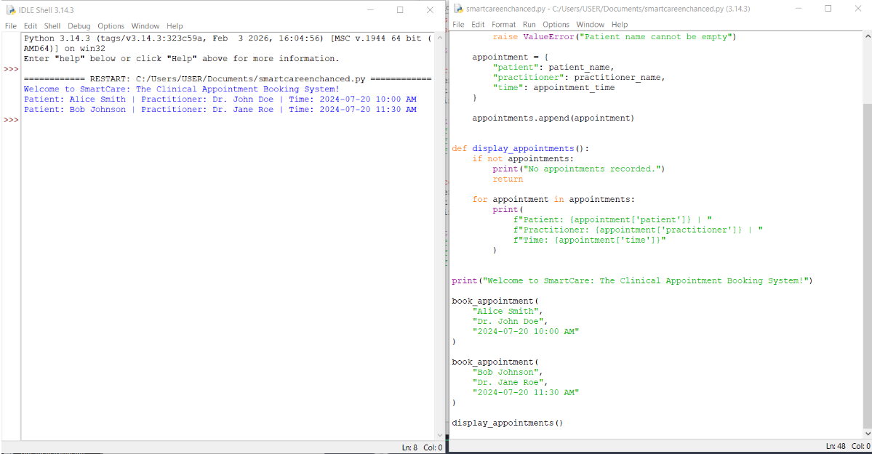
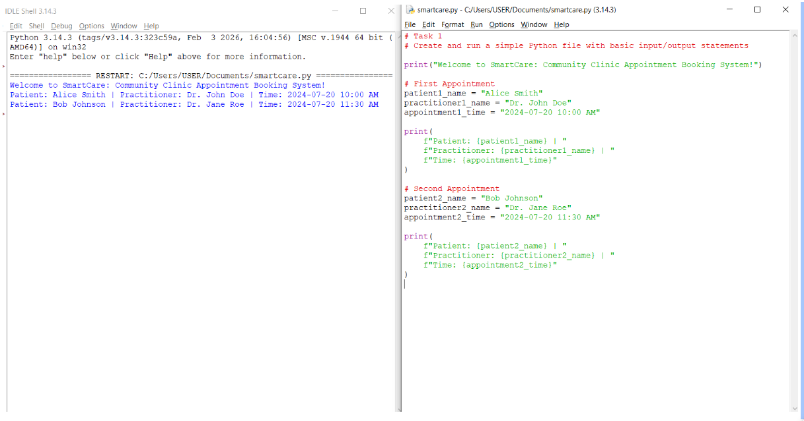

- Test normal input – done. Book_appointment(“Cara Lee”, “Dr. Amir Khan”, “2024-07-20 01:00 PM”) is stored and shows up in display_appointments(). Still works after the duplicate check was added:

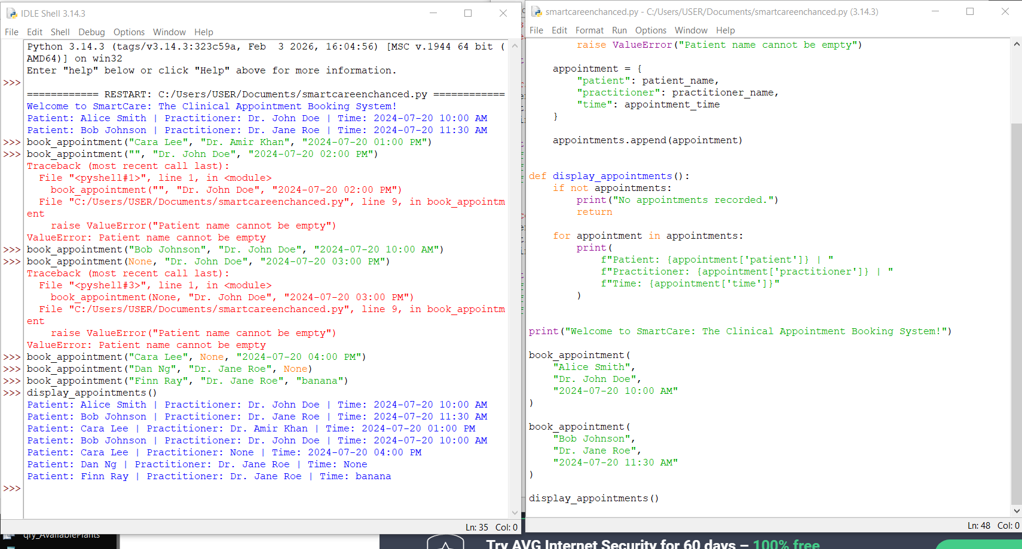

- Test unusual input – done. Blank Patient name raises ValueError. Duplicate practitioner + time was accepted before my change and now raises ValueError. Still accepted: practitioner=None, time=None, blank practitioner, and time=”banana”:
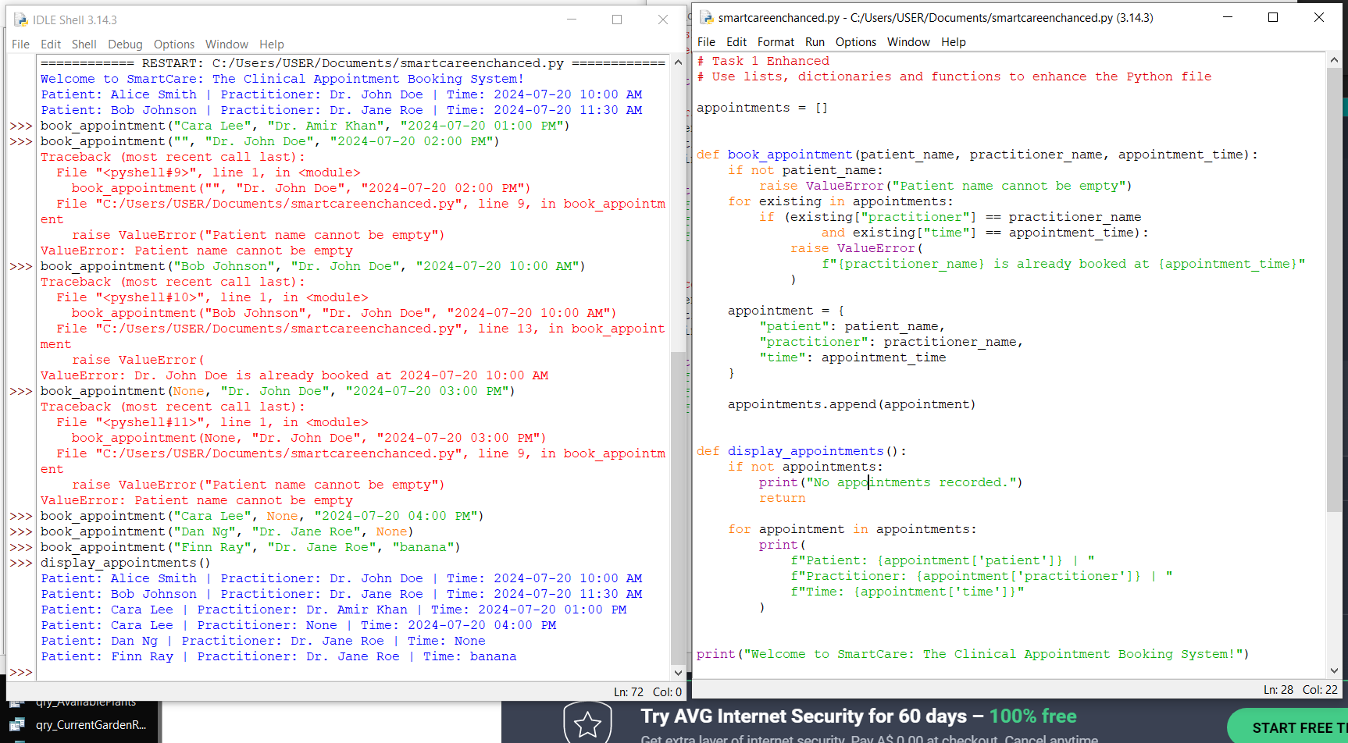
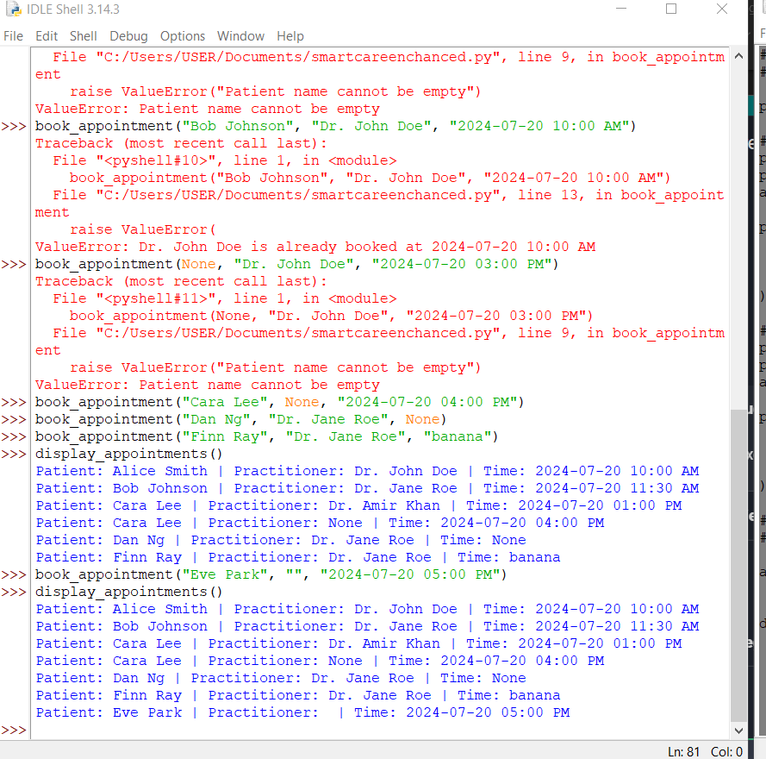
- Compare with requirements – done: Checked each copilot suggestion against the case study problem list. Only duplicate check matched a stated client problem, which is why it was the one I implemented
- Ask tutor/peer
- Check documentation – done.

Explain
Can I explain the final code without reading the AI response? What do I still need to understand?
Yes I can explain it. Book_appoitment first checks the patient name is not empty, then loops through the existing appointments list and compares each stored practioner and time against the ones being booked. If both match it raises an error, the the duplicate never gets into the list. Otherwise it builds a dictionary with the three keys and appends it. Display_appoitments handles the empty case first, then loops and prints one line per appointment
I still need to understand how to properly validate a date or time string, copilot named this as a problem but didn’t say how to do it. As well as whether raising an exception is the right response to a duplicate booking or whether a real system should return a message and let the receptionist pick another slot. Finally, how the appointments list would survive the program closing.

