

TASK
Exploratory Data Analysis on the Movies Data Set



Introduction
The movies dataset is a sample dataset provided for us to do EDA and relevant visualizations as a part of Capstone Project III. This dataset contains the information about approximately 4800 movies, including the title, genres, language, release date, budget, revenue, vote counts, popularity, etc. The dataset can be used to answer the variety of questions such as, what is the total yearly budget of the movies, how many movies are released over the years and how much revenue they have generated, etc. As a part of this Capstone project, I’ve done the EDA on this dataset and created few visualizations to gains insights on the dataset. I will be explaining furthermore about data cleaning process, extracted insights and visualization ahead in this report.

DATA CLEANING
- After having a good understanding of the dataset I’m dealing with, I started with the procedure to clean my dataset. The very first thing I’ve done is that I’ve dropped few of the columns that seems irrelevant to me for the type of analysis we’re going to do. I dropped few columns namely keyword, homepage, status, tagline, original language, overview, etc. which will not be used in the analysis.

- I also removed the duplicate rows keeping only the first one among the duplicates. Some movies in the dataset have zero budget or zero revenue which implies that their values have not been recorded or some information is missing, for that reason, I have also discarded the entries from budget and revenue columns which has the zero value.

- To deal with the release date more effectively, I have converted the release date column into the datetime format. And I created the release year column based on the released date.

- I’ve changed the budget and revenue columns format to integer data type.

- I defined a function which takes two arguments: column and key. It extracts the value of specified key from JSON object in the column, and it creates new string of the extracted values separated by comma and gives us a complete list.

MISSING DATA
The dataset does not seem to have much missing data, at least within the columns that we are using. So, I did not have to deal with the missing data in this dataset.

DATA STORIES AND VISUALISATIONS
Through the exploration of the dataset, I have identified many patterns and extracted few insights as well. The first thing I did with this dataset was cleaning it so that I can have a clearer view and neat visualizations.

Firstly I have identified and listed the top five most expensive movies, top five most profitable movies and the top five most popular movies. And later in this task, I have explored through few visualizations to find pattern and relationships in between different variables to extract the useful insights as well.

Top five most expensive movies:
- Pirates of the Caribbean: On Stranger Tides
- Pirates of the Caribbean: At World’s End
- Avengers: Age of Ultron
- Superman Returns
- John Carter
As per our observation, Pirates of the Caribbean: On Stranger Tides is the most expensive movie in our dataset. The total budget of this movie was 380 million.

Top five most profitable movies:
- Avatar
- Titanic
- Jurassic World
- Furious 7
- The Avengers
Avatar is the most profitable movie with total profit of approximate 2.55 billion.

Top five most popular movies:
- Minions
- Interstellar
- Deadpool
- Guardians of the Galaxy
- Mad Max: Fury Road
The most popular movie is Minions with the total popularity score of 875.58.

Most Successful genres:
To have a clear view of most successful genres over the years, I have created a bar plot which I have presented below.

Figure: A
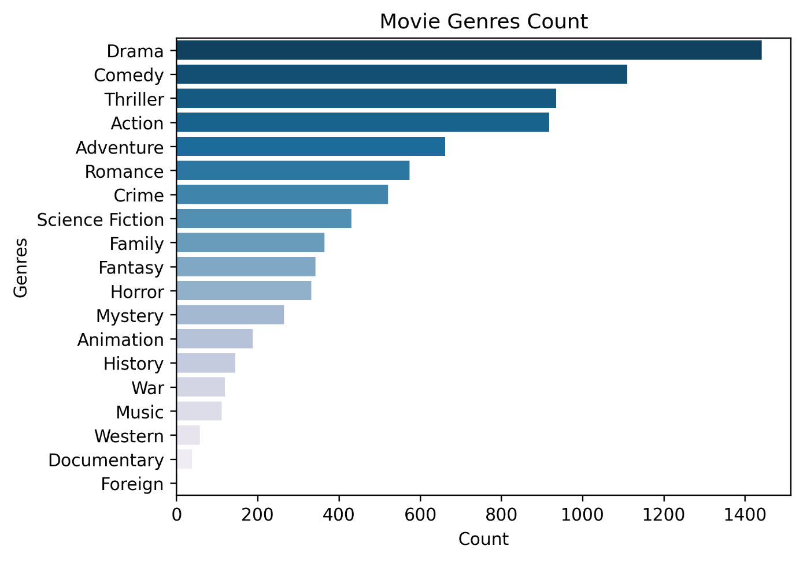
The above bar plot shows the frequency of movies in each genre. It comes with no surprise that Drama is the most successful genre followed by Comedy, Thriller, Action and many more. As per the graph above, more than 1400 movies are of Drama genres. There are more than thousand Comedy genre movies, and around 900 Thriller and Action genre movies releases. We can observe that the Thriller and the Action genres have almost the same number of movie releases. Documentary genre has the lowest movie releases.

Correlation between Revenue and Profit:
In this section of this report, I will be talking about correlation between revenue and profit of the movies. Below is the graphical representation of the same.

Figure: B
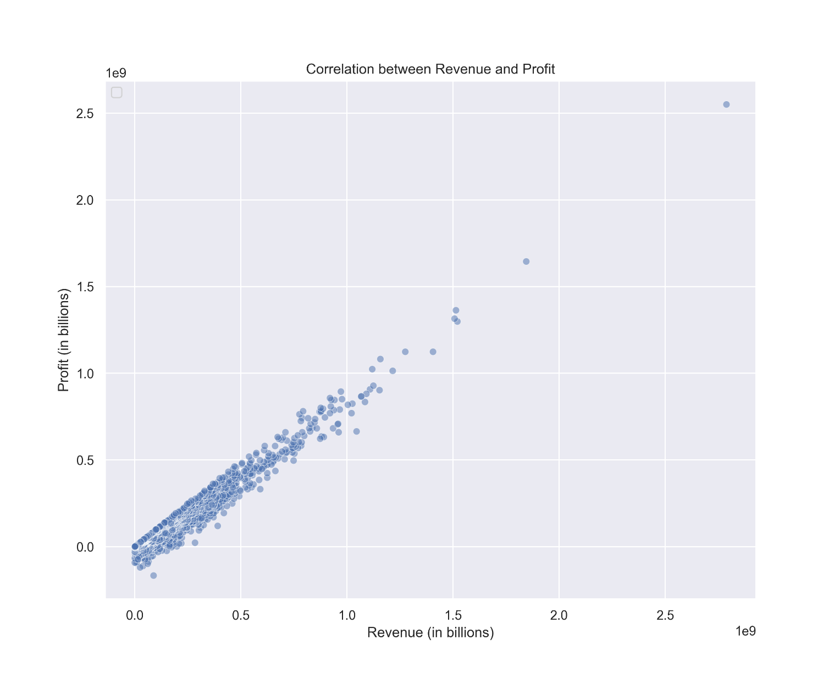

The above scatterplot shows the relationship between revenue and profit of the movies. The visualization shows that there's a positive correlation in between revenue and profit of the movies made, meaning if a movie has a higher revenue, the profit also tends to be higher.

Correlation between popularity and vote count:
I have also attempted to explore and find pattern of correlation of the movie’s popularity and vote count. The graphical presentation below will help us understand it better.

Figure: C
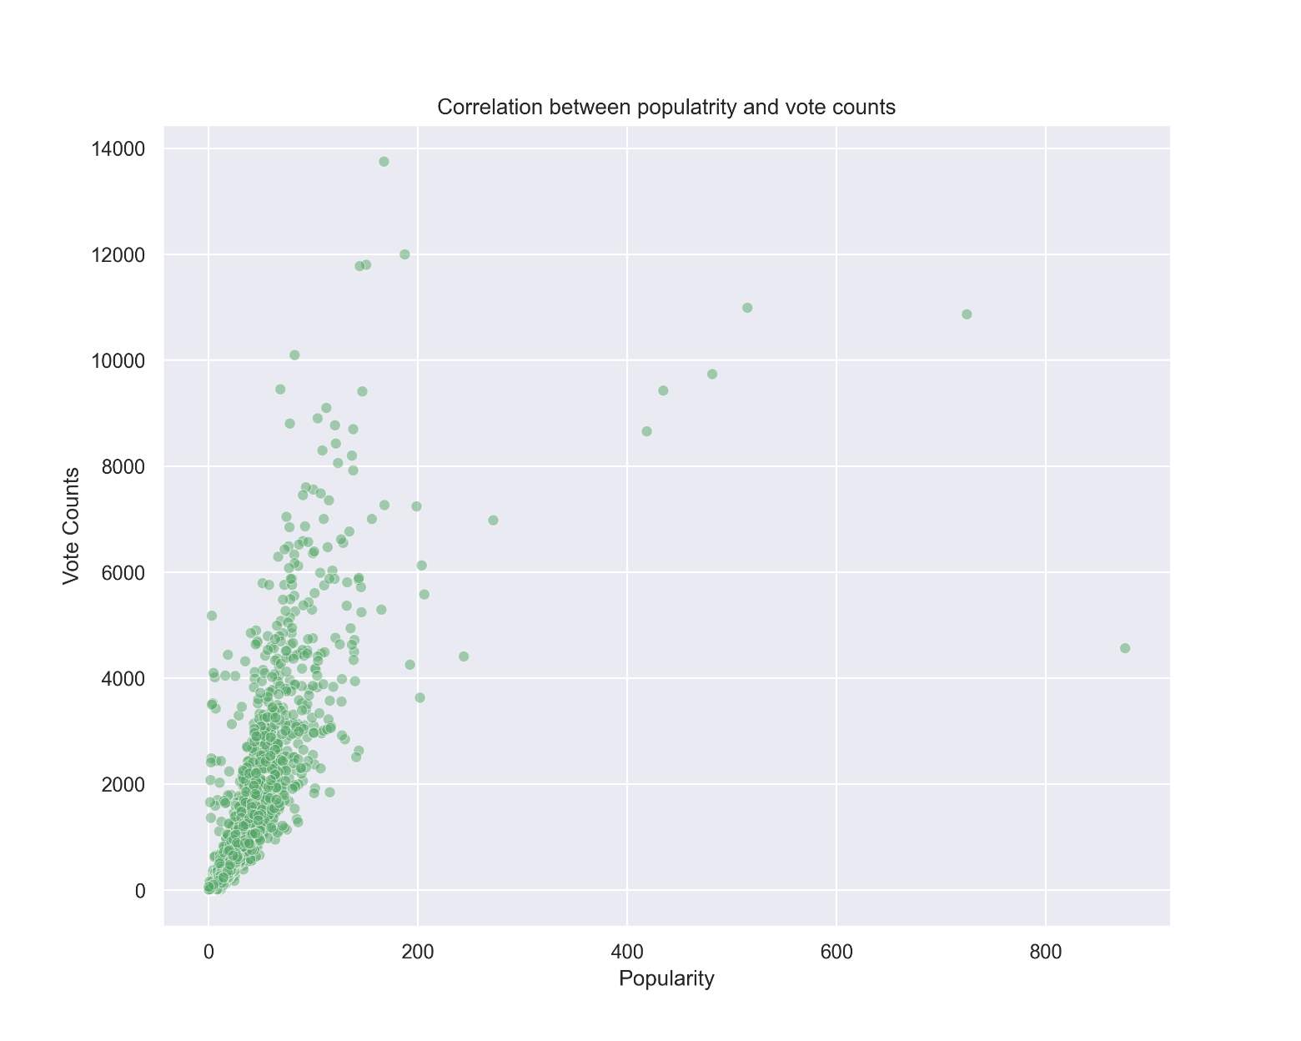
The above visualization looks very interesting. There are only a few movies which has the popularity score of more than 200. Majority of the movies have popularity score around below 100. Most of the movies in our dataset has vote counts in between 0 to 4,000 and very few movies have votes above 8,000. We can observe that in many instances, even if the movie has many votes, the movie seems to be less popular. But generally, if the movie is more popular, they have more vote counts. There may be several reasons behind this such as, the target audience, market size, some movie may have niche market but strong fan base, promotions etc.
Yearly movie releases and revenue:
This section of the report gives light on yearly movies releases over the years, and yearly revenue generated. Through this visualization, we will understand how the overall movie industry did over the years, which year saw the movies with most revenue, trends of movie releases and revenue generation, etc. Let’s investigate the visualization below.

Figure: D

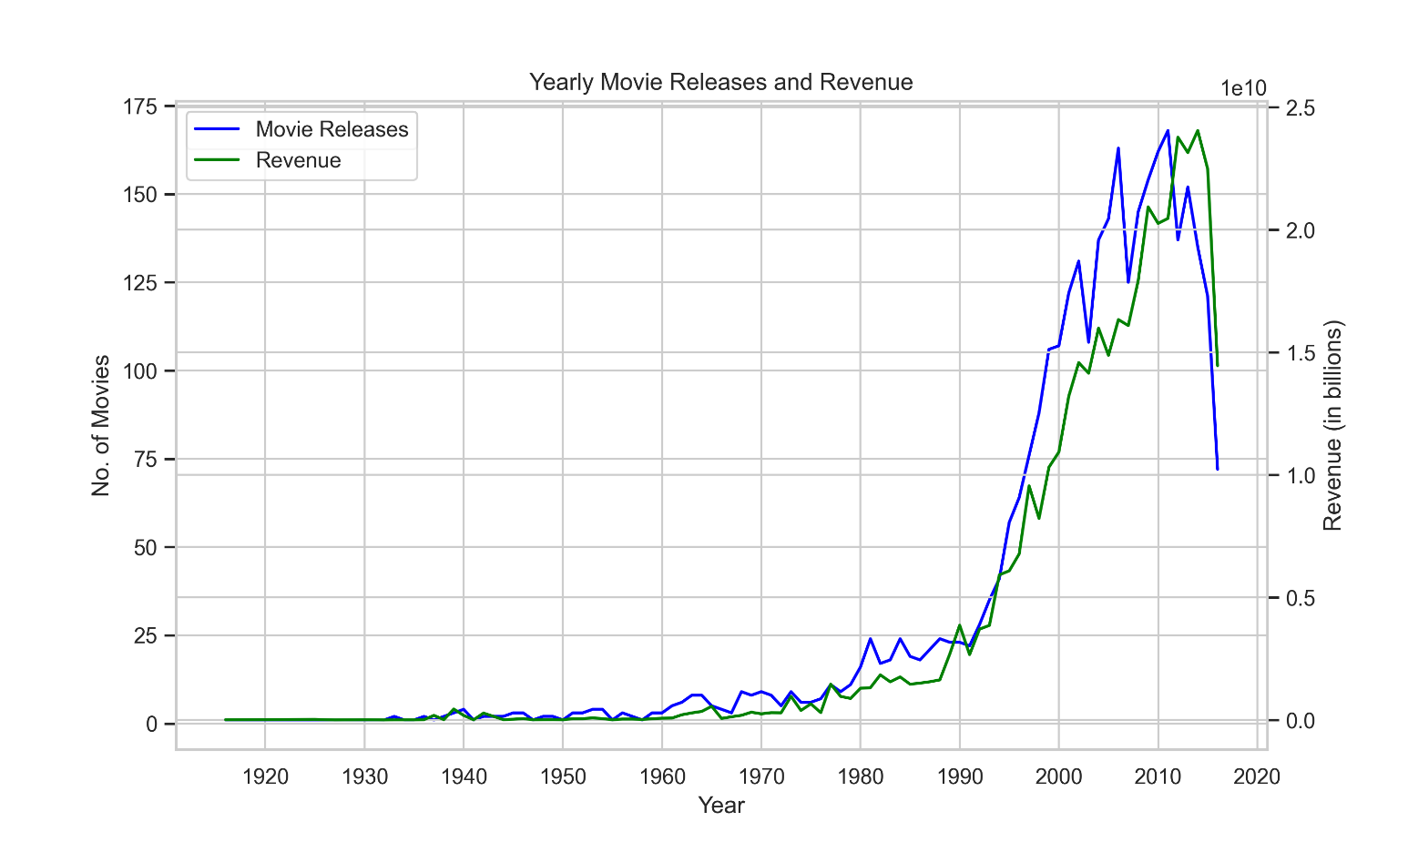
I've created the dual axis line chart to visualize the number of movies released over the years and total yearly revenue generated. Above visualization shows us that there's positive correlation in between the number of movie releases and revenue generated from the movies, higher the number of movie releases, higher the revenue and vice-versa. There is a slight upward growth of both the number of movie releases and revenue until 1990, and they start to grow significantly after that year. What makes this chart more interesting is, there's straight upward growth after 1990 till early 2010s and it seems like starting from early 2010s there's significant downward trend in the growth of movie releases and revenue. There may be several reasons behind this negative growth, one of many reasons could be because of the slowdowns in economic growth in many countries in the world including the European countries, overall a slower economic growth worldwide after 2008 financial crisis.

With the completion of an exploratory data analysis on this dataset, I have observed several patterns and extracted few insights as well. The dataset consists of approximately 4800 movies where are of different languages and from different countries. The most popular genres in our dataset are Drama, comedy and Thriller. The most profitable movie is Avatar, which was released in 2009 and the most popular one is Minions, which was released in 2015.

The revenue and the profit seem to have a positive correlation. Same applies to the number of movie releases and yearly revenues over the years, they have the same growth pattern. The industry saw it’s peak in terms of movie releases and revenue collection at around early 2010s.

The ‘movies’ dataset can also be very useful for conducting further analysis of other aspects which we may not have covered this time.

THIS REPORT WAS WRITTEN BY: AJAY GHIMIRE, Data Science / HyperionDev

