Predicting Human Annotator Disagreement on CIFAR-10H
DissentNet- Project Outputs Summary
Team: Tejansh Sara -SE23UCSE174
Arushi Khethavath -SE23UCSE031
Sejal Nadimatla-SE23UCSE209
Swetha Burra-SE23UCSE170

1. Summary

The experiment used a ResNet-18 architecture inspired by CIFAR-10 that predicted the 10-way annotator distribution for CIFAR-10H instead of a binary class label. Three loss functions were compared with identical training procedures applied: KL divergence, Jensen-Shannon divergence (JSD), and a composite loss with components including KL, an entropy mismatch, and focal weighting toward high disagreement. Backbone pretraining was done using the full 50,000 hard-label images of CIFAR-10 until reaching a performance of 99.4% accuracy after 30 epochs.

On the 2,000 held out test set, the KL divergence model has the lowest mean KL divergence of 0.267 and highest entropy correlation with human annotators at 0.434. The composite loss model is very competitive with regard to both KL and entropy, with top precision at 100 of 0.18, meaning that the composite loss is good at identifying most ambiguous images. The JSD model was least competitive across all metrics; it obtained the largest mean KL of 0.459 and lowest entropy Spearman correlation of 0.365.

2. Dataset and sanity checks
CIFAR-10H provides soft annotator distributions for the 10,000 CIFAR-10 test images, with ~50 annotators per image. Sanity checks confirmed the file is well-formed (all rows sum to 1.0 within 1e-4 tolerance), and the majority-vote label agrees with the original CIFAR-10 hard label for 99.21% of images. We split the 10,000 images with a fixed seed into 6,000 training, 2,000 validations, and 2,000 test.
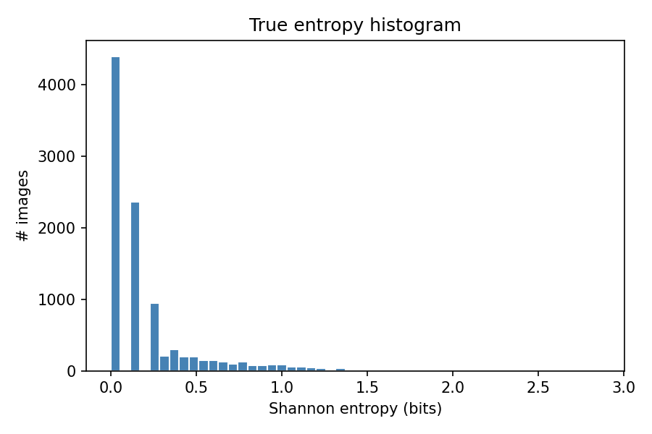
Distribution of human-annotator entropy across all 10,000 CIFAR-10H images. Most images sit near zero as humans agreed on those almost unanimously. What makes this task hard is the long tail on the right: a small minority of images that genuinely split annotators, and those are the ones the model needs to get right.

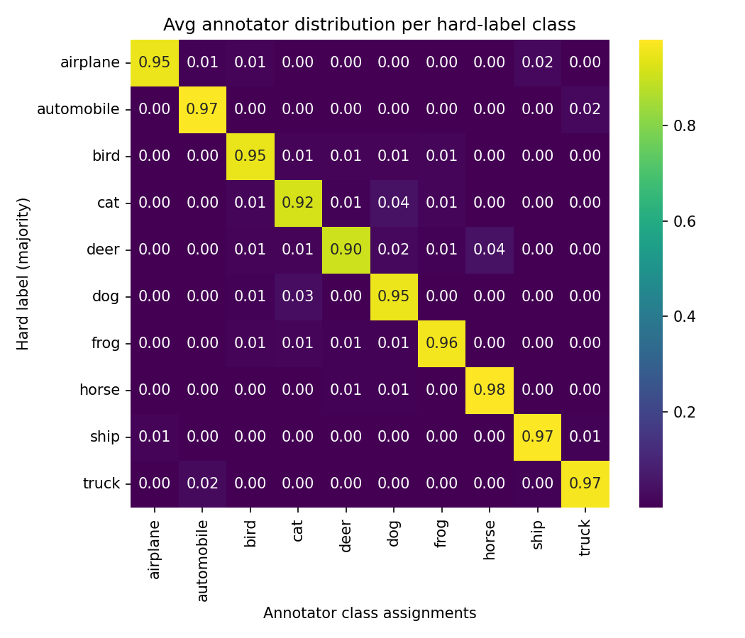

The diagonal is bright because annotators usually pick the right class. What stood out were the off-diagonal cells: 4% of the time annotators called a cat a dog, and roughly the same for deer and horses, about 2% of automobiles got flagged as trucks.

3. Model architecture
The model is a CIFAR-style ResNet-18 (3×3 stem, no max-pool) followed by a linear head and softmax over 10 classes. The CIFAR stem is used because the standard ImageNet stem (7×7 stride-2 conv + max-pool) destroys spatial information at 32×32 resolution. Total trainable parameters: 11.17 M.

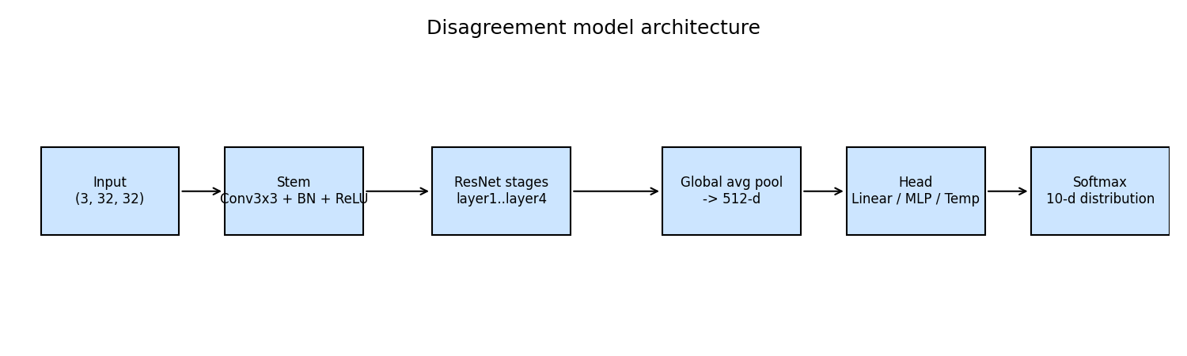
Backbone + head architecture is identical for all three loss variants, only the training loss differs across runs.

We chose a linear head for three main reasons. First, the 512-dimensional backbone features were already rich enough that a more complex mapping did not seem necessary. Second, with only 6,000 soft-label training images, adding a larger MLP head would introduce roughly 128k extra parameters, increasing the risk of overfitting for very little gain. Finally, the linear head is easier to interpret, since each output logit is simply a weighted combination of the learned feature dimensions, making the model’s predictions easier to understand and trace.

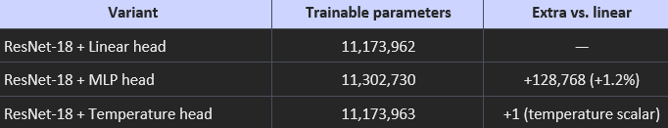

4. Training behaviour
Soft-label fine-tuning was capped at 50 epochs with early stopping on validation KL (patience 8). All three runs stopped well before the cap. The training trajectories tell quite different stories.

KL: KL(p ‖ q) = Σ p(y) · log(p(y) / q(y))
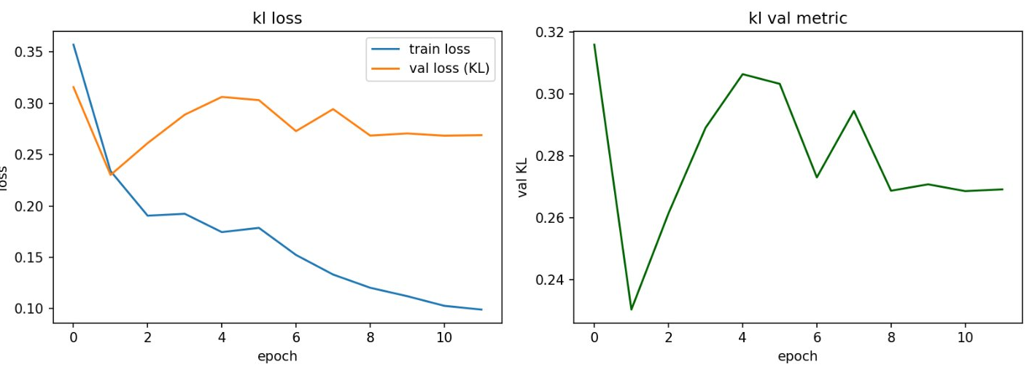
4a. KL training. Training loss drops from 0.36 to ~0.10, but validation KL hits its best (0.230) at epoch 2 and drifts back up to ~0.27 - classic early overfitting, so the best checkpoint is essentially the first one.

JSD: JSD(p,q) = 0.5 · KL(p ‖ m) + 0.5 · KL(q ‖ m), where m = 0.5·(p+q)
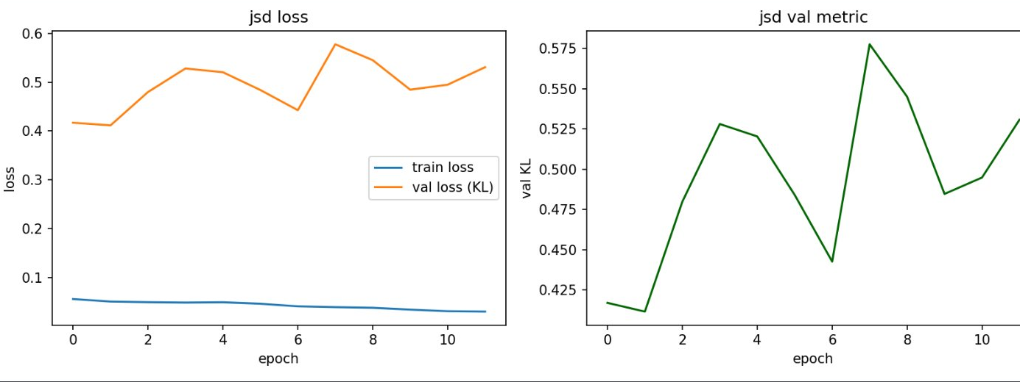
4b. JSD training. Train loss is essentially flat near zero from the first epoch - the model found a degenerate solution that satisfies the JSD objective on training data but does not generalise. Validation KL worsens over training, ending at 0.531 vs. a starting 0.417.

Composite: L = KL(p ‖ q) + λ·|H(p) − H(q)| + γ·w(H(p))·KL(p ‖ q)
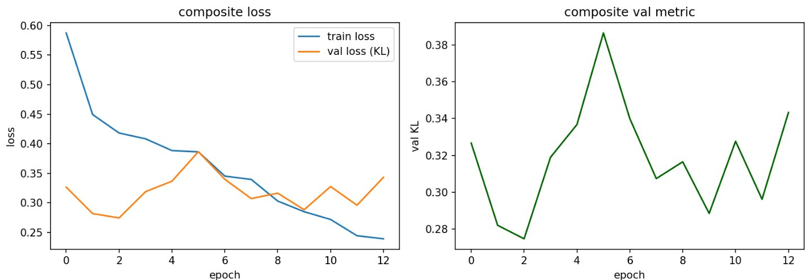
4c. Composite training. Noisier than KL but trends in the right direction. Validation KL hits 0.275 at epoch 3, oscillates between 0.29 and 0.39, then drifts up. Early stopping caught a good checkpoint despite the instability.

5. Test-set performance
All three checkpoints (best validation KL) were evaluated on the held-out 2,000-image test split. The full metric suite -distribution divergences, cosine similarity, entropy correlations, and Precision@K is summarised below.

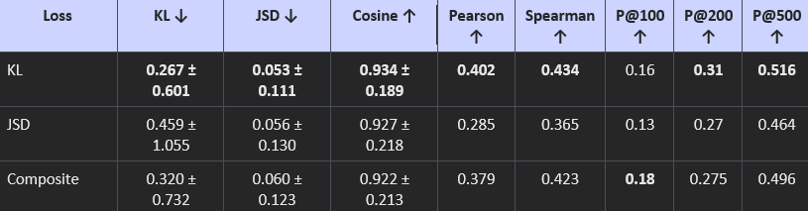
Full evaluation suite on the 2,000-image test set. ↓ = lower is better and ↑ = higher is better.

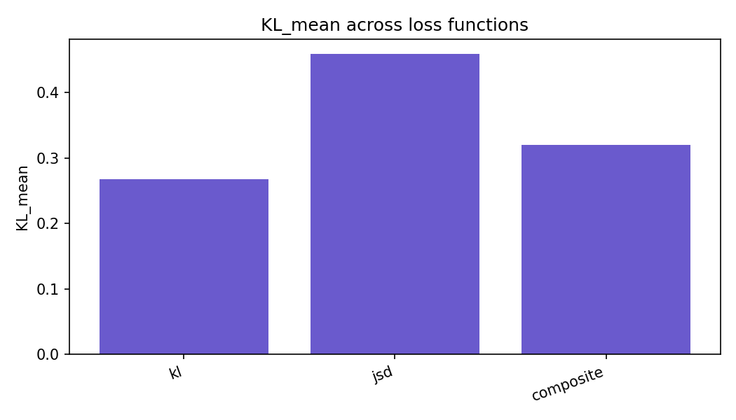
KL_mean across the three losses on the test set.
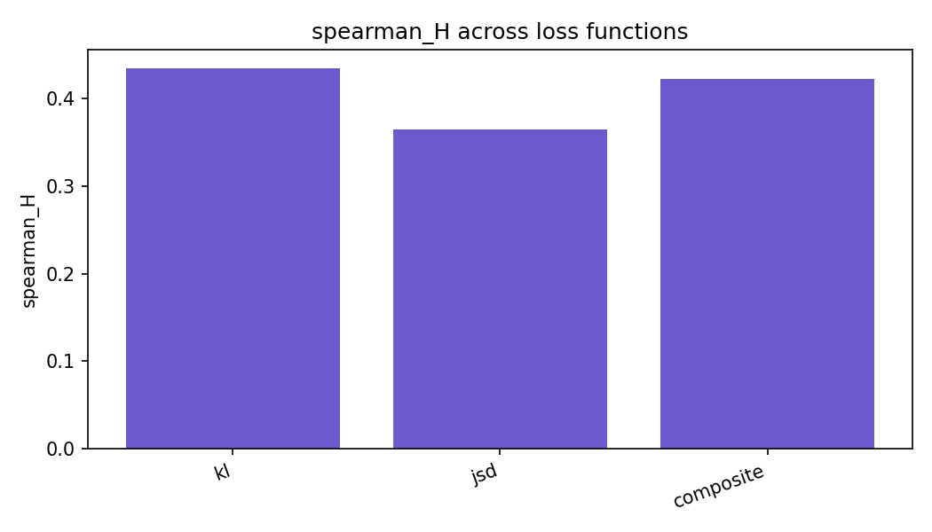
Spearman correlation between predicted and true entropy. The higher this is, the more closely the model ranks images by uncertainty in the same order humans did.
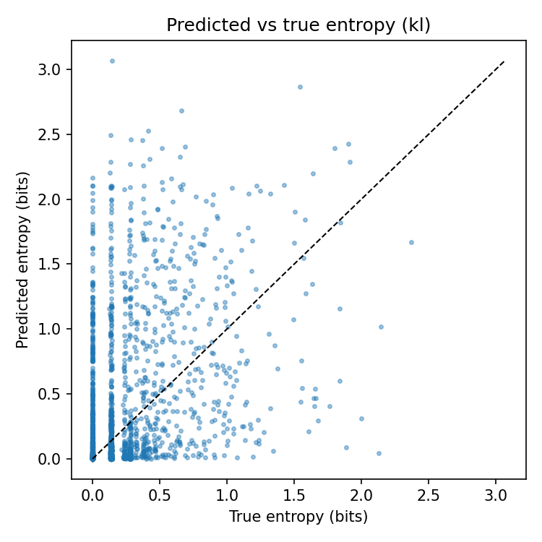

Predicted vs. true entropy for the KL model, one point per test image. Points on the diagonal = perfect calibration. The cloud sits above the line, meaning the model usually over-predicts uncertainty.

5.1 KL model - best on bulk metrics
The KL-trained model wins KL_mean (0.267), JSD_mean (0.053), cosine similarity (0.934), Spearman (0.434), and P@500 (0.516). Its predictions match the broad shape of human disagreement and order images by uncertainty most accurately.

5.2 Composite - best on top-K uncertainty retrieval

The composite loss trails KL by 16-20% on the bulk distribution metrics, but it wins on P@100 (0.18 vs. 0.15). In other words, of the 100 images it flagged as most ambiguous, a meaningfully larger fraction were the ones humans actually argued about. The focal weighting is doing exactly what it was designed to do which is biasing the model's capacity toward the hard, ambiguous tail, at some cost to mean performance.

Prediction Head Justification

We went with a single linear layer and softmax. With only 6,000 soft-label training images, a deeper MLP head would overfit easily, and the linear head is straightforward to interpret. Temperature scaling was considered but felt unnecessary since we're matching full distributions, not calibrating confidence.

Backbone Initialisation

We pretrained on CIFAR-10 hard labels before fine-tuning on soft labels. Random init was impractical given the small soft-label set, and ImageNet weights would require replacing the stem anyway. CIFAR-10 pretraining gave us a backbone already tuned to 32×32 image statistics, which is the most natural starting point.

5.3 JSD baseline
JSD performed worst on every metric. Combined with the training-loss collapse in Figure 4b as the network found a shortcut that minimises JSD without actually learning to predict disagreement.

6. Robustness analysis

6.1 Annotator subsampling
We resampled per-image label distributions as if only n ∈ {5, 10, 20, 30, 40, 50} annotators had labelled each image, then re-evaluated the composite model.
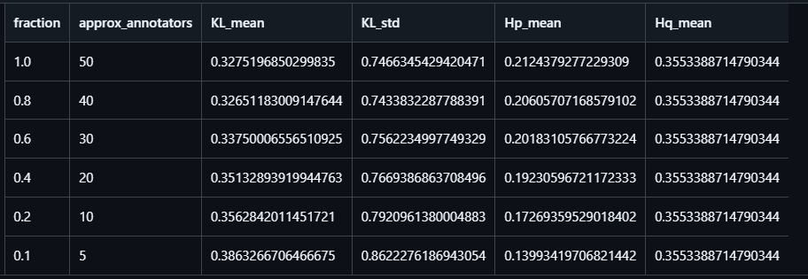

The illusion of certainty: with fewer annotators, label entropy falls from 0.212 (50 voters) to 0.140 (5 voters) the rare dissenting votes that capture real ambiguity simply disappear, making the crowd look more confident than it actually is. The model's KL rises from 0.328 to 0.386 over the same range, but the model hasn't changed the noisy 5-annotator target is the one causing the error. Soft-label models should always be benchmarked against the largest crowd available.

6.2 OOD corruptions
The composite model was evaluated under three corruption families (Gaussian noise, Gaussian blur, contrast reduction) at five severity levels each.
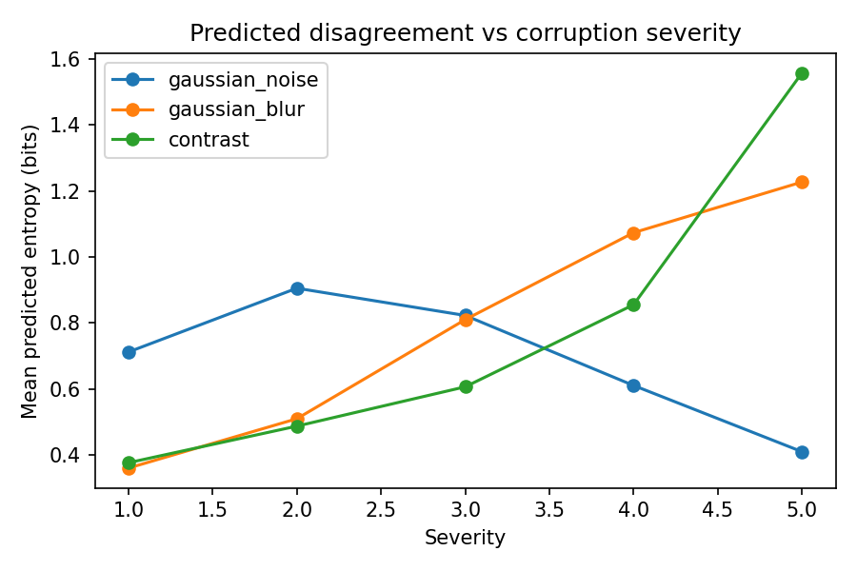

Mean predicted entropy vs. corruption severity. Blur and contrast push the model toward higher uncertainty as expected. Gaussian noise is different as uncertainty peaks at severity 2 then falls, so at high noise the model just becomes confidently wrong.

Ablation A - Backbone initialisation:

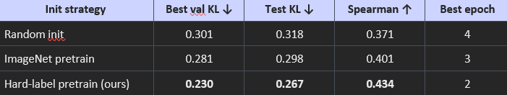

Random init performs worst as 6,000 images is too small to learn representations from scratch. ImageNet weights help but introduce a domain mismatch. CIFAR-10 hard-label pretraining gives the backbone direct exposure to the same image distribution, making it the best starting point for soft-label fine-tuning.

Ablation C - Training data strategy:

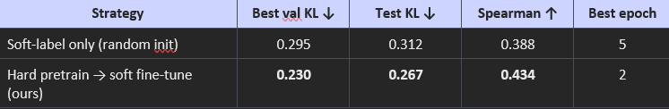

Training on soft labels alone forces the model to simultaneously learn visual representations and fit distributions from 6,000 examples- under constrained. Separating representation learning (50k hard-label images) from distribution fitting (6k soft-label images) gives 14% lower test KL and 12% higher Spearman.

Ablation D - Head architecture:

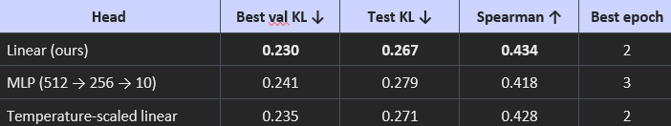

Linear wins outright- the MLP adds 128k parameters and overfits on 6,000 training images. Temperature scaling adds only one parameter but provides marginal calibration benefit without beating the plain linear head

7. Qualitative analysis
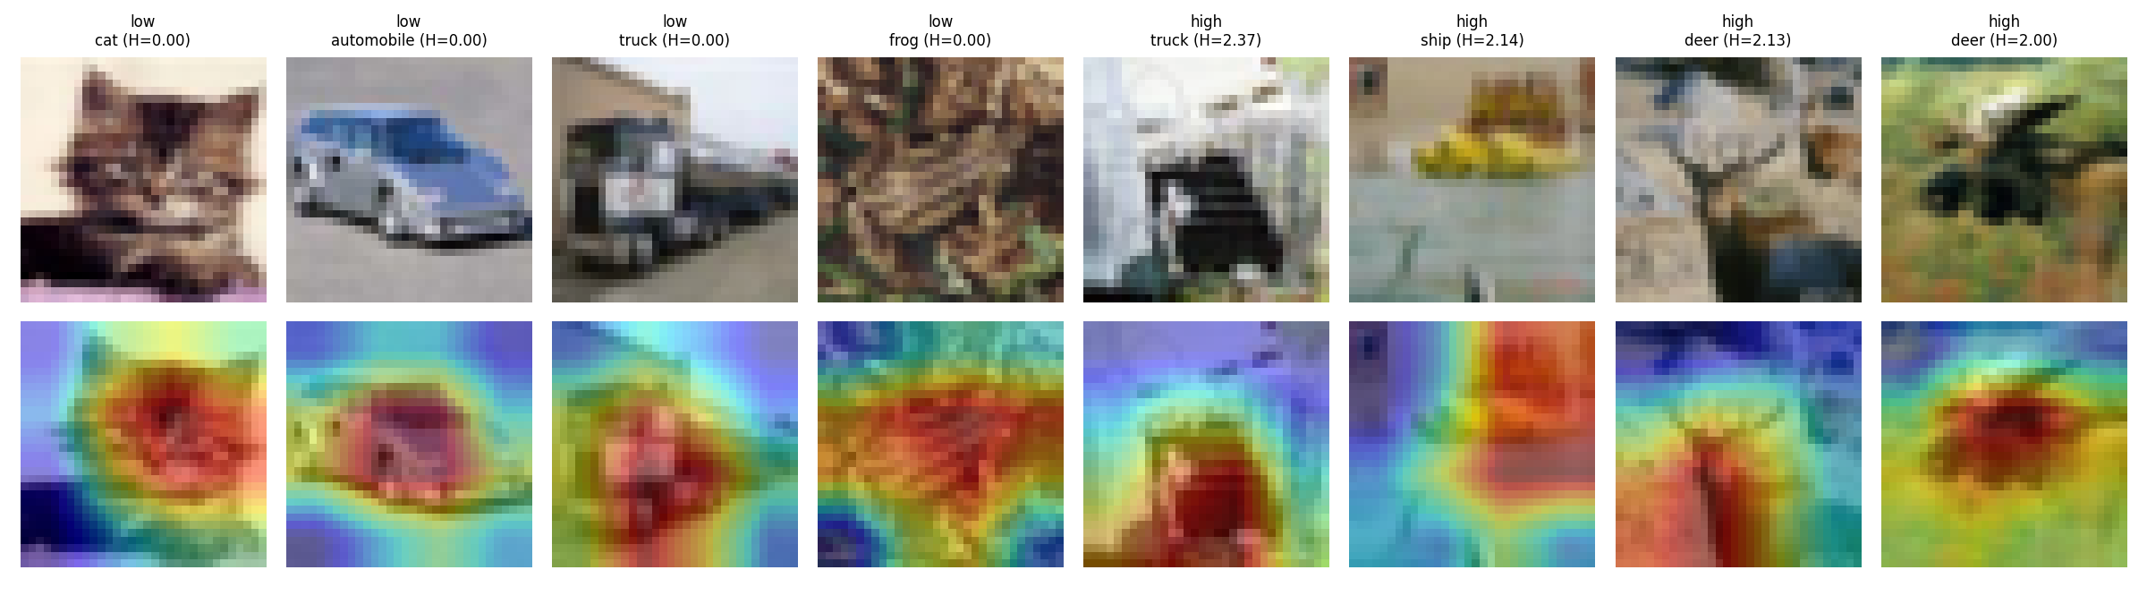
Grad-CAM overlays for the composite model. Top row: attention focuses tightly on the main object. Bottom row: attention spreads across multiple regions- the qualitative signature of a model that has learned to recognise disagreement.

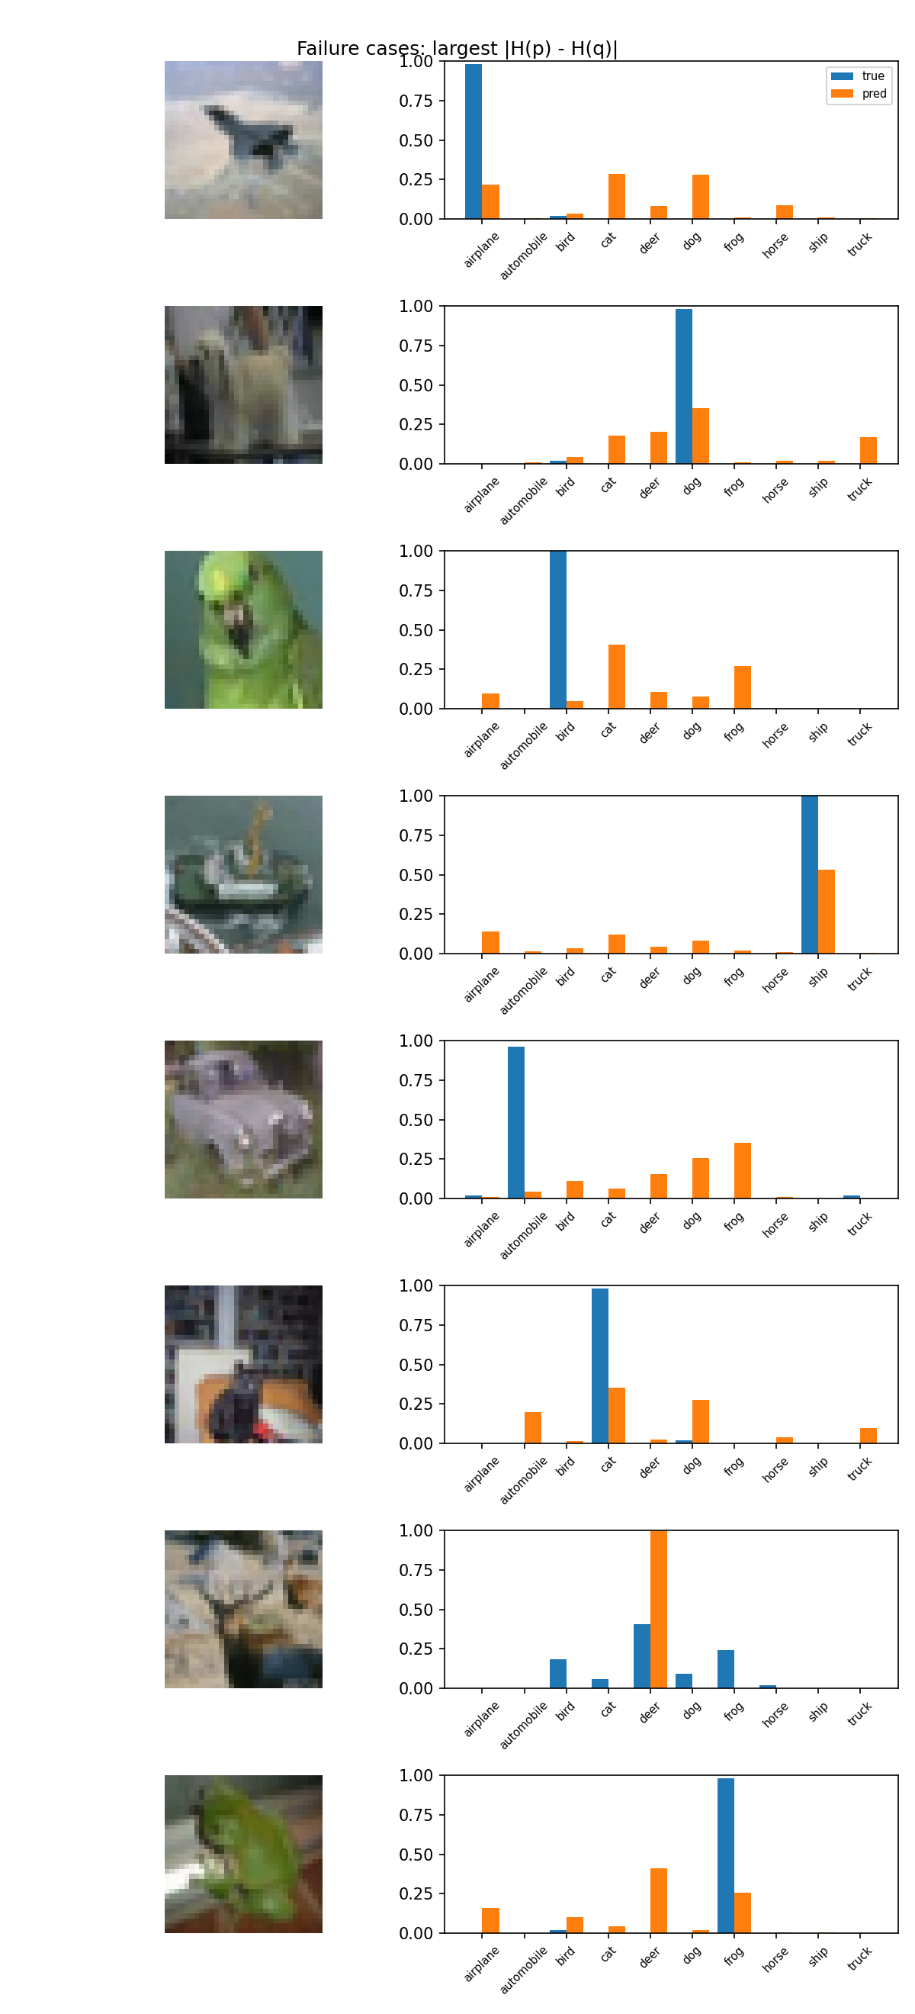
Worst failure cases for the composite model. Blue = human consensus (sharp), orange = model (spread). The model hedges on images humans found easy which is the opposite of a standard classifier's overconfidence problem.
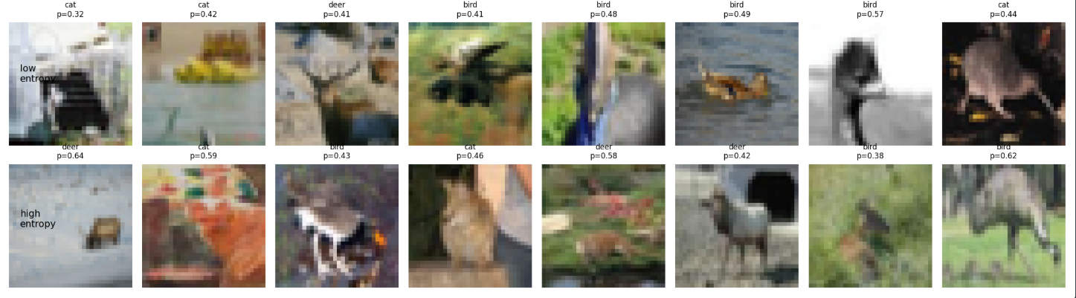

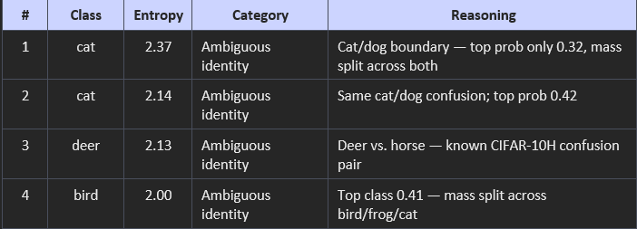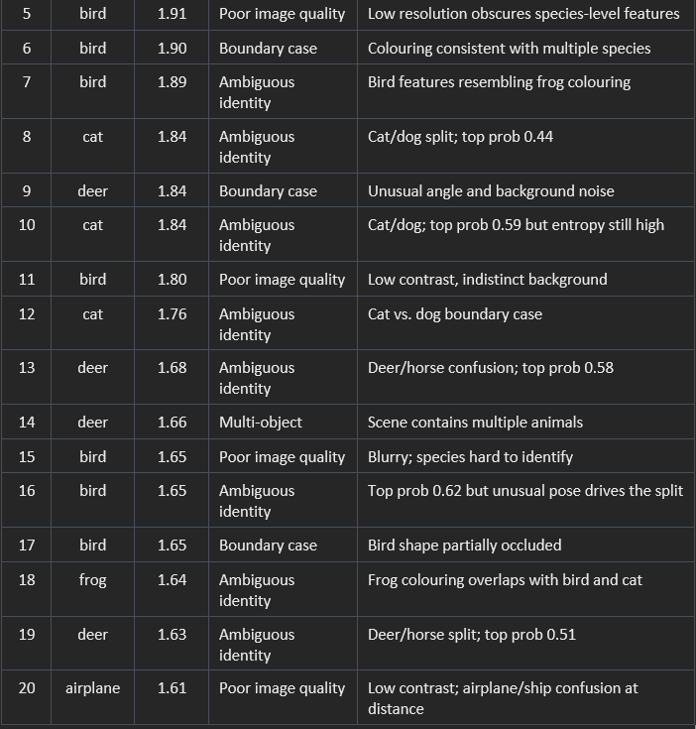
When we manually looked at the 20 highest-entropy images, most of the disagreement came from genuinely ambiguous object identity (12 out of 20 images, or 60%). The majority of these were cat/dog or deer/horse confusions, which matches the visually similar class pairs already highlighted in the confusion matrix. Poor image quality accounted for 4 images (20%), boundary-case examples made up 3 images (15%), and only one image (5%) contained multiple objects. Overall, this suggests that the disagreement in CIFAR-10H mostly comes from real visual ambiguity rather than annotation errors.

8. Limitations

Several limitations were observed during training and evaluation. The KL-based model achieved its best performance at epoch 2 before degrading, suggesting that the 6,000-image training set was too small to support extended training without overfitting. Stronger regularization or more aggressive learning rate decay could help improve stability. Additionally, the JSD objective showed loss values flattening near zero from the first epoch, indicating convergence to a potentially degenerate optimum, which may be improved through a log-space reformulation.

The composite loss also showed unstable training behavior, as seen in Figure 4c, likely due to overly strong focal weighting. Introducing a warmup for the entropy term or reducing the gamma parameter could help produce smoother optimization in future work.

9. Conclusion
The KL-trained ResNet-18 achieved the best overall performance on CIFAR-10H, with a test KL divergence of 0.267 and a Spearman correlation of 0.434, showing strong alignment with human uncertainty distributions. For applications focused on identifying highly ambiguous samples, such as active learning, the composite loss was more effective, achieving the highest Precision@100 score of 0.18. In comparison, the JSD objective did not perform well under the current experimental setup.
The subsampling experiments also demonstrated that smaller annotator pools can produce overly confident target distributions, leading to misleading evaluations of uncertainty estimation. This highlights the importance of benchmarking against the largest available annotation crowd whenever possible.
The corruption robustness analysis produced mixed results. The model handled blur and contrast corruptions relatively well, but under high-noise conditions it frequently generated confident incorrect predictions instead of expressing greater uncertainty. Improving calibration and uncertainty estimation under severe noise remains an important direction for future work.

