

# Index

Student Database Management System

By:- Akash kumar, tanish garg and deepali walia

* Acknowledgement
* Introduction
* Scope
* Purpose
* Data Flow Diagram
* Requirements
* Detailed Description
* Bibliography

Acknowledgement

I have taken efforts in this project. However it would not have been possible without the kind support and help of many individuals. I would like to extend my sincere thanks to all of them.

I am highly indebted to the faculty members of our department for their guidance and constant supervision as well as for providing necessary information regarding the project and also for their support in completing the project.

I would like to express my gratitude towards my team members for their cooperation and encouragement which help me in the completion of the project

Introduction

This Student Database Management System has been designed to store and manage student data. This data includes student’s personal, academic, family data and his document. The design has been focused on two types of users:-

* Faculty
* Student

Scope

The scope of the project includes the following:-

* Any student can create his own id(No duplicates Allowed)
* Id’s for faculty members have a complete view of student details
* A student can access only an abstract view of another student
* A student can upload pictures of his academic and identification documents
* An Overview of course can be seen
* The user can change his password

Purpose

Our database is a store house of information regarding various students and the various attributes encapsulated in it. To maintain such a huge list of diverse data, a lot of paperwork is required and it is time consuming as well and has more chances of integrity loss and data loss. This huge amount of data can be made easily maintainable and accessible by use of computers. A database manage system can ease the process of such automation.

Data Flow Diagram

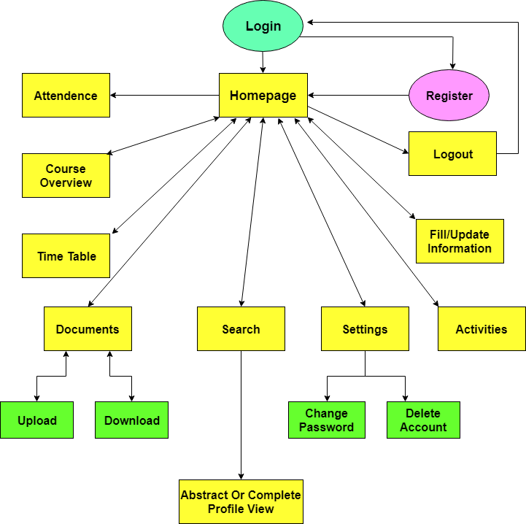

Requirements

# Hardware Requirements:-

* Processor : Intel Pentium IV series & above
* Ram : 512 MB RAM
* Monitor : 15” Color Monitor
* Mouse

# Software Requirements:-

* Operating System : Linux 14.04 or Windows 7 & above
* Database : phpmyadmin
* Browser : Chrome, Opera or Equivalent

# Description

The main aim of this project is to reduce the paperwork required to maintain the record of hundreds and thousands of students. This system even allows the user to upload his documents and access thrm whenever needed.

Features of this system:-

* User can fill/update his information.
* Connected to Attendance portal.
* Provides an overview of your course.
* Allows you to search other users.
* Connect to attendance portal.
* User can change his password.
* User can delete his account.
* Allows user to upload files and download them when needed.

This system has two types of users:-

* Student:-

This type of user has limited access as he cannot see complete details of other users or access other user’s documents. He has access to his own information and documents and has access to only an abstract part of other user’s details.

* Faculty:-

This type of user has complete access to the student data. User can see complete data of the students including their uploaded documents. While searching another user this type of user has complete view of student details like his personal info, academic info and his family details.

At first user is directed to login page where user has to enter his username and his password. If the credentials match then user is redirected to the homepage else an error message is displayed that Username or Password is incorrect. If user does not has an account then he can create it by clicking on Register here link.

User has to enter a username (unique), password and an email and click register if the username is unique and the passwords match then the user is registered and redirected to homepage else error messages are displayed.

At homepage the user can go to attendance portal directly (no need to remember the ip address). User can see an overview of his course details although the study material will not be provided there.

User can check his timetable as well and keep him updated in case there are any changes in the timetable.

User can even search other users and access partial or complete details of other user, depending on his user type i.e. faculty or student.

This system also allows the user to upload his documents and access them when needed. There is a settings section where the user can change his password or delete his account.

At last the user can log out of his account to prevent auto login next time a user visits.

# Bibliography

* w3schools.com
* stackoverflow.com
* youtube.com/darkcode