Milestone 3 - Database
Team ViPe

We will be using mySQL as our Database Management System. The database will utilized mostly for storing and accessing customer order invoices to and from the website. Separate tables have been created for both customer information as well as order information, which are linked by the ‘customerId’ key. We also require a table for admin login authentication, so that has been created as well. Below is our Entity Relationship Diagram:

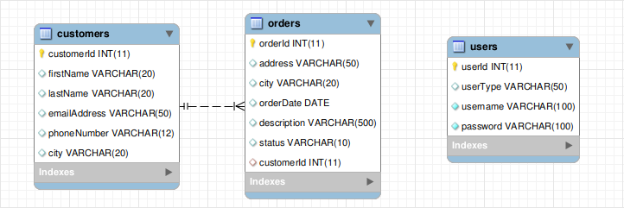
A link to our database creation and data population script can be found here

