Moore’s Law:

“The number of transistors in an Integrated Circuit doubles approximately every 2 years.”

This is not a scientific law, just an observation seen by Gordon Moore in 1965.

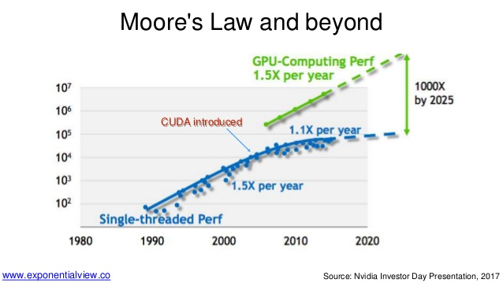

As we can see the blue line in above graph, recently, due to various physical limitations, growth in transistor density is saturating.

**Physical Limitations:**

**Power**: When you make processors smaller, the more tightly packed electrons will heat up a chip—so much so that unless today’s most powerful chips are cooled down, they will melt inside their packaging. As the Transistor density increases, Power increases and as the Power increase, Temperature increases.

**Size:** it’s also important to realize that chips can’t get smaller forever. At some point Moore’s Law will run into the unyielding laws of nature. Chip pathways certainly can’t be shorter than a single molecule, and the actual physical limit is likely larger than that.

**Voltage Scaling**: The switching power dissipated by a chip using static CMOS gates is…

P = C . V2 . f

Accordingly, dynamic voltage scaling is widely used as part of strategies to manage switching power consumption in battery powered devices such as cell phones and laptop computers. Voltage scaling helps to reduce the power consumption, but it is limited due to threshold(noise) voltage. But it can’t prevent the power loss due to electrical leakage.