Beyond the Fence
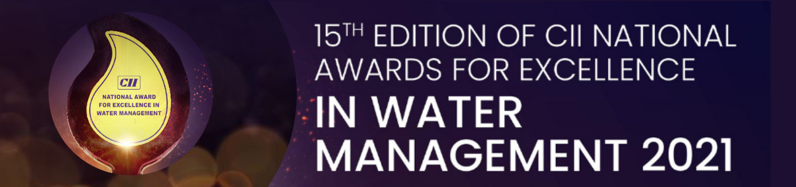

Guidelines
- This questionnaire is meant to capture specific information pertaining to a particular “site & project”.
- Entries are invited for projects already completed or in advanced stages.
- Entries are invited only from Industry (public and private sector).
- Questionnaire without application fee would not be considered for evaluation
- The questionnaire along with supporting documents would be treated confidentially. The same would be shared only with the judges for evaluation.
- Decision of the panel of judges is final.

Instructions for filling in the questionnaire
- Fill in all the questions.
- If a particular question is not applicable, give reasons.
- Adhere to the word limit.
- Weightage would be given to questions supported with quantitative information.
- Give due attention to the “unit”. Use uniform units across the questionnaire.
- Please specify the annexure number, wherever applicable.

Questionnaire
Company Name:
Project Title
Project Timeframe | Start date:  End date:
Project Location | Project Area |  | District |  | State
Geographical coordinates | Latitude
Geographical coordinates | Longitude
Contact Person: |  | Designation:
Mobile: |  | Email:
Correspondence Address:
City: |  | Pin code:
Annual Turnover of the company (Corporate) (2020 – 21):

Q1. Short description and objective of the project (500 words)

Q2. Reasons for undertaking the project [200 words]

Q3. Achievements under the project [200 words]

Q4. Did you undertake any scientific study prior to undertaking the project? If yes, share as annexure.

Q5. Project strategy [500 words]
How was the project executed?

Q6. Describe the key activities under the project [300 words]

Q7. Who were the project partners and their roles? [500 words]

 | Name of the Institution | Role
Government
Private Sector
Civil Society
Community Organization
Others

Q8. Who is the target group/project beneficiaries? [100 words]

Q9. Elucidate the role of the community in the project cycle. Please mention how community was involved in conceptualizing / planning / implementing / maintaining etc. [500 words]

Q10. Did the project incorporate gender sensitive design? If yes, how? [200 words]

Q 11. Project benefits [Quantify social, economic and environmental benefits] [500 words]

Envisaged | Accrued | Remarks (if any)

Q12. What has been the project funding mechanism? [200 words]

Q13. Did the project involve dovetailing with any ongoing Government scheme/project? [200 words]

Q14. Mention the monitoring mechanism (institutional structure / instruments/ data system for collection, analysis and tracking progress) to ensure effective implementation of the project and measurement of benefits of the project. [500 words]

Q15. Explain measures taken to ensure sustainability (social, economic, environmental) of the project Also detail out measures in place (in case of project handover to the community) and brief about exit strategy [600 words]

Q16. Have you conducted third party assessment of the project? If yes, highlight the important findings. [500 words] Share report as annexure.
.

Q17. Any outreach/awareness generation material prepared? Any certificates of recognition and appreciation. Please include the same.

Q18. Lessons learnt for scalability and replicability (250 words)

Glossary
- Project: A project, as defined in the field of project management, consists of a temporary endeavour undertaken to create a unique product, service or result. Projects involve "a collaborative enterprise, frequently involving research or design, that is carefully planned to achieve a particular aim".

- Deliverables: In Project Management terms, a deliverable is a tangible or intangible object produced as a result of project execution, as part of an obligation.

- Target Groups: A target group/ target audience is the primary group of people that project is aimed at serving / appealing to. A target group can be people of a certain age group, caste, community, village, etc. (e.g. cultivators, daily wage workers, dalits, farmer groups, women etc.)

- Public Sector Institutions: includes government whether national, regional, local/municipal or Gram Panchayats etc.

- Private sector: includes Industry, company, corporate houses, banks or any other non-public units

- Civil society institution: includes totality of voluntary civic and social organizations and institutions [e.g. academia, community organizations, cooperatives, charities, civic groups, foundations, non-governmental organizations (NGOs), non-profit organizations (NPOs), women's groups]

- Project Sustainability: Sustainability is relevant to development projects. A definition of development sustainability is "continuation of benefits after major assistance from the donor has been completed. Ensuring that development projects are sustainable can reduce the likelihood of them collapsing after they have finished; it also reduces the financial cost of development projects and the subsequent social problems, such as dependence of the stakeholders on external donors and their resources

- Project Budget: The sum established by the implementing agency as available for the entire project, including the personnel costs, administration costs, capital expenditure, travel costs etc. that may be required to achieve project deliverables in the given time frame.

- Community empowerment is the state of affairs that exists when members of a community feel empowered to achieve their self-determined goals, with some measure of significant control over the processes and strategies to attain these.

- Gender Sensitive Design: In development projects, gender mainstreaming is designed to provide both men and women with opportunities to access all project resources and services, proportional to the importance of the activity to them and their lives.
Declaration
To the best of my knowledge, the information furnished is correct
We ___________________________(organization name), hereby declare that we do not have any litigation or case pending in the court of law, either in the past or present, regarding water and wastewater.
Name:
Designation:
Signature:
Company seal:
Date:
Please note:
- The questionnaire should be completed in all respects and sent to waterawards@cii.in / Priya.narula@cii.in / Vipin.varghese@cii.in
- Incomplete questionnaire will not be considered.
- This questionnaire needs to be submitted along with the application fee.

