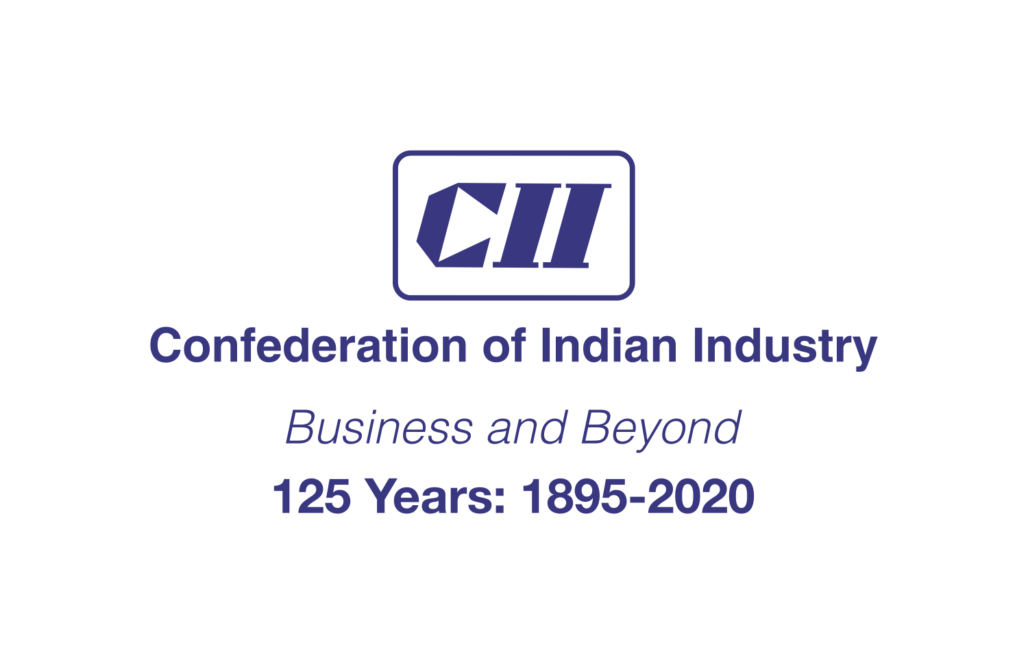


Innovative Water Saving Product

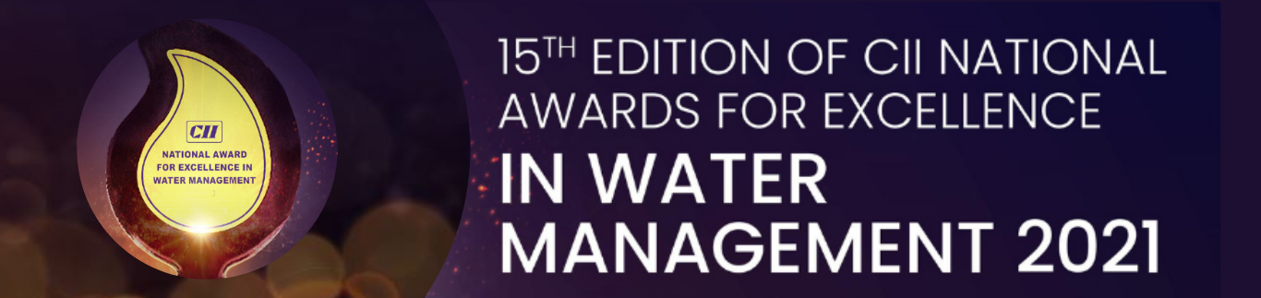

Guidelines
- The Questionnaire should be product specific.
- Entries are invited for technology already developed and implemented.
- Companies will be short-listed for the next level of evaluation based on the duly filled questionnaire.
- The questionnaire along with supporting documents would be treated confidentially. The same would be shared only with the judges for evaluation.
- Decision of the panel of judges is final.
- Questionnaire without application fee would not be considered for evaluation.

Instructions for filling in the questionnaire
- Fill in all the questions.
- If a question is not applicable, give reasons.
- Weightage would be given to questions supported with backup information/ reference documents.
- Give due attention to the “unit”. Use uniform units across the questionnaire.
- Please specify the annexure number, wherever applicable.

Questionnaire

Company Details
Company Name
Address for Communication
Phone
Email
Contact person
Designation
Type of products manufactured / provided
Annual Turnover of the company (corporate) (2020 – 2021)

Brief description of Innovative product developed and implemented successfully
Provide following details:

Technical Details of innovative product:

Is the product leading to:
        - Improvement in Water Quality
        - Improvement in Water Savings

Year of development

Has the technology been used for 2 or more years?

Principle of operation / Technology of the product. Explain the chemistry behind the technology, if applicable

What is the cost of technology? [Indicate both capex and opex cost in relation to the capacity of water/wastewater that the technology/product handles (in Rs./m³)]

How & why it is innovative in comparison to similar products available in the market?

Impact of the product on water management including cost economics.

Replication potential in the Indian Market.

Any demo video of the product is available? (If Yes, provide link)

Does the company own patent for the product. (If yes, kindly share)

Provide two technical evidences of the successful implementation of the product. Also, attach the testimonials

Company at which implemented & the year of implementation
Water Consumption before installation (m³ /annum)
Water consumption after installation (m³ /annum)
Savings in Operating cost (Lakhs/annum)
Investment (Rs Lakhs)
Payback Period (Months)
Contact details of the company

If the product has led to improvement in Water Quality
Company at which implemented & the year of implementation
Water Quality before installation
(mg /liter)
Water Quality after installation
(mg / liter)
Savings in Operating cost (Lakhs/annum)
Investment (Rs Lakhs)
Payback Period (Months)
Contact details of the company
Declaration

To the best of my knowledge, the information furnished is correct
We ___________________________(company name), hereby declare that we do not have any litigation or case pending in the court of law, either in the past or present, regarding water and wastewater.
Name:
Designation:
Signature:
Company seal:
Date:
Please note:
- The questionnaire should be completed in all respects and sent to waterawards@cii.in / Priya.narula@cii.in / Vipin.varghese@cii.in
- Incomplete questionnaire will not be considered.
- This questionnaire needs to be submitted along with the application fee.

