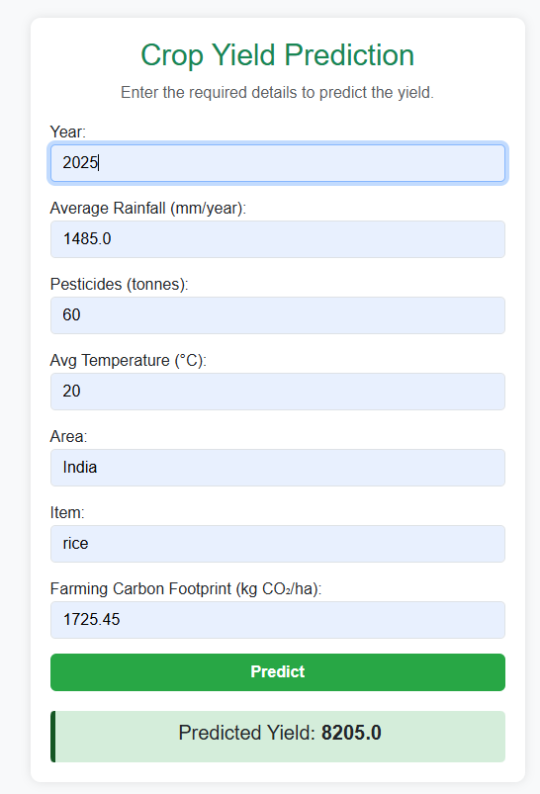 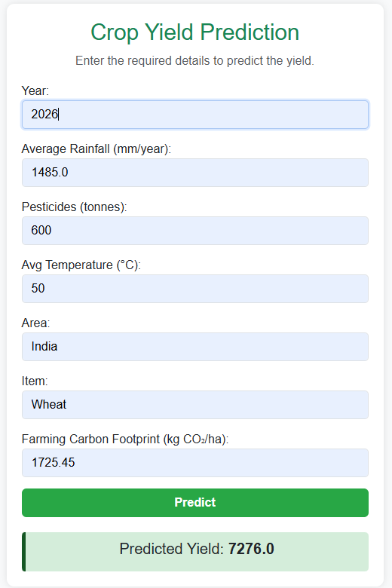

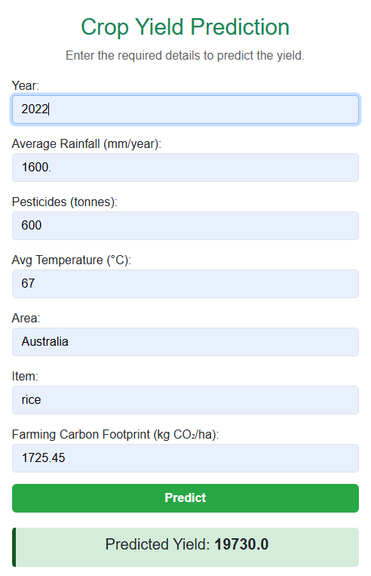 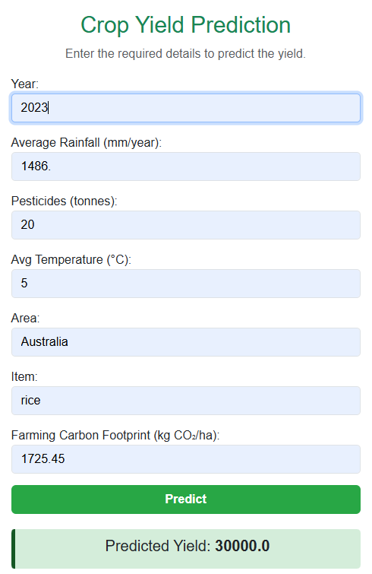

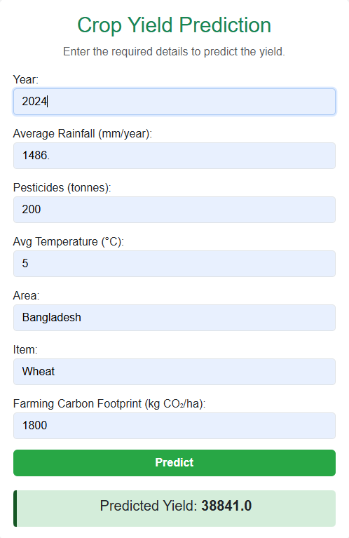

|  |  |  |  |  |  |  |  |  |  |
| --- | --- | --- | --- | --- | --- | --- | --- | --- | --- |
| Area | |  | | --- | |  |  |  | | --- | | **item** | | Year | Yield (hg/ha) | Rainfall (mm) | Pesticides (tonnes) | Temp (°C) | Carbon Footprint (kg CO₂/ha) |
| Albania | Maize | 1990 | 36613 | 1485.0 | 121.0 | 16.37 | 2321.81 |
| Albania | Potatoes | 1990 | |  | | --- | |  |  |  | | --- | | 66667 | | 1485.0 | 121.0 | 16.37 | 2349.21 |
| Albania | Rice, paddy | 1990 | |  | | --- | |  |  |  | | --- | | 23333 | | 1485.0 | 121.0 | 16.37 | 1372.73 |
| Albania | Sorghum | 1990 | 12500 | 1485.0 | 121.0 | 16.37 | 1725.45 |
| Albania | |  | | --- | |  |  |  | | --- | | Soybeans | | 1990 | 4507 | 1485.0 | 121.0 | 16.37 | 1579.64 |
| India | Rice | 2025 | 8205 | 1485 | 60.0 | 20.00 | 1725.45 |
| India | Wheat | 2026 | 7276 | 1485 | 600.0 | 50.00 | 1725.45 |
| Australia | Rice | 2022 | 19730 | 1600 | 600.0 | 67.00 | 1725.45 |
| Australia | Rice | 2023 | 30000 | 1486 | 20.0 | 5.00 | 1725.45 |
| Bangladesh | Wheat | 2024 | 38841 | 1486 | 200.0 | 5.00 | 1800.00 |