Books Table:
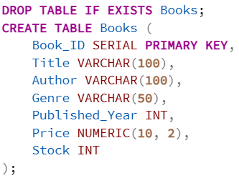
Customers Table:
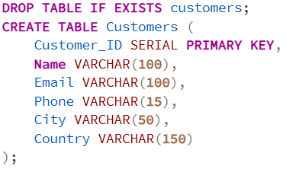
Orders Table:
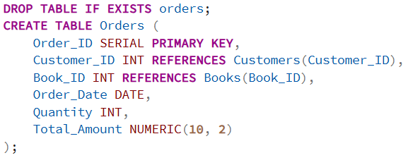

- Retrieve all books in the "Fiction" genre:
Filtering the catalog by genre to identify specific product segments, such as "Fiction," which helps in understanding the variety of popular titles available.
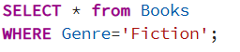
Output:
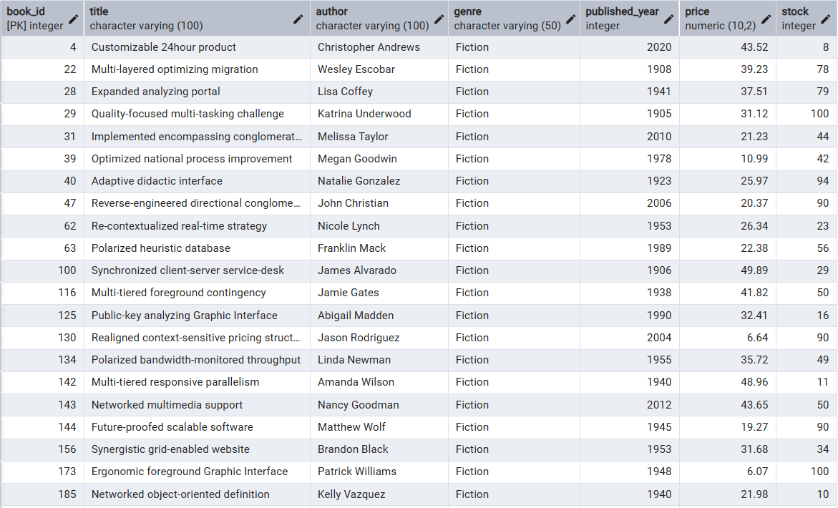
- Find books published after the year 1950:
Modernizing the dataset by excluding older editions to focus on contemporary literature and modern publishing trends.
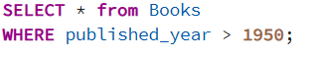
Output:
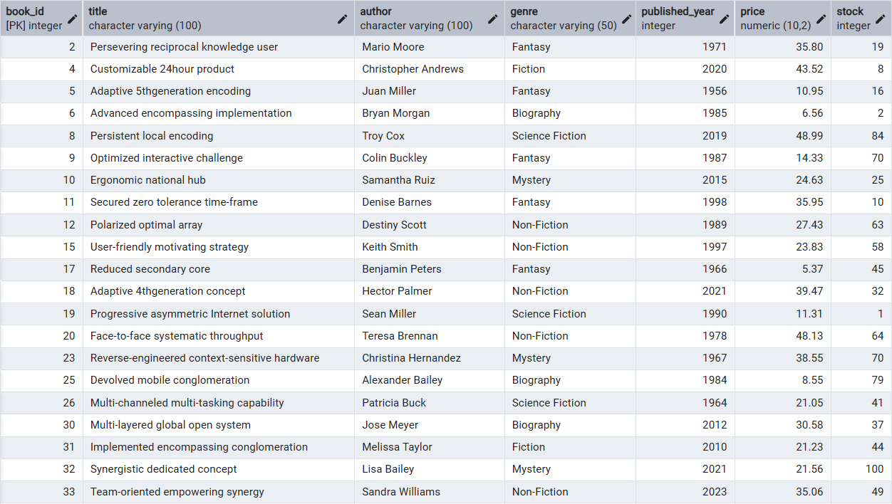
- List all customers from the Canada:
Segmenting the customer base by geographic location to assist in regional marketing strategies or shipping logistics.
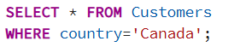
Output:
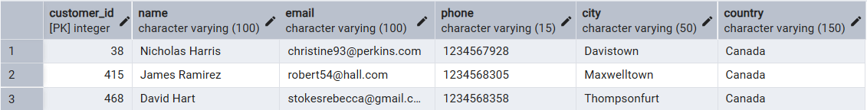
- Show orders placed in November 2023:
Performing a temporal analysis to track sales performance and order volume during a specific high-traffic month.
Output:
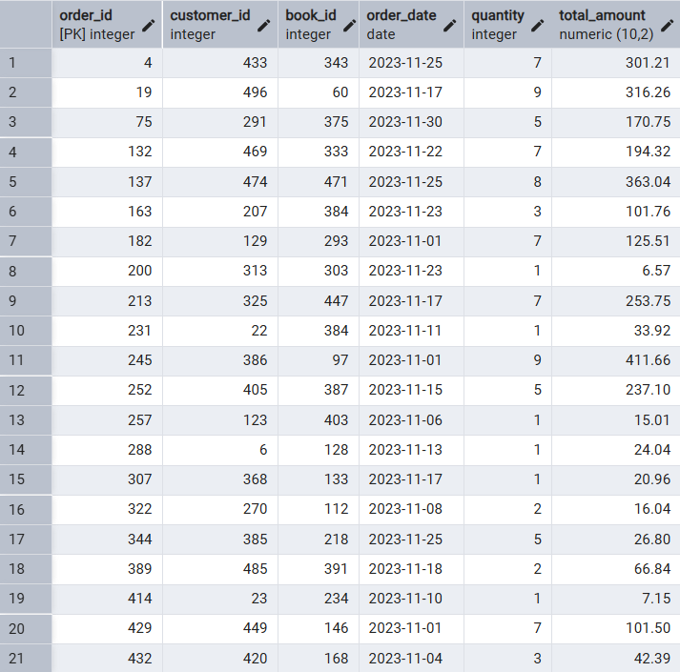

- Retrieve the total stock of books available:
Assessing overall stocks levels to ensure the bookstore has sufficient stock to meet general demand.
Output:
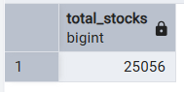
- Find the details of the most expensive book:
Identifying high-value items to understand the upper end of the store's pricing structure.
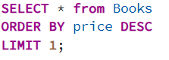
Output:
- Show all customers who ordered more than 1 quantity of a book:
Finding customers who are buying in bulk.
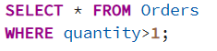
Output:
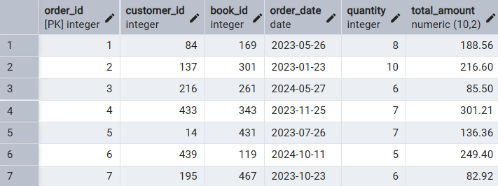
8) Retrieve all orders where the total amount exceeds $20:
Output:
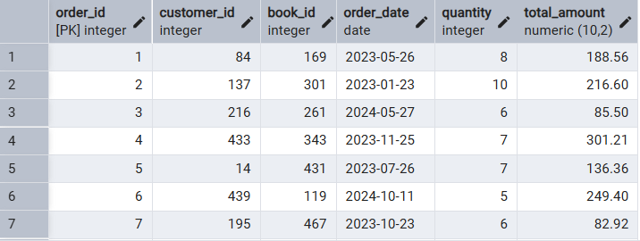
9) List all genres available in the Books table:
Giving a quick list of all the categories of books we sell.
Output:
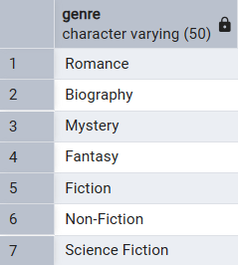

10) Find the book with the lowest stock:
Alerts us which book is almost sold out and needs restocking.
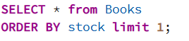
Output:
11) Calculate the total revenue generated from all orders:
Shows the total money made from all the sales.
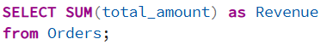
Output:
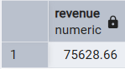
12) Retrieve the total number of books sold for each genre:
Showing which category is in more demand and popular.
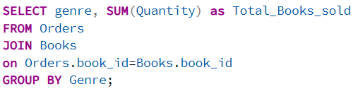
Output:
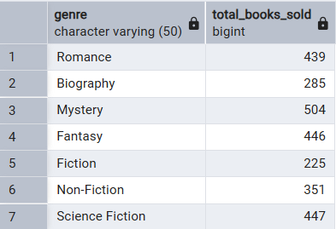
13) Find the average price of books in the "Fantasy" genre:
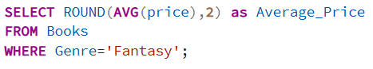
Output:
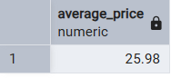
14) List customers who have placed at least 2 orders:
Identifying our Regular and loyal customers.
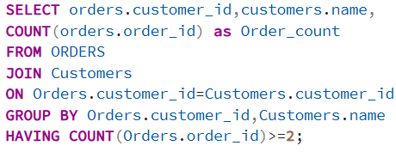
Output:
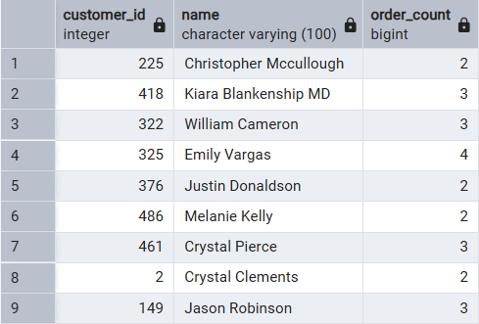

15) Find the most frequently ordered book:
Identifying the best seller of shop, so that it won’t be out of stock.
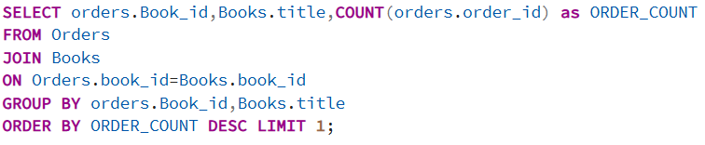
Output:
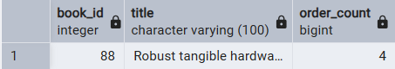
16) Show the top 3 most expensive books of 'Fantasy' Genre:
Identifying the most sold books from Fantasy genre.
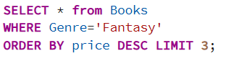
Output:
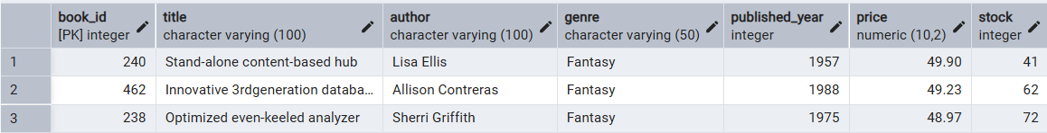

17) Retrieve the total quantity of books sold by each author:
Shows which authors are bringing in the most sales.
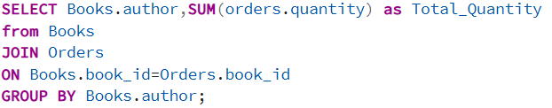
Output:
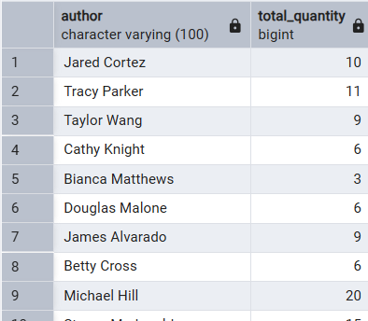
18) List the cities where customers who spent over $30 are located:
Finds the locations of our "big spender" customers.
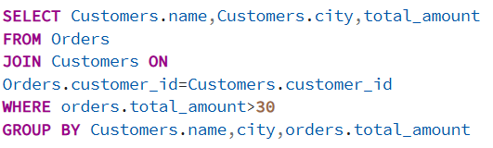
Output:
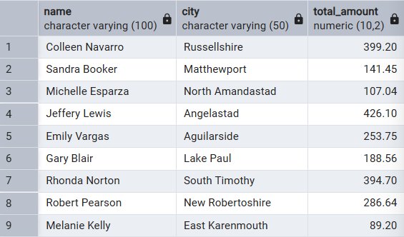
19) Find the customer who spent the most on orders:
Identifying our customer with most buys.
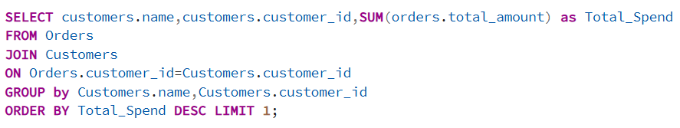
Output:
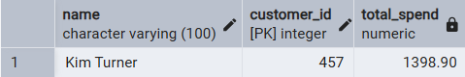
20) Calculate the stock remaining after fulfilling all orders:
Identifying which books needs to restocked.
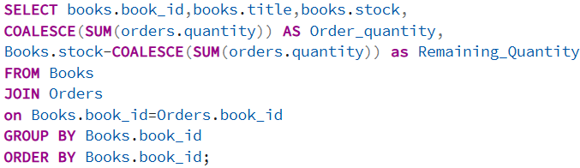
Output:
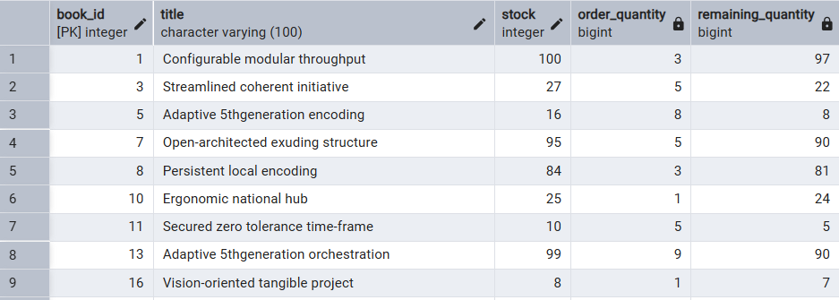

Conclusion: This analysis helped us understand three things:
- Best Sellers: We now know which authors and genres (like Mystery) make the most money.
- Stock Management: We identified which books are running low and need to be re-ordered.
- Customer Loyalty: We found our top-spending customers so we can offer them better service in the future.

