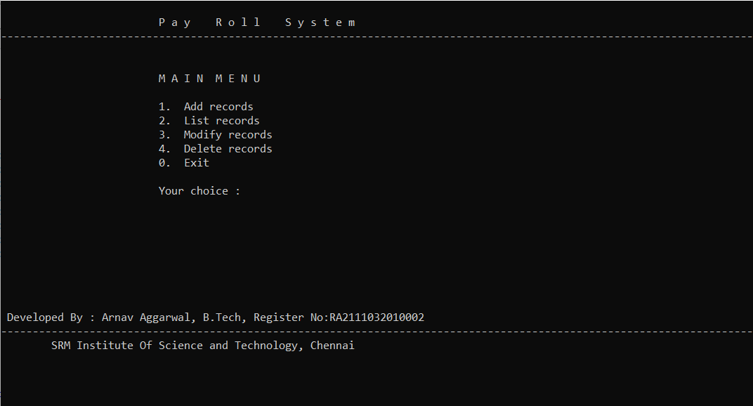

**Title:-PayRoll System**

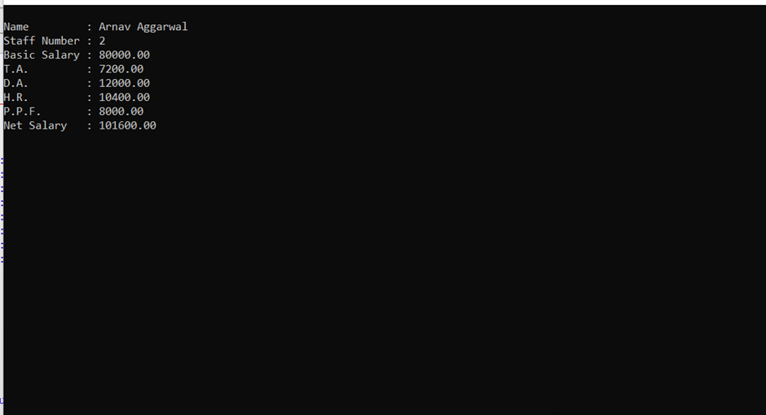 1.Firstly view all the records by entering **choice-2**

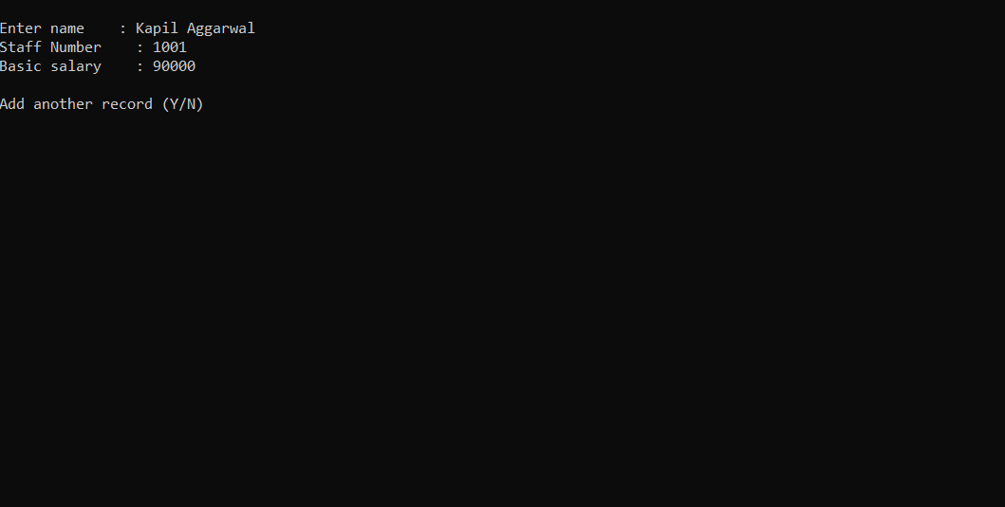

2.To add new record enter **choice-1**.

And accept by pressing **Y**.

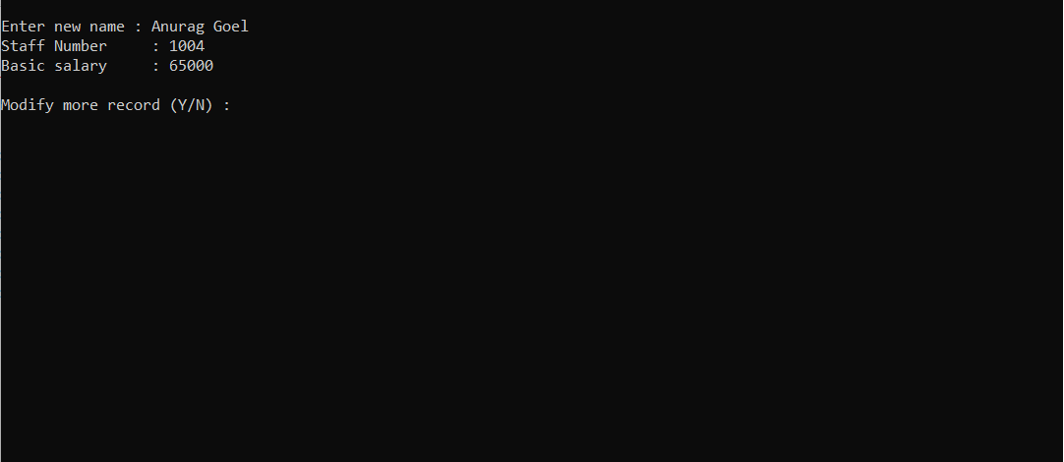

3.To modify the record enter **choice-3** and enter staff number to modify.

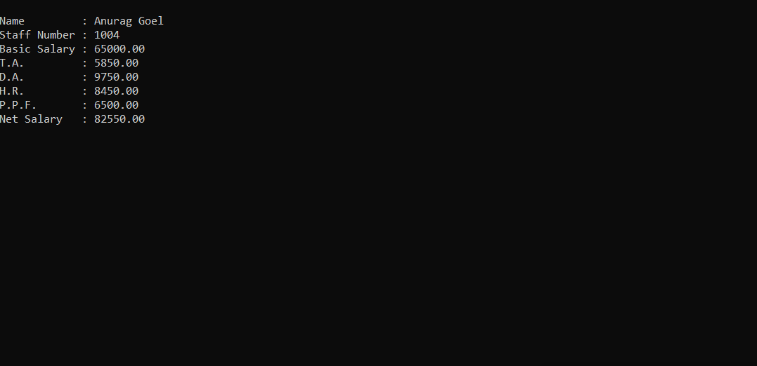

4.Again you can list the records to view the modification. Similarly, to delete the record press **choice-4** and enter staff number and confirm by pressing **Y**.

To exit press **0**.

**Name**-Arnav Aggarwal

**Register No.**RA2111032010002 <=***MADE BY***

**Branch**-CSE w/s IoT **Section**-U2