Online Certificate Request System | Mini Project Report
A PROJECT REPORT
Submitted by

AAKANKSHA BOSMIYA (250283116003)
In partial fulfilment for the award of the degree of

BACHELOR OF ENGINEERING
in

Information Technology L.D. College of Engineering, Ahmedabad


Gujarat Technological University, Ahmedabad, 2026

1. Introduction
Educational institutions issue Bonafide, Character, Transfer and Course Completion Certificates for internships, placements, scholarships, examinations and higher studies. In a traditional process, students may need to visit an administrative office, fill a paper form, submit details, wait for verification and visit again to collect the certificate. This creates queues, paperwork and uncertainty about request progress.
The proposed Online Certificate Request System, called CertiFlow, digitizes this workflow. A student submits a request through a web form. The application validates the information, stores it in a MySQL database and generates a unique request identifier. Administrative staff can view and process requests from a dashboard.

2. Problem Statement
The problem is to design and develop a web-based system that allows students to request certificates online and enables administrative staff to manage those requests efficiently. The solution should validate data, store records securely, provide a unique request ID and show a clear processing status.
Manual Problem | Digital Solution
Physical forms | Online form
Repeated visits | Remote submission
Paper registers | MySQL database
No tracking | Request ID + status
Manual errors | Validation
Difficult retrieval | Database queries

3. Objectives
- Provide an online certificate request form.
- Collect student identity, enrollment, email, certificate type and purpose.
- Validate important fields before storage.
- Generate a unique request ID.
- Store requests in MySQL.
- Provide an administrative dashboard.
- Represent workflow using Pending, Approved and Rejected states.
- Reduce paperwork and repeated office visits.
- Demonstrate frontend, backend and database integration.

4. Scope
The academic version covers the core request lifecycle: submission, validation, database storage, request identification and administrative viewing. Authentication, automated notifications, digital signatures and PDF certificate generation are treated as future extensions.
In Scope | Future / Out of Scope
Request form | University SSO
Validation | Digital signatures
MySQL storage | Payment gateway
Admin listing | Automated PDF certificate
Request status | Mobile application

5. Existing vs Proposed System
Parameter | Existing | Proposed
Request method | Paper / office visit | Web form
Storage | Register / spreadsheet | MySQL
Reference | Manual | Generated ID
Status | Manual communication | System status
Validation | Staff dependent | Client + server
Availability | Office hours | Web based

6. Tools and Technologies
Technology | Use
HTML5 | Forms and page structure
CSS3 | Responsive user interface
JavaScript | Client-side validation
PHP | Server-side processing
MySQL | Persistent data storage
Apache / XAMPP | Local web server
VS Code | Development
Git/GitHub | Version control

The architecture uses a presentation layer (HTML/CSS/JavaScript), an application layer (PHP) and a data layer (MySQL).

7. Functional Requirements
ID | Requirement | Expected Result
FR-01 | Open portal | Request form appears
FR-02 | Enter details | Student data accepted
FR-03 | Select certificate | Certificate type selected
FR-04 | Validate | Invalid input rejected
FR-05 | Store | New database row
FR-06 | Generate ID | CR-xxxx reference
FR-07 | Admin view | Requests listed
FR-08 | Status | Pending/Approved/Rejected

8. Non-Functional Requirements
Category | Requirement
Usability | Simple, readable and responsive
Performance | Fast response for normal local usage
Reliability | No incomplete records
Security | Server validation + prepared SQL
Maintainability | Separated files/modules
Compatibility | Modern browsers

9. System Design
The student opens the portal, fills the form and submits it. JavaScript provides quick feedback while PHP performs final validation. Valid data is inserted into MySQL using a prepared statement. The system displays a confirmation page with the request ID and Pending state. The administrator reviews the request from the dashboard.

10. Database Design
Field | Type | Description
id | INT PK AUTO_INCREMENT | Unique request ID
student_name | VARCHAR(100) | Student name
enrollment_no | VARCHAR(30) | Enrollment number
email | VARCHAR(120) | Email
certificate_type | VARCHAR(80) | Requested certificate
purpose | TEXT | Reason
status | ENUM | Pending/Approved/Rejected
requested_at | TIMESTAMP | Submission time

Database name: certificate_portal. Main table: certificate_requests.

11. Folder Structure
Online-Certificate-Request-System/
├── index.php
├── request.php
├── admin.php
├── config.php
├── style.css
├── script.js
├── database.sql
└── assets/
├── screenshots/
└── documentation/
File | Responsibility
index.php | Student request form
request.php | POST processing + success page
admin.php | Administrative dashboard
config.php | MySQL connection
style.css | Common UI styling
script.js | Client-side validation
database.sql | Database/table/sample data

12. Module Description

12.1 Student Request Module
Provides fields for student name, enrollment number, email, certificate type and purpose. Required fields prevent basic incomplete submissions. CSS Grid creates a two-column desktop layout and a single-column mobile layout.

12.2 Validation Module
Validation occurs at two levels. JavaScript provides immediate feedback, while PHP repeats important checks on the server because client-side validation can be bypassed.

12.3 Request Processing Module
request.php reads POST data, trims values, validates the email and executes a prepared INSERT statement. The returned insert ID is formatted as CR-0042.

12.4 Administration Module
admin.php queries the request table and displays request IDs, student names, certificate types, statuses and timestamps. A production system should additionally enforce authentication and authorization.

12.5 Database Module
MySQL provides persistent storage with an auto-increment primary key and a controlled status field.

13. Technical Explanation

13.1 Form Submission
The form uses POST and sends data to request.php. POST is suitable because request information should not be exposed through a URL.

13.2 Server Validation
PHP checks the request method, trims input, verifies required values and validates the email with filter_var().

13.3 Prepared SQL
Prepared statements with placeholders and bind_param() prevent user input from being directly concatenated into SQL and provide safer database interaction.

13.4 Request ID
MySQL creates the numeric primary key. PHP retrieves insert_id and formats it using str_pad(), producing identifiers such as CR-0042.

13.5 Responsive Design
CSS media queries convert the form from two columns to one column on smaller screens.

14. User Interface Screenshots
The following output images are generated for this project and represent the expected working interface.

15. Source Code
The complete source files are supplied separately in the project package. Key implementation files are included below as readable code listings.

config.php
<?php
$host="localhost"; $db="certificate_portal"; $user="root"; $pass="";
$conn=new mysqli($host,$user,$pass,$db);
if($conn->connect_error) die("Database connection failed");
$conn->set_charset("utf8mb4");
?>

index.php
<form action="request.php" method="POST" id="requestForm">
<input name="student_name" required>
<input name="enrollment_no" required>
<input type="email" name="email" required>
<select name="certificate_type" required>
<option>Bonafide Certificate</option>
<option>Character Certificate</option>
<option>Transfer Certificate</option>
</select>
<textarea name="purpose" required></textarea>
<button type="submit">Submit Request</button>
</form>

request.php
$name=trim($_POST["student_name"] ?? "");
$enrollment=trim($_POST["enrollment_no"] ?? "");
$email=trim($_POST["email"] ?? "");
$type=trim($_POST["certificate_type"] ?? "");
$purpose=trim($_POST["purpose"] ?? "");
$sql="INSERT INTO certificate_requests
(student_name,enrollment_no,email,certificate_type,purpose,status)
VALUES (?, ?, ?, ?, ?, 'Pending')";
$stmt=$conn->prepare($sql);
$stmt->bind_param("sssss",$name,$enrollment,$email,$type,$purpose);
$stmt->execute();
$requestId=$stmt->insert_id;

admin.php
$result=$conn->query(
"SELECT id,student_name,enrollment_no,certificate_type,
status,requested_at FROM certificate_requests
ORDER BY requested_at DESC"
);
while($row=$result->fetch_assoc()){
echo htmlspecialchars($row["student_name"]);
}

15.1 Output Screenshots
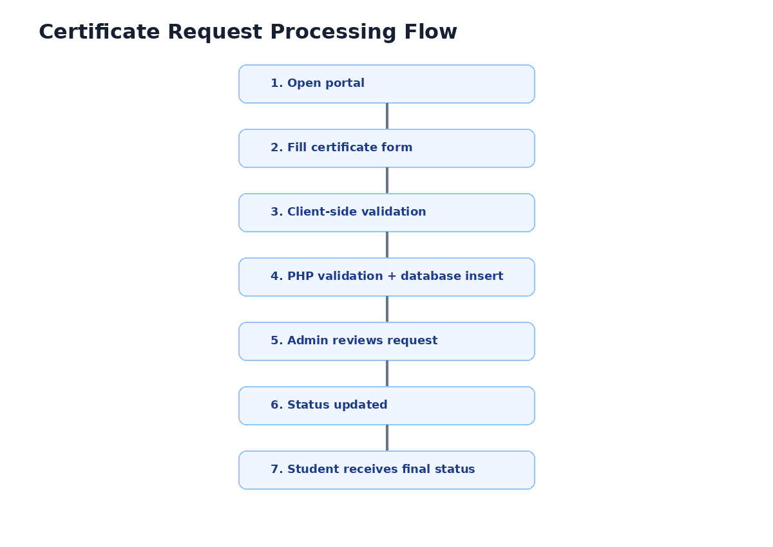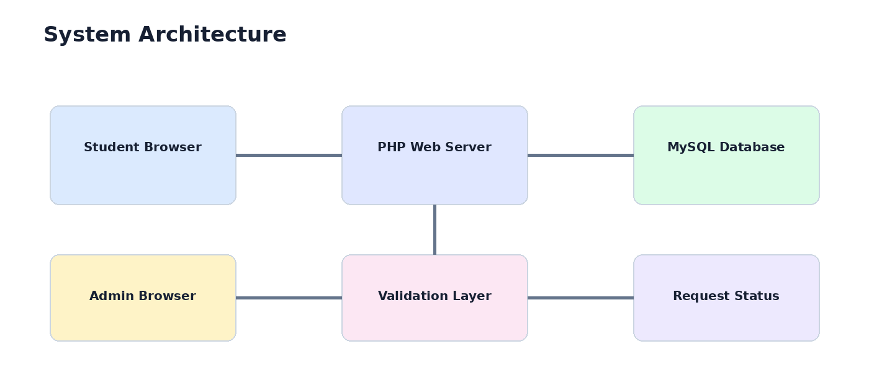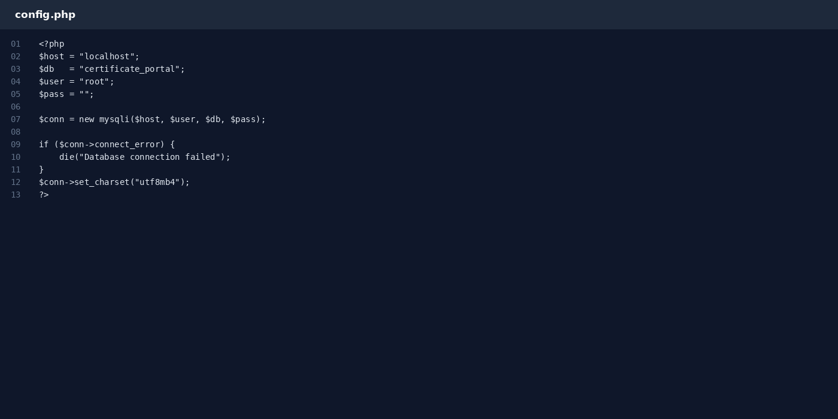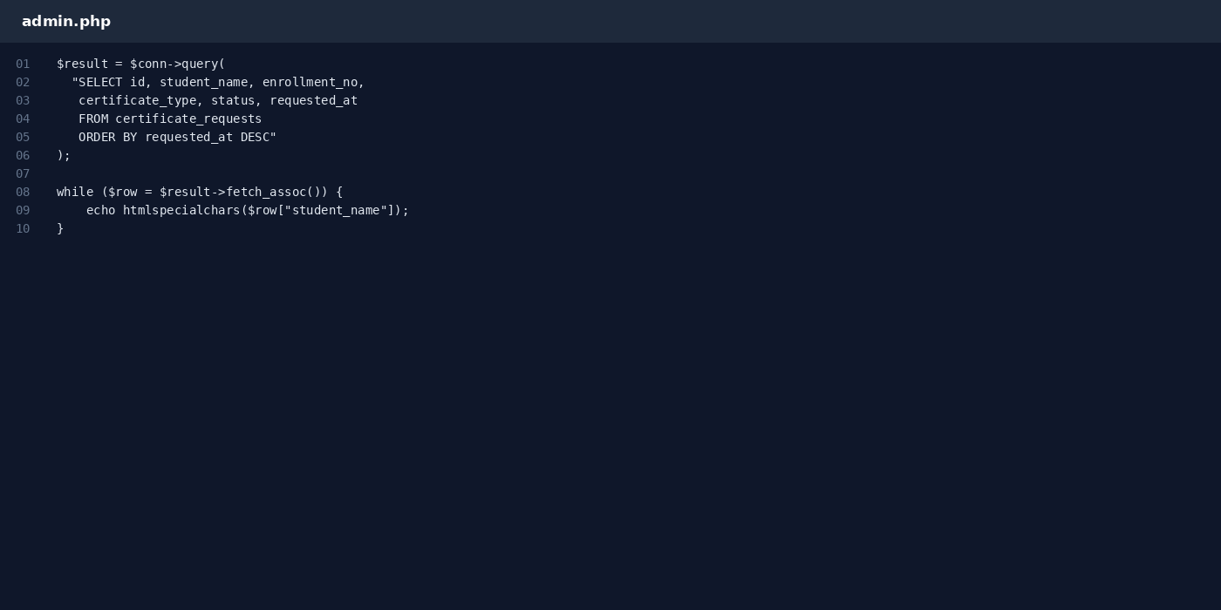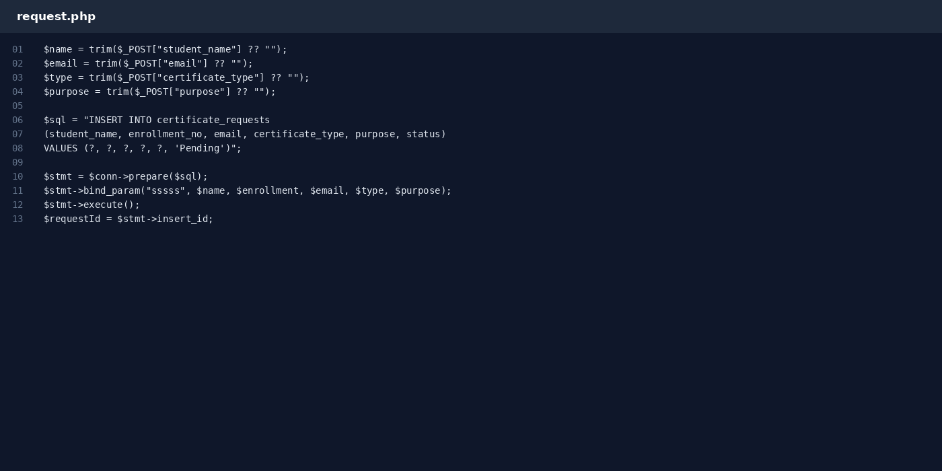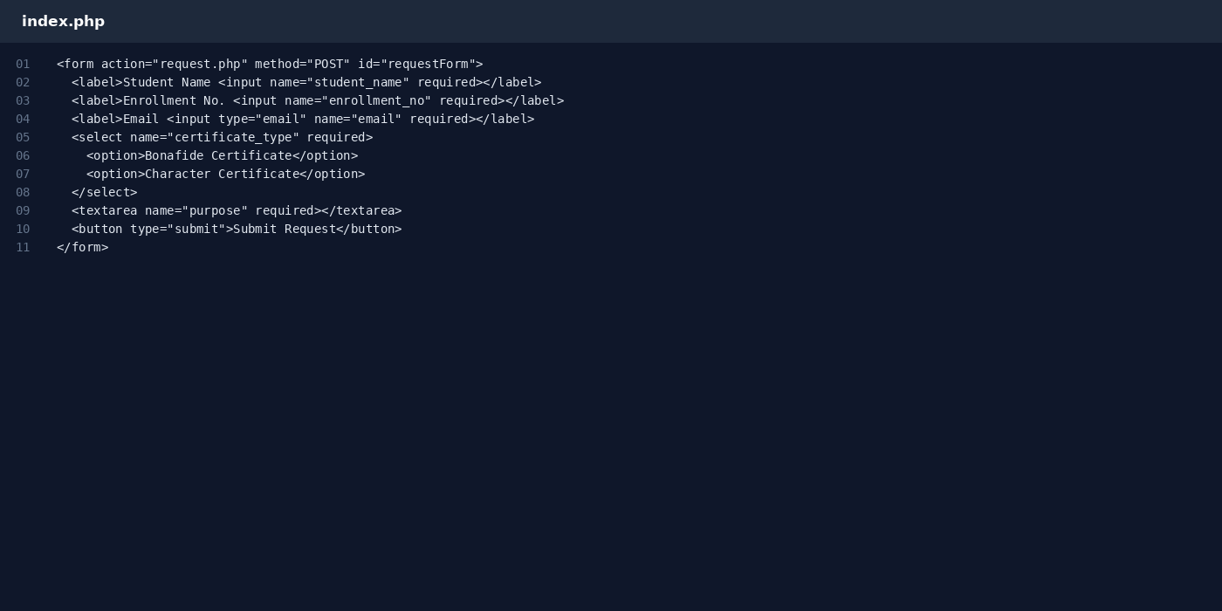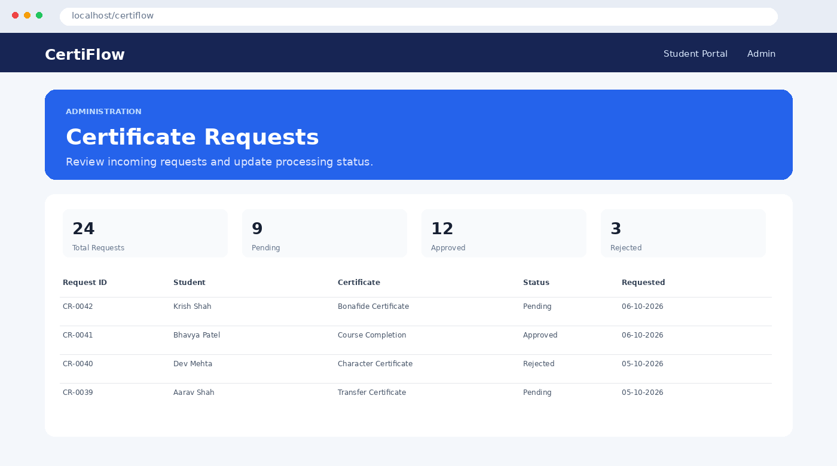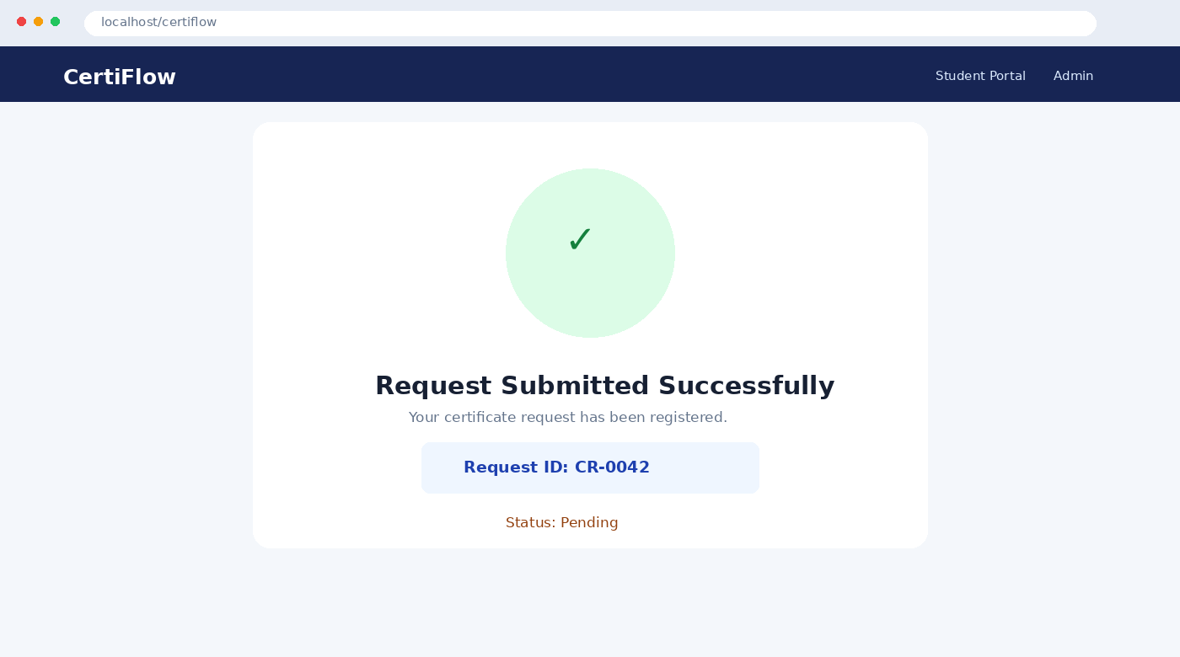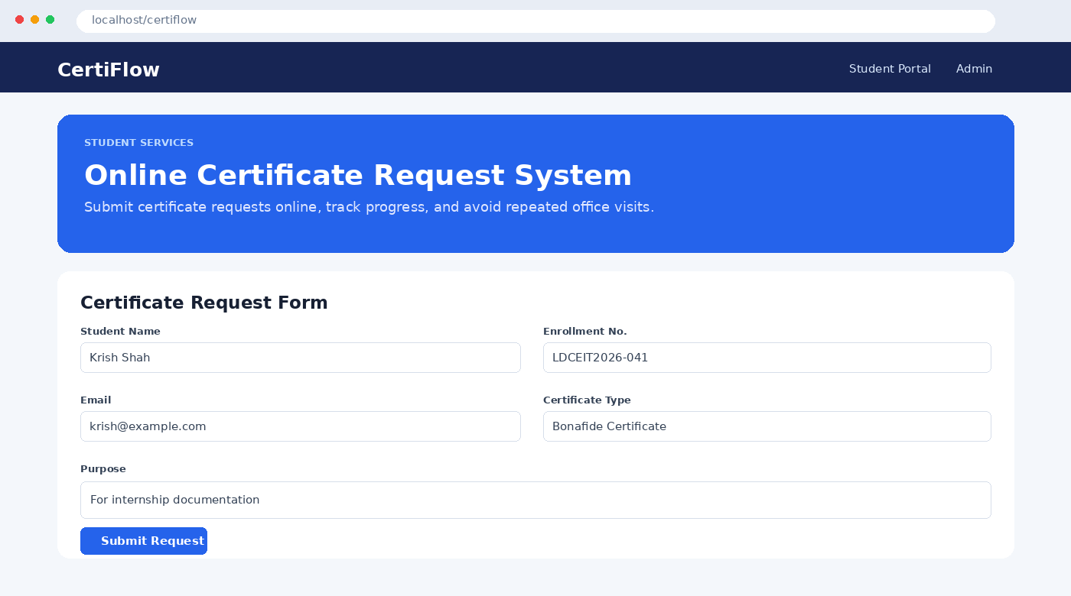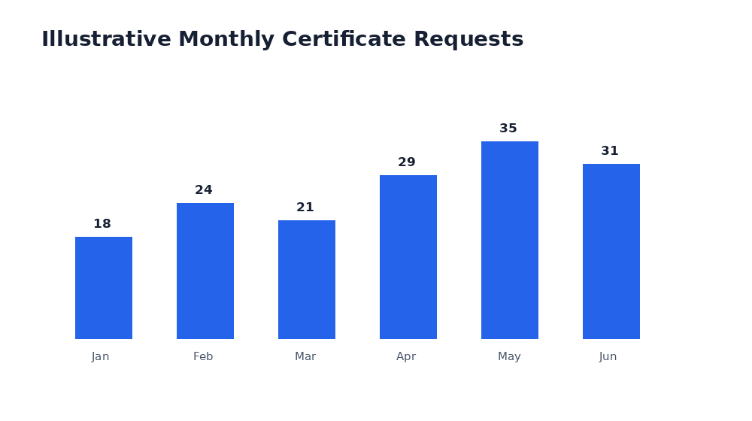

16. Testing and Test Cases
ID | Test | Expected | Result
TC-01 | Open portal | Page displayed | Pass
TC-02 | Valid submission | CR ID + Pending | Pass
TC-03 | Blank name | Rejected | Pass
TC-04 | Invalid email | Rejected | Pass
TC-05 | Short enrollment | Rejected | Pass
TC-06 | Short purpose | Rejected | Pass
TC-07 | Database insert | New row | Pass
TC-08 | Admin listing | Request visible | Pass
TC-09 | Mobile viewport | Single-column layout | Pass
TC-10 | Special characters | Safely stored | Pass

Metric | Result
Total tests | 10
Passed | 10
Failed | 0
Pass rate | 100%

17. Sample Results and Analysis
The chart is illustrative and demonstrates how database records could be aggregated for administration. A production version could generate live charts from MySQL using a JavaScript charting library.
Operation | Expected Output
Valid request | Success page + request ID
Invalid email | Validation error
Missing fields | Rejected
Database insert | New record
Admin view | Request appears
Processed request | Status changes

18. Security Considerations
- Use prepared SQL statements.
- Repeat validation on the server.
- Use HTTPS in production.
- Keep database credentials outside public repositories.
- Add admin authentication and authorization.
- Use password_hash() for passwords.
- Escape displayed data with htmlspecialchars().
- Add CSRF protection to administrative actions.
- Maintain backups and audit logs.

19. Advantages, Limitations and Future Scope

19.1 Advantages
- Less paperwork.
- Fewer office visits.
- Centralized records.
- Clear request reference.
- Simple technology stack.
- Easy to extend.

19.2 Limitations
- No complete authentication in the academic demo.
- Admin status editing is simplified.
- No email/SMS notifications.
- No digital signature.
- Sample statistics are illustrative.

19.3 Future Scope
- Student/admin login and RBAC.
- Email notifications.
- PDF certificate generation.
- QR verification and digital signatures.
- Supporting document upload.
- Advanced search and analytics.
- Cloud deployment.
- PWA/mobile version.
- Audit logs.

20. Conclusion
The Online Certificate Request System demonstrates how a common college administrative process can be transformed into a web application. HTML5, CSS3 and JavaScript provide the interface and validation, PHP handles server-side processing, and MySQL provides persistent storage. The application covers the complete basic workflow from student submission to administrative review.
The project also demonstrates important Web Application Development concepts including form handling, validation, database connectivity, prepared statements, responsive design, modular organization and testing. With authentication, notifications, PDF generation and digital verification, the same foundation can be evolved into a production-level institutional service.

21. References
- PHP Documentation – PHP language and MySQLi reference.
- MySQL Documentation – SQL and database operations.
- MDN Web Docs – HTML, CSS and JavaScript.
- Apache Friends XAMPP documentation.
- W3C Web Standards.

