Name: Akash Sachin Jadhav Class: TY09 Roll No.: 38

Experiment No.: 10

backend/server.js:

const express = require('express');
const mongoose = require('mongoose');
const cors = require('cors');

const app = express();
app.use(express.json());
app.use(cors());

// MongoDB Connection
mongoose.connect('mongodb://localhost:27017/quizSystem');

const ContactSchema = new mongoose.Schema({
name: String,
email: String,
message: String,
date: { type: Date, default: Date.now }
});

const Contact = mongoose.model('Contact', ContactSchema);

// Quiz result schema: stores user details, score, answers and submission time
const QuizResultSchema = new mongoose.Schema({
name: { type: String, required: true },
email: { type: String },
score: { type: Number, required: true },
total: { type: Number, required: true },
answers: { type: Array, default: [] },
submittedAt: { type: Date, default: Date.now }
});

const QuizResult = mongoose.model('QuizResult', QuizResultSchema);

// API Route
app.post('/api/contact', async (req, res) => {
try {
const newQuery = new Contact(req.body);
await newQuery.save();
res.status(201).json({ message: "Saved successfully!" });
} catch (err) {
res.status(500).json({ error: err.message });
}
});

// Save quiz results
app.post('/api/results', async (req, res) => {
try {
const { name, email, score, total, answers } = req.body;
if (!name || typeof score !== 'number' || typeof total !== 'number') {
return res.status(400).json({ error: 'Invalid payload' });
}

const result = new QuizResult({ name, email, score, total, answers });
await result.save();
res.status(201).json({ message: 'Result saved', id: result._id });
} catch (err) {
res.status(500).json({ error: err.message });
}
});

app.listen(5000, () => console.log("Server running on port 5000"));

OUTPUT:
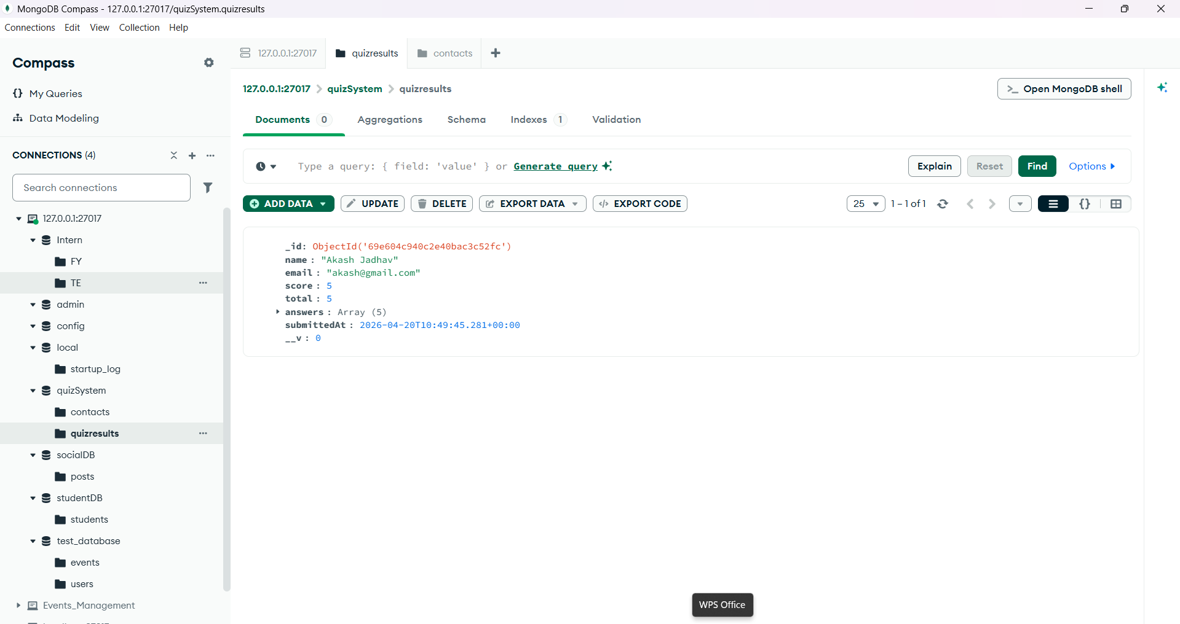

frontend/vite-project/src/APP.jsx:

import React, { useState } from 'react';
import './App.css';
import { motion } from 'framer-motion';
import axios from 'axios';

const App = () => {
const [stage, setStage] = useState('details');
const [user, setUser] = useState({ name: '', email: '' });

const questions = [
{ q: 'What does MERN stand for?', options: ['Mango, Express, React, Node', 'MongoDB, Express, React, Node', 'MySQL, Express, React, Node'], correct: 1 },
{ q: 'Which library is used for building UIs?', options: ['Express', 'React', 'Mongoose'], correct: 1 },
{ q: 'Which database is used in MERN?', options: ['MongoDB', 'MySQL', 'Postgres'], correct: 0 },
{ q: 'Which runtime executes JavaScript on the server?', options: ['Node', 'Django', 'Rails'], correct: 0 },
{ q: 'Which package is used to connect MongoDB in Node?', options: ['mongoose', 'axios', 'cors'], correct: 0 },
];

const [answers, setAnswers] = useState(Array(questions.length).fill(null));
const [score, setScore] = useState(null);

const startQuiz = () => {
if (!user.name.trim()) return alert('Please enter your name to start the quiz');
setStage('quiz');
};

const selectAnswer = (qi, idx) => {
setAnswers(prev => {
const next = [...prev];
next[qi] = idx;
return next;
});
};

const submitQuiz = async () => {
let correct = 0;
questions.forEach((q, i) => { if (answers[i] === q.correct) correct += 1; });
setScore(correct);
// send result to backend
try {
await axios.post('http://localhost:5000/api/results', {
name: user.name,
email: user.email,
score: correct,
total: questions.length,
answers
});
} catch (err) {
console.error('Failed to save result', err?.message || err);
}
setStage('result');
};

const reset = () => {
setUser({ name: '', email: '' });
setAnswers(Array(questions.length).fill(null));
setScore(null);
setStage('details');
};

return (
<div className="min-h-screen bg-slate-50 p-8 font-sans">
<motion.header
initial={{ opacity: 0, y: -20 }}
animate={{ opacity: 1, y: 0 }}
className="text-center mb-12"
>
<h1 className="text-4xl font-bold text-indigo-600">QuizMaster Pro</h1>
<p className="text-gray-600">Test your knowledge, track your progress.</p>
</motion.header>

<div className="max-w-4xl mx-auto gap-8">
{stage === 'details' && (
<div className="bg-white p-6 rounded-2xl shadow-lg">
<h2 className="text-xl font-semibold mb-4">Enter your details</h2>
<div className="space-y-3">
<input value={user.name} onChange={(e) => setUser({...user, name: e.target.value})} placeholder="Name" className="w-full p-2 border rounded-md" />
<input value={user.email} onChange={(e) => setUser({...user, email: e.target.value})} placeholder="Email" className="w-full p-2 border rounded-md" />
<button onClick={startQuiz} className="w-full bg-indigo-600 text-white py-2 rounded-md hover:bg-indigo-700">Start Quiz</button>
</div>
</div>
)}

{stage === 'quiz' && (
<div className="bg-white p-6 rounded-2xl shadow-lg">
<h2 className="text-xl font-semibold mb-4">Quiz</h2>
<form className="space-y-6" onSubmit={(e) => { e.preventDefault(); submitQuiz(); }}>
{questions.map((qq, i) => (
<div key={i} className="p-4 border rounded-md">
<p className="font-medium">{i+1}. {qq.q}</p>
<div className="mt-2 space-y-2">
{qq.options.map((opt, oi) => (
<label key={oi} className="flex items-center space-x-3">
<input type="radio" name={`q-${i}`} checked={answers[i]===oi} onChange={() => selectAnswer(i, oi)} />
<span>{opt}</span>
</label>
))}
</div>
</div>
))}

<div className="flex gap-3">
<button type="submit" className="flex-1 bg-green-600 text-white py-2 rounded-md">Submit Answers</button>
<button type="button" onClick={reset} className="flex-1 bg-gray-200 py-2 rounded-md">Reset</button>
</div>
</form>
</div>
)}

{stage === 'result' && (
<div className="bg-white p-6 rounded-2xl shadow-lg">
<h2 className="text-xl font-semibold mb-4">Result</h2>
<p className="mb-4">{user.name}, your score: <strong>{score}/{questions.length}</strong></p>
<div className="space-y-3">
{questions.map((q, i) => (
<div key={i} className="p-3 border rounded-md">
<p className="font-medium">{i+1}. {q.q}</p>
<p className="text-sm">Your answer: <strong>{answers[i] != null ? q.options[answers[i]] : 'No answer'}</strong></p>
<p className="text-sm">Correct answer: <strong>{q.options[q.correct]}</strong></p>
</div>
))}
</div>
<div className="mt-4 flex gap-3">
<button onClick={reset} className="bg-indigo-600 text-white py-2 px-4 rounded-md">Retake</button>
</div>
</div>
)}
</div>
</div>
);
};

export default App;

frontend/vite-project/src/APP.css:

* {
box-sizing: border-box;
margin: 0;
padding: 0;
}

body {
margin: 0;
font-family: 'Inter', -apple-system, BlinkMacSystemFont, 'Segoe UI', Roboto, sans-serif;
background-color: #f8fafc; /* Slate 50 */
color: #1e293b; /* Slate 800 */
-webkit-font-smoothing: antialiased;
}

.min-h-screen {
min-height: 100vh;
padding: 2rem;
}

/* 2. Layout Containers */
.max-w-4xl {
max-width: 1000px;
margin: 0 auto;
display: grid;
grid-template-columns: repeat(auto-fit, minmax(300px, 1fr));
gap: 2rem;
margin-top: 3rem;
}

/* 3. Header Styling */
.text-center {
text-align: center;
}

.text-4xl {
font-size: 2.5rem;
color: #4f46e5; /* Indigo 600 */
margin-bottom: 0.5rem;
}

.text-gray-600 {
color: #64748b;
font-size: 1.1rem;
}

/* 4. Card Styling (Quiz & Form) */
.bg-white {
background: #ffffff;
padding: 2rem;
border-radius: 1.25rem;
box-shadow: 0 10px 25px -5px rgba(0, 0, 0, 0.05),
0 8px 10px -6px rgba(0, 0, 0, 0.05);
border: 1px solid #eef2ff;
}

.text-xl {
font-size: 1.25rem;
font-weight: 600;
margin-bottom: 1.5rem;
color: #1e1b4b;
}

/* 5. Interactive Quiz Buttons */
.space-y-2 > * + * {
margin-top: 0.75rem;
}

.w-full {
width: 100%;
}

.text-left {
text-align: left;
}

button.border {
background: transparent;
border: 2px solid #e2e8f0;
padding: 1rem;
border-radius: 0.75rem;
cursor: pointer;
font-size: 1rem;
transition: all 0.2s ease;
color: #475569;
}

button.border:hover {
background-color: #f5f3ff;
border-color: #c7d2fe;
color: #4f46e5;
transform: translateX(5px);
}

/* 6. Form Styling */
.space-y-4 > * + * {
margin-top: 1rem;
}

input, textarea {
width: 100%;
padding: 0.75rem 1rem;
border: 1.5px solid #e2e8f0;
border-radius: 0.5rem;
font-size: 0.95rem;
outline: none;
transition: border-color 0.2s;
}

input:focus, textarea:focus {
border-color: #818cf8;
box-shadow: 0 0 0 3px rgba(129, 140, 248, 0.1);
}

textarea {
resize: vertical;
min-height: 100px;
}

/* Utility classes used in the quiz markup */
.p-4 { padding: 1rem; }
.p-3 { padding: 0.75rem; }
.border { border: 1px solid #e6eef8; }
.rounded-md { border-radius: 0.5rem; }
.rounded-2xl { border-radius: 1.25rem; }
.flex { display: flex; }
.items-center { align-items: center; }
.space-x-3 > * + * { margin-left: 0.75rem; }
.mt-2 { margin-top: 0.5rem; }
.mt-4 { margin-top: 1rem; }
.mb-4 { margin-bottom: 1rem; }
.font-medium { font-weight: 600; }

/* Quiz-specific styling */
.question-card {
background: linear-gradient(180deg, #ffffff 0%, #fbfdff 100%);
border: 1px solid #eef2ff;
}

.option-label {
display: flex;
align-items: center;
gap: 0.75rem;
padding: 0.6rem 0.5rem;
border-radius: 0.5rem;
cursor: pointer;
transition: background 0.15s, transform 0.08s;
}

.option-label:hover { background: #f8fafc; transform: translateX(2px); }

input[type="radio"] {
width: 1rem;
height: 1rem;
accent-color: #4f46e5; /* Indigo */
}

.submit-button { background: #059669; color: #fff; border: none; padding: 0.75rem; border-radius: 0.5rem; font-weight: 600; cursor: pointer; }
.submit-button:hover { background: #047857; }

.btn-reset { background: #f1f5f9; color: #0f172a; border: none; padding: 0.6rem; border-radius: 0.5rem; cursor: pointer; }

.result-item { padding: 0.75rem; border-radius: 0.5rem; margin-top: 0.5rem; }
.correct { background: #ecfdf5; border-left: 4px solid #10b981; }
.incorrect { background: #fff7f7; border-left: 4px solid #ef4444; }

/* Make primary/secondary button utilities consistent */
.bg-green-600 { background-color: #059669; color: white; }
.bg-green-600:hover { background-color: #047857; }
.bg-gray-200 { background-color: #f1f5f9; }

/* 7. Primary Action Button */
.bg-indigo-600 {
background-color: #4f46e5;
color: white;
border: none;
padding: 0.75rem;
border-radius: 0.5rem;
font-weight: 600;
cursor: pointer;
display: flex;
align-items: center;
justify-content: center;
transition: background 0.2s;
}

.bg-indigo-600:hover {
background-color: #4338ca;
}

.mr-2 {
margin-right: 0.5rem;
}

/* 8. Status Messages */
.text-green-600 {
color: #16a34a;
background: #f0fdf4;
padding: 0.75rem;
border-radius: 0.5rem;
text-align: center;
}

/* Responsive Adjustments */
@media (max-width: 768px) {
.min-h-screen {
padding: 1rem;
}
.text-4xl {
font-size: 2rem;
}
}

OUTPUT:
