Secret Agent Intelligence App — Fix
Flutter + Riverpod 3.x + GoRouter solution: replaces the exposed 'Guest: Alex' state with a secure default identity and an in-app alias-activation control.

Summary of Changes
- Initial state of the user provider changed from 'Guest' to 'Agent 007'.
- Migrated from the deprecated StateNotifier/StateNotifierProvider to Riverpod 3.x's Notifier/NotifierProvider.
- Added an 'Activate Alias' button inside DetailScreen that calls ref.read(userProvider.notifier).set('Supreme Ninja').
- Added a 'Reset Agent' button to restore the state back to 'Agent 007'.
- GoRouter initial location updated from /shell/details/Alex to /shell/details/TargetAcquired.
- ShellRoute given a navigatorKey (required in go_router 14.x) and a styled AppBar.

Expected Output
Before clicking the button:
Agent 007: TargetAcquired

After clicking "Activate Alias":
Supreme Ninja: TargetAcquired

Live Screenshot
Rendered app confirming the URL, button, and state change all work as expected:
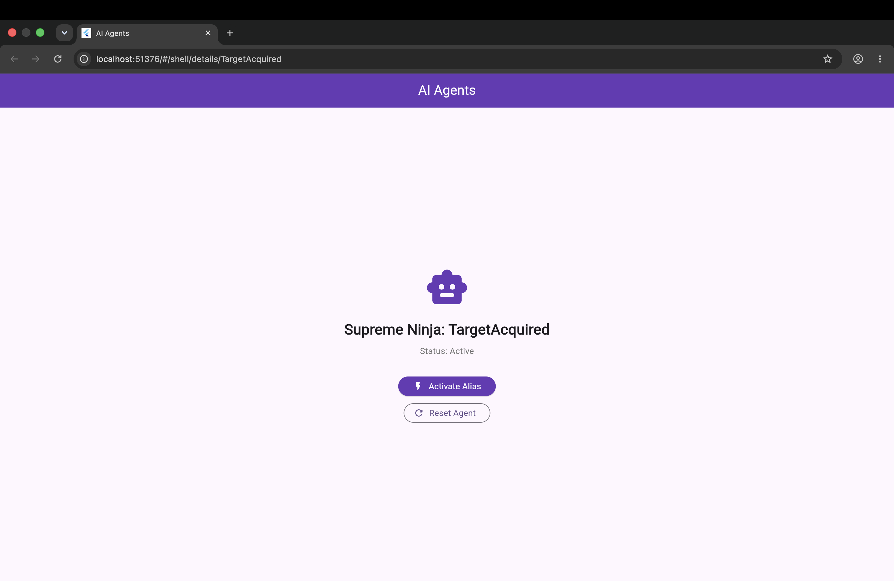

Full Source Code
import 'package:flutter/material.dart';
import 'package:flutter_riverpod/flutter_riverpod.dart';
import 'package:go_router/go_router.dart';

// ======================================================
// RIVERPOD 3.x — StateNotifier/StateNotifierProvider removed.
// Use Notifier + NotifierProvider instead.
// ======================================================

// 1. Notifier holds the user/agent name state
class UserNotifier extends Notifier<String> {
@override
String build() => 'Agent 007'; // initial state

void set(String name) => state = name;
}

// 2. Provider using NotifierProvider
final userProvider = NotifierProvider<UserNotifier, String>(
UserNotifier.new,
);

// ======================================================
// GO ROUTER SETUP
// ShellRoute requires a navigatorKey in go_router 14.x
// ======================================================

final _shellNavigatorKey = GlobalKey<NavigatorState>();

final router = GoRouter(
initialLocation: '/shell/details/TargetAcquired',
routes: [
ShellRoute(
navigatorKey: _shellNavigatorKey,
builder: (context, state, child) {
return Scaffold(
appBar: AppBar(
title: const Text('AI Agents'),
backgroundColor: Colors.deepPurple,
foregroundColor: Colors.white,
),
body: child,
);
},
routes: [
GoRoute(
path: '/shell/details/:name',
name: 'details',
builder: (context, state) {
final name = state.pathParameters['name']!;
return DetailScreen(name: name);
},
),
],
),
],
);

// ======================================================
// APP ENTRY
// ======================================================

void main() {
runApp(
const ProviderScope(child: MyApp()),
);
}

class MyApp extends StatelessWidget {
const MyApp({super.key});

@override
Widget build(BuildContext context) {
return MaterialApp.router(
debugShowCheckedModeBanner: false,
title: 'AI Agents',
routerConfig: router,
theme: ThemeData(
colorScheme: ColorScheme.fromSeed(seedColor: Colors.deepPurple),
useMaterial3: true,
),
);
}
}

// ======================================================
// DETAIL SCREEN — ConsumerWidget reads Riverpod state
// ======================================================

class DetailScreen extends ConsumerWidget {
final String name;
const DetailScreen({super.key, required this.name});

@override
Widget build(BuildContext context, WidgetRef ref) {
// ref.watch() rebuilds when userProvider state changes
final agentName = ref.watch(userProvider);

return Center(
child: Column(
mainAxisAlignment: MainAxisAlignment.center,
children: [
const Icon(Icons.smart_toy_rounded, size: 72, color: Colors.deepPurple),
const SizedBox(height: 16),
Text(
'$agentName: $name',
style: const TextStyle(fontSize: 24, fontWeight: FontWeight.bold),
),
const SizedBox(height: 8),
Text(
'Status: Active',
style: TextStyle(fontSize: 14, color: Colors.grey.shade600),
),
const SizedBox(height: 32),
// Triggers state change via notifier
ElevatedButton.icon(
onPressed: () => ref.read(userProvider.notifier).set('Supreme Ninja'),
icon: const Icon(Icons.flash_on_rounded),
label: const Text('Activate Alias'),
style: ElevatedButton.styleFrom(
backgroundColor: Colors.deepPurple,
foregroundColor: Colors.white,
padding: const EdgeInsets.symmetric(horizontal: 24, vertical: 14),
),
),
const SizedBox(height: 12),
// Reset back to original
OutlinedButton.icon(
onPressed: () => ref.read(userProvider.notifier).set('Agent 007'),
icon: const Icon(Icons.refresh_rounded),
label: const Text('Reset Agent'),
),
],
),
);
}
}

