Preview

[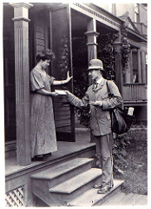](https://www.flickr.com/photos/smithsonian/2550236041/)  
"[Letter Carrier Delivering Mail](https://www.flickr.com/photos/smithsonian/2550236041/)" ([Public Domain](https://www.flickr.com/commons/usage/)) by [Smithsonian Institution](https://www.flickr.com/people/smithsonian/)

[[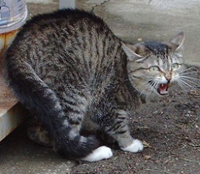](https://www.flickr.com/photos/consumerist/4609603403/)](https://www.flickr.com/photos/consumerist/4609603403/)  
"[Hissing cat](https://www.flickr.com/photos/consumerist/4609603403/)" ([CC BY 2.0](https://creativecommons.org/licenses/by/2.0/)) by [Consumerist Dot Com](https://www.flickr.com/people/consumerist/)