# COVID-19 : Nature Vs Man

# (Tackling COVID19 with Social Distancing)

### By- Abhay Kshirsagar

On 1 December 2019, many patients with pneumonia-like symptoms were discovered in *Wuhan City* in *Hubei*  Province, *China*. The new virus named SARS-CoV-2 (severe acute respiratory syndrome coronavirus 2) by ICTV (International Committee on Taxonomy of Viruses) was identified in a bronchoalveolar lavage fluid (BALF) sample from three patients in Wuhan using metagenomic *next-generation sequencing* technology. This virus is the third virus in the series of pandemic corona-viruses viruses after **SARS** (severe acute respiratory syndrome) and ***MERS*** (Middle East respiratory syndrome) outbreaks.

A total of 1.5 million cases have been reported with over 90,000 deaths. It has been the highest of all the pandemics related to coronaviruses. The highest by far has been held by 1918 Spanish flu, which infected around a third of the population and killed around 50 million people.

The main reason why such outbreaks res-ulted in a global pandemic is the rapid person to person transmission due to lack of proper quaran-tine measures. Take, for example, the Spanish flu; it probably spread due to lack of screening measures during mass refugee crisis during World War I. The disease keeps infecting people, and with each infection, the Spanish flu mutated, making it even harder to curb.

**About SARS-CoV-2**

SARS-CoV-2 or COVID-19 belongs to the family CoronaViridae, which is a family of zoonotic viruses. CoV is a class of viruses with enveloped, positive-sense ssRNA. They further divided into subfamilies α, β, γ and δ of these α and β families infect humans. After analysis, SARS-CoV-2 was identified to be β; other viruses that belong to β-CoV are SARS-COV-1 and MERS. Genome-wide phylogenetic analysis tells us that SARS-CoV-2 shares 79.5 percent of its genomic identity with SARS-CoV-1. Both of these viruses attach to the human *angiotensin-converting enzyme* 2 (ACE2) receptor for cell entry.

Regarding origin, all SARS-like CoV viruses have their natural roots in Horseshoe bats? Generally, Bat SARS cannot infect humans directly unless they undergo mutation or recombination with animal hosts; for example, the hosts for SARS-CoV-1 and MERS-CoV were civets and camels. Currently, very little is known about the origin of COVID19. However, the genomic analysis suggests that pangolin might be the hosts.

### 

### Current Situation

 If we look at the above chart, which shows the number of confirmed cases against the number of days passed, we can see from the graph that the rate of confirmed cases has been stabilized for China and South Korea, which means that the number of newly confirmed cases has gone down. The numbers are plotted on a*logarithmic*scale on the y-axis.

In this age of globalization, with its fast-paced travel, makes it really hard to control a pandemic; however, we should learn from our past experiences of pandemics and understand the urgency of quarantine during pandemics. China and South Korea can be seen to have acted according to recent reports, and even from the chart, it is apparent. The mandatory lockdown in Hubei province from 23 January evidently resisted the spread to nearby districts. During the lockdown, all major national events where a gathering could take place were either canceled or postponed.

The above strategy worked in China to flatten the curve. In contrast, South Korea implemented a rigorous testing regime and clear public information, which resulted in people practicing more and more social distancing and self-isolation by infected or people that are under quarantine. This strategy of south Korea helped in reducing the spread even further.

Out of these two strategies, we will be discussing Social distancing with the help of SEIR Models to better understand it.

### SEIR Modelling

**SEIR** stands for **S**usceptible, **E**xposed, **I**nfected, and **R**ecovered or **R**emoved as it also includes deceased by the virus.

* α is the rate of incubation
* β is the average contact rate in the population
* 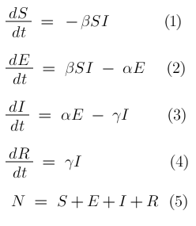 γ is the inverse of the mean infectious period

There is another value in epidemiology used quite frequently, R0; it's the Basic Reproductive number, which can be thought of as the expected number of cases directly generated by one case in a population where all are susceptible.

R0 is found by the following formula.



After solving the ODE's with our initial population to be 10000 ten thousand with one person exposed, we will sample our data for each day, for a normal outbreak, we get the following graph. (Lets take the values α = 0.4 and β = 1.5 and γ =0.6)

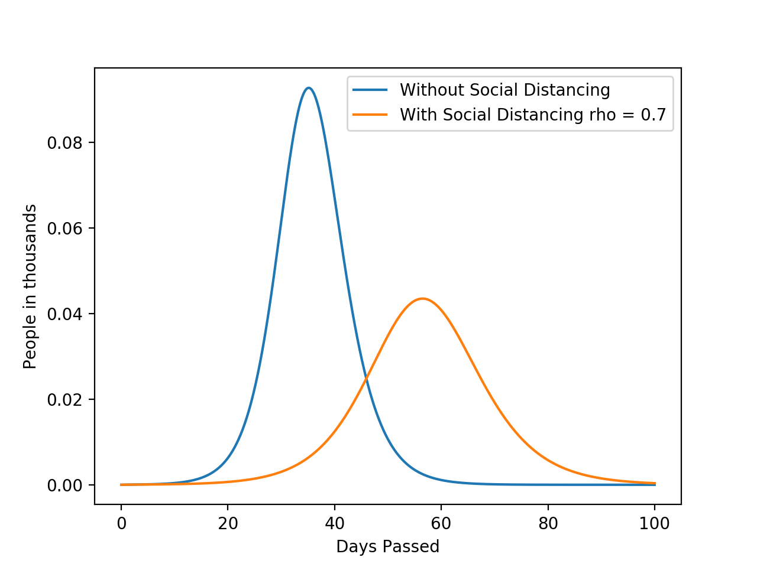With our base case, we can see that about 15% of our population will be infected.

### With Social Distancing

For modeling social distancing, we will define another value *“ρ* ” where  *ρ* = 1 means everyone is exposed and  *ρ* = 0 means strict lockdown. For our example, we will consider  *ρ* = 0.7.

From our previous simulation less number of people have been infected(nearly halved), and the onset of spread has been delayed

### Conclusion

With the current age of globalization, we are able to commute anywhere easily and also making us venerable to such diseases. However, with proper quarantine measures, we can control the disease to the point we ourselves develop immunity towards it or find a cure. Including Social Distancing and Government Lockdown we there should be more funding toward constant testing as well as practicing proper hygiene like carrying a hand sanitizer and a mask all the time.

Just like coronavirus, there are other zoonotic diseases that are diseases that can affect other animals. Hence we should also reduce the consumption of meat obtained from animals that carry these diseases. This will also help conserve our biodiversity and keep the diseases at bay.

References:

1) Data : <https://github.com/datasets/covid-19/blob/master/data/time-series-19-covid-combined.csv>

2) [https://en.wikipedia.org/wiki/2019%E2%80%9320_coronavirus_pandemic](https://en.wikipedia.org/wiki/2019–20_coronavirus_pandemic)

3) <https://researchmatters.in/news/urgency-social-distancing-india-lessons-learn-past-and-present>

4) <https://www.mdpi.com/1999-4915/12/4/372/htm>

5) <https://www.medrxiv.org/content/10.1101/2020.03.04.20031187v1>

6) <https://en.wikipedia.org/wiki/Compartmental_models_in_epidemiology>

7) Code for the plots :