CMPE-282: Cloud Services
Homework #5 – Security
Student: Atharva Kulkarni
Email: atharva.kulkarni@sjsu.edu
Date: April 25, 2026
GitHub Repository: https://github.com/AK9175/cmpe282-hw5-security

Part A: Configure Apache Web Server with SSL/TLS
This section documents the configuration of an Apache Web Server on Amazon Linux 2 to use SSL/TLS, verified via deep analysis on SSL Labs (ssllabs.com).

Step A.1 – Launch EC2 Instance
An Amazon Linux 2 t2.micro EC2 instance named hw5-ssl-server was launched using the AWS CLI. A new security group was created allowing inbound traffic on ports 22 (SSH), 80 (HTTP), and 443 (HTTPS).
aws ec2 run-instances --image-id ami-0058102e678cd65ab --instance-type t2.micro \
--key-name hw5-key --security-group-ids sg-03b91fea232ceb60a \
--tag-specifications 'ResourceType=instance,Tags=[{Key=Name,Value=hw5-ssl-server}]'

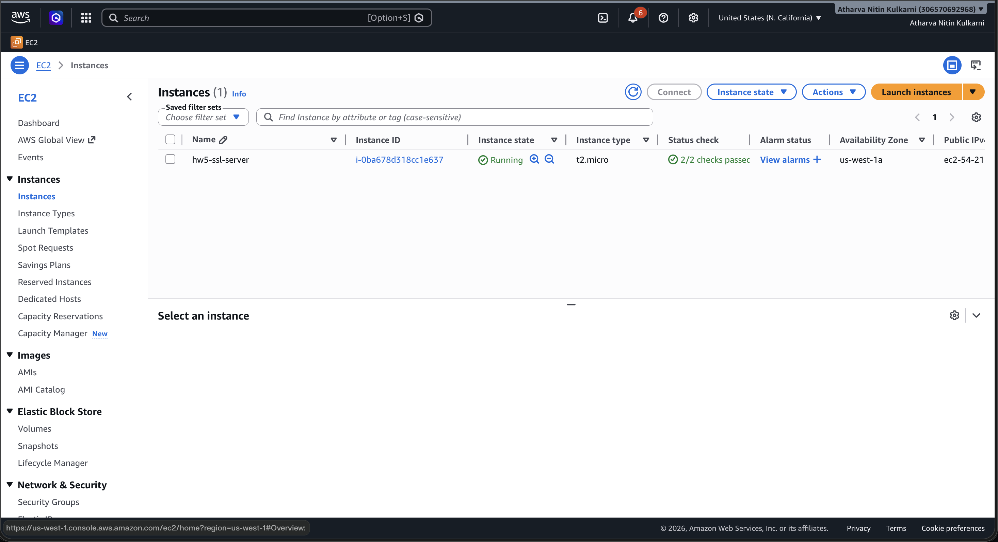
Figure 1: EC2 instance hw5-ssl-server in Running state (Public IP: 54.219.251.209)

Step A.2 – Install Apache and mod_ssl
Apache HTTP Server and mod_ssl were installed on the EC2 instance via SSH. Apache was started and enabled to launch on system boot.
sudo yum install -y httpd mod_ssl
sudo systemctl start httpd
sudo systemctl enable httpd

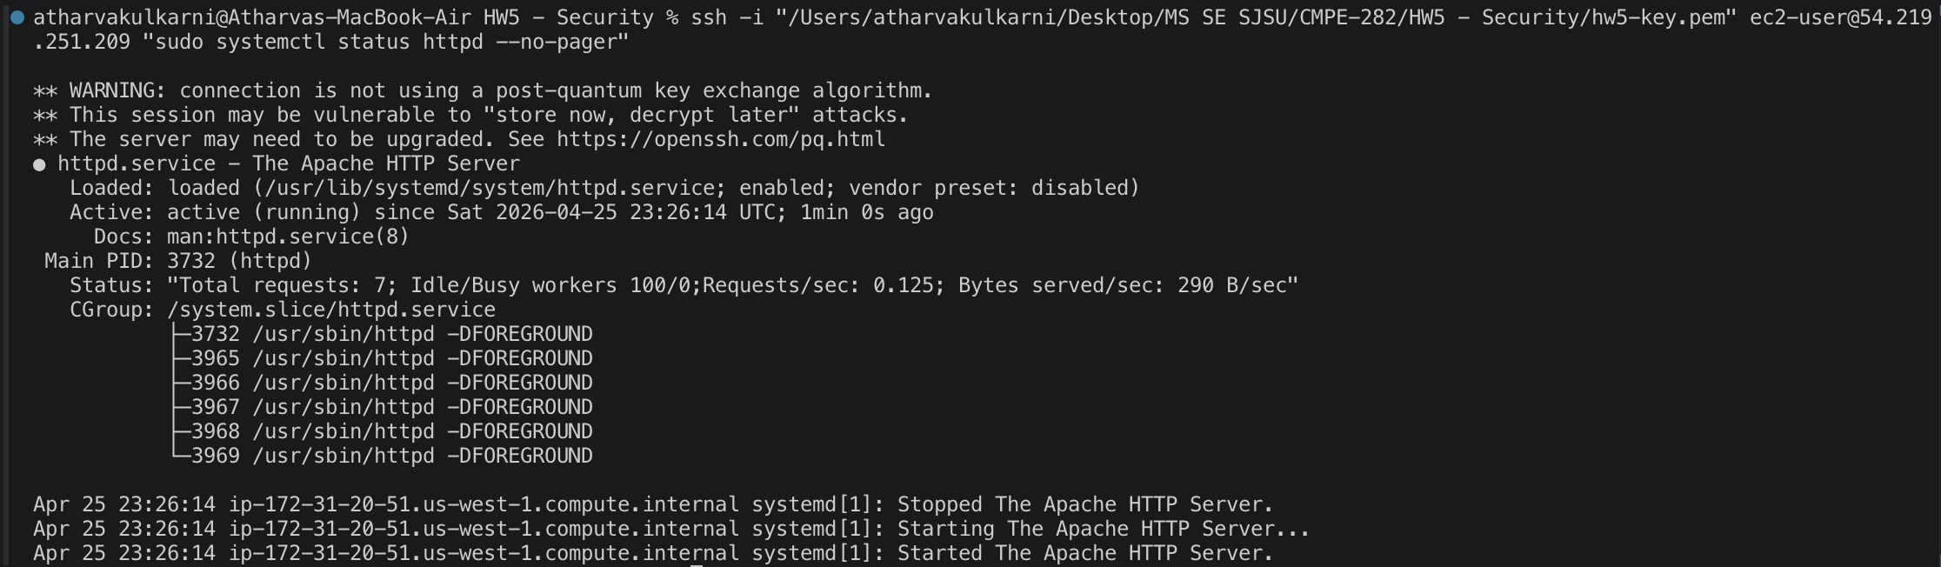
Figure 2: Apache HTTP Server active and running on EC2

Step A.3 – Obtain SSL Certificate via Let's Encrypt (Certbot)
Certbot was installed via EPEL and used to obtain a trusted SSL/TLS certificate from Let's Encrypt for the domain 54.219.251.209.nip.io (nip.io provides free wildcard DNS for any IP, eliminating the need to purchase a domain). The certificate was automatically configured in Apache.
sudo amazon-linux-extras install epel -y
sudo yum install -y certbot python2-certbot-apache
sudo certbot --apache -d 54.219.251.209.nip.io --non-interactive --agree-tos -m atharva.kulkarni@sjsu.edu
HSTS (HTTP Strict Transport Security) was also enabled to enforce HTTPS connections, improving the SSL Labs score.
Header always set Strict-Transport-Security "max-age=63072000; includeSubDomains"

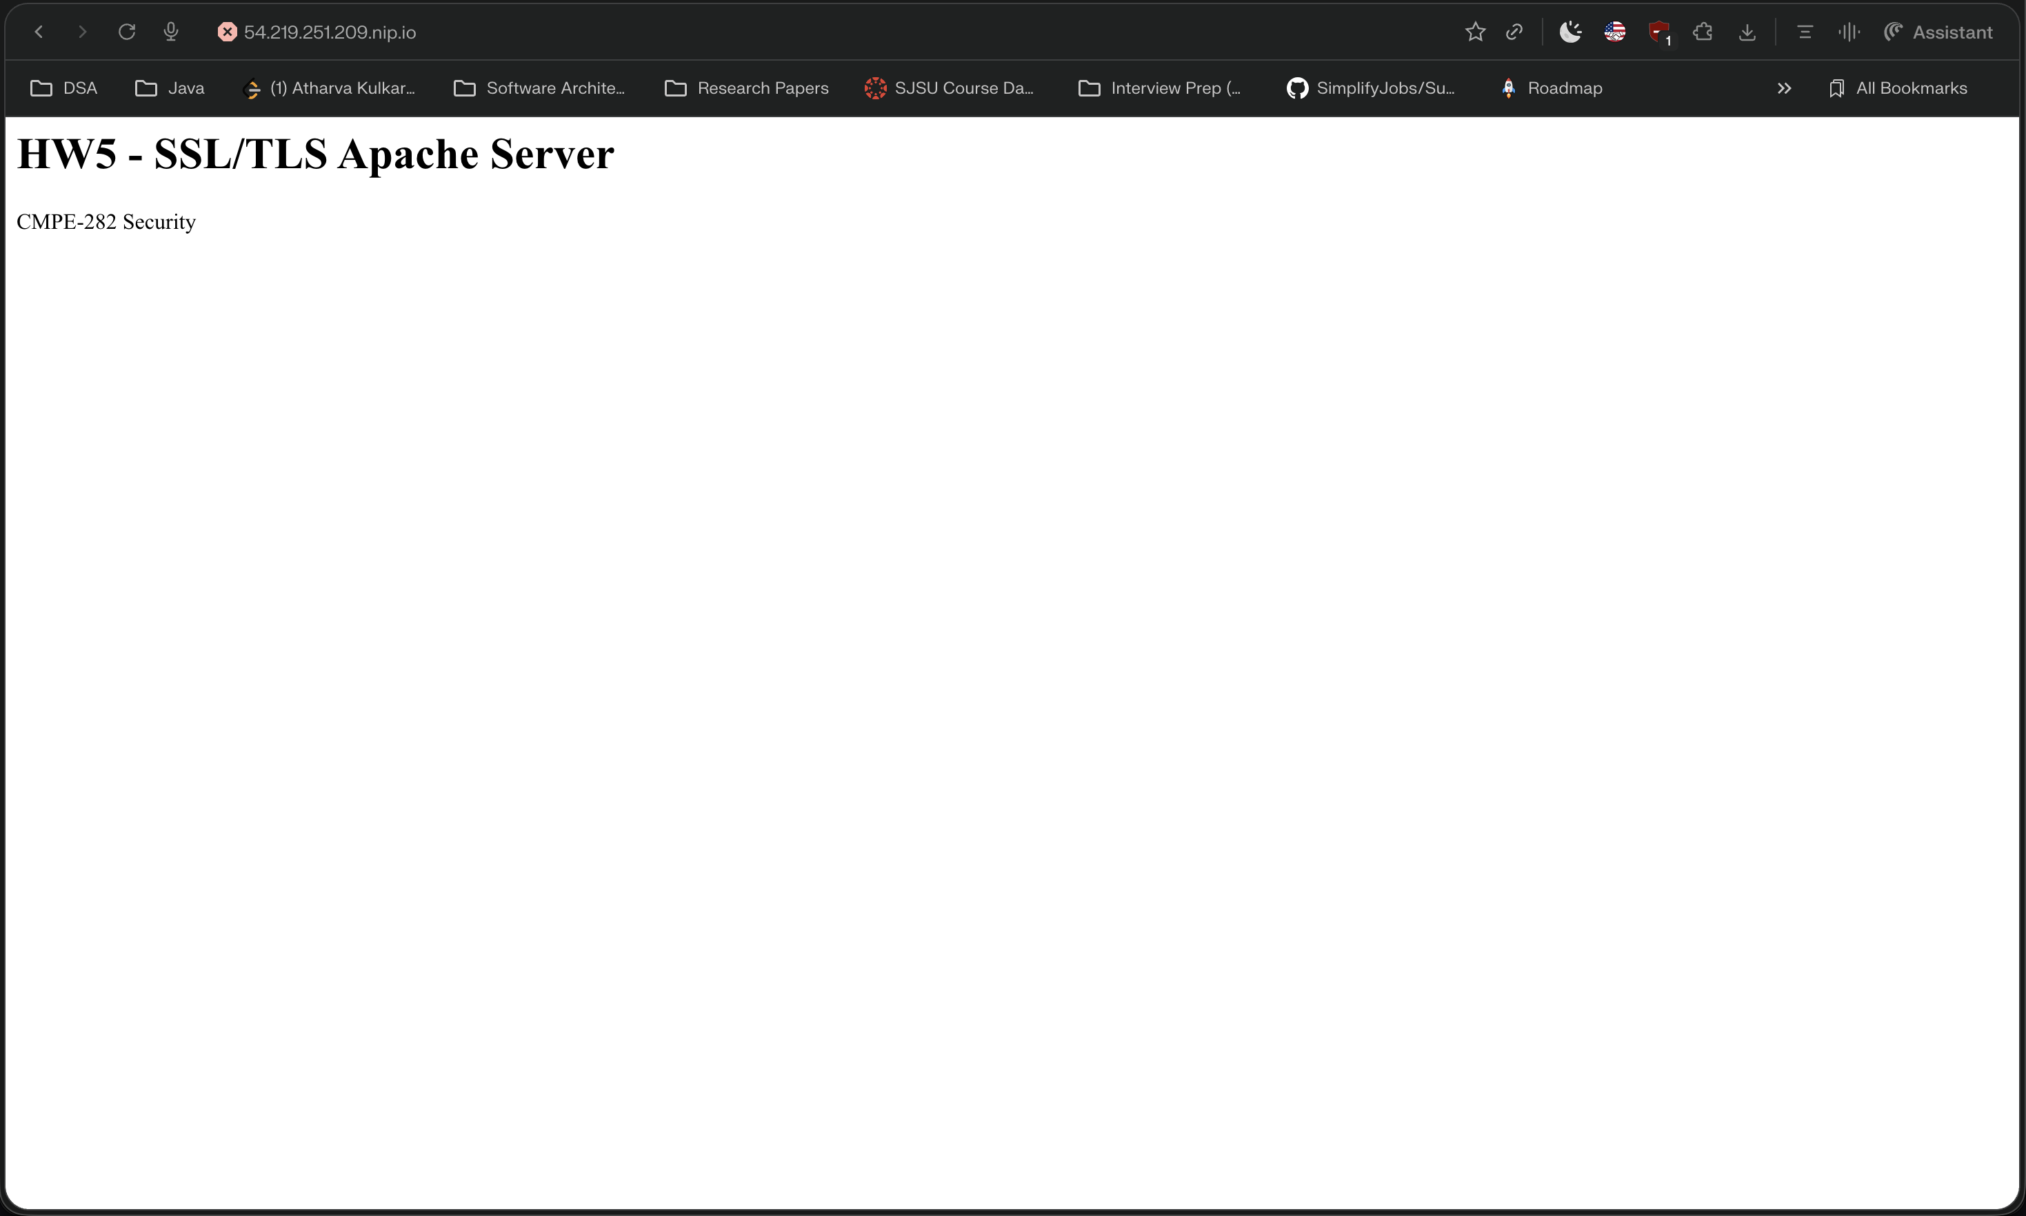
Figure 3: HTTPS site loading with valid SSL certificate in browser

Step A.4 – SSL Labs Deep Analysis
The SSL configuration was analyzed using the Qualys SSL Labs Server Test at https://www.ssllabs.com/ssltest/analyze.html. The server achieved an A- overall rating, with the certificate trusted by Mozilla, Apple, Android, Java, and Windows root stores. The certificate was issued by Let's Encrypt (R13 intermediate, ISRG Root X1).
Key findings from SSL Labs analysis:
- Overall Grade: A-
- Certificate: Valid, trusted by all major root stores
- Protocol Support: TLS 1.2
- Key Exchange: Strong (ECDHE)
- Cipher Strength: Strong (AES-256)
- HSTS: Configured with long duration

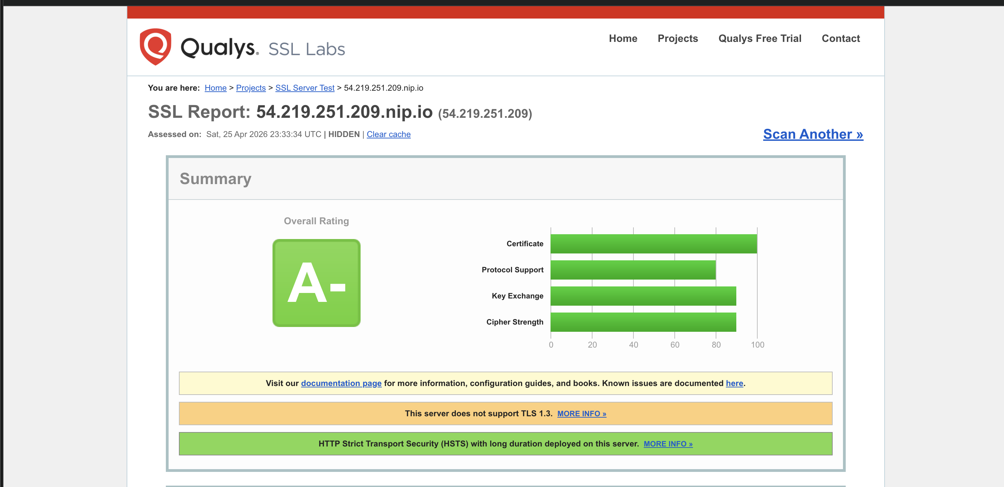
Figure 4: SSL Labs analysis showing A- grade for 54.219.251.209.nip.io

Full setup script available on GitHub: https://github.com/AK9175/cmpe282-hw5-security/blob/main/apache-ssl-setup.sh

Part B: Use IAM Roles to Grant Access to an AWS Application on EC2
This section demonstrates using IAM Roles to securely grant an EC2 instance read-only access to Amazon S3 without embedding any credentials in the application code.

Step B.1 – Create IAM Role with S3 Read-Only Access
An IAM role named hw5-s3-readonly-role was created with a trust policy allowing EC2 to assume it. The AWS managed policy AmazonS3ReadOnlyAccess was attached, and an instance profile was created to associate the role with an EC2 instance.
aws iam create-role --role-name hw5-s3-readonly-role \
--assume-role-policy-document '{"Version":"2012-10-17","Statement":[{"Effect":"Allow",
"Principal":{"Service":"ec2.amazonaws.com"},"Action":"sts:AssumeRole"}]}'
aws iam attach-role-policy --role-name hw5-s3-readonly-role \
--policy-arn arn:aws:iam::aws:policy/AmazonS3ReadOnlyAccess
aws iam create-instance-profile --instance-profile-name hw5-s3-readonly-profile
aws iam add-role-to-instance-profile --instance-profile-name hw5-s3-readonly-profile \
--role-name hw5-s3-readonly-role

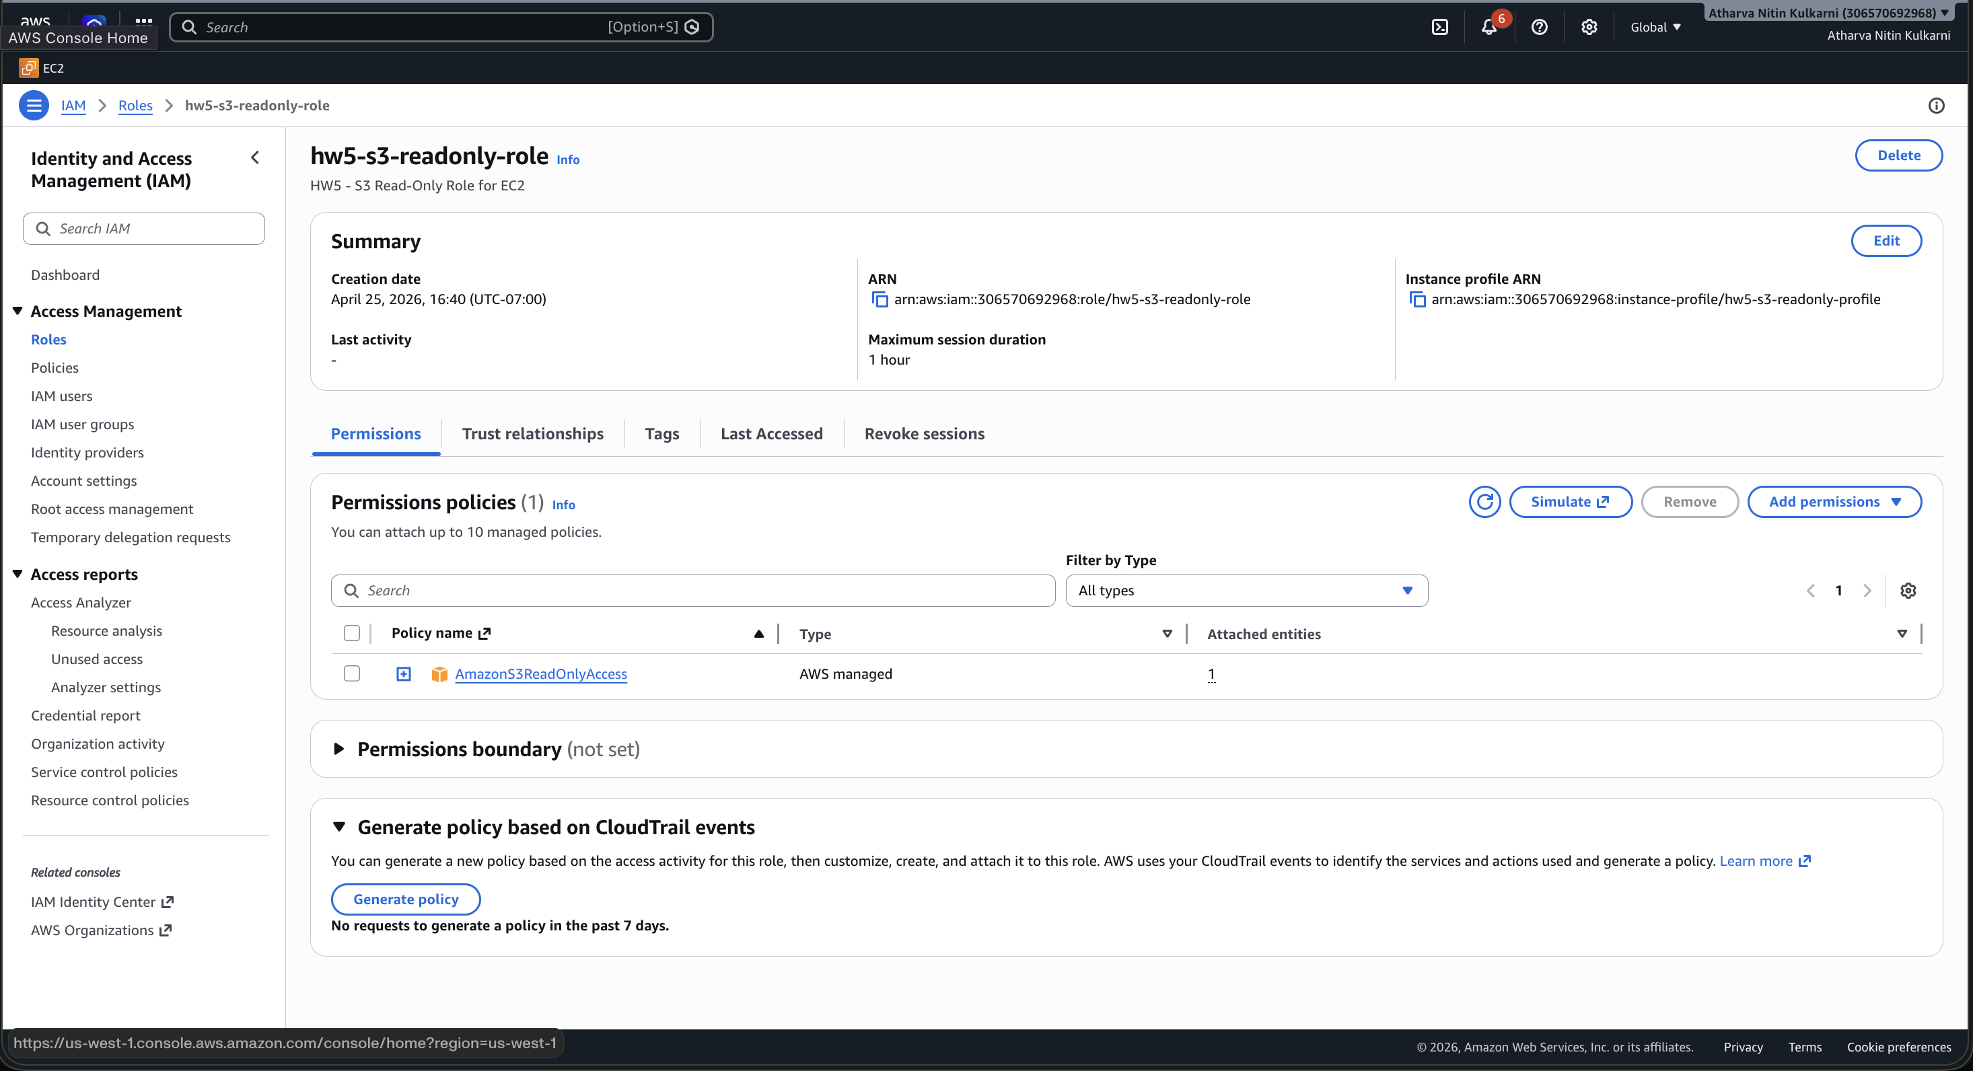
Figure 5: IAM role hw5-s3-readonly-role with AmazonS3ReadOnlyAccess policy attached

Step B.2 – Launch EC2 Instance with IAM Role
A second EC2 instance named hw5-s3-app-server was launched with the IAM instance profile attached. This grants the instance automatic, temporary, rotating credentials to access AWS services — no hardcoded keys required.
aws ec2 run-instances --image-id ami-0058102e678cd65ab --instance-type t2.micro \
--key-name hw5-key --iam-instance-profile Name=hw5-s3-readonly-profile \
--tag-specifications 'ResourceType=instance,Tags=[{Key=Name,Value=hw5-s3-app-server}]'

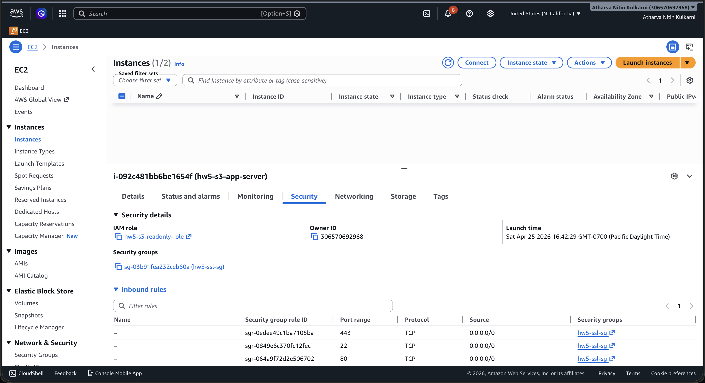
Figure 6: EC2 instance hw5-s3-app-server with hw5-s3-readonly-role attached

Step B.3 – Transfer Application to EC2
A Python application (s3_app.py) was written using the AWS SDK for Python (boto3). The application lists all S3 buckets and their objects using credentials automatically provided by the EC2 instance metadata service via the attached IAM role. The file was transferred to the EC2 instance using SCP.
# Source code: https://github.com/AK9175/cmpe282-hw5-security/blob/main/s3_app.py
scp -i hw5-key.pem s3_app.py ec2-user@3.101.191.21:~/s3_app.py

Figure 7: s3_app.py transferred to EC2 instance via SCP

Step B.4 – Run Application on EC2
The application was executed on the EC2 instance. boto3 automatically retrieved temporary credentials from the EC2 Instance Metadata Service (IMDS) using the attached IAM role — no AWS keys were configured on the instance. The app successfully listed all S3 buckets and their contents, confirming read-only access.
pip3 install boto3
python3 ~/s3_app.py

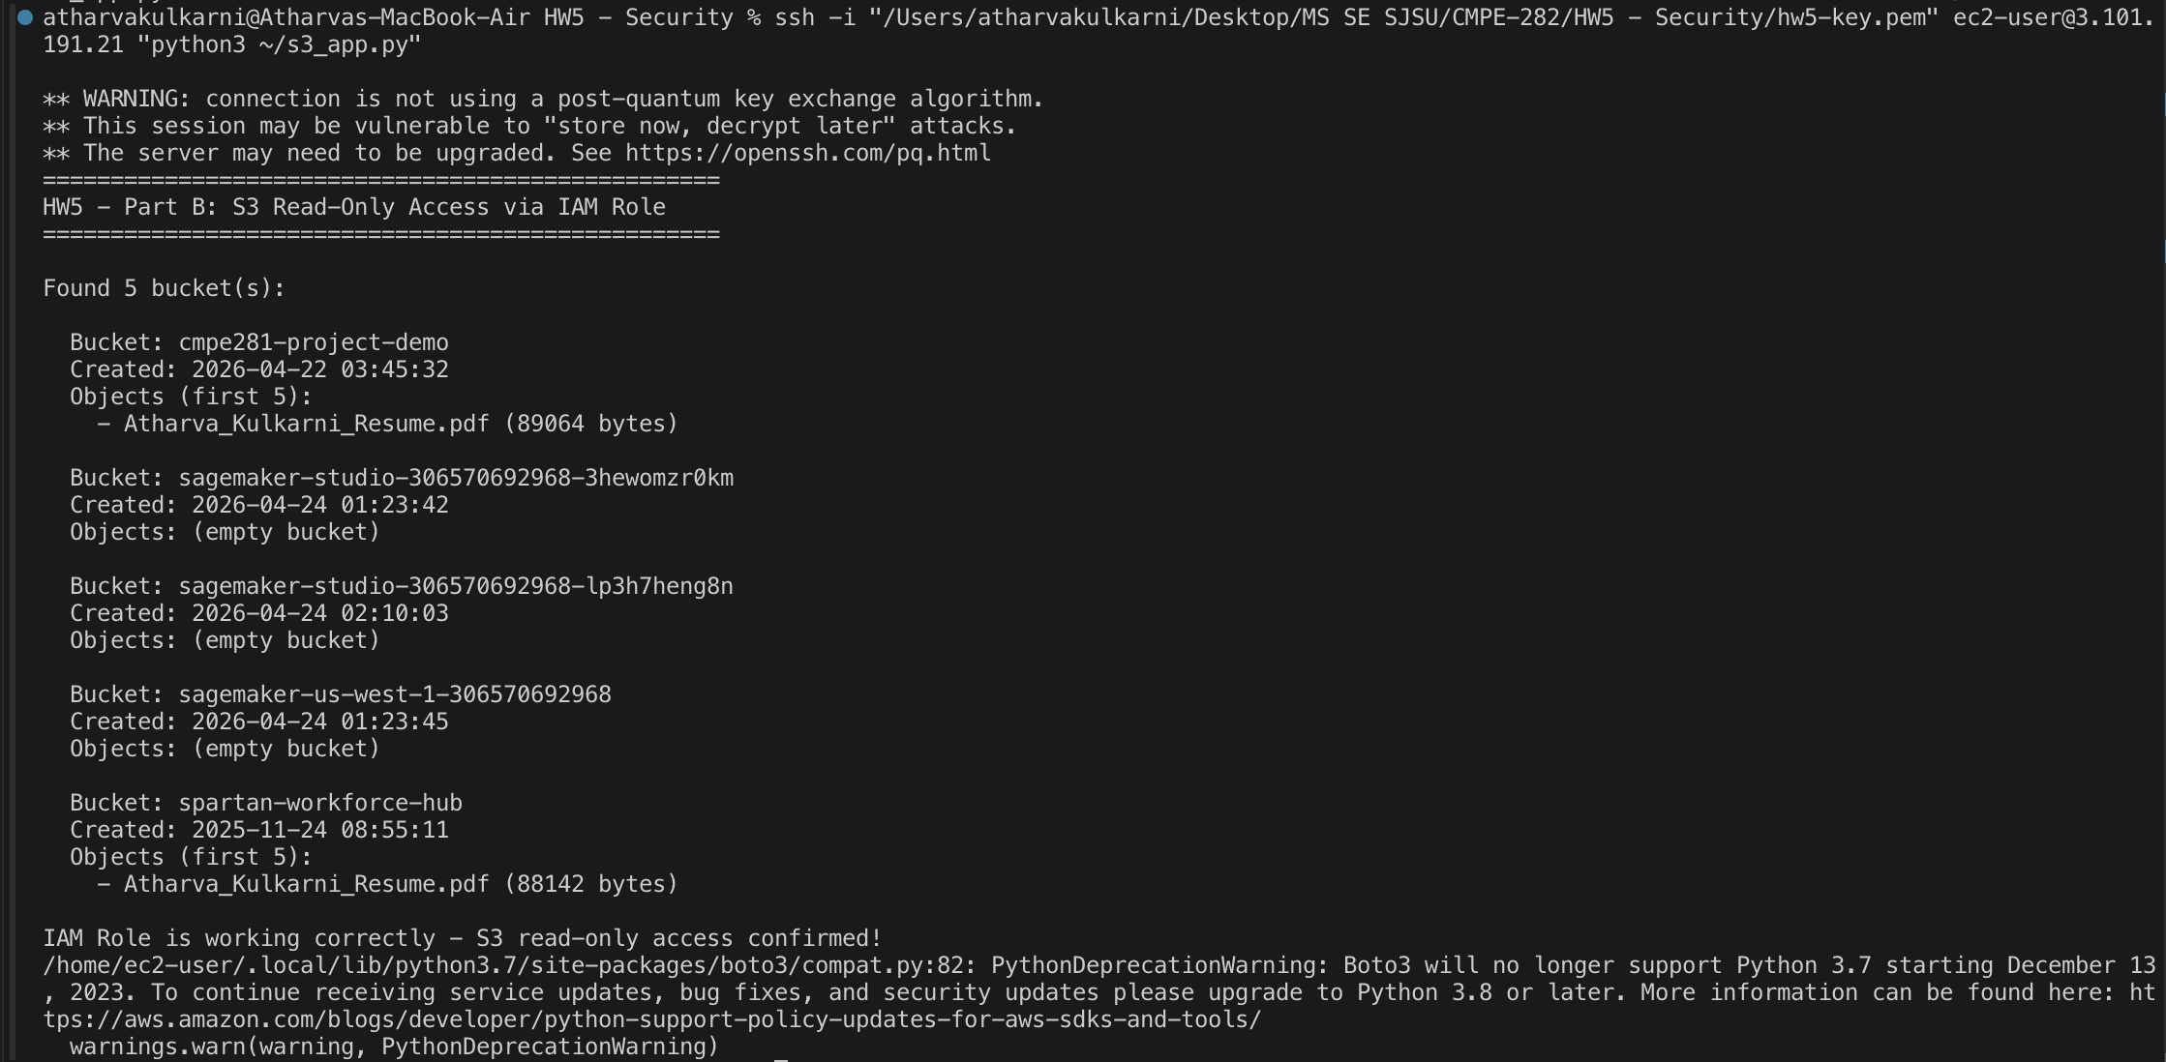
Figure 8: s3_app.py running on EC2 — S3 buckets listed via IAM role

References
- AWS Documentation – SSL on Amazon Linux 2: https://docs.aws.amazon.com/linux/al2/ug/SSL-on-amazon-linux-2.html
- Qualys SSL Labs Server Test: https://www.ssllabs.com/ssltest/analyze.html
- AWS Documentation – IAM Roles for EC2: https://docs.aws.amazon.com/AWSEC2/latest/UserGuide/iam-roles-for-amazon-ec2.html
- GitHub Repository – cmpe282-hw5-security: https://github.com/AK9175/cmpe282-hw5-security
- s3_app.py – S3 SDK Application: https://github.com/AK9175/cmpe282-hw5-security/blob/main/s3_app.py
- apache-ssl-setup.sh – Apache SSL Setup Script: https://github.com/AK9175/cmpe282-hw5-security/blob/main/apache-ssl-setup.sh
- iam-setup.sh – IAM Role Setup Script: https://github.com/AK9175/cmpe282-hw5-security/blob/main/iam-setup.sh

