**Cancellation feature in Booking app.**

Initially, As seen in the below screenshots In mybookings we created a simple Cancel booking Button from where the user can easily cancel the booking.

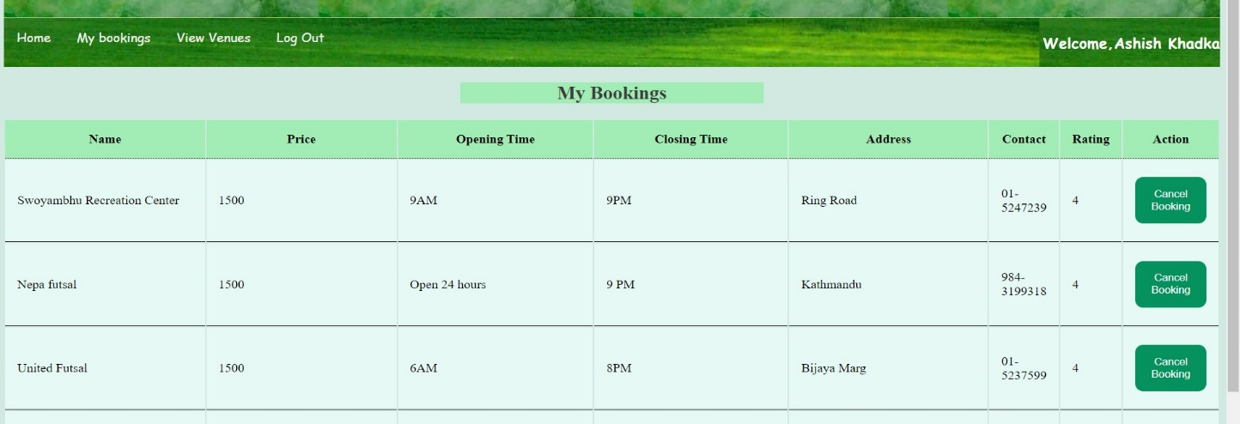

After clicking the button of cancellation for Nepa futsal

the booking_Id of Nepa futsal (56) get deleted.

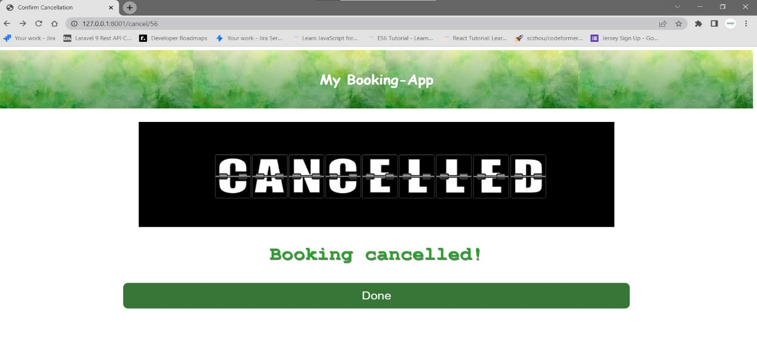

Over and Above, Clicking Done will redirect towards MY Bookings page. Where the user will not be able to see the Nepa futsal Booking.

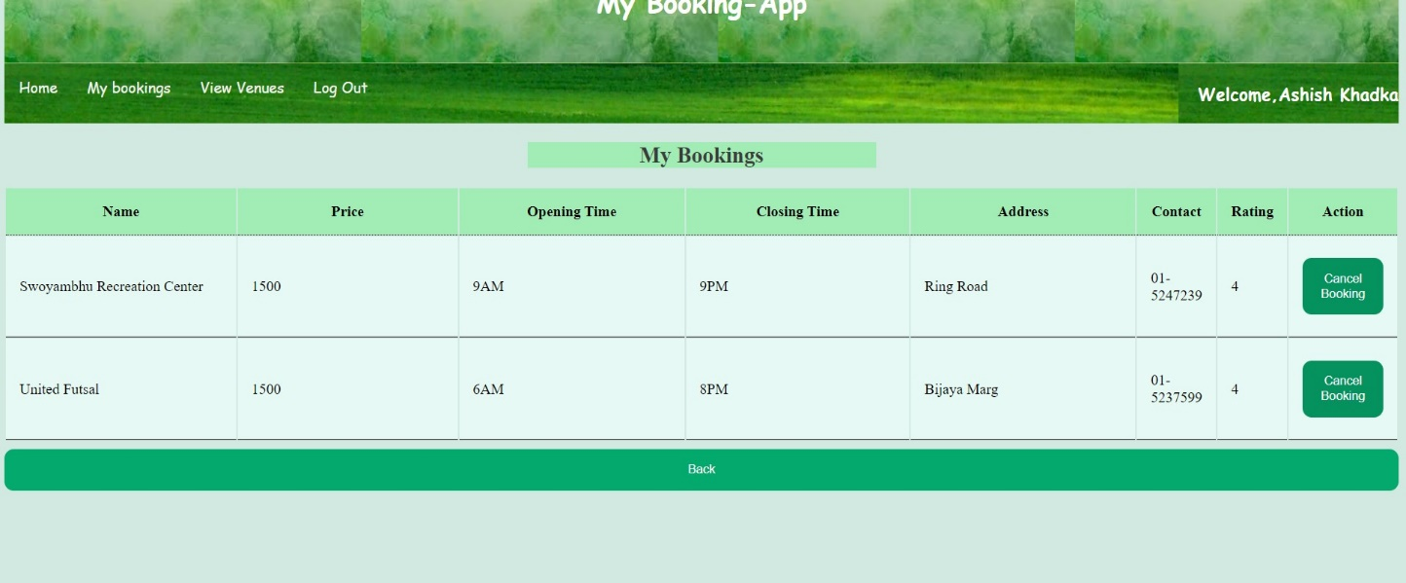

How we created cancel button:

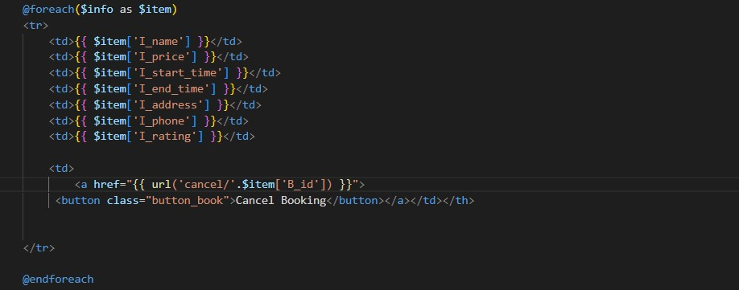

Also, For the cancellation of booking we have fetched the delete method from API because of which it sends the response by deleting the booking.

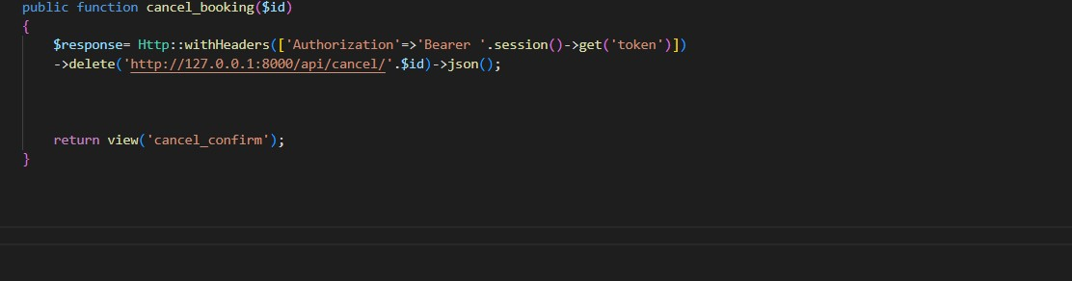

And return view to (Confirm_cancellation) Page.