Research on ETL

* If you need to bring data from multiple different data sources into one, centralized database, you must first:
* E-(Extract): Data from its original source.
* T-(Transform): Data by deduplicating it combining it and ensuring quality.
* L-(Load): Data into the target database.

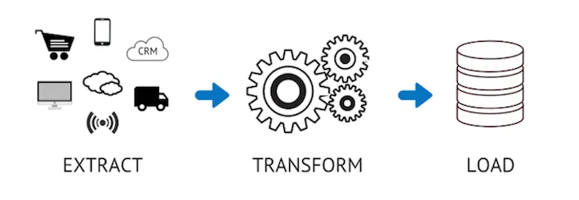

Using data scraper to extract data in excel and parse those data in MYSQL database

1. Using (instant data scraper) as extension for collecting information from website:

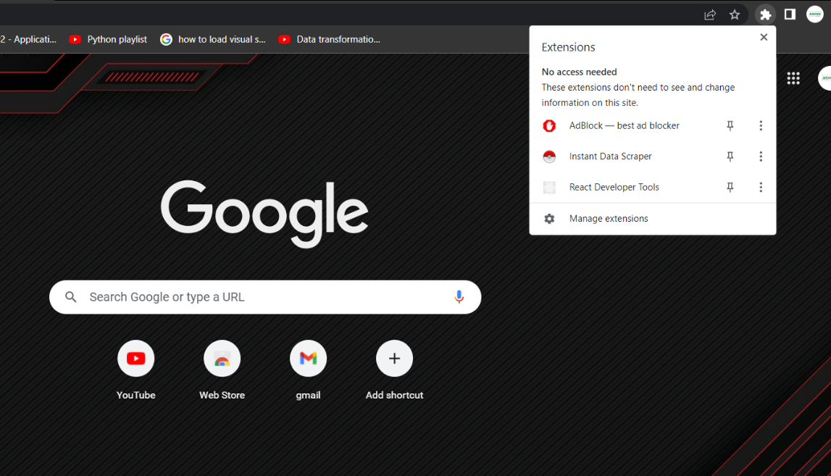

1. Extracting data in excel:

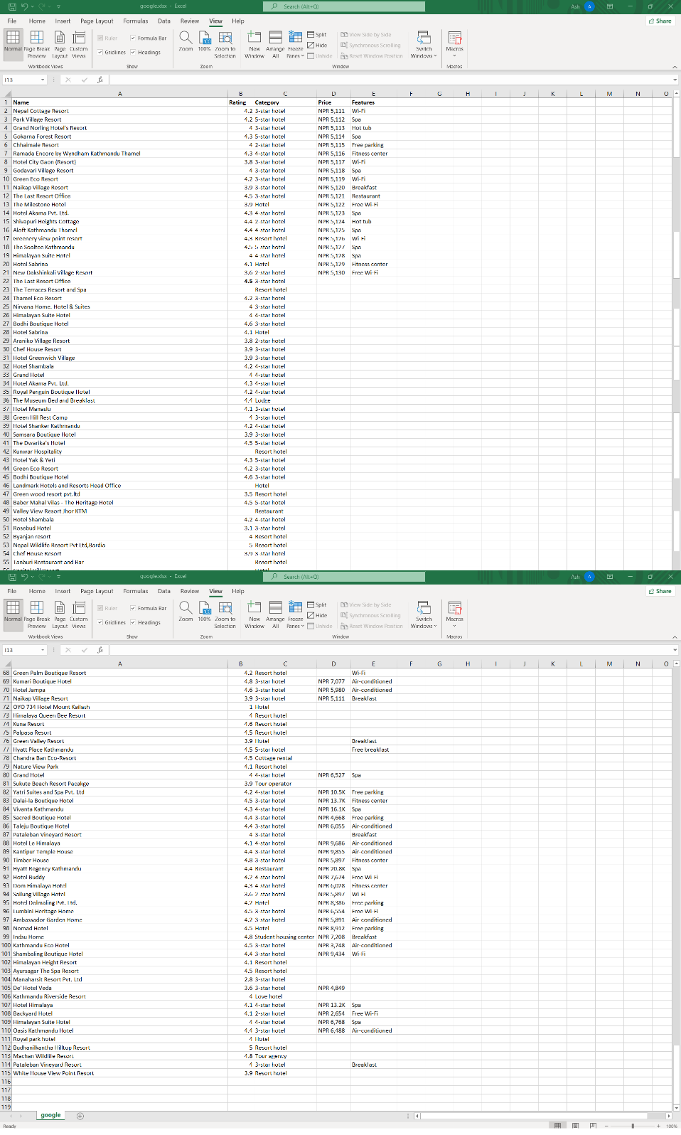

Using MYSQL Workbench

* MYSQL Workbench is a unified visual tool for database architects, developers and DBAs. MYSQL Workbench is cross-platform supportive and can be used on different operating systems including Windows, Linux and mac OS.

1. Created default root user:

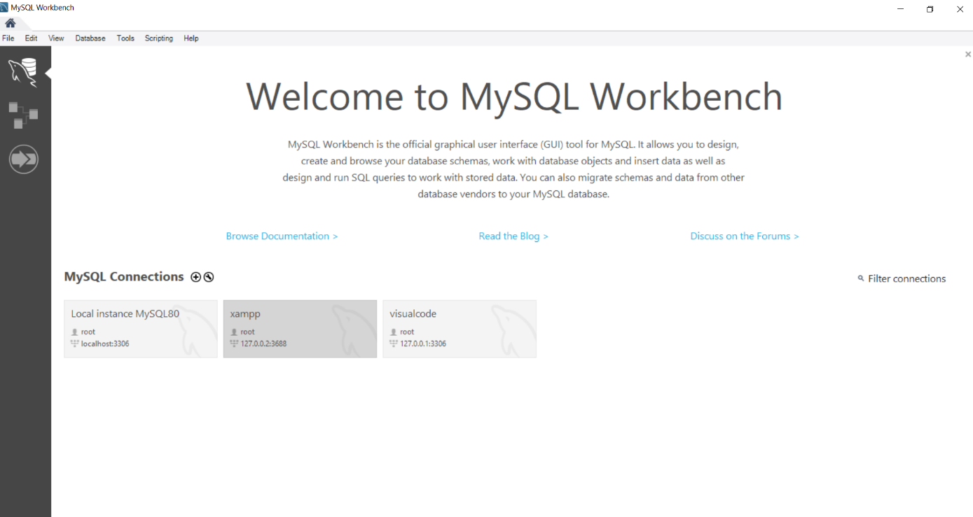

1. Created a new schema (database) as tesdb2:

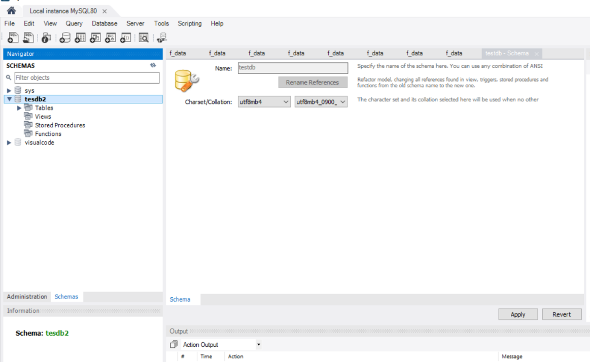

1. Using python script for data transformation in (visual studio code):

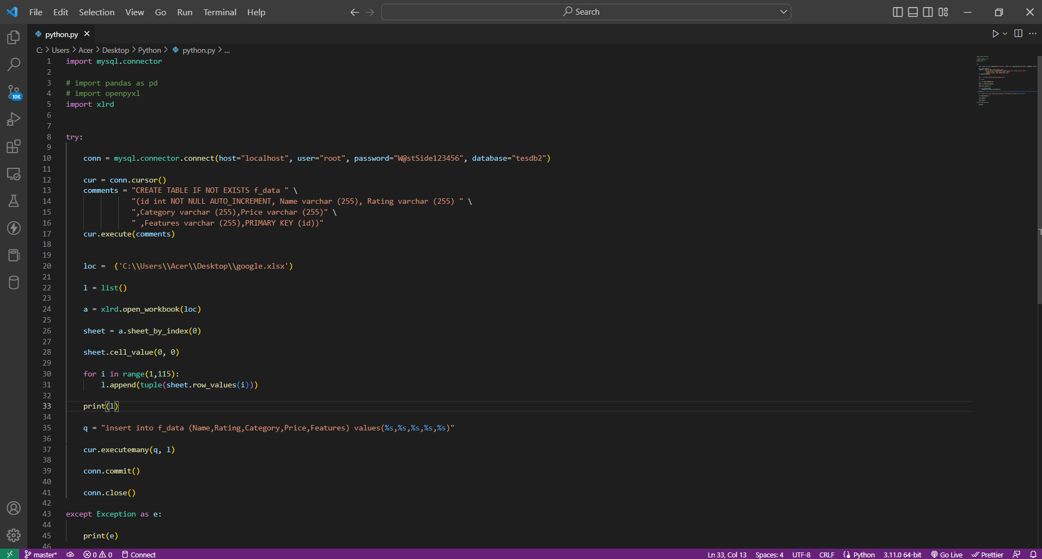

1. After the script data has been stored in the tables as shown in image below:

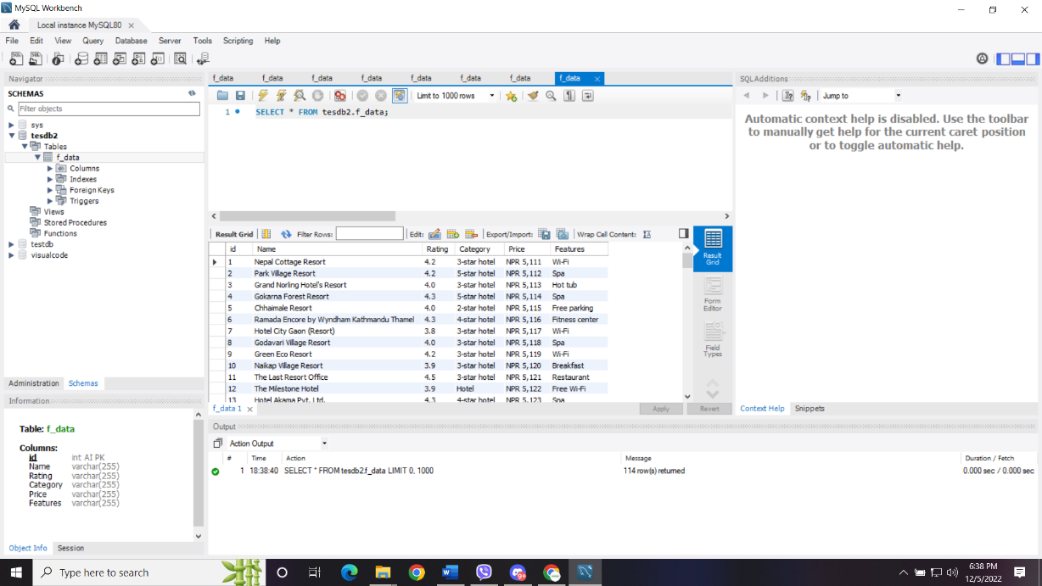

1. Error occurred in python script (xlrd not found).

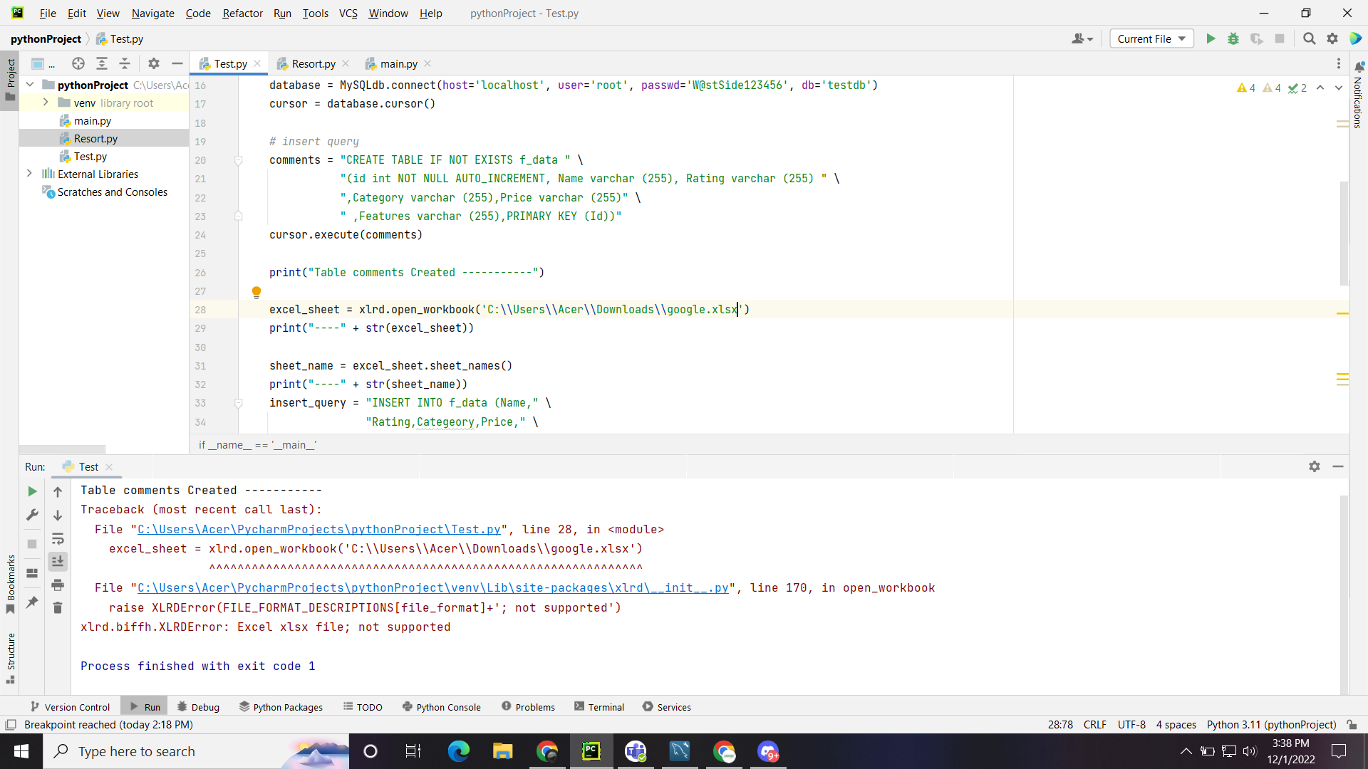

1. Error solved by installing xlrd package:

