1. Launched 1-instances & created directories.

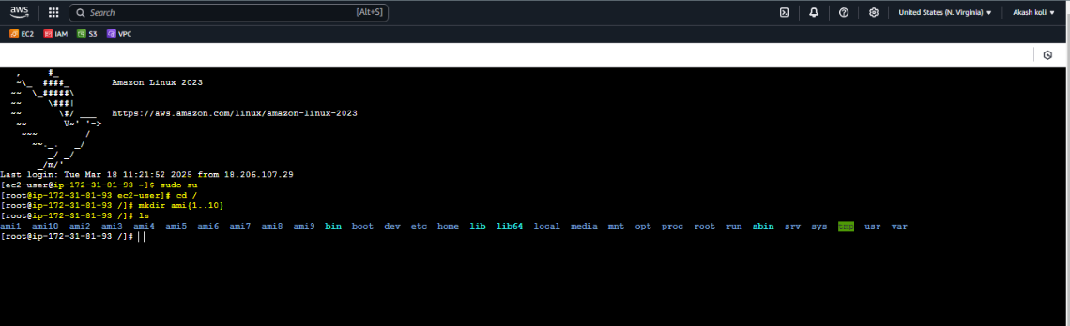

1. Created AMI from above instance.

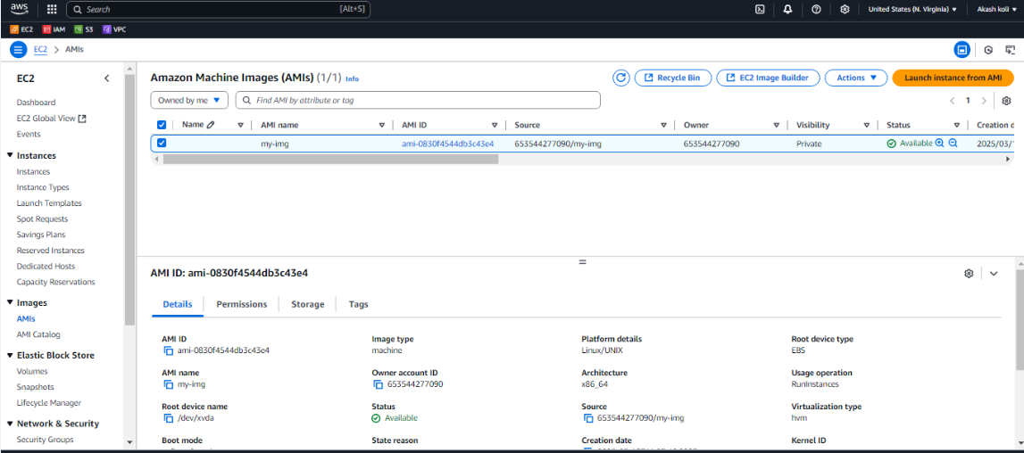

1. Using that AMI launched 2nd-instance ,able to see the created directories .

