**Autoscaling ::**

**1.Create auto scaling group(AG)**

**a. launch template : create->Name-> select network (VPC, subnet)**

**:>scaling = select according your traffic on server min=1 max=4 ->launch template**

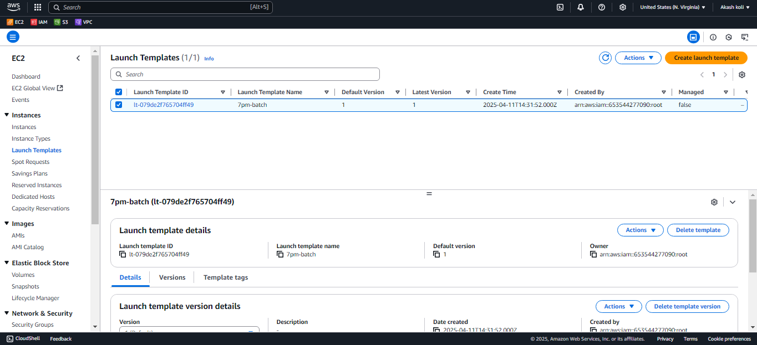

2. **Create Autoscaling Group:**

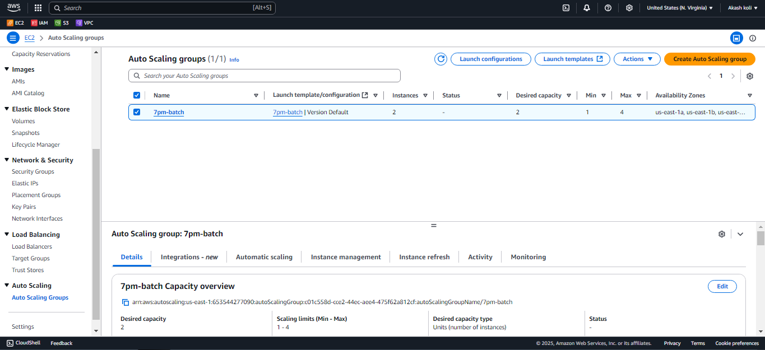

**3. Automatically created ec2 instance and able to connect :**

