**CloudWatch:**

1. Launch one **ec2-instance** with **public IP enable.**
2. **Create Alarm -> select metric**

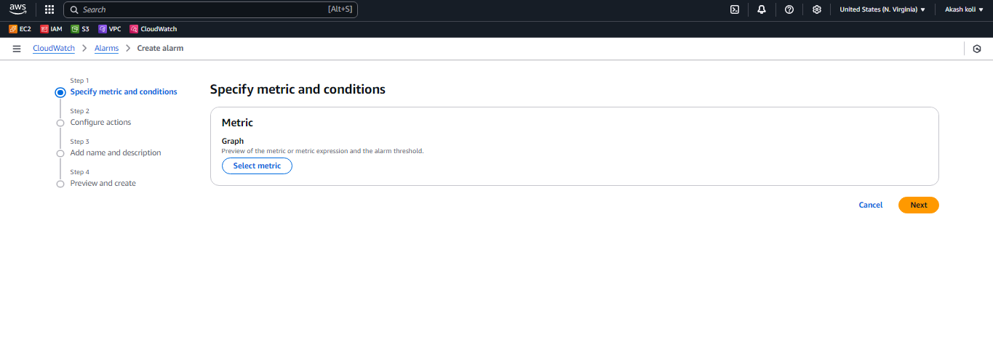

**3.select EC2-perinstance metrics-> paste instance** **ID ->select CPU utilization**

**Statics ->Avg-5min ->threshold ->greater&equal->20**

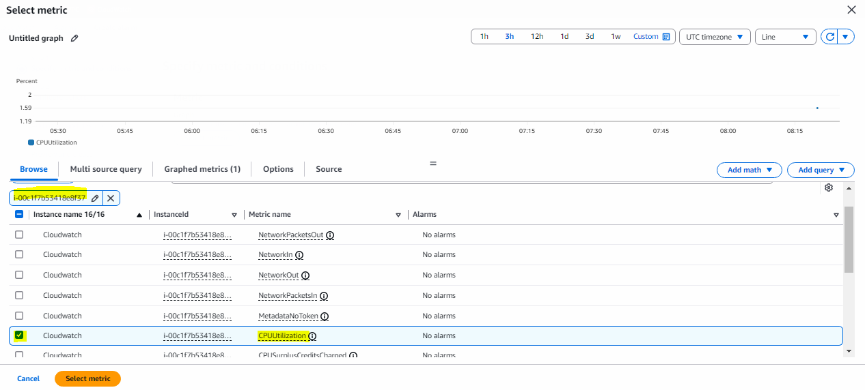

4.**Alarm state trigger->In Alarm->Create new topic->add your Mail ID for SNS notification.->**

**Next->Name -> create**

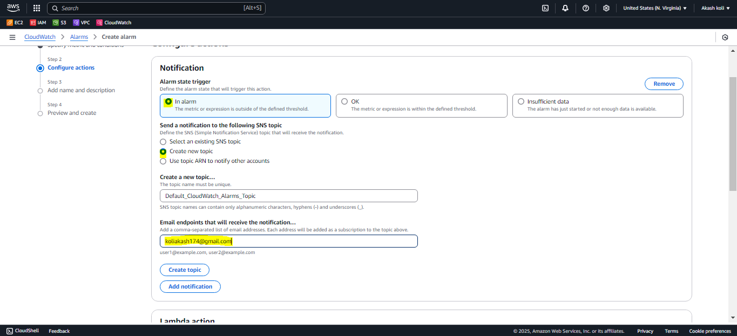

5.Check **your Mail** & **confirm subscription** .

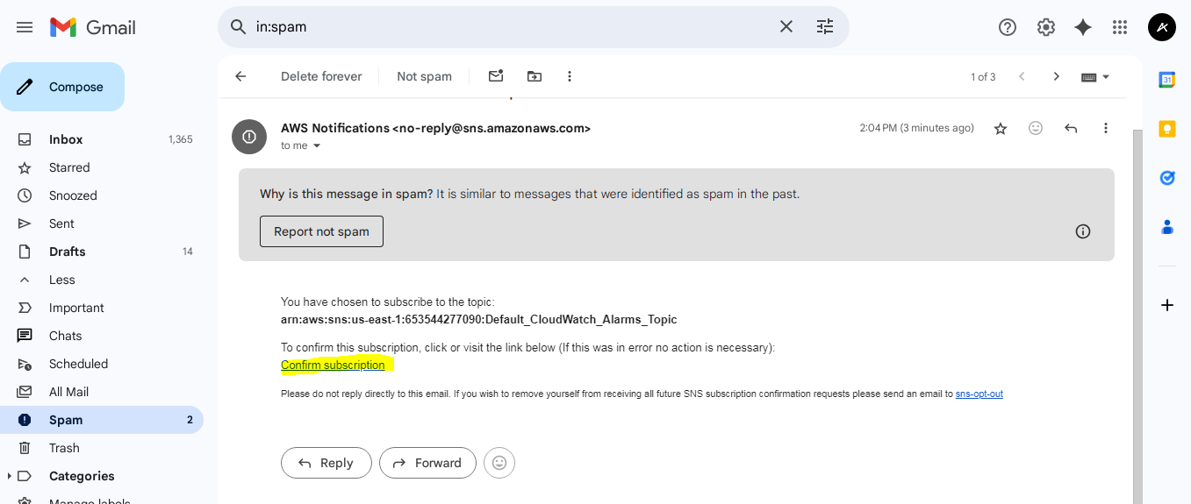

6. After confirmation sate will change .

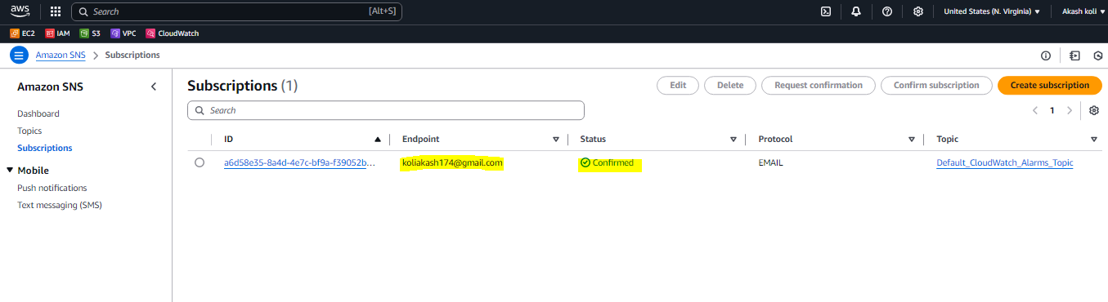

7. **Connect server and give the stress** :

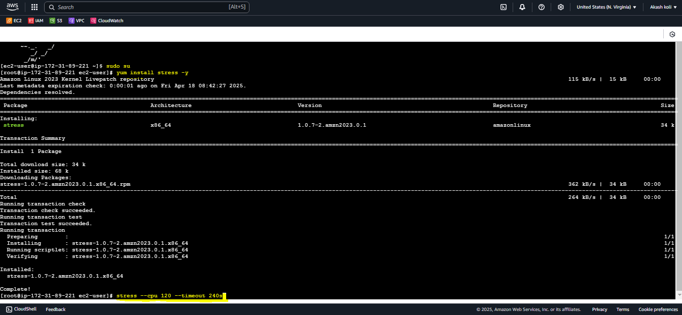

8. Now check **state of Alarm** it will **change** & check mail **SNS Notification** :

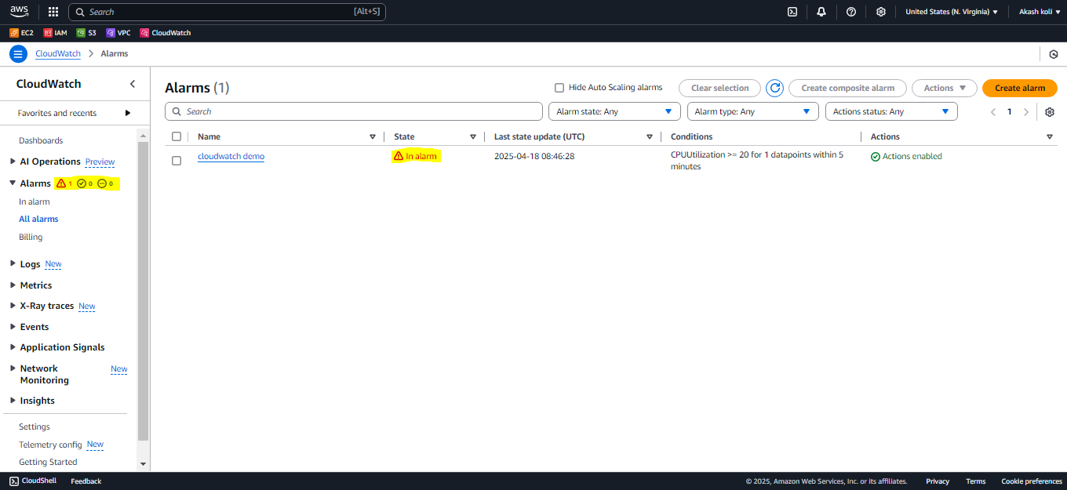

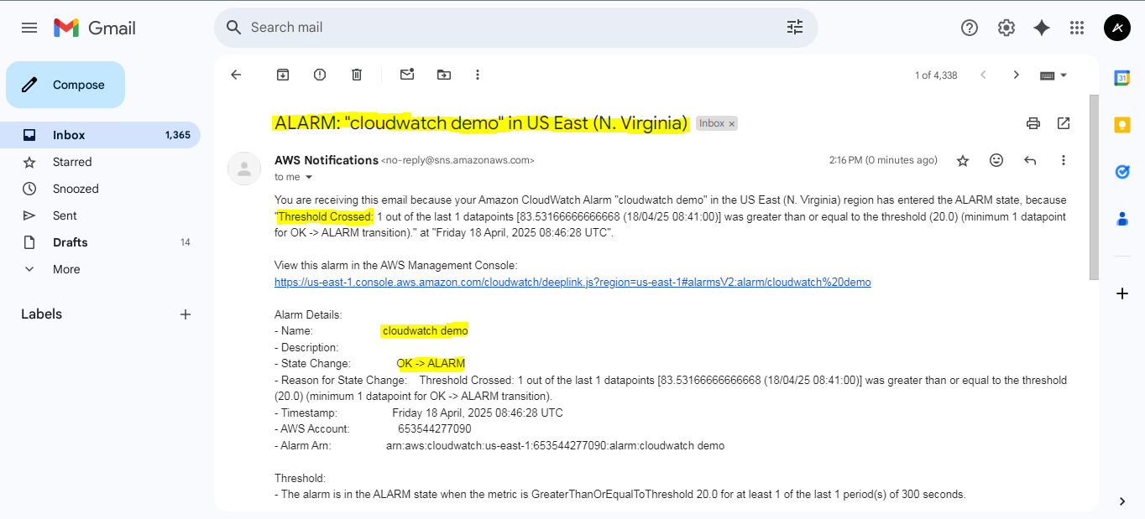

9.**View the utilization in gauge format->View->InMetrics->select gauge format**

