**SNS(Simple Notification Service)::**

1. Create **S3-bucket** & go-to SNS ->Create topic**->select standard->**give name& **Create subscription ->add mail**

**2.edit Access policy-> copy paste (sns access policy for s3 bucket)**

**Edit=>copy paste ARN of topic, Add AC ID, & Bucket ARN**

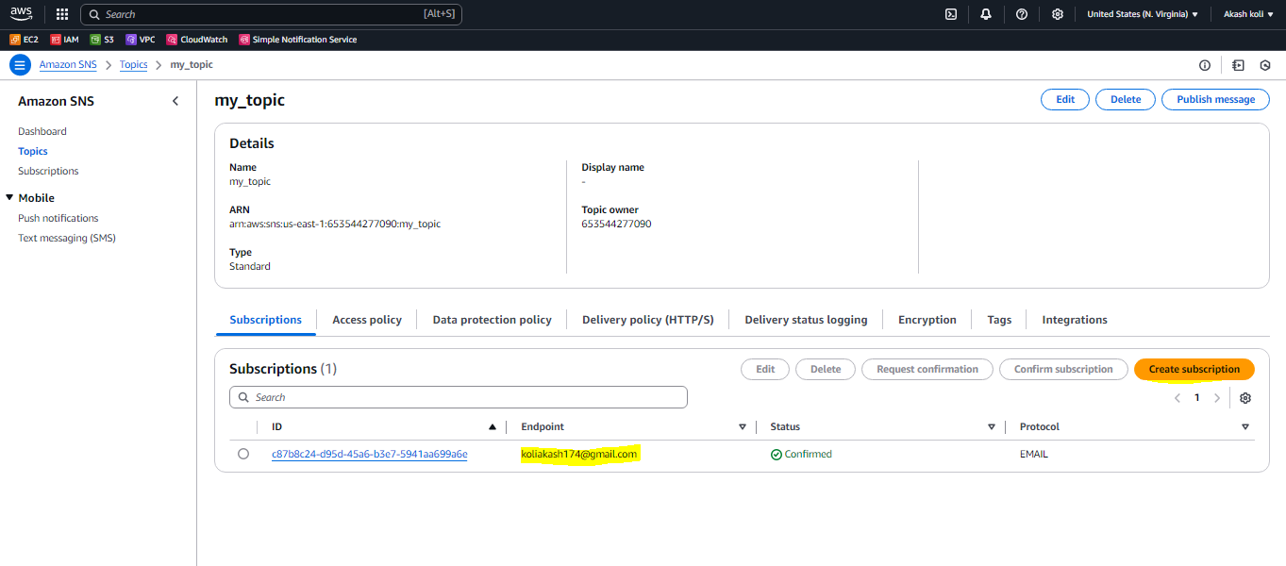

**3. confirm subscription form your mail.**

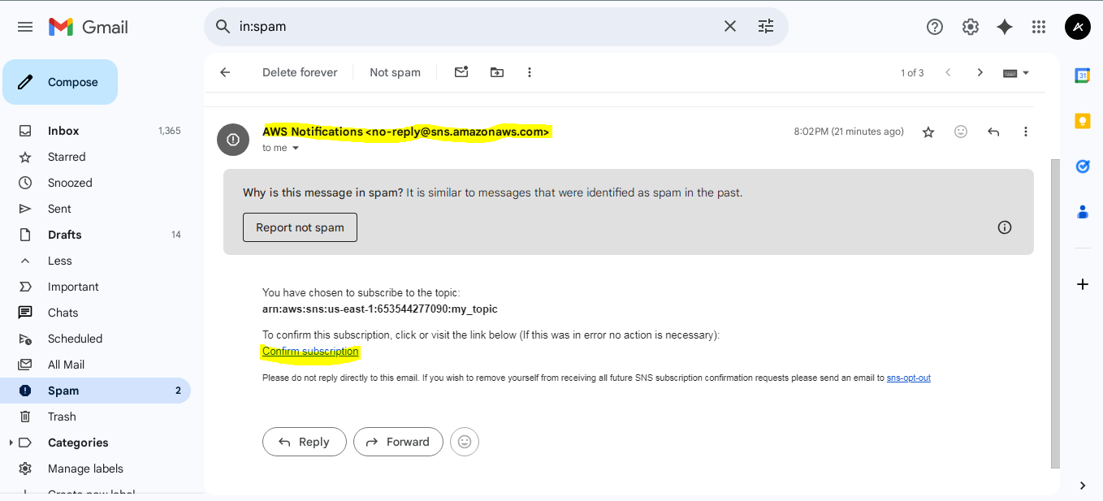

**4.go –to s3 Bucket->properties ->create ->event notification->**

**Action->select PUT->select destination(SNS-topic)**

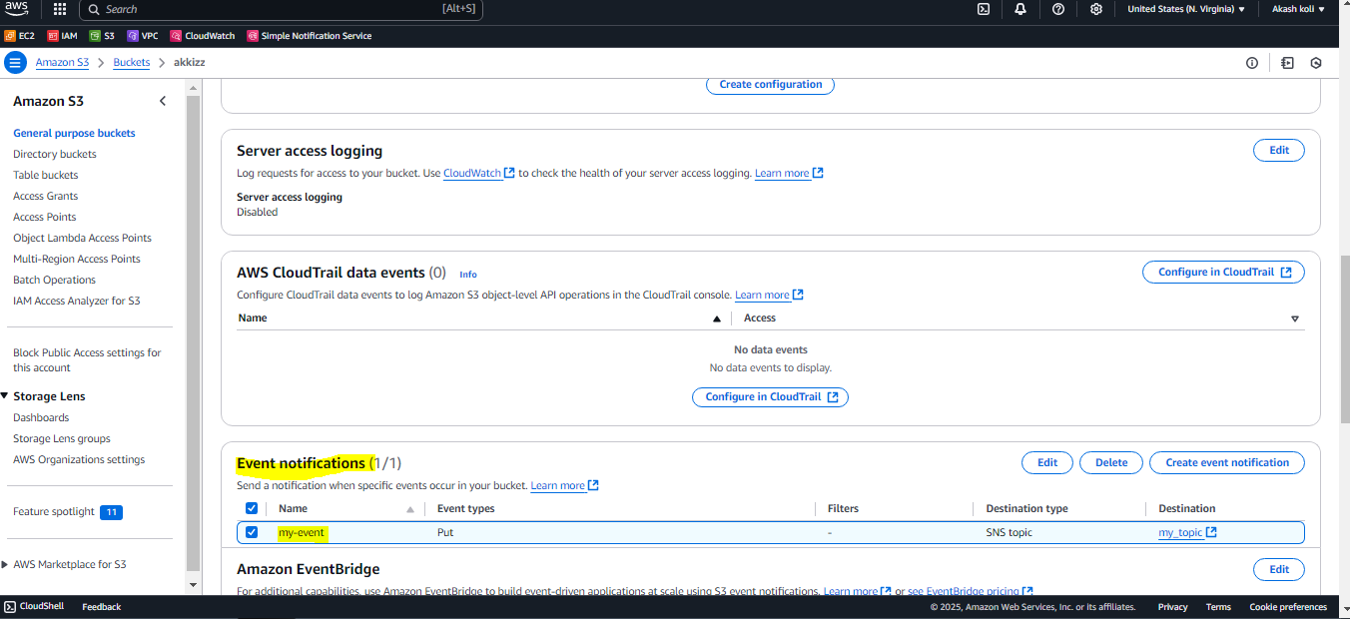

**5. upload object in s3 bucket**

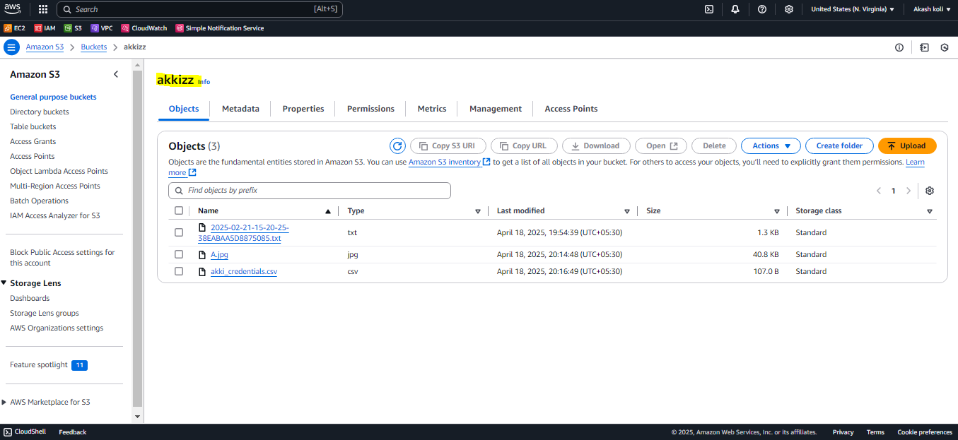

**6.Check your mail getting notification !!**

