1. Created 2-vpc (pub,pvt) and Transit-gateway& Attachment

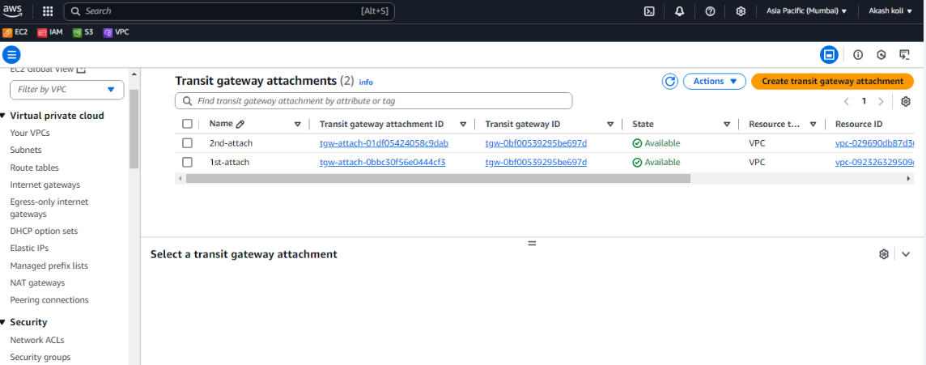

2.ater established transit connection getting response from pub-to-pvt instances.

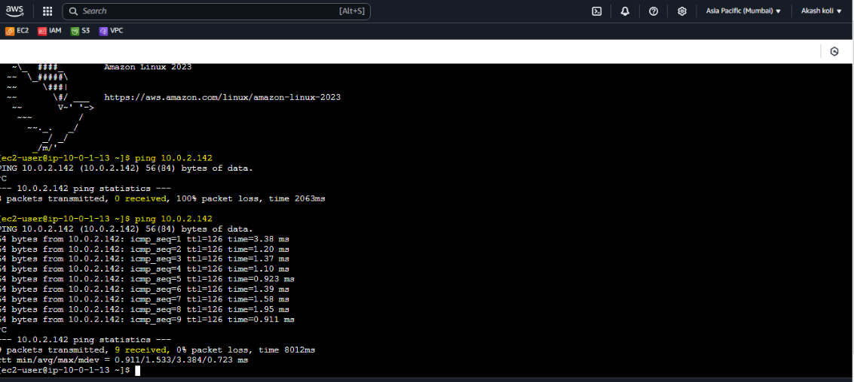

3.VPC-Flowlogs-stored in s3-buckets

