1. Launch ec2-instance with linux AMI.
2. Create volumes ->45GB->AZ must same (instance)->create-> Attach to instance

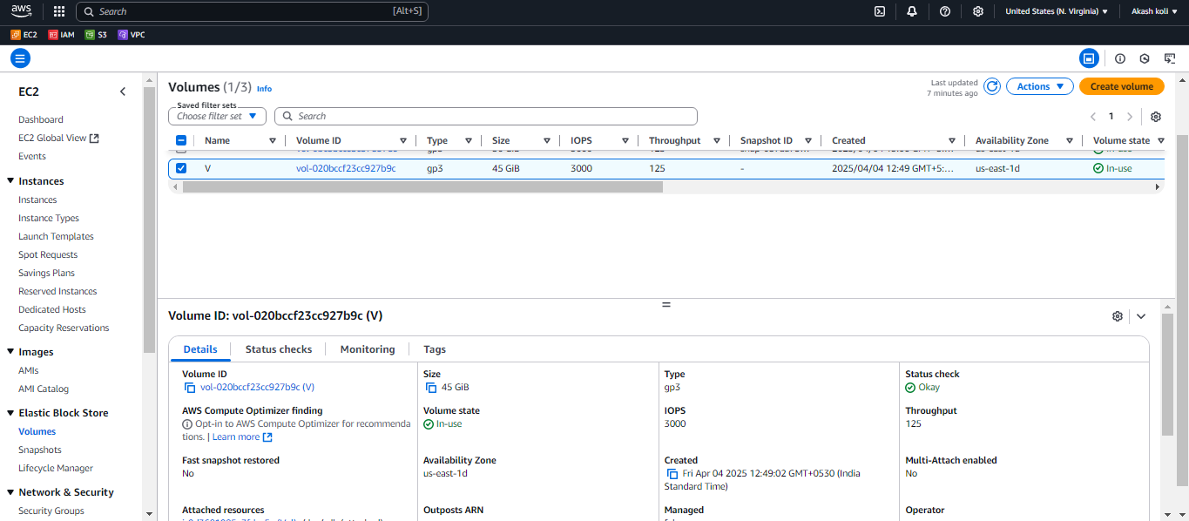

3.Connect ec2-instance : run this cmd

sudo su

1. lsblk

2 . file -s /dev/xvdb

3 . mkfs -t xfs /dev/xvdb

4 . mkdir /mnt/folder

5. mount /dev/xvdb /mnt/folder/

6. df –h

