1.created 1-vpc ,2-subnet . Pub-sub =>igw, pvt=>endpoint

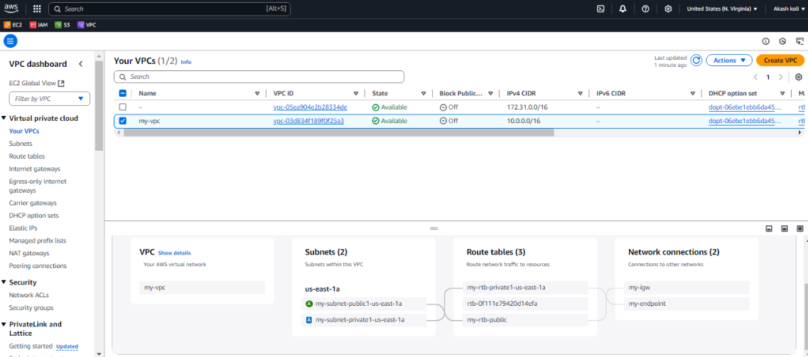

2. Created buckets uploaded objects.

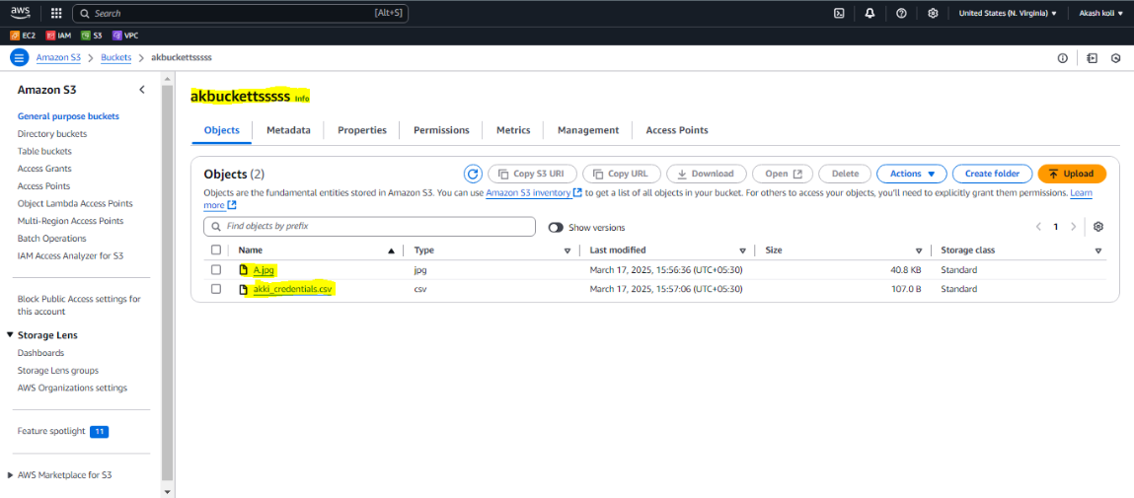

3.Connected pub-to pvt instance &configure the credential ,able to see the created buckets&object.

