Kyle Antczak

Octave Plot/Salt/Smooth

Octave makes plotting smoothing and salting done very easily. In total I have 6 functions to complete these tasks.

1. function x = fn_get_x_vals(start,last,amount)

This function uses the built in function linspace(0,800,400), and I use it to create a row vector x that consists of 400 x values from 0-800.

1. function y = fn_get_y_vals(x)

This function takes in the x vector and creates a row vector of y values. I used this to create variable y and the equation 3x + 5 = y for my line.

1. function plottedgraph = fn_plot_points(x,y)

This function takes in both my x and y row vectors and plots them. I also used some additional functions to change the look of the graph by adding a title, xlabel, ylabel and increasing the font size. This is a picture of my line graph:

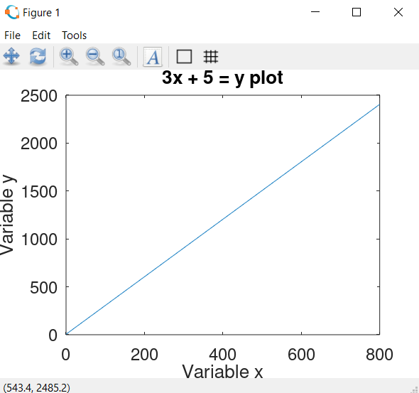

1. function saltedy = fn_salt_y(y)

This function takes in y and returns a row vector of salted y values. To do this I created 2 rand() row vectors of length y. For the one vector I named saltval I multiplied each value by 1000, so instead of the random number being between 0-1 its now 0-1000. I then used the second random vector to turn some of the values negative, so the total range of the salt is -1000-1000.

1. function [salted, plottedsalt] = fn_plot_salt(x,y)

This function takes in the row vectors x and y and had 2 output variables of the row vector of salted y values I named saltedy and the graph of the x and salted y’s. I also did the same graph editing as the first one. This is a picture of the salted y:

1. function plottedSmooth = fn_plot_smooth(x,saltedy)

This function takes in row vectors x and salted y and plots a smoothed graph. For my smoother I used the octave package data-smoothing which has the method regdatasmooth(x,y). Also for this graph I used the same graph editing methods. Here is a picture of the graph:

For fun I am going to include pictures of when I change my salter to the range -10000 – 10000 to see how well the smoother is able to perform. After looking at the pictures it seems the regdatasmooth(x,y) function continuously smooths the data until it is a line.

