Kyle Antczak

JfreeCharts and Apache Commons Plot/Salt/Smooth

After completing the assignment it seems way easier to do now. When doing it the main challenge was figuring out which methods from the packages to use and how to use them. What helped me figure out how to understand what to use from the packages was <https://www.codejava.net/java-se/graphics/using-jfreechart-to-draw-xy-line-chart-with-xydataset> this guide on how to make a line graph using jfreecharts and <https://commons.apache.org/proper/commons-math/userguide/fitting.html> the apache commons curve fitting guide.

For graphing from using the guide I understand how to create a panel and add the line chart with it needing a title axis labels and a dataset. The only thing that I copied over that I don’t fully understand is the swing utilities to make the graph runnable. Without copying the run from the guide I wasn’t able to figure out how to make it run differently.

For plotting and smoothing I used my methods from project one. My plotting which took in how many points wanted and the starting and end positions. My salting took in min and max range. Here are graphs for when I plotted 300 points from 0-2000 and salted with a range from 0-3000. Using a line of 3.5x + 5 = y

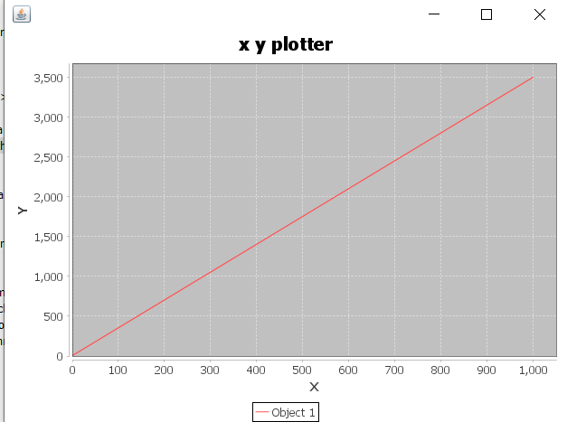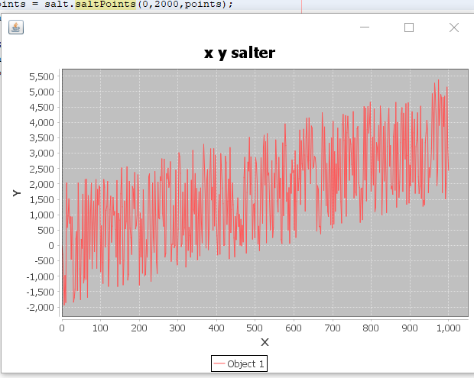

For smoothing I used the Polynomial Curve Fitter in apache commons to get a best fit line of the points. The curve fitter gave me a function from the salted points and I used the coefficients to produce the y values for the smoothed points. Here is the graph for the salted line above.

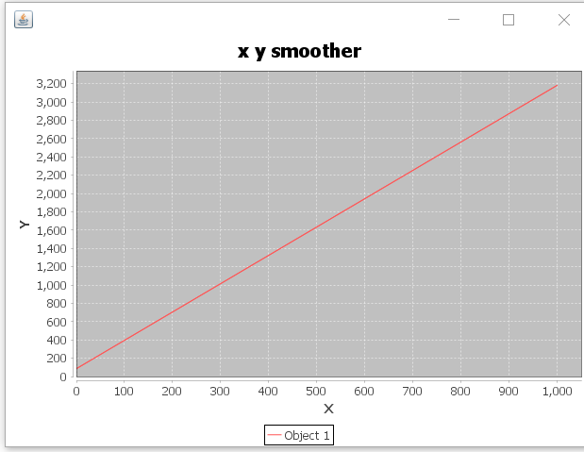

With the way I coded the implementation of this it was real easy to make a graph of all there so here is a graph with all three lines on it.

