LOCAL ACCOUNTING WORKSPACE
Cash2Ledger
Installation, TallyPrime Configuration & User Guide
A practical guide to locally process bank statements, review accounting entries and generate TallyPrime-ready XML files.
Purpose: To enable users to install Cash2Ledger correctly, connect it with TallyPrime, review bank entries efficiently and import the generated XML files with confidence.
Prepared for Capstone Project Submission (AICA Level 2)
CA Harshita Agrawal (Membership No. 438122)

1. Before You Begin
Cash2Ledger is designed to operate locally on a Windows computer. It processes the bank statement on the user’s machine and connects only to the locally open instance of TallyPrime. Ensure that the relevant company is open in TallyPrime before launching Cash2Ledger.
Requirement | What to check
Operating system | Windows computer with permission to run the Cash2Ledger executable.
TallyPrime | TallyPrime must be open and the target company must be loaded.
Bank statement | Use a supported PDF or Excel file. The file should contain transaction date, narration and debit/credit or equivalent amount information.
Application package | Keep Cash2Ledger.exe and the _internal folder together in the same folder. Do not rename, move or delete the _internal folder.

2. Configure TallyPrime Connectivity
Complete this configuration once on the computer where Cash2Ledger will be used. The settings allow Cash2Ledger to read the locally open company and ledger masters from TallyPrime.
- Open TallyPrime and load the company in which the bank entries will be imported.
- Press F1 (Help) and open Settings, then navigate to Connectivity > Client/Server Configuration.
- Update the connectivity settings as shown below and accept/save the configuration.
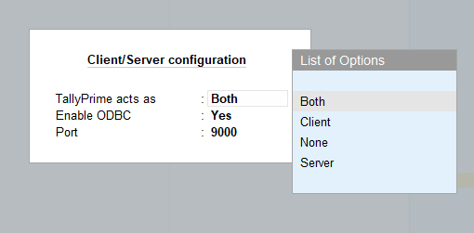

3. Install and Launch Cash2Ledger
- Copy the Cash2Ledger distribution folder to a suitable local location, such as the Desktop or a designated application folder.
- Extract the ZIP file, if the package was shared as a ZIP file.
- Confirm that Cash2Ledger.exe and the _internal folder are present in the same folder.
- Double-click Cash2Ledger.exe to start the application.

4. Process a Bank Statement
- Click Connect to Tally. The application will read the companies and ledger masters available in the locally open TallyPrime instance.
- Select the required Company from the Company drop-down list.
- Select the relevant Bank account (Savings / Current / OD / CC) ledger. This is the bank ledger to which the statement relates.
- Upload the bank statement in PDF or Excel format. Cash2Ledger will display the detected transactions for review.

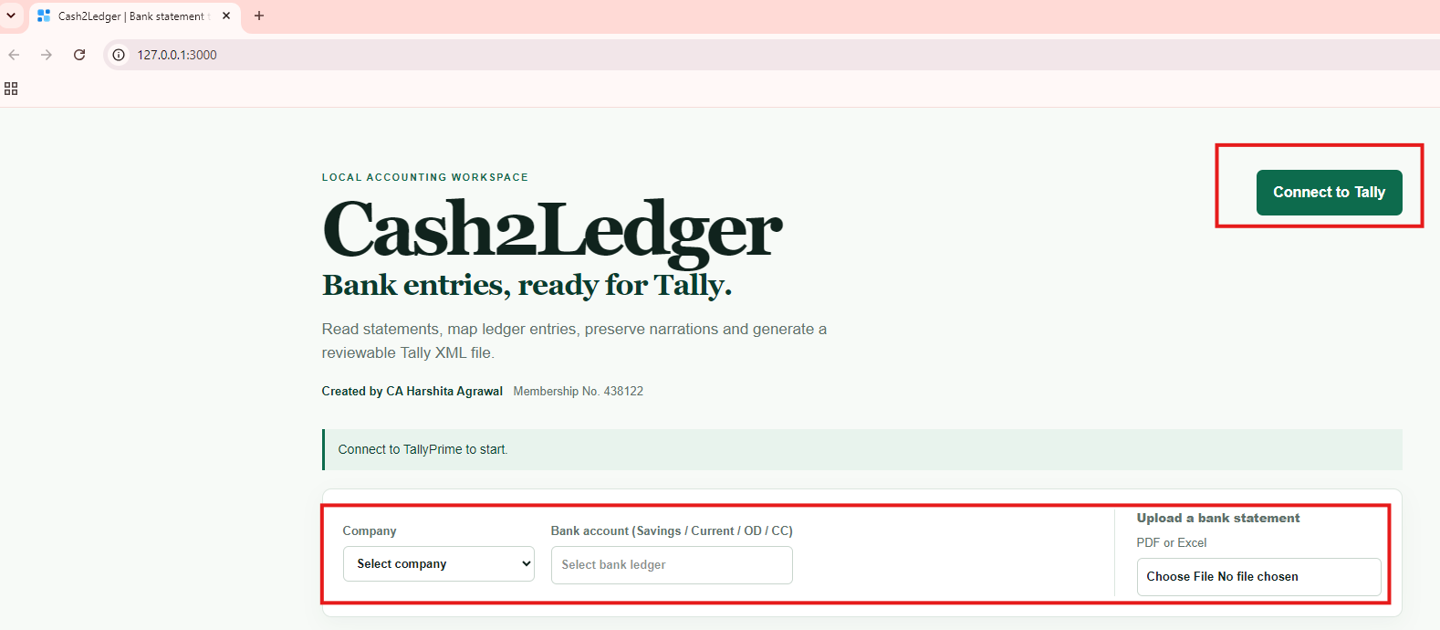

- Review each entry and select the appropriate Posting Ledger from the Tally master list. Type the opening letters of a ledger name to narrow the available choices.
Control point: The selected bank account is deliberately not available as a Posting Ledger. This prevents an invalid voucher with the same bank ledger on both debit and credit sides.

5. Review and Classify Entries
Cash2Ledger retains the accountant’s control over posting decisions. Review the transaction narration, type and amount before generating XML.
Feature | Recommended use
Column filters | Use the filters above Date, Narration, Type, Amount and Posting Ledger to work on a focused group of entries.
Ledger search  B  A | Type the first letters of a ledger name in the Posting Ledger field to locate it from the selected company’s Tally masters.
Bulk posting option  C | After filtering, select a ledger in the first visible entry and use the checkbox to apply that ledger to the other visible filtered entries, where appropriate.
Blank - ledger not selected  D | Use this Posting Ledger filter to locate entries that still need a manual ledger selection.
Filled - ledger selected  E | Use this filter when you want to review or export only the entries for which a posting ledger has been selected.  Note: This is helpful to exclude the contra entries already recorded in Tally

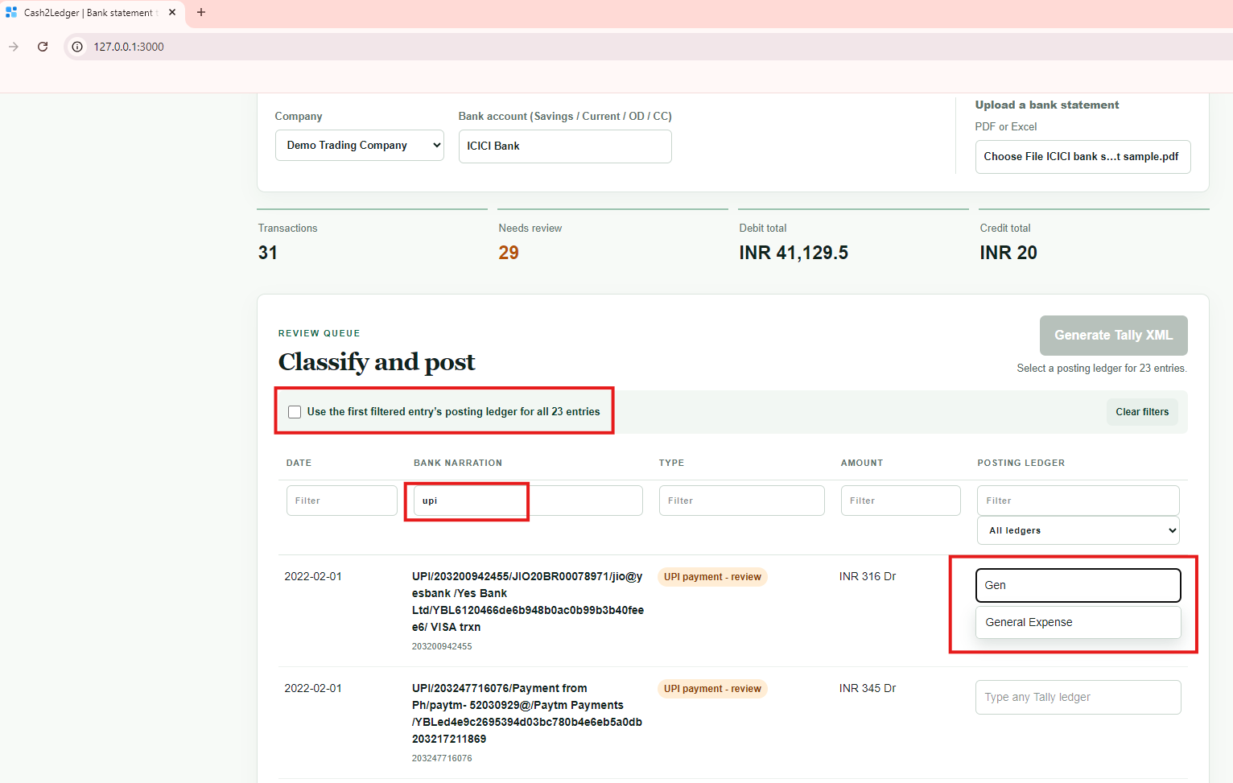
C
B
A
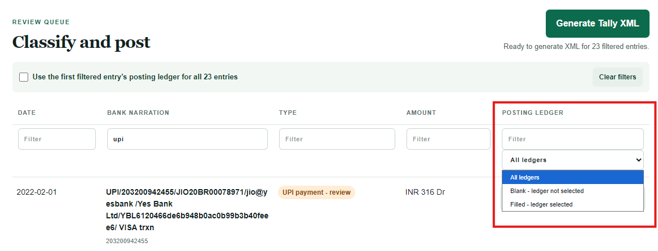
E
D

6. Generate and Import Tally XML
- Apply any required filters. If a filter is active, Cash2Ledger will ask for confirmation before generating XML only for the filtered entries.
- Confirm that all required posting ledgers are selected and click Generate Tally XML.
- Save the generated XML file in a known folder. If transactions span more than one financial year, the application may generate a ZIP file containing separate XML files by financial year.
- In TallyPrime, press Alt+O (Import), select Transactions and specify the location of the generated XML file.
- Complete the import and review TallyPrime’s import summary.

7. Good Practice
- Always keep the original bank statement and the generated XML file as part of the audit trail.
- Verify the selected company and bank ledger before uploading a statement.
- Review filtered entries before using the bulk posting checkbox; it applies the first visible entry’s posting ledger to the visible filtered entries.
Data-handling note: Cash2Ledger is designed for local operation. Bank statement processing and XML generation are performed on the user’s computer; users should still protect their computer and output files according to their organisation’s data-security practices.

