1. write a blog difference between documet object and windows object

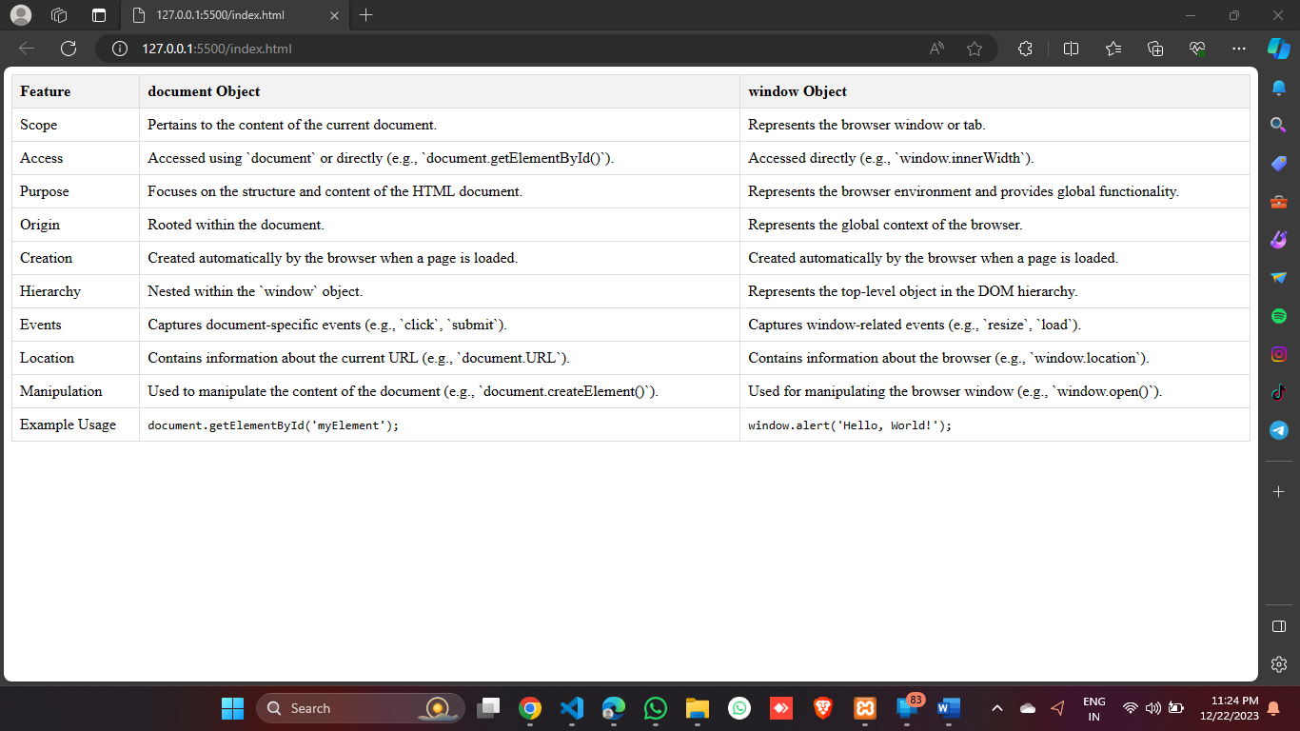

2 code kata practise