Test Case 1: Successful login test passed

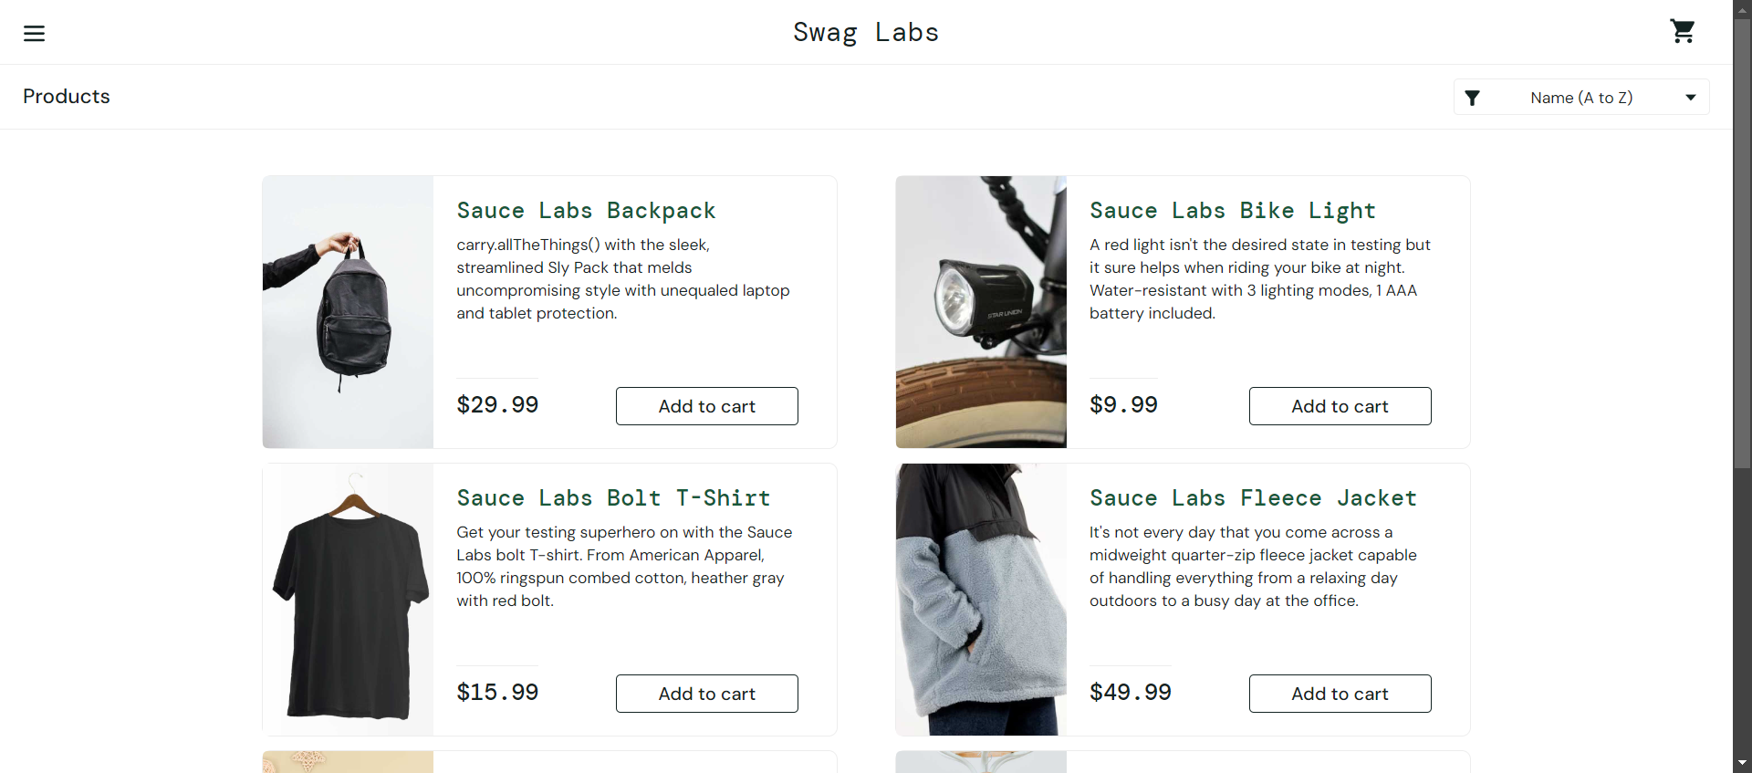

Test Case 2: Sorry, this user has been Locked

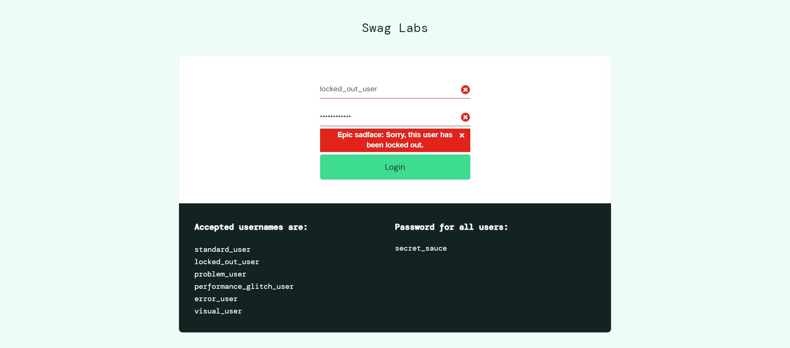

Test Case 3: Thank You header is shown in Checkout Complete page

