- MAKE A DOCUMENT STORE

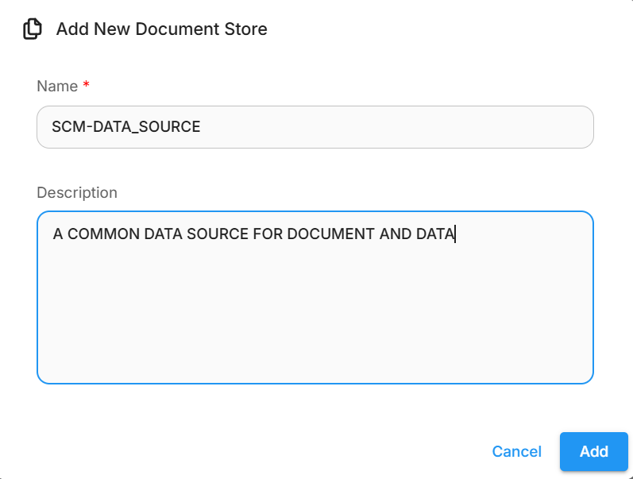
ADD PDF TO MY PDF-LOADER IN THIS DOCUMENT STORE
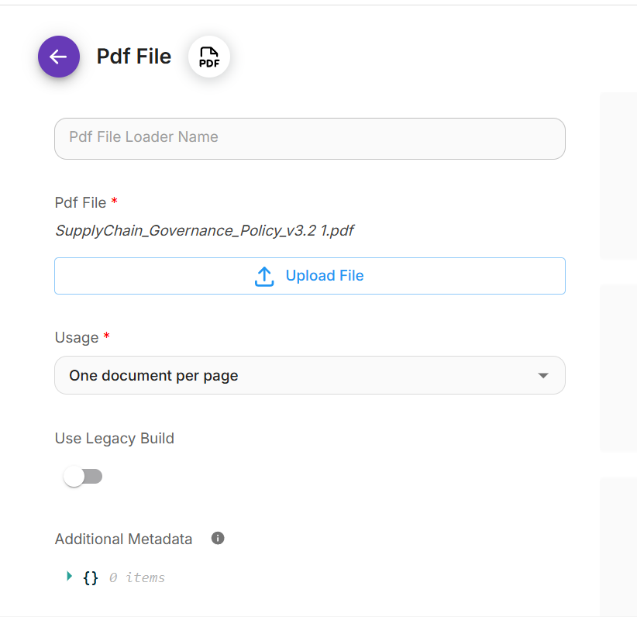

ADD TEXT SPLITERR(RECURSIVE CHARACTER TEXT SPLITTER):CHUNK SIZE AND CHUNK OVERLAP AND PROCESS
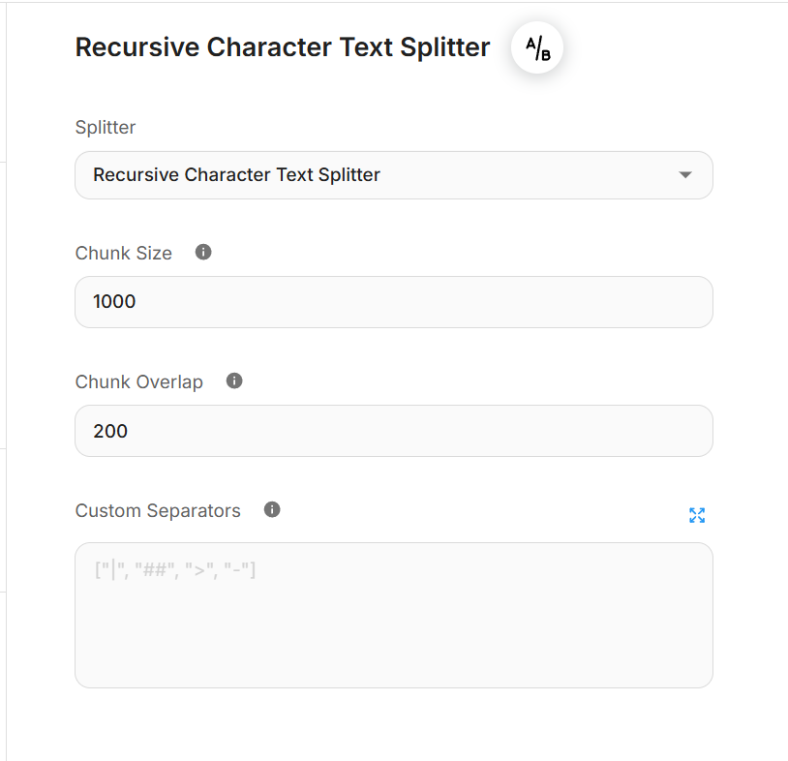
DO THE SAME FOR CSV FILE ALSO
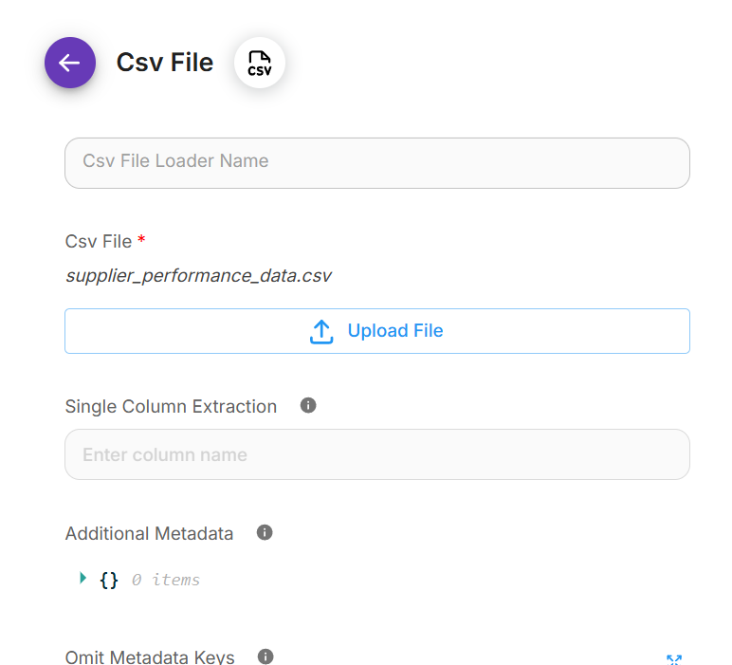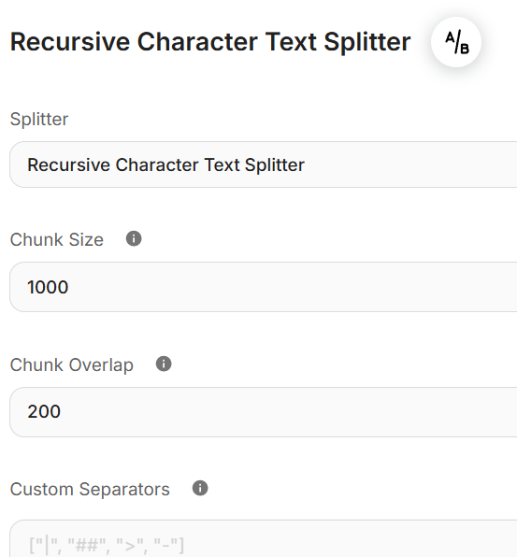

MAKE 2 DOCUMENT SOURCE WITH 2 DIFFERENT chunk size and chunk overlap
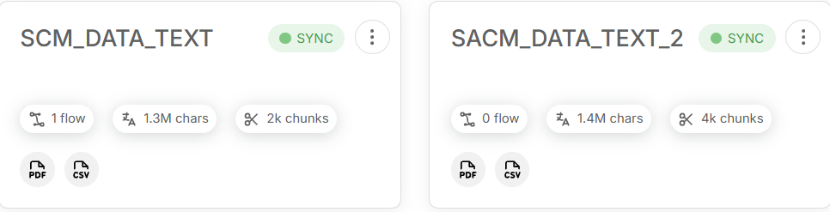

- ADD A NODE OD DOCUMENT SOURCE ON FLOWISE CANVA
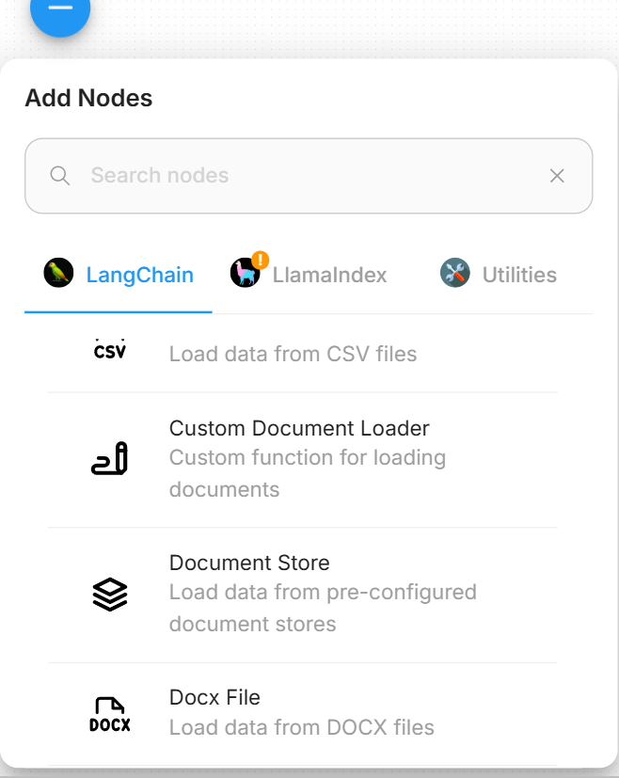
DRAG AND DROP THIS TO CANVAS AND SELECT YOUR DOCUMNET STORE
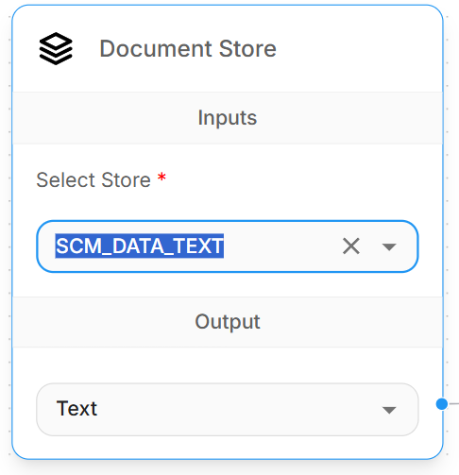
- ADD EMBEDDING (
- ) add an API KEY to connect credential and choose a model
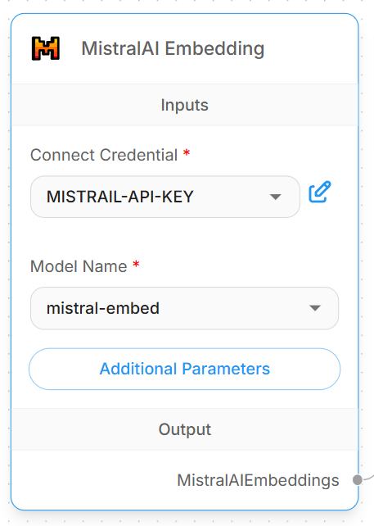

- choose one vector store(get )
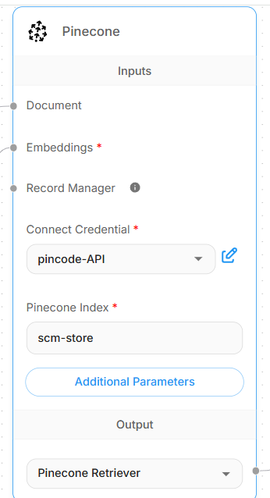

Connect document and enbedding to vector store
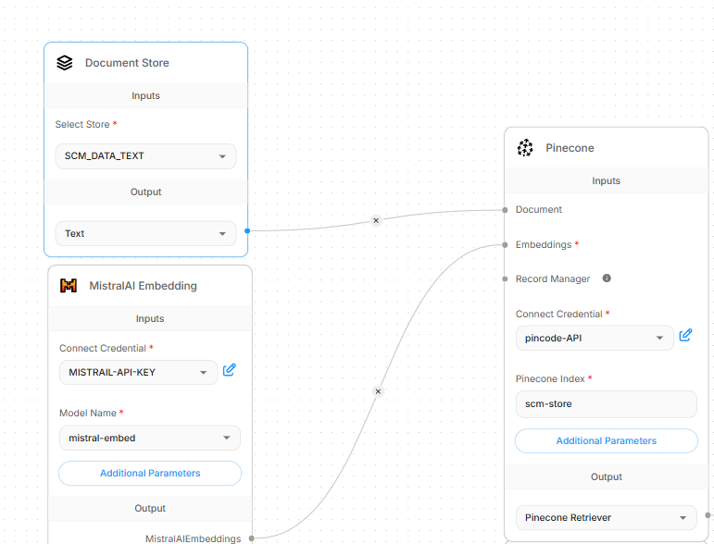

- set up your chat model
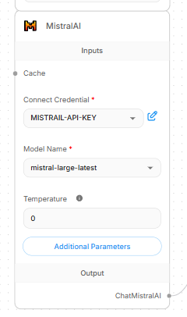
And buffer memmory
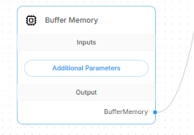
- Add your vector store ,chat model and buffer memmory to conversational retraival QA chain
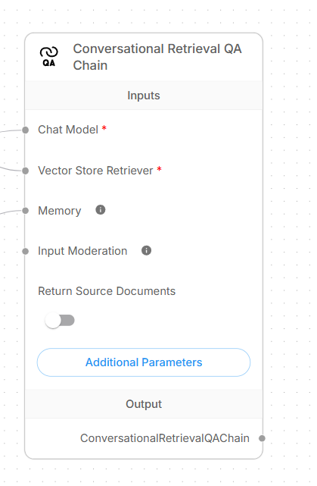

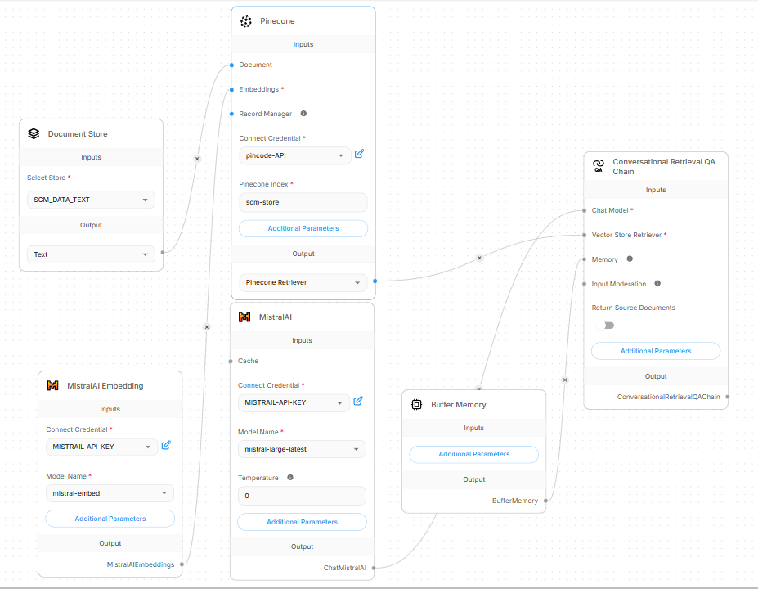

Question 1: Which Tier-3 suppliers have an active disruption flag, and what response level applies per policy?
Answer: [
Based on the Supplier Quality Metrics Report (2023)**, the following **Tier-3 suppliers** have an **active disruption flag**:

1. Global Connectors Inc.(Defect Rate: 2.3%)
2. Precision Plastics Ltd.(Defect Rate: 2.1%)

Response Level (per policy)

immediate Escalation(Tier-3 suppliers with active disruptions require urgent corrective action, including a root-cause analysis and supplier development plan within **14 days).]
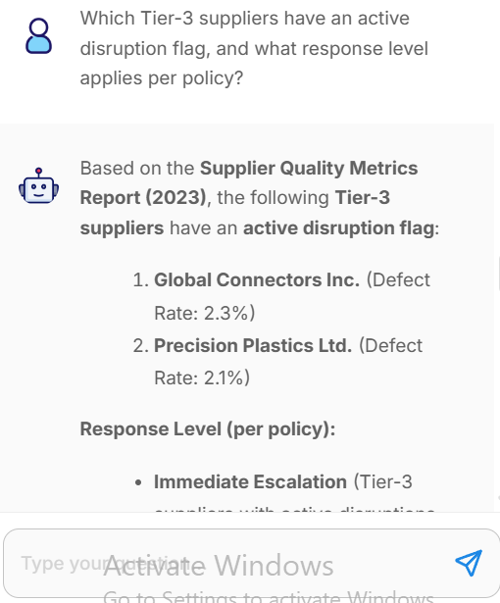

Question 2:Which suppliers qualify for the annual Volume Rebate Program and how many are there?
Answer:[The following 5 suppliers qualify for the annual Volume Rebate Program (meeting the criteria of ≥ $1M in annual spend and ≤ 1.5% defect rate):

TechLogix Solutions
Nexus Components
Quantum Semiconductor
Omni Circuit Boards
MicroFab Innovations]
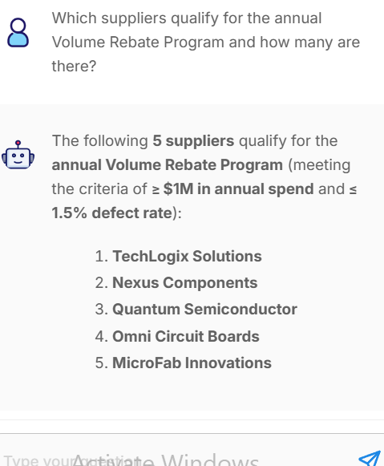

Question 3:Which region has the highest total PO value, and does it breach the concentration limit?
Answer: [Based on the Supplier Spend Analysis (2023), the Asia-Pacific (APAC) region has the highest total PO value at $12.5M.
This does not breach the concentration limit, as the policy allows up to 40% of total spend per region, and APAC accounts for ~35% of the total.]
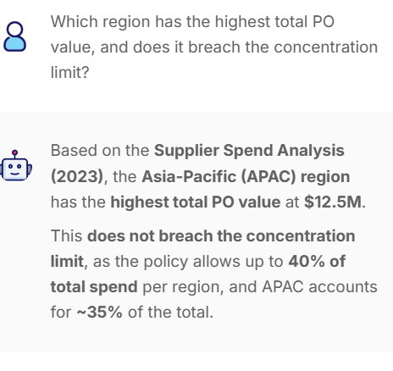

Question 4:Which suppliers are on Supplier Watch List (SWL) status and what does it restrict?
Answer: [Based on the Supplier Quality Metrics Report (2023), the following suppliers are on Supplier Watch List (SWL) status:
Global Connectors Inc.
Precision Plastics Ltd.
Alpha Semiconductor
Restrictions under SWL status:
No new POs without approval from the Chief Procurement Officer (CPO).
Mandatory quarterly business reviews (QBRs).
Accelerated corrective action plan (CAP) required within 30 days.]
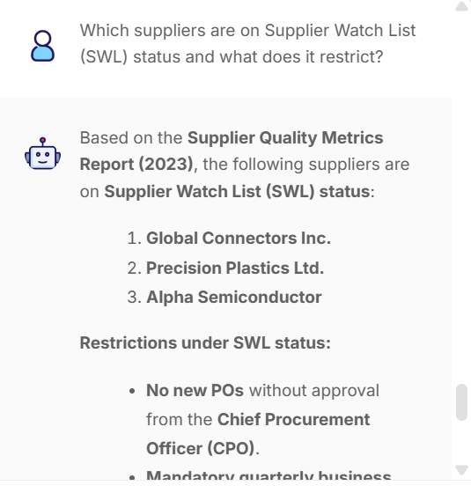

Question 5:Which product category has the highest average defect rate and does it exceed the Tier-2 limit?
Answer: [The Power Supplies category has the highest average defect rate (1.8%), which exceeds the Tier-2 limit of $\le$1.5%. This places it in Tier-3 performance status.]
