**VISVESVARAYA TECHNOLOGICAL UNIVERSITY**

**“JnanaSangama”, Belgaum -590014, Karnataka.**



LAB REPORT

on

OPERATING SYSTEMS

(23CS4PCOPS)

***Submitted by***

AKASH K S (1BM22CS028)

***in partial fulfillment for the award of the degree of***

**BACHELOR OF ENGINEERING**

***in***

COMPUTER SCIENCE AND ENGINEERING



B.M.S. COLLEGE OF ENGINEERING

**(Autonomous Institution under VTU)**

BENGALURU-560019

Apr-2024 to Aug-2024

B. M. S. College of Engineering,

**Bull Temple Road, Bangalore 560019**

(Affiliated To Visvesvaraya Technological University, Belgaum)

**Department of Computer Science and Engineering**



**CERTIFICATE**

This is to certify that the Lab work entitled “OPERATING SYSTEMS – 23CS4PCOPS” carried out by

**AKASH K S (1BM22CS028),** who is bonafide student of **B. M. S. College of Engineering.** It is in partial fulfillment for the award of **Bachelor of Engineering in Computer Science and Engineering** of the Visvesvaraya Technological University, Belgaum during the year 2024. The Lab report has been approved as it satisfies the academic requirements in respect of a **OPERATING SYSTEMS - (23CS4PCOPS)** work prescribed for the said degree.

Name of the Lab-Incharge **Dr. Jyothi S Nayak**

Designation Professor and Head

Department of CSE Department of CSE

BMSCE, Bengaluru BMSCE, Bengaluru

|  |  |  |
| --- | --- | --- |
| **Sl. No.** | **Experiment Title** | **Page No.** |
| 1. | Write a C program to simulate the following non-pre-emptive CPU scheduling algorithm to find turnaround time and waiting time. →FCFS → SJF (pre-emptive & Non-preemptive) | 1-6 |
| 2. | Write a C program to simulate the following CPU scheduling algorithm to find turnaround time and waiting time. → Priority (pre-emptive & Non-pre-emptive)  →Round Robin (Experiment with different quantum sizes for RR algorithm) | 7-16 |
| 3. | Write a C program to simulate multi-level queue scheduling algorithm considering the following scenario. All the processes in the system are divided into two categories – system processes and user processes. System processes are to be given higher priority than user processes. Use FCFS scheduling for the processes in each queue. | 17-19 |
| 4. | Write a C program to simulate Real-Time CPU Scheduling algorithms: a) Rate- Monotonic b) Earliest-deadline First c) Proportional scheduling | 20-25 |
| 5. | Write a C program to simulate producer-consumer problem using semaphores. | 25-29 |
| 6. | Write a C program to simulate the concept of Dining-Philosophers problem. | 30-32 |
| 7. | Write a C program to simulate Bankers algorithm for the purpose of deadlock avoidance. | 33-36 |
| 8. | Write a C program to simulate deadlock detection | 37-39 |
| 9. | Write a C program to simulate the following contiguous memory allocation techniques a) Worst-fit b) Best-fit c) First-fit | 40-43 |
| 10. | Write a C program to simulate page replacement algorithms a) FIFO b) LRU c) Optimal | 44-48 |

**Index Sheet**

**Course Outcome**

|  |  |
| --- | --- |
| CO1 | Apply the different concepts and functionalities of Operating System |
| CO2 | Analyze various Operating system strategies and techniques |
| CO3 | Demonstrate the different functionalities of Operating System |
| CO4 | Conduct practical experiments to implement the functionalities of Operating system |

**Program: 1 Question:**

**Write a C program to simulate the following non-pre-emptive CPU scheduling algorithm to find turnaround time and waiting time.**

**FCFS**

**Code:**

#include<stdio.h>

void sort(int proc_id[],int at[],int bt[],int n)

{

int min=at[0],temp=0; for(int i=0;i<n;i++)

{

min=at[i];

for(int j=i;j<n;j++)

{

if(at[j]<min)

{

temp=at[i]; at[i]=at[j]; at[j]=temp; temp=bt[j]; bt[j]=bt[i]; bt[i]=temp; temp=proc_id[i]; proc_id[i]=proc_id[j]; proc_id[j]=temp;

}

}

}

}

void main()

{

int n,c=0;

printf("Enter number of processes: "); scanf("%d",&n);

int proc_id[n],at[n],bt[n],ct[n],tat[n],wt[n]; double avg_tat=0.0,ttat=0.0,avg_wt=0.0,twt=0.0; for(int i=0;i<n;i++)

proc_id[i]=i+1; printf("Enter arrival times:\n"); for(int i=0;i<n;i++)

scanf("%d",&at[i]); printf("Enter burst times:\n"); for(int i=0;i<n;i++)

scanf("%d",&bt[i]);

sort(proc_id,at,bt,n);

//completion time for(int i=0;i<n;i++)

{

if(c>=at[i])

c+=bt[i]; else

c+=at[i]-ct[i-1]+bt[i]; ct[i]=c;

}

//turnaround time for(int i=0;i<n;i++)

tat[i]=ct[i]-at[i];

//waiting time for(int i=0;i<n;i++)

wt[i]=tat[i]-bt[i]; printf("FCFS scheduling:\n");

printf("PID\tAT\tBT\tCT\tTAT\tWT\n"); for(int i=0;i<n;i++)

printf("%d\t%d\t%d\t%d\t%d\t%d\n",proc_id[i],at[i],bt[i],ct[i],tat[i],wt[i]); for(int i=0;i<n;i++)

{

ttat+=tat[i];twt+=wt[i];

}

avg_tat=ttat/(double)n; avg_wt=twt/(double)n;

printf("\nAverage turnaround time:%lfms\n",avg_tat); printf("\nAverage waiting time:%lfms\n",avg_wt);

}

**Output:**

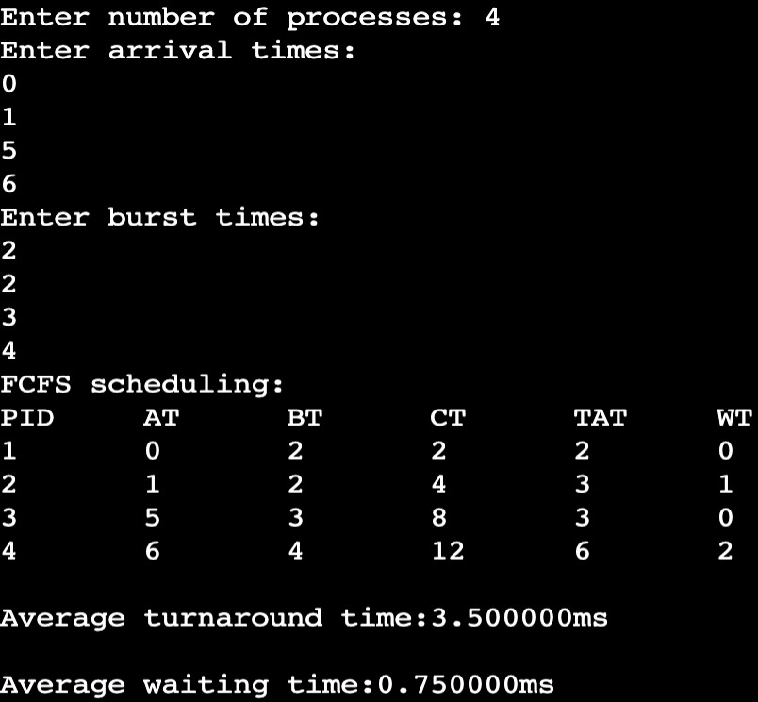

**SJF-Non Preemptive Code:**

#include<stdio.h> void main()

{

int n,c=0;

printf("Enter number of processes: "); scanf("%d",&n);

int proc_id[n],at[n],bt[n],ct[n],tat[n],wt[n],m[n]; double avg_tat=0.0,ttat=0.0,avg_wt=0.0,twt=0.0; for(int i=0;i<n;i++)

{ proc_id[i]=i+1;m[i]=0;} printf("Enter arrival times:\n"); for(int i=0;i<n;i++)

scanf("%d",&at[i]); printf("Enter burst times:\n"); for(int i=0;i<n;i++)

scanf("%d",&bt[i]);

//completion time

int count=0,mb,p=0,min=0; while(count<n)

{

min=bt[0];mb=0; for(int i=0;i<n;i++)

{

if(at[i]<=c && m[i]!=1)

{

min=bt[i];mb=i; for(int k=0;k<n;k++)

{

if(bt[k]<min && at[k]<=c && m[k]!=1)

{

min=bt[k];mb=k;

}

}

m[mb]=1;count++; if(c>=at[mb])

c+=bt[mb]; else

c+=at[mb]-ct[p]+bt[mb]; ct[mb]=c;

}

p=mb; if(count==n) break;

}

}

/*for(int i=0;i<n;i++)

{

if(c>=at[i])

c+=bt[i]; else

c+=at[i]-ct[i-1]+bt[i]; ct[i]=c;

}*/

//turnaround time for(int i=0;i<n;i++)

tat[i]=ct[i]-at[i];

//waiting time for(int i=0;i<n;i++)

wt[i]=tat[i]-bt[i];

printf("FCFS scheduling:\n"); printf("PID\tAT\tBT\tCT\tTAT\tWT\n"); for(int i=0;i<n;i++)

printf("P%d\t%d\t%d\t%d\t%d\t%d\n",proc_id[i],at[i],bt[i],ct[i],tat[i],wt[i]);

for(int i=0;i<n;i++)

{

ttat+=tat[i];twt+=wt[i];

}

avg_tat=ttat/(double)n; avg_wt=twt/(double)n;

printf("\nAverage turnaround time:%lfms\n",avg_tat); printf("\nAverage waiting time:%lfms\n",avg_wt);

}

**Output:**

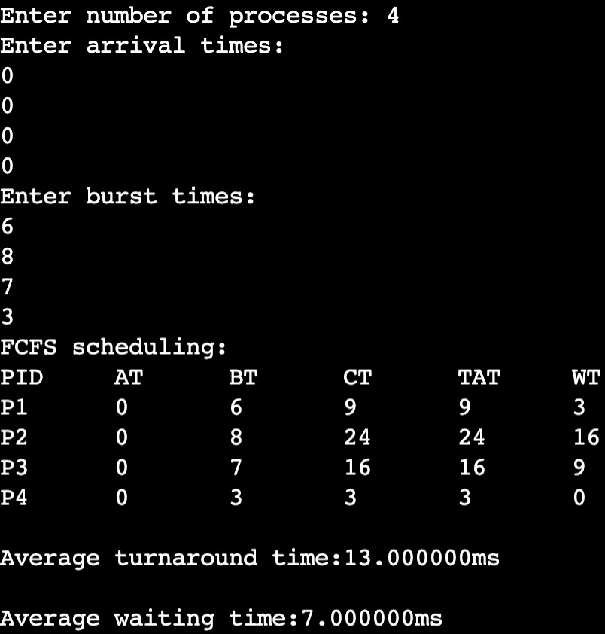

**SJF Preemptive: Code:**

#include<stdio.h> void main()

{

int n,c=0;

printf("Enter number of processes: "); scanf("%d",&n);

int proc_id[n],at[n],bt[n],ct[n],tat[n],wt[n],m[n],b[n]; double avg_tat=0.0,ttat=0.0,avg_wt=0.0,twt=0.0; for(int i=0;i<n;i++)

{ proc_id[i]=i+1;m[i]=0;} printf("Enter arrival times:\n"); for(int i=0;i<n;i++)

scanf("%d",&at[i]); printf("Enter burst times:\n"); for(int i=0;i<n;i++)

{ scanf("%d",&bt[i]);b[i]=bt[i];}

//completion time

int count=0,mb,p=0,min=0; while(count<n)

{

min=b[0];mb=0; for(int i=0;i<n;i++)

{

if(at[i]<=c && m[i]!=1)

{

min=b[i];mb=i; for(int k=0;k<n;k++)

{

if(b[k]<=min && at[k]<=c && m[k]!=1) min=b[k];mb=k;

}

if(b[mb]==1)

{m[mb]=1;count++;} if(c>=at[mb])

{ c++;b[mb]--;}

else

c+=at[mb]-ct[p]; if(b[mb]==0)

ct[mb]=c;

}

p=mb; if(count==n) break;

}

}

//turnaround time for(int i=0;i<n;i++)

tat[i]=ct[i]-at[i];

//waiting time for(int i=0;i<n;i++)

wt[i]=tat[i]-bt[i];

printf("SJF(Pre-Emptive) scheduling:\n"); printf("PID\tAT\tBT\tCT\tTAT\tWT\n"); for(int i=0;i<n;i++)

printf("P%d\t%d\t%d\t%d\t%d\t%d\n",proc_id[i],at[i],bt[i],ct[i],tat[i],wt[i]); for(int i=0;i<n;i++)

{

ttat+=tat[i];twt+=wt[i];

}

avg_tat=ttat/(double)n; avg_wt=twt/(double)n;

printf("\nAverage turnaround time:%lfms\n",avg_tat); printf("\nAverage waiting time:%lfms\n",avg_wt);

}

**Output:**

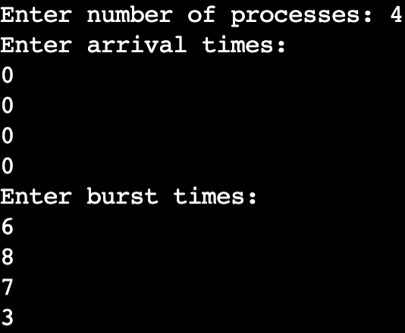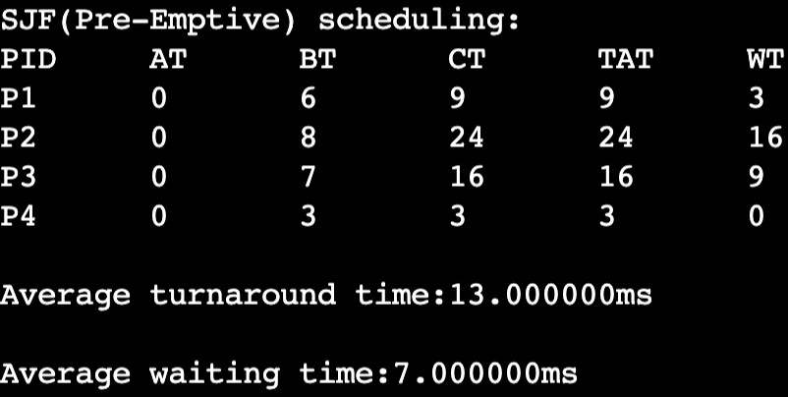

**Program: 2**

**Question: Write a C program to simulate the following CPU scheduling algorithm to find**

**turnaround time and waiting time.**

1. **Priority (pre-emptive & Non-preemptive)**
2. **Round Robin**
3. **Priority Non-Preemptive: CODE:**

#include<stdio.h>

void

sort (int proc_id[], int p[], int at[], int bt[], int n)

{

int min = p[0], temp = 0; for (int i = 0; i < n; i++)

{

min = p[i];

for (int j = i; j < n; j++)

{

if (p[j] < min)

{

}

}

}

void main ()

{

temp = at[i]; at[i] = at[j]; at[j] = temp; temp = bt[j]; bt[j] = bt[i]; bt[i] = temp; temp = p[j]; p[j] = p[i]; p[i] = temp;

temp = proc_id[i]; proc_id[i] = proc_id[j]; proc_id[j] = temp;

}

int n, c = 0;

printf ("Enter number of processes: "); scanf ("%d", &n);

int proc_id[n], at[n], bt[n], ct[n], tat[n], wt[n], m[n], rt[n], p[n]; double avg_tat = 0.0, ttat = 0.0, avg_wt = 0.0, twt = 0.0;

for (int i = 0; i < n; i++)

{

proc_id[i] = i + 1; m[i] = 0;

}

printf ("Enter priorities:\n"); for (int i = 0; i < n; i++)

scanf ("%d", &p[i]); printf ("Enter arrival times:\n"); for (int i = 0; i < n; i++)

scanf ("%d", &at[i]); printf ("Enter burst times:\n"); for (int i = 0; i < n; i++)

{

scanf ("%d", &bt[i]); m[i] = -1;

rt[i] = -1;

}

sort (proc_id, p, at, bt, n);

//completion time

int count = 0, pro = 0, priority = p[0]; int x = 0;

c = 0;

while (count < n)

{

for (int i = 0; i < n; i++)

{

if (at[i] <= c && p[i] >= priority && m[i] != 1)

{

x = i;

priority = p[i];

}

}

if (rt[x] == -1)

rt[x] = c - at[x]; if (at[x] <= c)

c += bt[x];

else

c += at[x] - c + bt[x];

count++; ct[x] = c;

m[x] = 1;

while (x >= 1 && m[--x] != 1)

{

x++;

priority = p[x]; break;

}

if (count == n)

break;

}

//turnaround time and RT for (int i = 0; i < n; i++)

tat[i] = ct[i] - at[i];

//waiting time

for (int i = 0; i < n; i++) wt[i] = tat[i] - bt[i];

printf ("\nPriority scheduling:\n");

printf ("PID\tPrior\tAT\tBT\tCT\tTAT\tWT\tRT\n"); for (int i = 0; i < n; i++)

printf ("P%d\t %d\t\t%d\t%d\t%d\t%d\t%d\t%d\n", proc_id[i], p[i], at[i], bt[i], ct[i], tat[i], wt[i], rt[i]);

for (int i = 0; i < n; i++)

{

ttat += tat[i]; twt += wt[i];

}

avg_tat = ttat / (double) n; avg_wt = twt / (double) n;

printf ("\nAverage turnaround time:%lfms\n", avg_tat); printf ("\nAverage waiting time:%lfms\n", avg_wt);

}

**Output:**

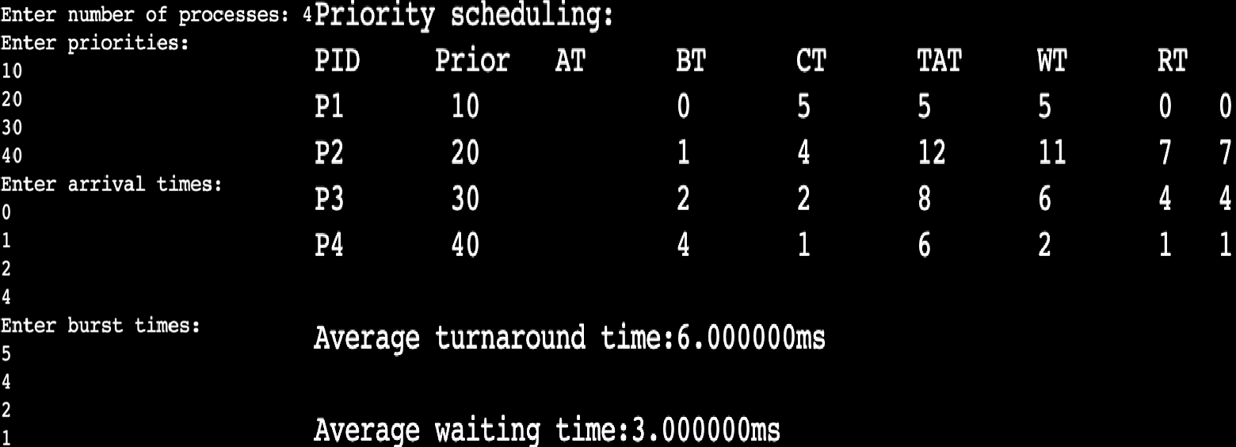

1. **Priority (Preemptive):**

**Code:**

#include<stdio.h> void

sort (int proc_id[], int p[], int at[], int bt[], int b[], int n)

{

int min = p[0], temp = 0; for (int i = 0; i < n; i++)

{

min = p[i];

for (int j = i; j < n; j++)

{

if (p[j] < min)

{

temp = at[i]; at[i] = at[j]; at[j] = temp; temp = bt[j]; bt[j] = bt[i]; bt[i] = temp; temp = b[j]; b[j] = b[i]; b[i] = temp; temp = p[j]; p[j] = p[i]; p[i] = temp;

temp = proc_id[i]; proc_id[i] = proc_id[j]; proc_id[j] = temp;

}

}

}

}

Void main (){ int n, c = 0;

printf ("Enter number of processes: "); scanf ("%d", &n);

int proc_id[n], at[n], bt[n], ct[n], tat[n], wt[n], m[n], b[n], rt[n], p[n]; double avg_tat = 0.0, ttat = 0.0, avg_wt = 0.0, twt = 0.0;

for (int i = 0; i < n; i++)

{

proc_id[i] = i + 1; m[i] = 0;

}

printf ("Enter priorities:\n"); for (int i = 0; i < n; i++)

scanf ("%d", &p[i]); printf ("Enter arrival times:\n");

for (int i = 0; i < n; i++) scanf ("%d", &at[i]);

printf ("Enter burst times:\n"); for (int i = 0; i < n; i++)

{

scanf ("%d", &bt[i]); b[i] = bt[i];

m[i] = -1;

rt[i] = -1;

}

sort (proc_id, p, at, bt, b, n);

int count = 0, pro = 0, priority = p[0]; int x = 0;

c = 0;

while (count < n)

{

for (int i = 0; i < n; i++)

{

if (at[i] <= c && p[i] >= priority && b[i] > 0 && m[i] != 1)

{

}

if (b[x] > 0)

{

x = i;

priority = p[i];

}

if (rt[x] == -1)

rt[x] = c - at[x];

b[x]--; c++;

}

if (b[x] == 0)

{

count++; ct[x] = c;

m[x] = 1;

while (x >= 1 && b[x] == 0) priority = p[--x];

}

if (count == n)

break;

}

//turnaround time and RT for (int i = 0; i < n; i++)

tat[i] = ct[i] - at[i];

//waiting time

for (int i = 0; i < n; i++) wt[i] = tat[i] - bt[i];

printf ("Priority scheduling(Pre-Emptive):\n");

printf ("PID\tPrior\tAT\tBT\tCT\tTAT\tWT\tRT\n"); for (int i = 0; i < n; i++)

printf ("P%d\t %d\t\t%d\t%d\t%d\t%d\t%d\t%d\n", proc_id[i], p[i], at[i], bt[i], ct[i], tat[i], wt[i], rt[i]);

for (int i = 0; i < n; i++)

{

ttat += tat[i]; twt += wt[i];

}

avg_tat = ttat / (double) n; avg_wt = twt / (double) n;

printf ("\nAverage turnaround time:%lfms\n", avg_tat); printf ("\nAverage waiting time:%lfms\n", avg_wt);

}

**Output:**

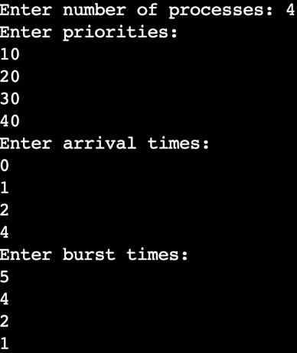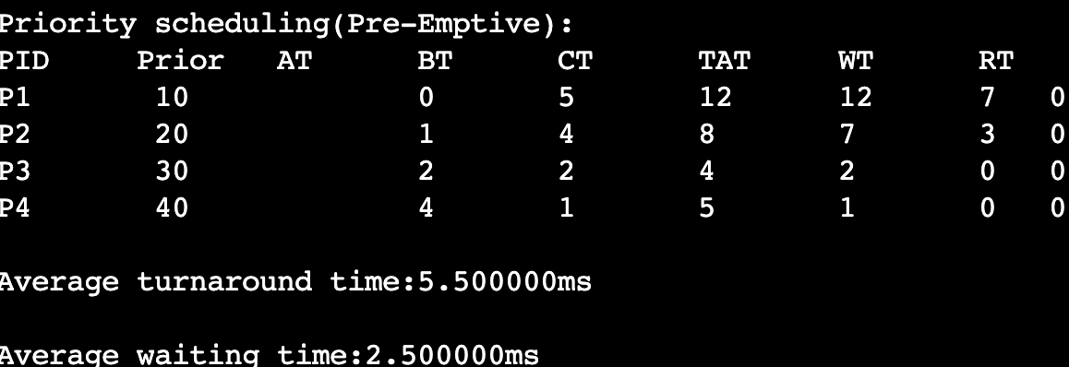

1. **RoundRobin: Code:**

//RRS #include<stdio.h>

void

sort (int proc_id[], int at[], int bt[], int b[], int n)

{

int min = at[0], temp = 0; for (int i = 0; i < n; i++)

{

min = at[i];

for (int j = i; j < n; j++)

{

if (at[j] < min)

{

temp = at[i]; at[i] = at[j]; at[j] = temp; temp = bt[j]; bt[j] = bt[i]; bt[i] = temp; temp = b[j]; b[j] = b[i]; b[i] = temp;

temp = proc_id[i]; proc_id[i] = proc_id[j]; proc_id[j] = temp;

}

}

}

}

void main (){

int n, c = 0, t = 0;

printf ("Enter number of processes: "); scanf ("%d", &n);

printf ("Enter Time Quantum: "); scanf ("%d", &t);

int proc_id[n], at[n], bt[n], ct[n], tat[n], wt[n], b[n], rt[n], m[n]; int f = -1, r = -1;

int q[100]; int count = 0;

double avg_tat = 0.0, ttat = 0.0, avg_wt = 0.0, twt = 0.0; for (int i = 0; i < n; i++)

proc_id[i] = i + 1;

printf ("Enter arrival times:\n"); for (int i = 0; i < n; i++)

scanf ("%d", &at[i]); printf ("Enter burst times:\n"); for (int i = 0; i < n; i++)

{

scanf ("%d", &bt[i]); b[i] = bt[i];

m[i] = 0;

rt[i] = -1;

}

sort (proc_id, at, bt, b, n); f = r = 0;

q[0] = proc_id[0]; int p = 0, i = 0; while (f >= 0)

{

p = q[f++]; i = 0;

while (p != proc_id[i]) i++;

if (b[i] >= t)

{

else

if (rt[i] == -1)

rt[i] = c;

b[i] -= t; c += t; m[i] = 1;

}

{

if (rt[i] == -1)

rt[i] = c;

c += b[i];

b[i] = 0;

m[i] = 1;

}

m[0] = 1;

for (int j = 0; j < n; j++)

{

if (at[j] <= c && proc_id[j] != p && m[j] != 1)

{

}

if (b[i] == 0)

{

q[++r] = proc_id[j]; m[j] = 1;

}

count++;

else

ct[i] = c;

}

q[++r] = proc_id[i];

if (f > r)

f = -1;

}

for (int i = 0; i < n; i++)

{

tat[i] = ct[i] - at[i];

rt[i] = rt[i] - at[i];

}

//waiting time

for (int i = 0; i < n; i++) wt[i] = tat[i] - bt[i]; printf ("\nRRS scheduling:\n");

printf ("PID\tAT\tBT\tCT\tTAT\tWT\tRT\n"); for (int i = 0; i < n; i++)

printf ("%d\t%d\t%d\t%d\t%d\t%d\t%d\n", proc_id[i], at[i], bt[i], ct[i], tat[i], wt[i], rt[i]);

for (int i = 0; i < n; i++)

{

ttat += tat[i]; twt += wt[i];

}

avg_tat = ttat / (double) n; avg_wt = twt / (double) n;

printf ("\nAverage turnaround time:%lfms\n", avg_tat); printf ("\nAverage waiting time:%lfms\n", avg_wt);

}

**Output:**

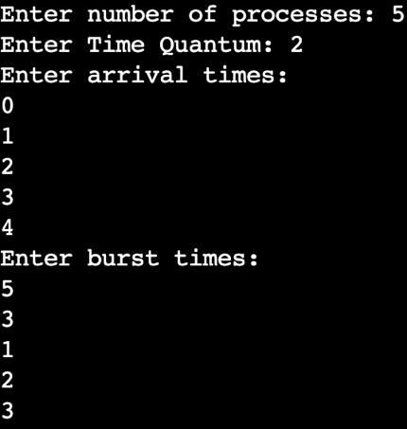

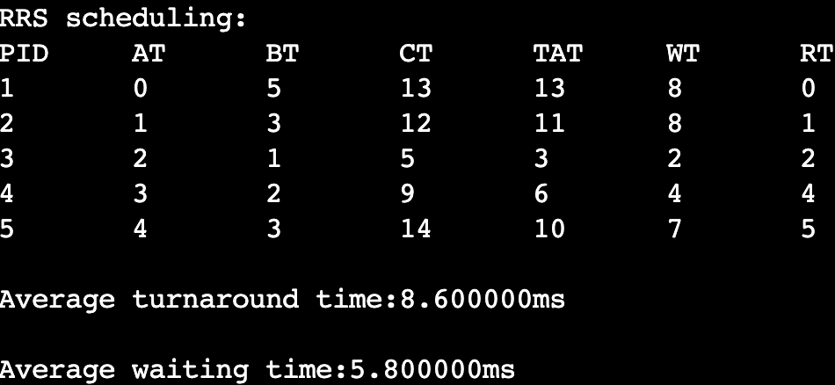

**Program:3 Question:**

**Write a C program to simulate multi-level queue scheduling algorithm considering the following scenario. All the processes in the system are divided into two categories – system processes and user processes. System processes are to be given higher priority than user processes. Use FCFS scheduling for the processes in each queue.**

**Code:**

#include<stdio.h>

void sort(int proc_id[],int at[],int bt[],int n)

{

int temp=0;

for(int i=0;i<n;i++)

{

for(int j=i;j<n;j++)

{

if(at[j]<at[i])

{

temp=at[i];at[i]=at[j];at[j]=temp;

temp=bt[j];bt[j]=bt[i];bt[i]=temp; temp=proc_id[i];proc_id[i]=proc_id[j];proc_id[j]=temp;

}

}

}

}

void fcfs(int at[],int bt[],int ct[],int tat[],int wt[],int n,int *c)

{

double ttat=0.0,twt=0.0;

//completion time for(int i=0;i<n;i++)

{

if(*c>=at[i])

*c+=bt[i]; else

*c+=at[i]-ct[i-1]+bt[i]; ct[i]=*c;

}

//turnaround time for(int i=0;i<n;i++)

tat[i]=ct[i]-at[i];

//waiting time for(int i=0;i<n;i++)

wt[i]=tat[i]-bt[i];

}

void main()

{

int sn,un,c=0;int n=0;

printf("Enter number of system processes: "); scanf("%d",&sn);n=sn;

int sproc_id[n],sat[n],sbt[n],sct[n],stat[n],swt[n]; for(int i=0;i<sn;i++)

sproc_id[i]=i+1;

printf("Enter arrival times of the system processes:\n"); for(int i=0;i<sn;i++)

scanf("%d",&sat[i]);

printf("Enter burst times of the system processes:\n"); for(int i=0;i<sn;i++)

scanf("%d",&sbt[i]);

printf("Enter number of user processes: "); scanf("%d",&un);n=un;

int uproc_id[n],uat[n],ubt[n],uct[n],utat[n],uwt[n]; for(int i=0;i<un;i++)

uproc_id[i]=i+1;

printf("Enter arrival times of the user processes:\n"); for(int i=0;i<un;i++)

scanf("%d",&uat[i]);

printf("Enter burst times of the user processes:\n"); for(int i=0;i<un;i++)

scanf("%d",&ubt[i]);

sort(sproc_id,sat,sbt,sn); sort(uproc_id,uat,ubt,un);

fcfs(sat,sbt,sct,stat,swt,sn,&c); fcfs(uat,ubt,uct,utat,uwt,un,&c);

printf("\nScheduling:\n"); printf("System processes:\n");

printf("PID\tAT\tBT\tCT\tTAT\tWT\n"); for(int i=0;i<sn;i++)

printf("%d\t%d\t%d\t%d\t%d\t%d\n",sproc_id[i],sat[i],sbt[i],sct[i],stat[i],swt[i]); printf("User processes:\n");

for(int i=0;i<un;i++) printf("%d\t%d\t%d\t%d\t%d\t%d\n",uproc_id[i],uat[i],ubt[i],uct[i],utat[i],uwt[i]);

}

**Output:**

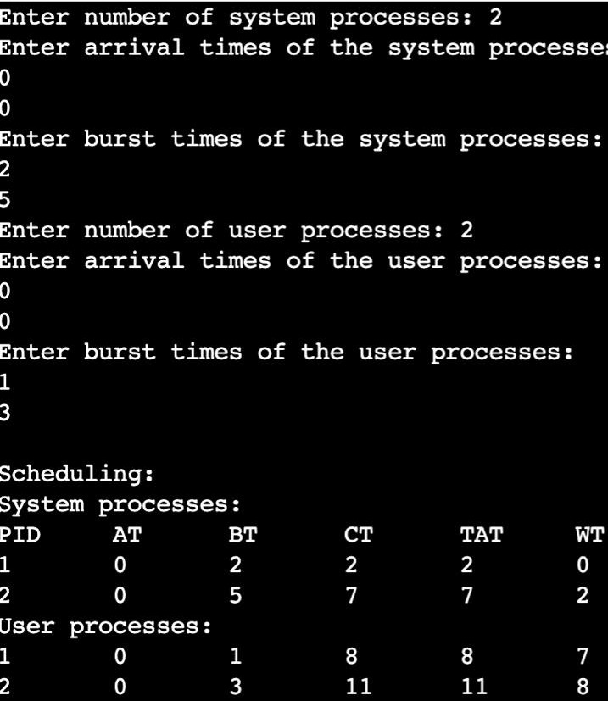

**Program:4 Question:**

**Write a C program to simulate Real-Time CPU Scheduling algorithms:**

1. **Rate- Monotonic**
2. **Earliest-deadline First**
3. **Proportional scheduling**
   1. **Rate-Monotonic: Code:**

#include <stdio.h> #include <stdlib.h> #include <math.h> void

sort (int proc[], int b[], int pt[], int n)

{

int temp = 0;

for (int i = 0; i < n; i++)

{

for (int j = i; j < n; j++)

{

if (pt[j] < pt[i])

{

temp = pt[i]; pt[i] = pt[j]; pt[j] = temp; temp = b[j]; b[j] = b[i]; b[i] = temp;

temp = proc[i]; proc[i] = proc[j]; proc[j] = temp;

}

}

}

}

int

gcd (int a, int b)

{

int r;

while (b > 0)

{

r = a % b; a = b;

b = r;

}

return a;

}

int

lcmul (int p[], int n)

{

int lcm = p[0];

for (int i = 1; i < n; i++)

{

lcm = (lcm * p[i]) / gcd (lcm, p[i]);

}

return lcm;

}

void main ()

{

int n;

printf ("Enter the number of processes:"); scanf ("%d", &n);

int proc[n], b[n], pt[n], rem[n];

printf ("Enter the CPU burst times:\n"); for (int i = 0; i < n; i++)

{

scanf ("%d", &b[i]); rem[i] = b[i];

}

printf ("Enter the time periods:\n"); for (int i = 0; i < n; i++)

scanf ("%d", &pt[i]); for (int i = 0; i < n; i++)

proc[i] = i + 1; sort (proc, b, pt, n);

//LCM

int l = lcmul (pt, n); printf ("LCM=%d\n", l);

printf ("\nRate Monotone Scheduling:\n"); printf ("PID\t Burst\tPeriod\n");

for (int i = 0; i < n; i++)

printf ("%d\t\t%d\t\t%d\n", proc[i], b[i], pt[i]);

//feasibility double sum = 0.0;

for (int i = 0; i < n; i++)

{

sum += (double) b[i] / pt[i];

}

double rhs = n * (pow (2.0, (1.0 / n)) - 1.0);

printf ("\n%lf <= %lf =>%s\n", sum, rhs, (sum <= rhs) ? "true" : "false"); if (sum > rhs)

exit (0);

printf ("Scheduling occurs for %d ms\n\n", l);

//RMS

int time = 0, prev = 0, x = 0; while (time < l)

{

int f = 0;

for (int i = 0; i < n; i++)

{

if (time % pt[i] == 0) rem[i] = b[i];

if (rem[i] > 0)

{

if (prev != proc[i])

{

printf ("%dms onwards: Process %d running\n", time, proc[i]);

prev = proc[i];

}

}

if (!f)

{

rem[i]--; f = 1;

break; x = 0;

}

if (x != 1)

{

}

time++;

}

}

printf ("%dms onwards: CPU is idle\n", time); x = 1;

}

**Output**

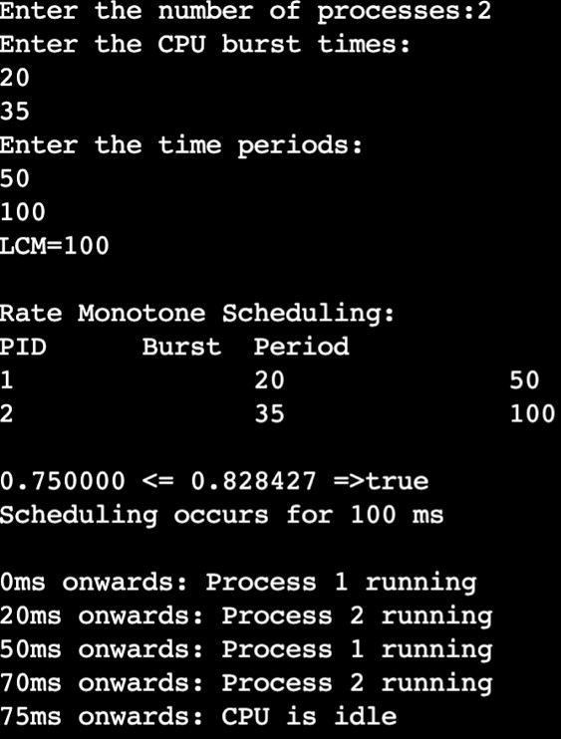

* 1. **Earliest-Deadline First: Code:**

#include <stdio.h> #include <stdlib.h> #include <math.h> void

sort (int proc[], int d[], int b[], int pt[], int n)

{

int temp = 0;

for (int i = 0; i < n; i++)

{

for (int j = i; j < n; j++)

{

if (d[j] < d[i])

{

temp = d[j]; d[j] = d[i]; d[i] = temp; temp = pt[i]; pt[i] = pt[j]; pt[j] = temp; temp = b[j]; b[j] = b[i]; b[i] = temp;

temp = proc[i]; proc[i] = proc[j]; proc[j] = temp;

}

}

}

}

int

gcd (int a, int b)

{

int r;

while (b > 0)

{

r = a % b;

a = b;

b = r;

}

return a;

}

int

lcmul (int p[], int n)

{

int lcm = p[0];

for (int i = 1; i < n; i++)

{

lcm = (lcm * p[i]) / gcd (lcm, p[i]);

}

return lcm;

}

void main ()

{

int n;

printf ("Enter the number of processes:"); scanf ("%d", &n);

int proc[n], b[n], pt[n], d[n], rem[n]; printf ("Enter the CPU burst times:\n"); for (int i = 0; i < n; i++)

{

scanf ("%d", &b[i]); rem[i] = b[i];

}

printf ("Enter the deadlines:\n"); for (int i = 0; i < n; i++)

scanf ("%d", &d[i]);

printf ("Enter the time periods:\n"); for (int i = 0; i < n; i++)

scanf ("%d", &pt[i]); for (int i = 0; i < n; i++)

proc[i] = i + 1;

sort (proc, d, b, pt, n);

//LCM

int l = lcmul (pt, n);

printf ("\nEarliest Deadline Scheduling:\n"); printf ("PID\t Burst\tDeadline\tPeriod\n"); for (int i = 0; i < n; i++)

printf ("%d\t\t%d\t\t%d\t\t%d\n", proc[i], b[i], d[i], pt[i]); printf ("Scheduling occurs for %d ms\n\n", l);

//EDF

int time = 0, prev = 0, x = 0; int nextDeadlines[n];

for (int i = 0; i < n; i++)

{

nextDeadlines[i] = d[i]; rem[i] = b[i];

}

while (time < l)

{

for (int i = 0; i < n; i++)

{

if (time % pt[i] == 0 && time != 0)

{

nextDeadlines[i] = time + d[i]; rem[i] = b[i];

}

}

int minDeadline = l + 1; int taskToExecute = -1; for (int i = 0; i < n; i++)

{

if (rem[i] > 0 && nextDeadlines[i] < minDeadline)

{

minDeadline = nextDeadlines[i]; taskToExecute = i;

}

}

if (taskToExecute != -1)

{

printf ("%dms : Task %d is running.\n", time, proc[taskToExecute]); rem[taskToExecute]--;

}

else

{

printf ("%dms: CPU is idle.\n", time);

}

time++;

}

}

**Output:**

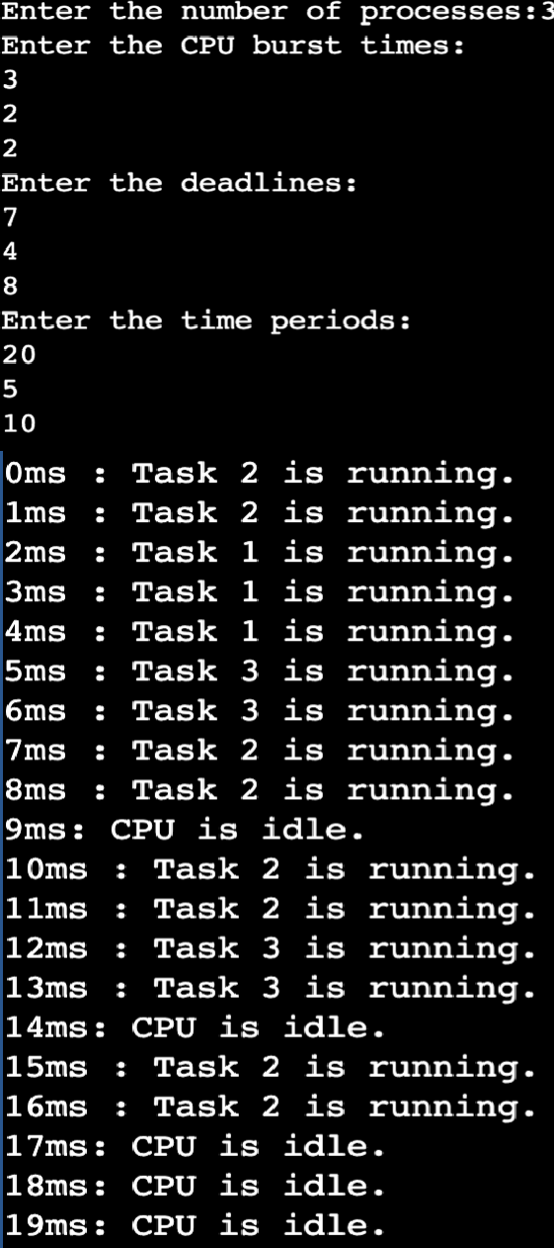 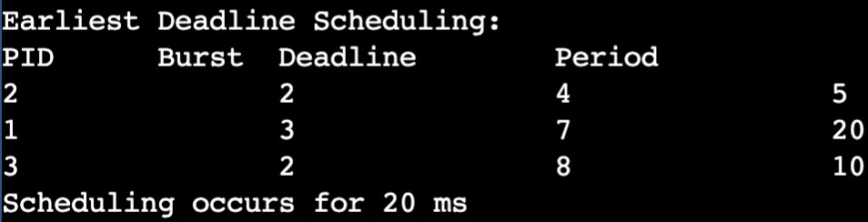

* 1. **Proportional Scheduling Code:**

#include <stdio.h> #include <stdlib.h> #include <time.h>

int main() { srand(time(NULL)); int n;

printf("Enter number of processes:");

scanf("%d",&n);

int p[n],t[n],cum[n],m[n];int c=0;int total = 0,count=0; printf("Enter tickets of the processes:\n");

for(int i=0;i<n;i++)

{

scanf("%d",&t[i]); c+=t[i];

cum[i]=c;

p[i]=i+1;

m[i]=0;

total+= t[i];

}

while(count<n)

{

int wt=rand()%total; for (int i=0;i<n;i++)

{

if (wt<cum[i] && m[i]==0)

{

printf("The winning number is %d and winning participant is: %d\n",wt,p[i]); m[i]=1;count++;

}

}

}

printf("\nProbabilities:\n"); for (int i = 0; i < n; i++)

{

printf("The probability of P%d winning: %.2f %\n",p[i],((double)t[i]/total*100));

}

}

**Output:**

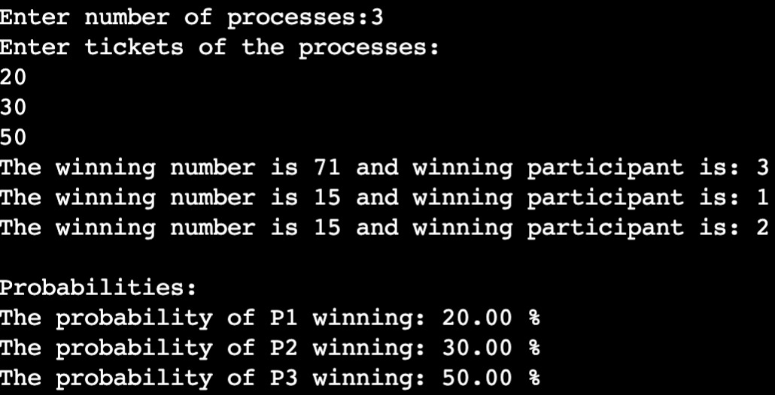

**Program:5 Question:**

**Write a C program to simulate producer-consumer problem using semaphores.**

**Code:**

#include<stdio.h> #include<stdlib.h>

int mutex=1,full=0,empty=5,x=0; void wait()

{

--mutex;

}

void signal()

{

++mutex;

}

void producer()

{

wait();++full;--empty;x++;

printf("Producer has produced: Item %d\n",x); signal();

}

void consumer()

{

wait();--full;++empty;

printf("Consumer has consumed: Item %d\n",x); x--;signal();

}

void main()

{

int ch;

printf("Enter 1.Producer 2.Consumer 3.Exit\n"); while(1)

{

printf("Enter your choice:\n"); scanf("%d",&ch);

switch(ch)

{

case 1:

if(mutex==1 && empty!=0) producer();

else

printf("Buffer is full!\n"); break;

case 2:

if(mutex==1 && full!=0) consumer();

else

printf("Buffer is empty!\n"); break;

case 3:exit(0); default:printf("Invalid choice!\n");

}

}

}

**Output:**

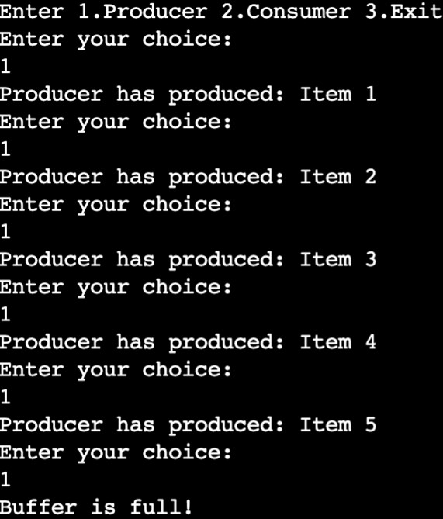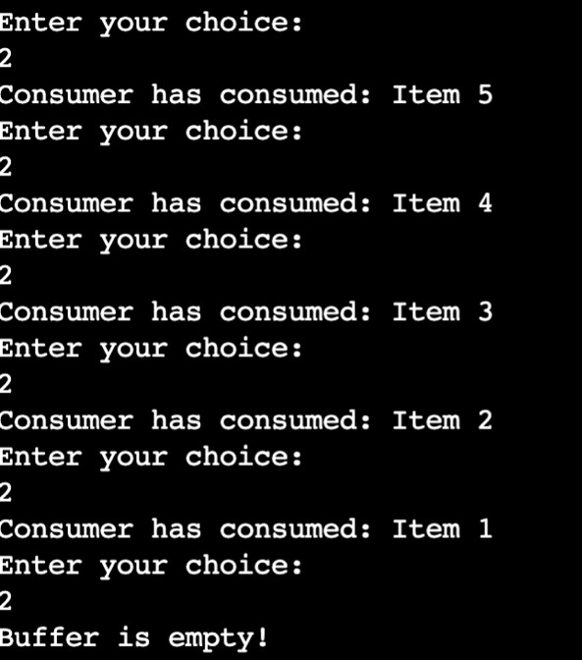

**Program:6 Question:**

**Write a C program to simulate the concept of Dining-Philosophers problem.**

**Code:**

#include <stdio.h> #include <stdlib.h> #include <pthread.h> #include <unistd.h>

#define MAX_PHILOSOPHERS 100

int mutex = 1; int mutex2 = 2;

int philosophers[MAX_PHILOSOPHERS]; void wait(int *sem) {

while (*sem <= 0); (*sem)--;

}

void signal(int *sem) { (*sem)++;

}

void* one_eat_at_a_time(void* arg) { int philosopher = *((int*) arg);

wait(&mutex);

printf("Philosopher %d is granted to eat\n", philosopher + 1); sleep(1);

printf("Philosopher %d has finished eating\n", philosopher + 1); signal(&mutex);

return NULL;

}

void* two_eat_at_a_time(void* arg) { int philosopher = *((int*) arg);

wait(&mutex2);

printf("Philosopher %d is granted to eat\n", philosopher + 1); sleep(1);

printf("Philosopher %d has finished eating\n", philosopher + 1);

signal(&mutex2);

return NULL;

}

int main() { int N;

printf("Enter the total number of philosophers: "); scanf("%d", &N);

int hungry_count;

printf("How many are hungry: "); scanf("%d", &hungry_count);

int hungry_philosophers[hungry_count]; for (int i = 0; i < hungry_count; i++) {

printf("Enter philosopher %d position (1 to %d): ", i + 1, N); scanf("%d", &hungry_philosophers[i]); hungry_philosophers[i]--;

}

pthread_t thread[hungry_count]; int choice;

do {

printf("\n1. One can eat at a time\n2. Two can eat at a time\n3. Exit\nEnter your choice: "); scanf("%d", &choice);

switch (choice) { case 1:

printf("Allow one philosopher to eat at any time\n"); for (int i = 0; i < hungry_count; i++) {

philosophers[i] = hungry_philosophers[i];

pthread_create(&thread[i], NULL, one_eat_at_a_time, &philosophers[i]);

}

for (int i = 0; i < hungry_count; i++) { pthread_join(thread[i], NULL);

}

break; case 2:

printf("Allow two philosophers to eat at the same time\n"); for (int i = 0; i < hungry_count; i++) {

philosophers[i] = hungry_philosophers[i];

pthread_create(&thread[i], NULL, two_eat_at_a_time, &philosophers[i]);

}

for (int i = 0; i < hungry_count; i++) { pthread_join(thread[i], NULL);

}

break; case 3:

printf("Exit\n"); break;

default:

printf("Invalid choice. Please try again.\n");

}

} while (choice != 3);

return 0;

}

**Output:**

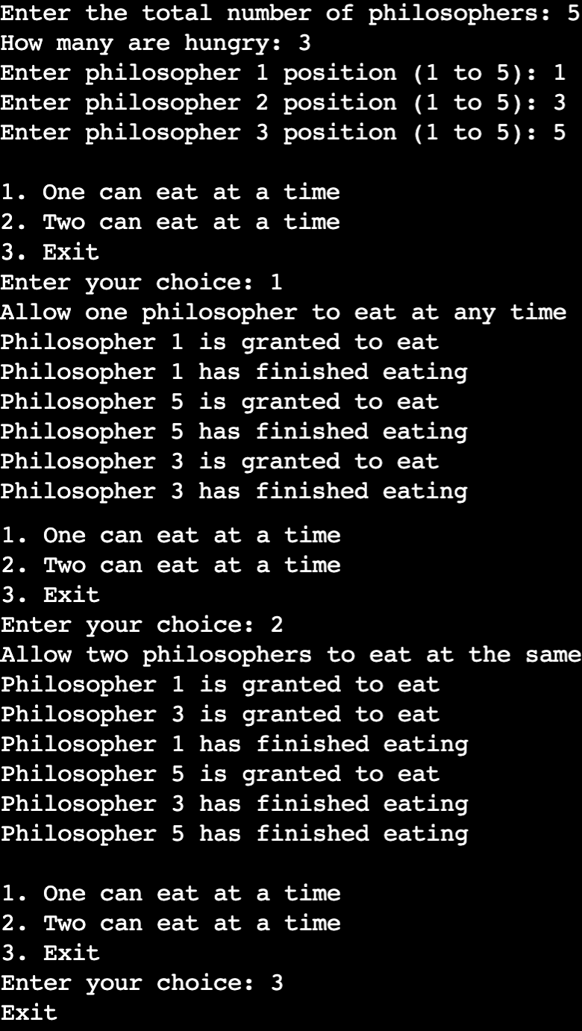

**Program:7 Question:**

**Write a C program to simulate Bankers algorithm for the purpose of deadlock avoidance.**

**Code:**

#include <stdio.h> #include <stdbool.h>

void calculateNeed(int P, int R, int need[P][R], int max[P][R], int allot[P][R]) { for (int i = 0; i < P; i++)

for (int j = 0; j < R; j++)

need[i][j] = max[i][j] - allot[i][j];

}

bool isSafe(int P, int R, int processes[], int avail[], int max[][R], int allot[][R]) { int need[P][R];

calculateNeed(P, R, need, max, allot);

bool finish[P];

for (int i = 0; i < P; i++) { finish[i] = 0;

}

int safeSeq[P]; int work[R];

for (int i = 0; i < R; i++) { work[i] = avail[i];

}

int count = 0; while (count < P) {

bool found = false;

for (int p = 0; p < P; p++) { if (finish[p] == 0) {

int j;

for (j = 0; j < R; j++)

if (need[p][j] > work[j]) break;

if (j == R) {

printf("P%d is visited (", p); for (int k = 0; k < R; k++) { work[k] += allot[p][k];

printf("%d ", work[k]);

}

printf(")\n"); safeSeq[count++] = p;

finish[p] = 1; found = true;

}

}

}

if (found == false) {

printf("System is not in safe state\n"); return false;

}

}

printf("SYSTEM IS IN SAFE STATE\nThe Safe Sequence is -- ("); for (int i = 0; i < P; i++) {

printf("P%d ", safeSeq[i]);

}

printf(")\n");

return true;

}

int main() { int P, R;

printf("Enter number of processes: "); scanf("%d", &P);

printf("Enter number of resources: "); scanf("%d", &R);

int processes[P]; int avail[R];

int max[P][R];

int allot[P][R];

for (int i = 0; i < P; i++) { processes[i] = i;

}

for (int i = 0; i < P; i++) { printf("Enter details for P%d\n", i); printf("Enter allocation -- ");

for (int j = 0; j < R; j++) { scanf("%d", &allot[i][j]);

}

printf("Enter Max -- "); for (int j = 0; j < R; j++) {

scanf("%d", &max[i][j]);

}

}

printf("Enter Available Resources -- "); for (int i = 0; i < R; i++) {

scanf("%d", &avail[i]);

}

isSafe(P, R, processes, avail, max, allot);

printf("\nProcess\tAllocation\tMax\tNeed\n"); for (int i = 0; i < P; i++) {

printf("P%d\t", i);

for (int j = 0; j < R; j++) { printf("%d ", allot[i][j]);

}

printf("\t");

for (int j = 0; j < R; j++) { printf("%d ", max[i][j]);

}

printf("\t");

for (int j = 0; j < R; j++) {

printf("%d ", max[i][j] - allot[i][j]);

}

printf("\n");

}

return 0;

}

**Output:**

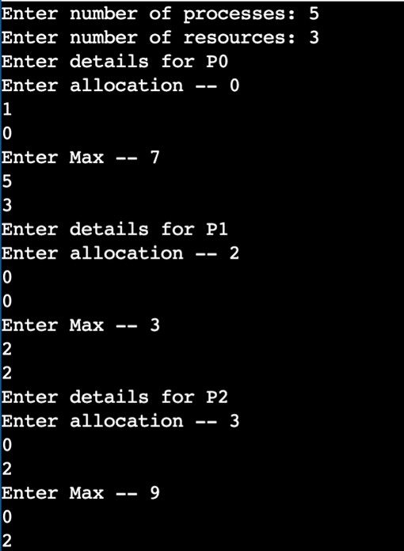

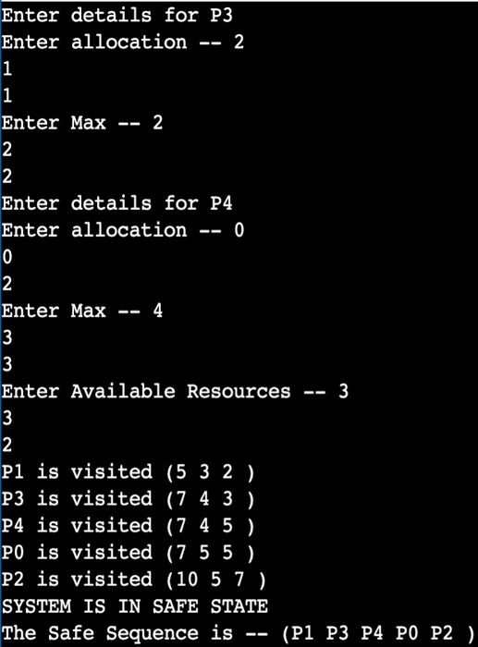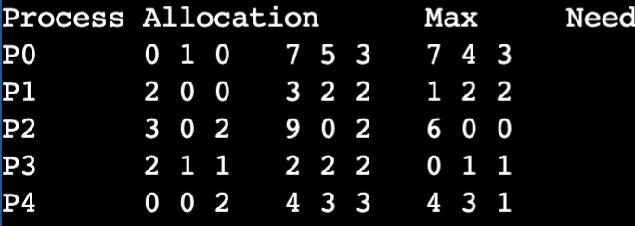

**Program:8 Question:**

**Write a C program to simulate deadlock detection. Code:**

#include <stdio.h> #include <stdbool.h>

void calculateNeed(int P, int R, int need[P][R], int max[P][R], int allot[P][R]) { for (int i = 0; i < P; i++)

for (int j = 0; j < R; j++)

need[i][j] = max[i][j] - allot[i][j];

}

bool isSafe(int P, int R, int processes[], int avail[], int max[][R], int allot[][R]) { int need[P][R];

calculateNeed(P, R, need, max, allot);

bool finish[P];

for (int i = 0; i < P; i++) { finish[i] = 0;

}

int safeSeq[P]; int work[R];

for (int i = 0; i < R; i++) { work[i] = avail[i];

}

int count = 0; while (count < P) {

bool found = false;

for (int p = 0; p < P; p++) { if (finish[p] == 0) {

int j;

for (j = 0; j < R; j++)

if (need[p][j] > work[j]) break;

if (j == R) {

printf("P%d is visited (", p); for (int k = 0; k < R; k++) { work[k] += allot[p][k];

printf("%d ", work[k]);

}

printf(")\n"); safeSeq[count++] = p; finish[p] = 1;

found = true;

}

}

}

if (found == false) {

printf("System is not in safe state\n"); return false;

}

}

printf("SYSTEM IS IN SAFE STATE\nThe Safe Sequence is -- ("); for (int i = 0; i < P; i++) {

printf("P%d ", safeSeq[i]);

}

printf(")\n");

return true;

}

int main() { int P, R;

printf("Enter number of processes: "); scanf("%d", &P);

printf("Enter number of resources: "); scanf("%d", &R);

int processes[P]; int avail[R];

int max[P][R];

int allot[P][R];

for (int i = 0; i < P; i++) { processes[i] = i;

}

for (int i = 0; i < P; i++) { printf("Enter details for P%d\n", i); printf("Enter allocation -- ");

for (int j = 0; j < R; j++) { scanf("%d", &allot[i][j]);

}

printf("Enter Max -- "); for (int j = 0; j < R; j++) {

scanf("%d", &max[i][j]);

}

}

printf("Enter Available Resources -- "); for (int i = 0; i < R; i++) {

scanf("%d", &avail[i]);

}

isSafe(P, R, processes, avail, max, allot);

printf("\nProcess\tAllocation\tMax\tNeed\n"); for (int i = 0; i < P; i++) {

printf("P%d\t", i);

for (int j = 0; j < R; j++) { printf("%d ", allot[i][j]);

}

printf("\t");

for (int j = 0; j < R; j++) { printf("%d ", max[i][j]);

}

printf("\t");

for (int j = 0; j < R; j++) {

printf("%d ", max[i][j] - allot[i][j]);

}

printf("\n");

}

return 0;

}

**Output:**

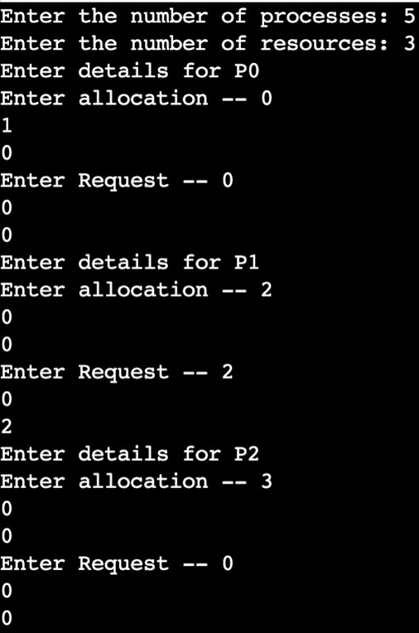 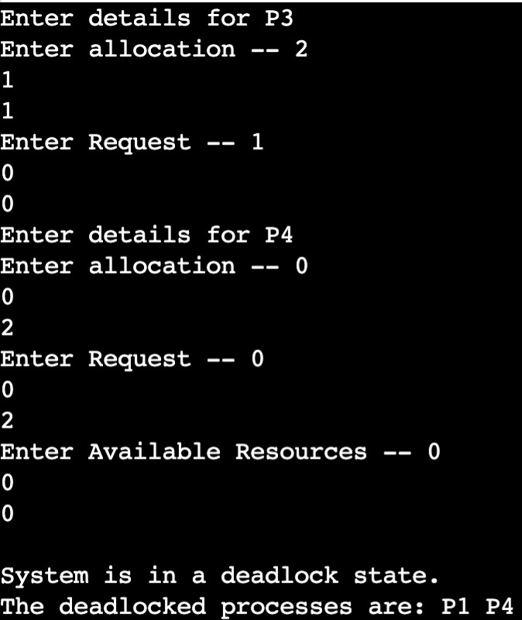

**Program:9 Question:**

**Write a C program to simulate the following contiguous memory allocation techniques**

1. **Worst-fit**
2. **Best-fit**
3. **First-fit**

**Code:**

#include <stdio.h> #define MAX 25

void firstFit(int nb, int nf, int b[], int f[]) {

int frag[MAX], bf[MAX] = {0}, ff[MAX] = {0};

int i, j, temp;

for (i = 1; i <= nf; i++) { for (j = 1; j <= nb; j++) {

if (bf[j] != 1) {

temp = b[j] - f[i]; if (temp >= 0) {

ff[i] = j; frag[i] = temp; bf[j] = 1; break;

}

}

}

}

printf("\nMemory Management Scheme - First Fit\n"); printf("File_no:\tFile_size :\tBlock_no:\tBlock_size:\tFragment\n"); for (i = 1; i <= nf; i++) {

printf("%d\t\t%d\t\t", i, f[i]); if (ff[i] != 0) {

printf("%d\t\t%d\t\t%d\n", ff[i], b[ff[i]], frag[i]);

} else {

printf("Not Allocated\n");

}

}

}

void bestFit(int nb, int nf, int b[], int f[]) {

int frag[MAX], bf[MAX] = {0}, ff[MAX] = {0};

int i, j, temp, lowest = 10000;

for (i = 1; i <= nf; i++) { for (j = 1; j <= nb; j++) {

if (bf[j] != 1) {

temp = b[j] - f[i];

if (temp >= 0 && lowest > temp) { ff[i] = j;

lowest = temp;

}

}

}

frag[i] = lowest; bf[ff[i]] = 1;

lowest = 10000;

}

printf("\nMemory Management Scheme - Best Fit\n"); printf("File No\tFile Size \tBlock No\tBlock Size\tFragment\n"); for (i = 1; i <= nf; i++) {

printf("%d\t\t%d\t\t", i, f[i]); if (ff[i] != 0) {

printf("%d\t\t%d\t\t%d\n", ff[i], b[ff[i]], frag[i]);

} else {

printf("Not Allocated\n");

}

}

}

void worstFit(int nb, int nf, int b[], int f[]) {

int frag[MAX], bf[MAX] = {0}, ff[MAX] = {0};

int i, j, temp, highest = 0;

for (i = 1; i <= nf; i++) { for (j = 1; j <= nb; j++) {

if (bf[j] != 1) {

temp = b[j] - f[i];

if (temp >= 0 && highest < temp) { ff[i] = j;

highest = temp;

}

}

}

frag[i] = highest; bf[ff[i]] = 1;

highest = 0;

}

printf("\nMemory Management Scheme - Worst Fit\n"); printf("File_no:\tFile_size :\tBlock_no:\tBlock_size:\tFragment\n"); for (i = 1; i <= nf; i++) {

printf("%d\t\t%d\t\t", i, f[i]); if (ff[i] != 0) {

printf("%d\t\t%d\t\t%d\n", ff[i], b[ff[i]], frag[i]);

} else {

printf("Not Allocated\n");

}

}

}

int main() {

int b[MAX], f[MAX], nb, nf;

printf("\nEnter the number of blocks:"); scanf("%d", &nb);

printf("Enter the number of files:"); scanf("%d", &nf);

printf("\nEnter the size of the blocks:-\n"); for (int i = 1; i <= nb; i++) {

printf("Block %d:", i);

scanf("%d", &b[i]);

}

printf("Enter the size of the files :-\n"); for (int i = 1; i <= nf; i++) {

printf("File %d:", i);

scanf("%d", &f[i]);

}

int b1[MAX], b2[MAX], b3[MAX];

for (int i = 1; i <= nb; i++) { b1[i] = b[i];

b2[i] = b[i];

b3[i] = b[i];

}

firstFit(nb, nf, b1, f); bestFit(nb, nf, b2, f); worstFit(nb, nf, b3, f);

return 0;

}

**Output:**

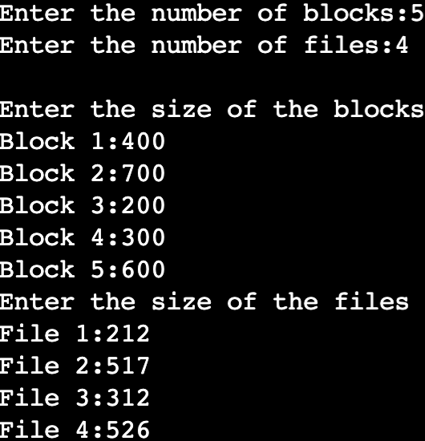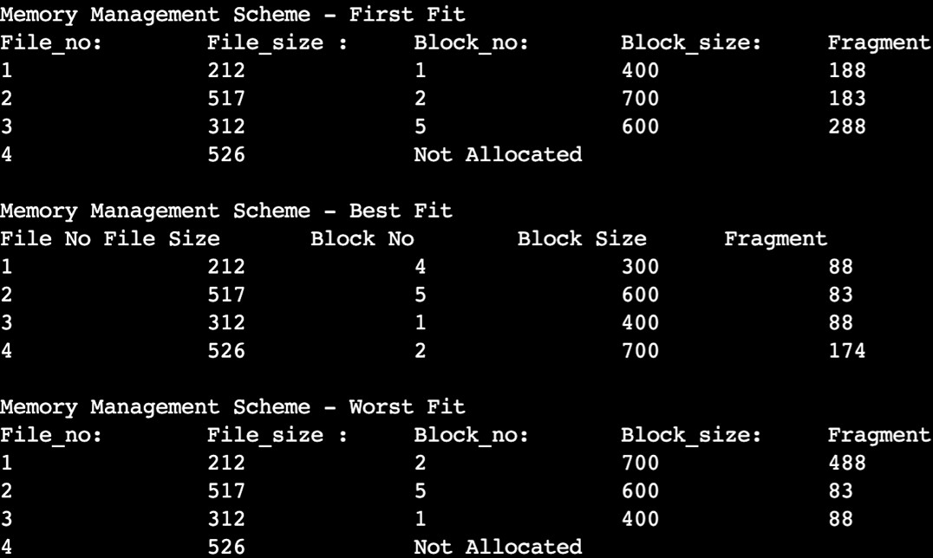

**Program:10 Question:**

**Write a C program to simulate page replacement algorithms**

1. **FIFO**
2. **LRU**
3. **Optimal**

**Code:**

#include <stdio.h>

// Function to check if the page is present in the frames int isPagePresent(int frames[], int n, int page) {

for (int i = 0; i < n; i++) { if (frames[i] == page) {

return 1;

}

}

return 0;

}

// Function to print the frames

void printFrames(int frames[], int n) { for (int i = 0; i < n; i++) {

if (frames[i] != -1) {

printf("%d ", frames[i]);

} else {

printf("- ");

}

}

printf("\n");

}

// Function to implement FIFO page replacement

void fifoPageReplacement(int pages[], int numPages, int numFrames) { int frames[numFrames];

int front = 0, pageFaults = 0;

// Initialize frames

for (int i = 0; i < numFrames; i++) { frames[i] = -1;

}

printf("FIFO Replacement\n"); printf("Reference String\tFrames\n"); for (int i = 0; i < numPages; i++) {

printf("%d\t\t", pages[i]);

if (!isPagePresent(frames, numFrames, pages[i])) { frames[front] = pages[i];

front = (front + 1) % numFrames; pageFaults++;

}

printFrames(frames, numFrames);

}

printf("\nTotal Page Faults: %d\n\n", pageFaults);

}

// Function to find the page to replace using the Optimal page replacement algorithm

int findOptimalReplacementIndex(int pages[], int numPages, int frames[], int numFrames, int currentIndex) {

int farthest = currentIndex; int index = -1;

for (int i = 0; i < numFrames; i++) { int j;

for (j = currentIndex; j < numPages; j++) { if (frames[i] == pages[j]) {

if (j > farthest) { farthest = j; index = i;

}

break;

}

}

// If the page is not found in future, return this index if (j == numPages) {

return i;

}

}

// If all pages are found in future, return the one with farthest future use return (index == -1) ? 0 : index;

}

// Function to implement Optimal page replacement

void optPageReplacement(int pages[], int numPages, int numFrames) { int frames[numFrames];

int pageFaults = 0;

// Initialize frames

for (int i = 0; i < numFrames; i++) { frames[i] = -1;

}

printf("Optimal Replacement\n"); printf("Reference String\tFrames\n"); for (int i = 0; i < numPages; i++) {

printf("%d\t\t", pages[i]);

if (!isPagePresent(frames, numFrames, pages[i])) { if (isPagePresent(frames, numFrames, -1)) {

for (int j = 0; j < numFrames; j++) { if (frames[j] == -1) {

frames[j] = pages[i]; break;

}

}

} else {

int index = findOptimalReplacementIndex(pages, numPages, frames, numFrames, i + 1); frames[index] = pages[i];

}

pageFaults++;

}

printFrames(frames, numFrames);

}

printf("\nTotal Page Faults: %d\n\n", pageFaults);

}

// Function to implement LRU page replacement

void lruPageReplacement(int pages[], int numPages, int numFrames) { int frames[numFrames];

int pageFaults = 0;

int timestamps[numFrames];

// Initialize frames and timestamps for (int i = 0; i < numFrames; i++) {

frames[i] = -1;

timestamps[i] = -1;

}

printf("LRU Replacement\n"); printf("Reference String\tFrames\n"); for (int i = 0; i < numPages; i++) {

printf("%d\t\t", pages[i]);

if (!isPagePresent(frames, numFrames, pages[i])) { int lruIndex = 0;

for (int j = 1; j < numFrames; j++) {

if (timestamps[j] < timestamps[lruIndex]) { lruIndex = j;

}

}

frames[lruIndex] = pages[i]; timestamps[lruIndex] = i; pageFaults++;

} else {

for (int j = 0; j < numFrames; j++) { if (frames[j] == pages[i]) {

timestamps[j] = i; break;

}

}

}

printFrames(frames, numFrames);

}

printf("\nTotal Page Faults: %d\n\n", pageFaults);

}

int main() {

int numFrames, numPages;

printf("Enter the number of frames: "); scanf("%d", &numFrames);

printf("Enter the number of pages: "); scanf("%d", &numPages);

int pages[numPages];

printf("Enter the reference string: "); for (int i = 0; i < numPages; i++) {

scanf("%d", &pages[i]);

}

fifoPageReplacement(pages, numPages, numFrames); optPageReplacement(pages, numPages, numFrames); lruPageReplacement(pages, numPages, numFrames);

return 0;

}

**Output:**

