Experiment – 7
Users, Roles and Permissions
Access Control in Zoho Creator
Department of Computer Science and Engineering
Student Name: Akash M
Roll No: 240701025
Application Name: College (Purchase Request / Procurement Application)

Objective
To implement role-based access control in a Zoho Creator application by adding users, defining a role hierarchy, and creating permission sets, so that each user sees and performs only the actions appropriate to their position.

Introduction
Zoho Creator controls access to an application through three connected concepts. A User is an individual who has been granted access to the solution. A Role places the user in a reporting hierarchy and decides whose records the user can see. A Permission Set (profile) decides what the user can do — access, view, edit, and delete — on each form and report. Every user added to an application is assigned one role and one permission set, so access is managed centrally rather than record by record.

Concepts Used
Concept | Description | Configured in this Experiment
User | A person invited to the application by e-mail and assigned an application, role, and permission | Super Admin, Requester, and a second user
Role | A position in the reporting hierarchy; higher roles can see the records of roles beneath them | CEO → Finance → HOD → Requester
Permission Set | A profile defining Access, View, Edit, Delete, and More rights for each module (form) | Finance, HOD, Read, Requester, Write
Data Sharing | Rules controlling how records are shared between roles beyond the hierarchy | Available under the Data Sharing tab
Table 7.1: Access-control concepts in Zoho Creator.

Configuration Summary
The Role Hierarchy created for the application is shown below. Each role reports to the one above it, so the CEO sits at the top and can view the records of every role beneath.
Role | Reports To | Purpose
CEO | Top of hierarchy | Overall visibility of all purchase requests
Finance | CEO | Financial review and approval
HOD | Finance | Department-level approval
Requester | HOD | Raises and tracks purchase requests
Table 7.2: Role hierarchy.
The Permission Sets created for the application are listed below.
Permission Set | Description
Finance | Finance Profile
HOD | HOD Profile
Read | Read permission for all components
Requester | Requester Profile — can raise and track purchase requests
Write | Write permission for all components
Table 7.3: Permission sets.
The users added to the account are listed below.
User | Account Type | Status
ARJUNRAJ M 240701049 | Super Admin | Active
Requester | Application user | Active
arjunrajm11 | Application user | Active
Table 7.4: Users in the account.

Screenshot-based lab record
The following pages contain the actual Zoho Creator screenshots of the user, role, and permission configuration.

Screenshots 1 – Users
The Users page of Zoho Creator lists every user with their e-mail address, status, and last activity. The first user is the Super Admin who owns the account, and the other users were invited to work in the application.
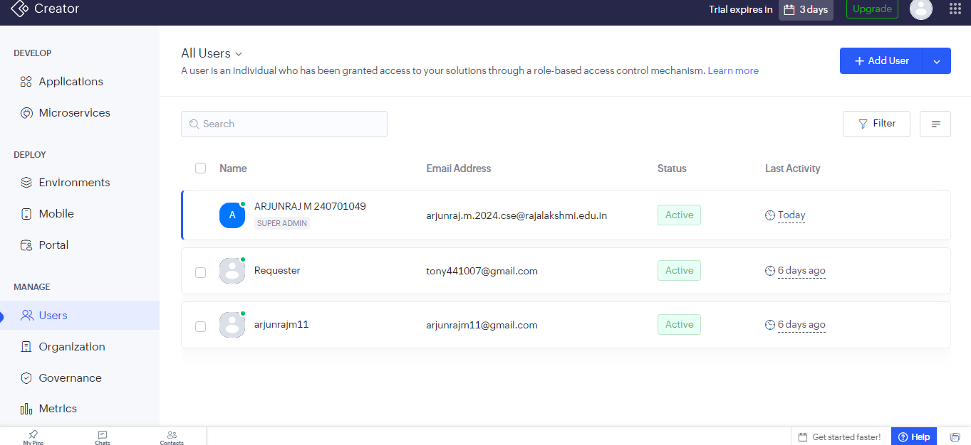
Figure 1.1: All Users page showing the Super Admin and two active users.
A new user is added using the Add User option. The e-mail address and name are entered, and the application, role, and permission are then selected under the User, Developer, or App Admin tab.
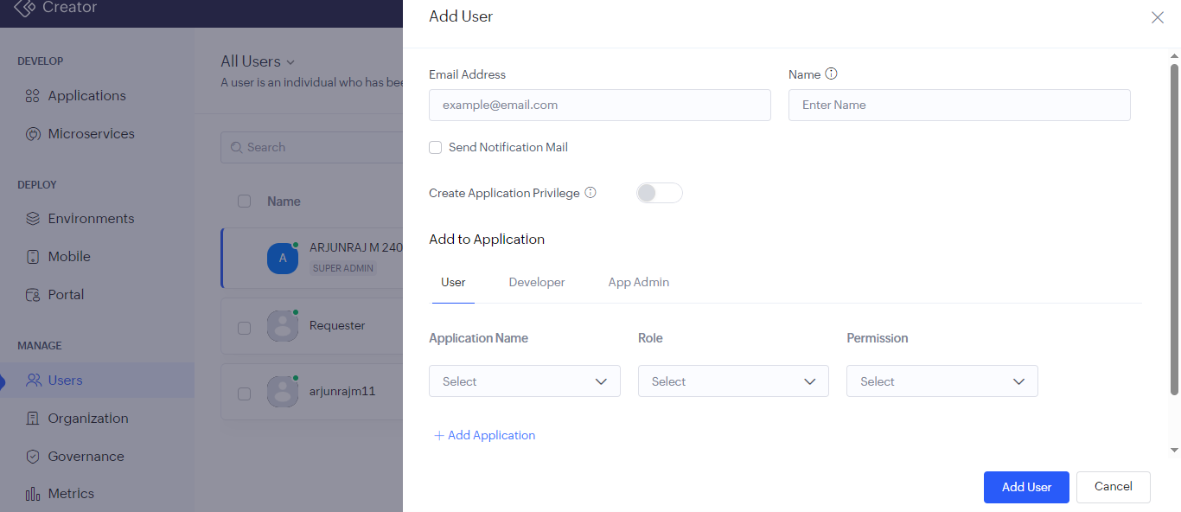
Figure 1.2: Add User panel with the Application Name, Role, and Permission selectors.

Screenshots 2 – Roles
Roles are managed from Settings → User Permissions → Roles. The hierarchy is displayed as a tree and can be expanded, collapsed, or rearranged using Manage Role Hierarchy.
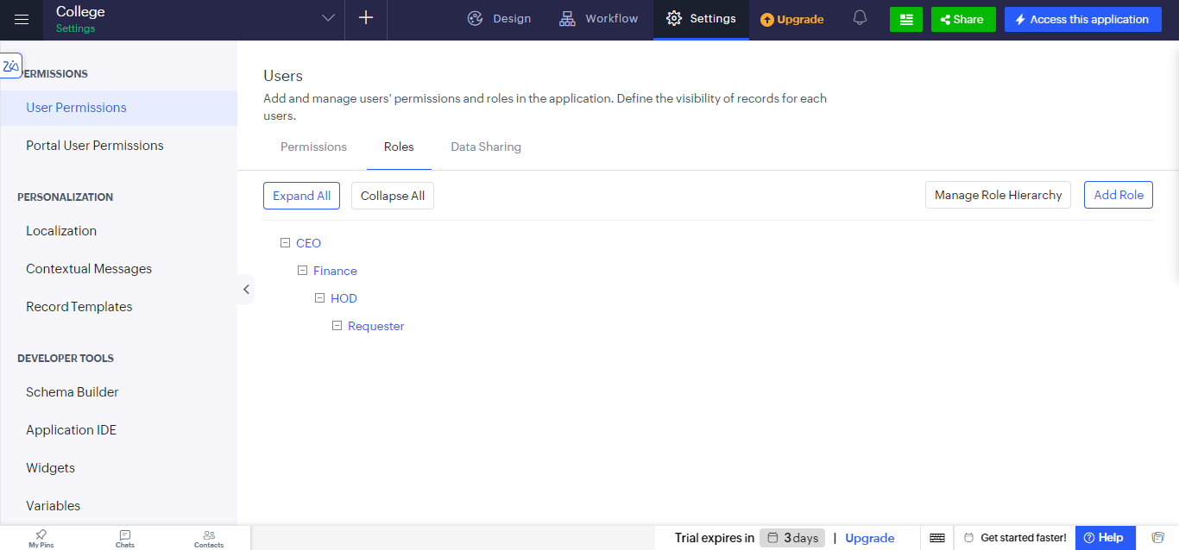
Figure 2.1: Roles tab showing the hierarchy CEO → Finance → HOD → Requester.
A new role is created with Add Role by giving it a name, choosing the role it reports to, and optionally adding a description. The Share Data with Peers option lets users of the same role see each other’s records.
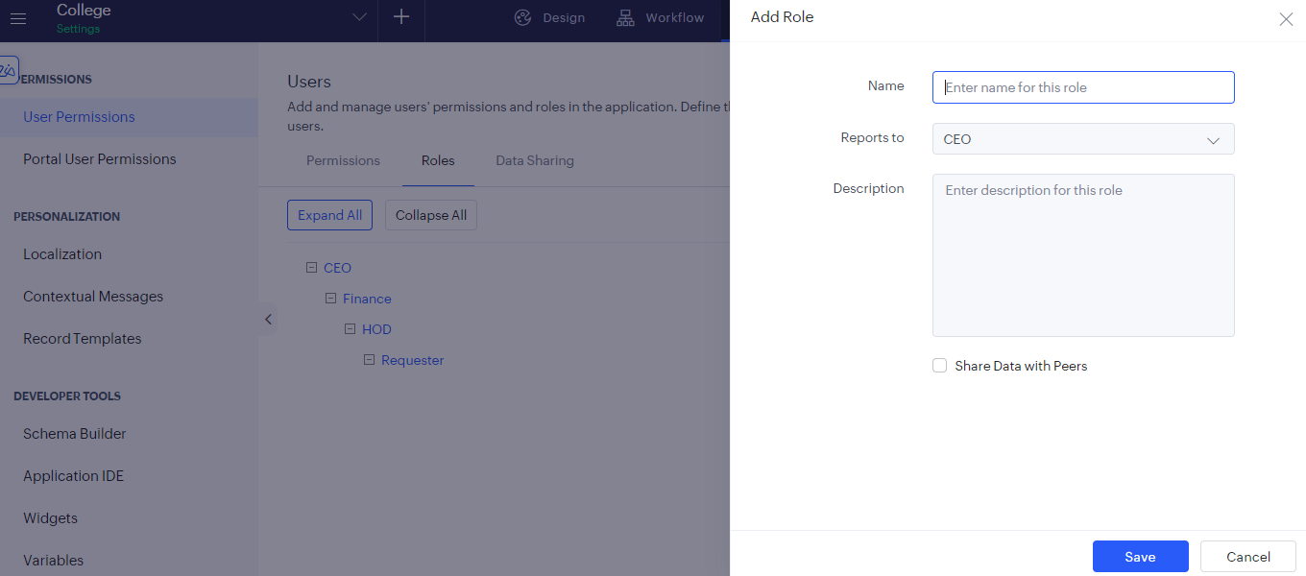
Figure 2.2: Add Role panel with Name, Reports to, Description, and Share Data with Peers.

Screenshots 3 – Permissions
Permission sets are managed from the Permissions tab. Each set has a name and description and can be assigned to any number of users.
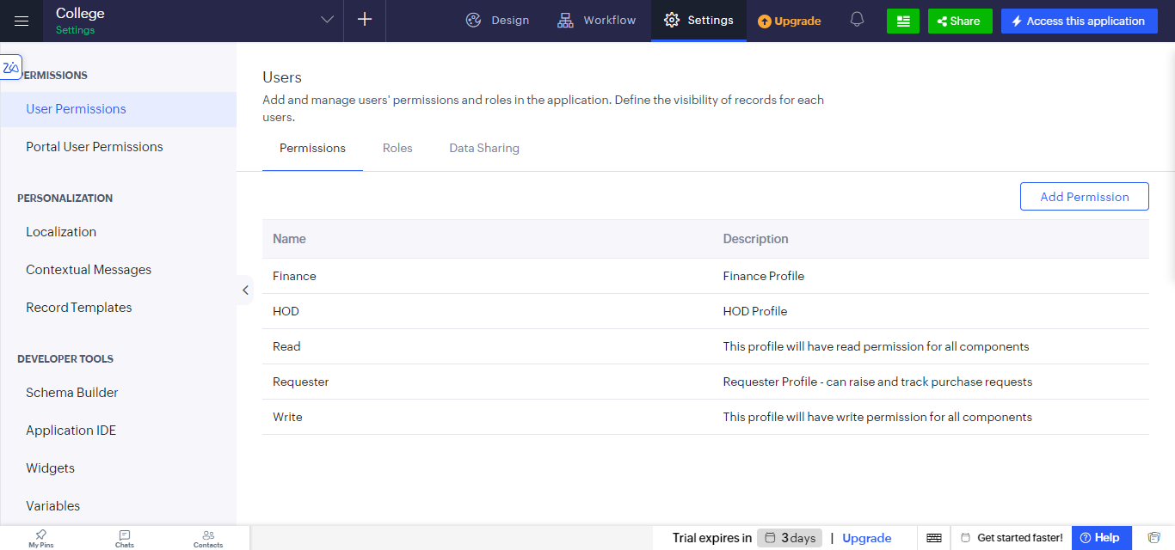
Figure 3.1: Permissions tab listing the Finance, HOD, Read, Requester, and Write permission sets.
A new permission set is created with Add Permission. The name and description are entered first, and API & Security permissions can be expanded for additional controls.
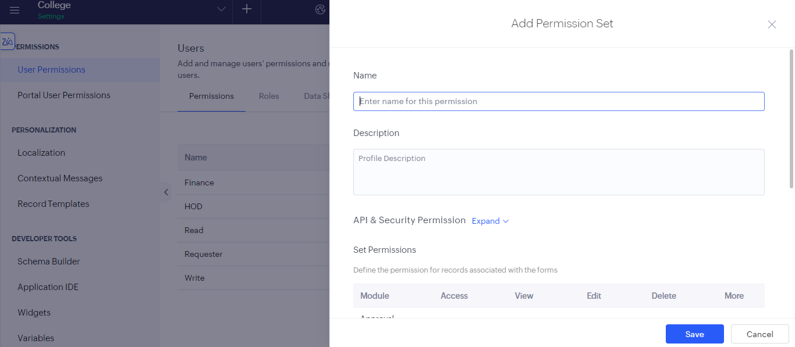
Figure 3.2: Add Permission Set panel — name, description, and API & Security Permission.
The Set Permissions table then defines, for each module (form) of the application, whether the user gets Access, View, Edit, Delete, and More rights, by ticking the corresponding check boxes.
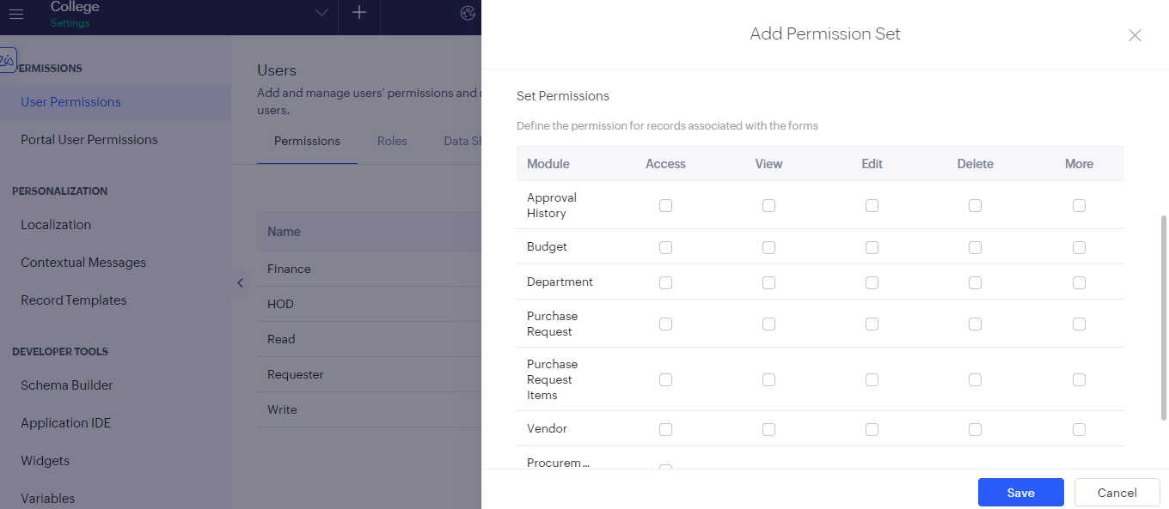
Figure 3.3: Set Permissions table with Access, View, Edit, Delete, and More rights for each module.

Observation
Access to the application was controlled entirely through configuration, without writing any code. The role hierarchy determines whose records a user can see, while the permission set determines what the user can do with those records, so the two settings work together. A Requester, for example, can be given a permission set that allows raising and tracking purchase requests, while the HOD, Finance, and CEO roles above it see those requests for approval. Permission sets can be reused for any number of users, which keeps administration simple as the number of users grows.

Result
Users, roles, and permission sets were successfully created in Zoho Creator, and a role hierarchy of CEO, Finance, HOD, and Requester was configured. Role-based access control was thereby implemented for the application.

