RockPaperScissors.cpp
Assignment 2 (Fix the game!)
Purpose
The original program let the user run a simple session of traditional game “Rock, paper scissors”, where they can type down their choices and a bot will display theirs. Although it fulfilled its intended purpose, the program still needed corrections. Therefore, the purpose of this new program is to improve various aspects of its predecessor, such as a better logic flow, upgraded user interface, improved interactions with the user, customization, etc.
Inputs
The program receives the following inputs from the user:
- Username
- Bot selection number
- Player moves for each round
- Whether the user wants to play again
Outputs
The program displays the following outputs:
- A welcome message
- Game rules
- A username prompt
- Bot selection menu
- Warning message for invalid inputs
- A prompt for the player’s move
- Bot selected move
- Score updates
- Match results (win, lose or tie)
- Bot dialogues for victory or defeat
- Ask if the user wants to play again
- Goodbye and thanks message

Variables
Variable | Type | Purpose
running | bool | Controls whether the game keeps running.
player_name | string | Saves the username entered by the player.
bot_name | string | Keeps the name of the selected bot.
bot_catalogue | string array | Stores the names for the bot.
chosen_bot | int | Stores the number selected by the user for the bot opponent.
moves | string array | Holds the valid move names: Rock, Paper, and Scissors.
player_move | string | Stores the move entered by the player.
bot_move | int | Stores the random array index used for the bot's move.
bot_pick | string | Saves the bot's chosen move.
player_score | int | Stores the player's score during a match.
bot_score | int | Stores the bot's score during a match.
bot_wins_lines | string array | Holds the dialogue printed when the bot wins a match.
bot_loses_lines | string array | Keeps dialogue printed when the bot loses a match.
answer | string | Saves the user's answer about whether to play again.

Key Design Choices
srand(time(0)): In the early trials of the program, although the bot move generation was random, it was creating a pseudo-pattern that could be tracked down by users who spend long times playing. Therefore, with this function, from the “<ctime>” library, a seed is located in the pattern randomly generated, and, since the seed is the current time, it will never start in the same position twice.
while(running) and game restart: The program uses a while-loop so the user can play multiple matches without restarting the program. In addition, the program resets variables “player_score” and “bot_score” at the beginning of each new match so previous match scores do not affect the next match.
Array optimization: The program uses multiple arrays for bot names, valid moves, and bot dialogues to avoid storing each option in separate variables. In addition, the arrays also improve the logic flow of the code itself while also saving a fair amount of time and lines. For instance, the original version of the code relied on an if-else statement sequence to display the bot choices, whereas this modified version utilizes the array “moves” along with the “rand() % 3” operation to pick a random move from the array and then simply display it in a matter of 3 lines of code.
std::getline() instead of std::cin>>: The program uses “std::getline” for most variable storage lines instead of the common “std::cin>>” because “std::cin” only stores the first word that it reads, which creates space for potential invalid inputs of user entering a correct word followed by a sentence full of gibberish. Instead, “std::getline” can read the whole line entered by the user, improving greatly user input reading, so that input such as "Scissors and pepper" can be read as one full line and rejected as invalid.
<cctype> and case-insensitivity: The program converts the lines in “player_move” to lowercase so inputs such as “ROCK”, “Rock”, “rock” or “rOCk” can be treated the same way. This is possible due the function “tolower()” from the <cctype> library. Once all characters are turned into lowercase, an if-else statement compares user input to the content in the array “moves” to make it consistent with the bot choices. Similarly, it also converts replay answers to lowercase so inputs such as “YES”, “Yes”, “y”, “N”, and “no” can be handled consistently.
nested for-loops: Is worth mentioning that, in order to make the code case-insensitive, a nested for-loop is used. The inner for-loop reads the user line character by character, turning them into lowercase. Moreover, if user input is invalid, not only is a warning message displayed, but also the counter of the outer loop, “rounds” is decreased by 1. This was done to avoid the rounds to ever reach 2 and provoke an accidental win through user’s writing errors, forcing the rounds to remain static until the user enters a valid move. Afterall, even if the rounds decrease in the inner loop, they are still increasing by the outer-loop headliner.
“Username and AI character” Addition: In order to make the code more user-friendly while also providing customization and a more interactive experience, the user is now capable of entering a nickname of their choice, being warned of the dangers of providing their real name in online spaces. Also, once their username is choose, the user can also pick a name for the bot, so instead of just playing against the terminal that will give no replies, the user can name the bot after famous AI models from both real world (ChatGPT, Claude and Gemini) and fictional AI (Skynet, R2D2 and Allied Mastercomputer (AM)). Not only that, but also, once the bot is given a name, it is also provided with dialogues to display when they win or lose a match against the player, so that a sense of competition can be emulated to some degree. The roots of the idea are from the chess.com app that allows you to play against special bots with custom dialogues. Finally, Allied Mastercomputer (AM) is hidden as an easter-egg (like a videogame rewarding user for digging into the material intensely) and can perform a unique exit from the code, given its wrathful personality. In other words, Allied Mastercomputer (AM) is meant to be a bad loser, eager to quit and ruin the experience of the game for everyone.
Program Steps (Algorithm)
1. Display the welcome message and rules.
2. Ask the user to enter a username.
3. Display the bot selection menu and let the user select their opponent based on the number. If the number entered is out of the scope, a warning message alerts the user.
4. Display the selected bot name or the secret bot message.
5. Start the game with 3 rounds.
6. If either player or bot scores at least 2 points, end the round loop early.
7. Ask the user to enter Rock, Paper, or Scissors.
8. If the move is invalid, the program displays a warning and restarts the round until user enters a valid move.
9. Display the bot's chosen move.
10. Compare player and bot choices. If both are the same, no point is given to either side. Otherwise, a point is given to the winner, and the updated score is displayed.
11. After three rounds, the game compares both scores and declares a winner.
12. If the player wins, displays winning message along with their final score and the bot losing dialogue. In the other hand, if the bot wins, the final score is shown along with their winning dialogue.
13. Special addition: If Allied Mastercomputer (AM) loses, a special ending is displayed, and AM will forcefully stop the program being enraged.
14. If the scores are equal, display the tie message.
15. Ask whether the user wants to play again.
16. If the user says yes, the game restarts. Else, the game stops and display good-bye message. Also, if the answer is invalid, the program asks again until a valid answer is given.
Functions
Function: int main()
Purpose: Runs the full “Rock, paper, scissors” game. The spinal cord of the code that holds variables, loop, program output and user input.
Sample Input/Output
Output | Input
||---Let's play 'Rock. Paper. Scissors!!'---||
||-----------RULES: Write your choice. Your opponent will choose theirs. Best of three rounds wins!!---------------------||
||Note: If no player has reached 2 points by the end of Round 3, the winner is determined by the highest score.||
Enter your username (Tip: Please don't use your real name for this type of thing, it's risky): | Buzio
Which artificial intelligence would you like to play with? Select its number to pick it:  0-???  1-ChatGPT  2-Claude  3-Gemini  4-Skynet  5-R2D2 | 5
Great!! You are playing against R2D2!!
Choose rock, paper or scissors: | Scissors
R2D2 has picked: Paper  +1 for Buzio  Buzio points: 1  R2D2 points: 0  Choose rock, paper or scissors: | Paper
Choose rock, paper or scissors: Paper  R2D2 has picked: Paper  Oh. No point for either side, I guess.  Buzio points: 1  R2D2 points: 0  Choose rock, paper or scissors: | Rock
R2D2 has picked: Scissors

+1 for Buzio
Buzio points: 2
R2D2 points: 0

Buzio wins with a total score of 2 over 0
R2D2: *angry astromech screaming* (translation censored by protocol droids)
Do you want to play again? [yes/no or y/n]: | No
Thanks for playing 'Rock. Paper. Scissors!!' with us. Bye-Bye!! :D
It’s worth noting that the exact bot moves and final result may change because the bot move is randomly generated.

Testing
Test Case 1: Perfect case-scenario.
Expected Result:
The program accepts ChatGPT as the selected bot, accepts the valid moves, plays the match, displays the score updates, asks whether to play again, and exits when the user enters no.
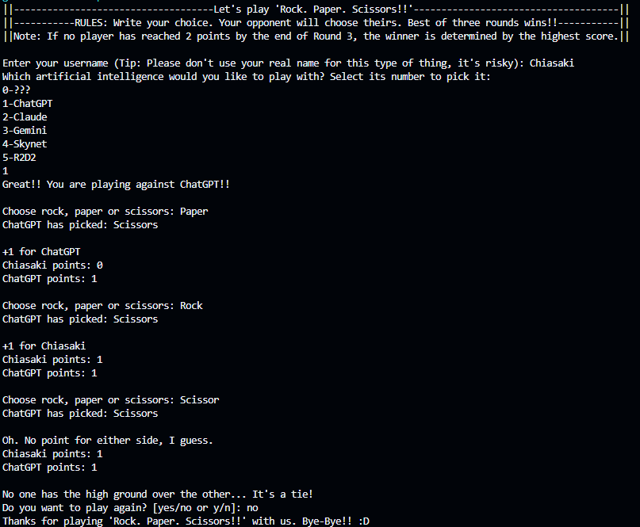

Test Case 2: Bot selection out of range
Expected Result:
The program rejects 8 as an invalid bot selection, asks for another number, accepts 2 as Claude, and continues the match.
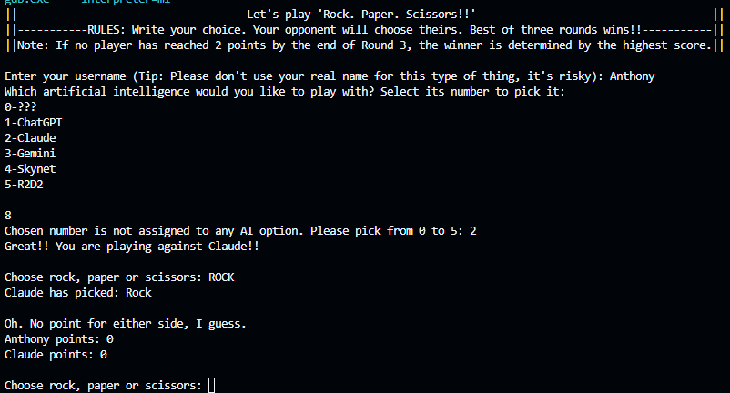
Test Case 3: Invalid moves
Expected Result:
The program rejects "Scissors and sea salt" because the full line is not exactly a valid move, then accepts Scissors, Rock, and Paper as valid moves.
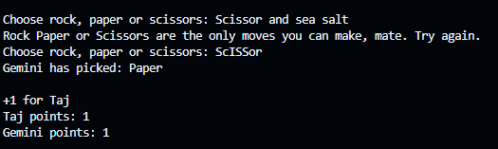

Test Case 4: AM easter egg and secret ending
Expected Result:
The program accepts Y as yes and starts a new match. It accepts 0 as the secret Allied Mastercomputer (AM) bot choice. It accepts n as no and exits unless the special AM ending stops the game first.
