**EXPLORATORY DATA ANALYSIS**

**Location:**

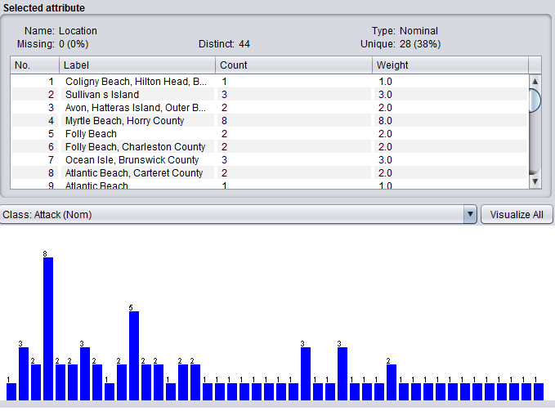

It can be observed that Myrtle Beach is prone to more number of attacks among all the locations of nc and sc.

**MoonPhaseExtended:**

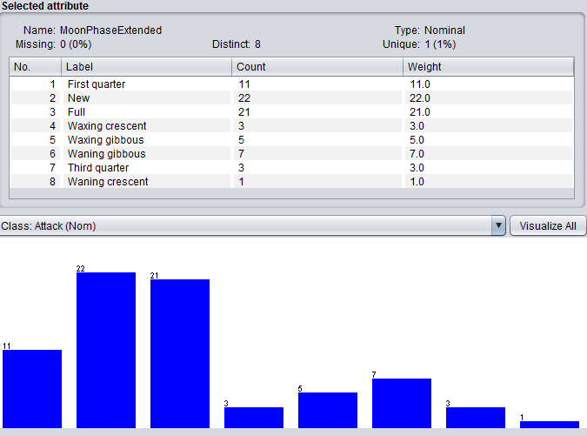

Attacks are almost equal in both the cases New moon and full moon. As we know tides favour the shark attacks, but when moon and sun align, known as full or new moon, the pull is at its strongest, causing the tides to be at their highest and lowest. This is known as spring tides. And because of the change from high tides to low tides and back again happens so quickly, sharks may move in areas closer to where people swim when the tide is low.

**Wind_Speed_Modified:**

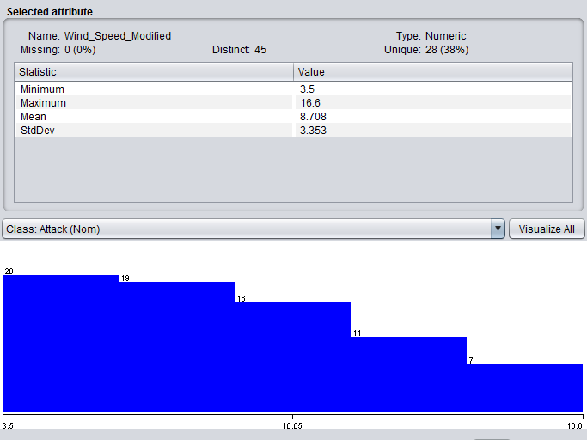

It is clearly understood that the number of attacks happened are constant for certain intervals of wind speed and decrease when the wind speed increases.

**Salinity:**

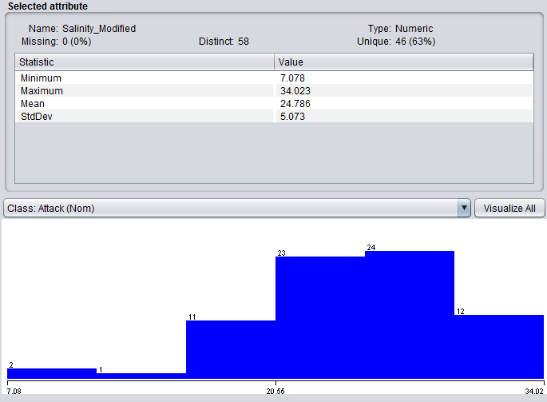

There is no particular proportionality for this relation. The number of attacks happened are highest when the salinity reached the optimal/desired levels.

**Turbidity_discretize:**

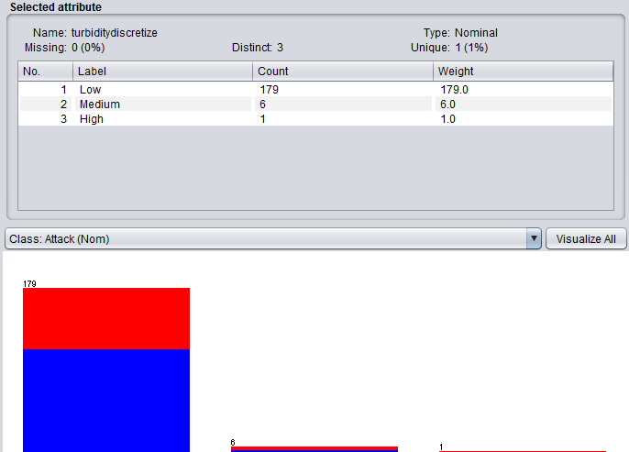

More number of attacks were happened when the relative clarity of water is high and the attacks are negligibly small when turbidity is low.

**CrabLandings:**

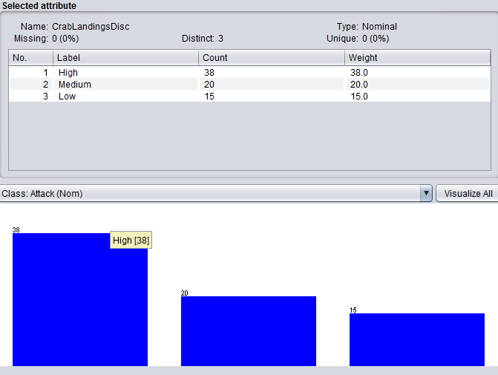

Attacks observed are high when the population of crabs i.e their landings are prominent

**Direction:**

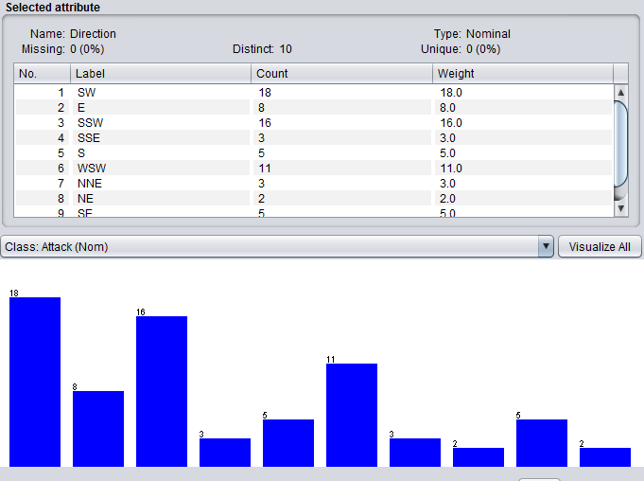

Attacks are almost equal in both the cases South-Southwest and Southwest winds. This might also be the area where shark population residing is high.

**Temperature:**

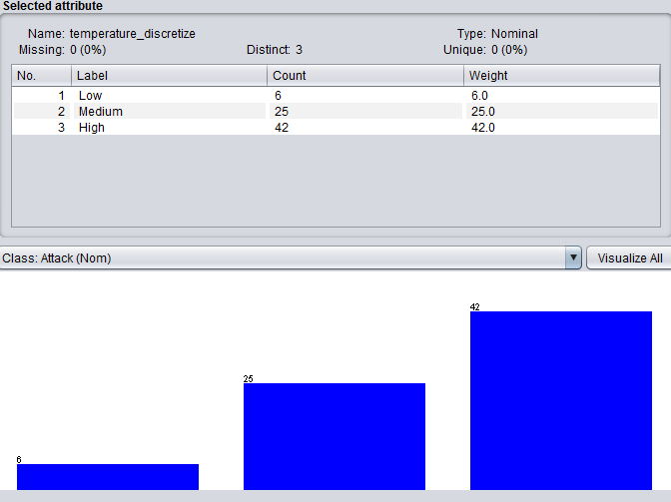

High temperature favours shark attacks. As the temperatures of the water increase, the sharks may move into new locations where they will be more comfortable. This means they can be in areas where people are fishing, boating, and swimming.