**Decision Tree:**

=== Run information ===

Scheme: weka.classifiers.trees.J48 -U -M 2

Relation: filebalancedWEKAfinal-weka.filters.unsupervised.attribute.Remove-R1-18,20-39,43,45-49,51-73

Instances: 186

Attributes: 6

Attack

salinitydiscretize

turbiditydiscretize

temperaturediscretize

pressurediscretize

CrabLandingsDisc

Test mode: 10-fold cross-validation

=== Classifier model (full training set) ===

J48 unpruned tree

------------------

salinitydiscretize = Medium

| temperaturediscretize = High

| | CrabLandingsDisc = High: Yes (27.0/9.0)

| | CrabLandingsDisc = Low: No (17.0/6.0)

| | CrabLandingsDisc = Medium: No (11.0/5.0)

| temperaturediscretize = Medium: No (14.0/4.0)

| temperaturediscretize = Low: No (1.0)

salinitydiscretize = High

| CrabLandingsDisc = High

| | pressurediscretize = Medium: No (24.0/8.0)

| | pressurediscretize = High: Yes (13.0/6.0)

| | pressurediscretize = Low: No (0.0)

| CrabLandingsDisc = Low: No (35.0/7.0)

| CrabLandingsDisc = Medium: No (41.0/14.0)

salinitydiscretize = Low: Yes (3.0)

Number of Leaves : 11

Size of the tree : 16

Time taken to build model: 0.04 seconds

=== Stratified cross-validation ===

=== Summary ===

Correctly Classified Instances 115 61.828 %

Incorrectly Classified Instances 71 38.172 %

Kappa statistic 0.1114

Mean absolute error 0.4618

Root mean squared error 0.5131

Relative absolute error 97.2328 %

Root relative squared error 105.3173 %

Total Number of Instances 186

=== Detailed Accuracy By Class ===

TP Rate FP Rate Precision Recall F-Measure MCC ROC Area PRC Area Class

0.851 0.750 0.642 0.851 0.732 0.126 0.488 0.590 No

0.250 0.149 0.514 0.250 0.336 0.126 0.488 0.434 Yes

Weighted Avg. 0.618 0.517 0.593 0.618 0.579 0.126 0.488 0.530

=== Confusion Matrix ===

a b <-- classified as

97 17 | a = No

54 18 | b = Yes

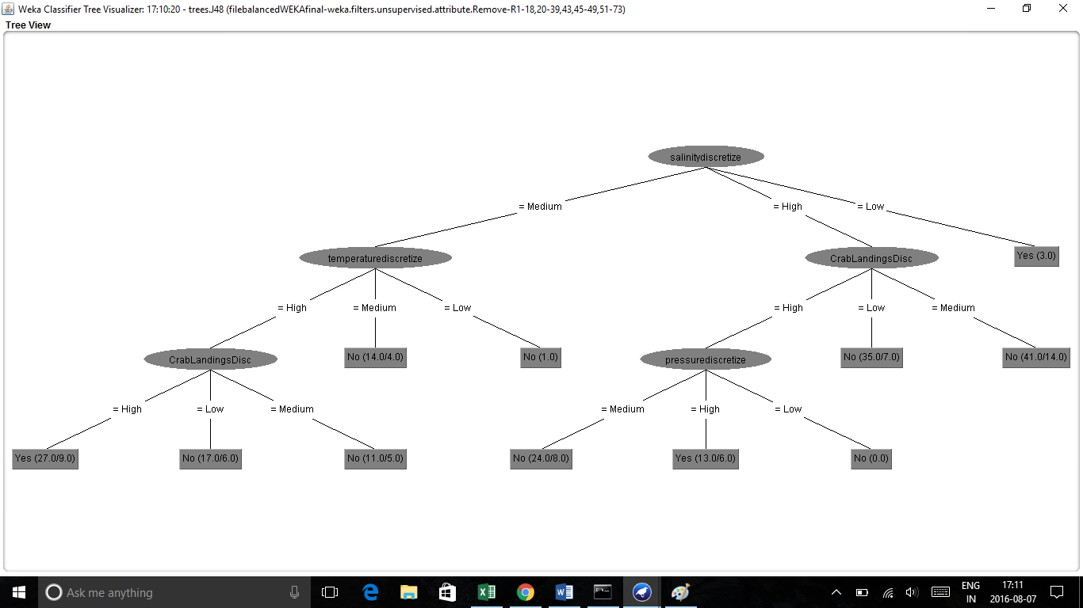

**Clusters:**

=== Run information ===

Scheme: weka.clusterers.SimpleKMeans -init 0 -max-candidates 100 -periodic-pruning 10000 -min-density 2.0 -t1 -1.25 -t2 -1.0 -N 2 -A "weka.core.EuclideanDistance -R first-last" -I 500 -num-slots 1 -S 10

Relation: filebalancedWEKAfinal-weka.filters.unsupervised.attribute.Remove-R1-18,20-39,43,45-49,51,53-73

Instances: 186

Attributes: 7

Attack

salinitydiscretize

turbiditydiscretize

temperaturediscretize

pressurediscretize

CrabLandingsDisc

Direction

Test mode: evaluate on training data

=== Clustering model (full training set) ===

kMeans

======

Number of iterations: 4

Within cluster sum of squared errors: 402.0

Initial starting points (random):

Cluster 0: No,Medium,Low,High,Medium,Low,SSW

Cluster 1: Yes,High,Low,Medium,Medium,High,SW

Missing values globally replaced with mean/mode

Final cluster centroids:

Cluster#

Attribute Full Data 0 1

(186.0) (125.0) (61.0)

========================================================

Attack No No Yes

salinitydiscretize High High Medium

turbiditydiscretize Low Low Low

temperaturediscretize High High High

pressurediscretize Medium Medium Medium

CrabLandingsDisc High Low High

Direction SSW SSW SW

Time taken to build model (full training data) : 0.01 seconds

=== Model and evaluation on training set ===

Clustered Instances

0 125 ( 67%)

1 61 ( 33%)

**Association Rules:**

Apriori with Discretized Values - find best rules for Attack = Y, find rules with attributes of interest from previous mining

=== Run information ===

Scheme: weka.associations.Apriori -N 50 -T 0 -C 0.75 -D 0.05 -U 1.0 -M 0.1 -S -1.0 -A -c 1

Relation: Changed File Weka-weka.filters.unsupervised.attribute.Remove-R2-10,12-16,18,22

Instances: 186

Attributes: 7

Attack

DissolvedO2discretize

windspeeddiscretize

CrabLandingsDisc

Direction

MoonPhase3daysextended

changetemp

=== Associator model (full training set) ===

Apriori

=======

Minimum support: 0.1 (19 instances)

Minimum metric <confidence>: 0.75

Number of cycles performed: 18

Best rules found:

18. CrabLandingsDisc=High Direction=SW MoonPhase3daysextended=Full_New 27 ==> Attack=Yes 21 conf:(0.78)

=== Run information ===

Scheme: weka.associations.Apriori -N 50 -T 0 -C 0.5 -D 0.05 -U 1.0 -M 0.1 -S -1.0 -A -c 1

Relation: Changed File Weka-weka.filters.unsupervised.attribute.Remove-R2-10,12-16,18,22-weka.filters.unsupervised.attribute.Remove-R4

Instances: 186

Attributes: 6

Attack

DissolvedO2discretize

windspeeddiscretize

Direction

MoonPhase3daysextended

changetemp

=== Associator model (full training set) ===

Apriori Algorithm

=======

Minimum support: 0.1 (19 instances)

Minimum metric <confidence>: 0.5

Number of cycles performed: 18

Best rules found:

1. windspeeddiscretize=Medium Direction=SW 37 ==> Attack=Yes 21 conf:(0.57)
2. windspeeddiscretize=Medium Direction=SW changetemp=EQ 37 ==> Attack=Yes 21 conf:(0.57)
3. Direction=SW MoonPhase3daysextended=Full_New 61 ==> Attack=Yes 34 conf:(0.56)
4. Direction=SW MoonPhase3daysextended=Full_New changetemp=EQ 61 ==> Attack=Yes 34 conf:(0.56)
5. DissolvedO2discretize=Medium Direction=SW MoonPhase3daysextended=Full_New 53 ==> Attack=Yes 28 conf:(0.53)
6. DissolvedO2discretize=Medium Direction=SW MoonPhase3daysextended=Full_New changetemp=EQ 53 ==> Attack=Yes 28 conf:(0.53)
7. Direction=SW 85 ==> Attack=Yes 44 conf:(0.52)
8. Direction=SW changetemp=EQ 85 ==> Attack=Yes 44 conf:(0.52)
9. DissolvedO2discretize=Medium Direction=SW 76 ==> Attack=No 38 conf:(0.5)
10. DissolvedO2discretize=Medium Direction=SW 76 ==> Attack=Yes 38 conf:(0.5)
11. DissolvedO2discretize=Medium Direction=SW changetemp=EQ 76 ==> Attack=No 38 conf:(0.5)
12. DissolvedO2discretize=Medium Direction=SW changetemp=EQ 76 ==> Attack=Yes 38 conf:(0.5)